**EXPERIMENT-7**

**AIM:**

To computea Pandas program to create a Pivot table and find the maximum and minimum sale value of the items.

**PROGRAM:**

import pandas as pd

data = {

'Date': ['2024-07-01', '2024-07-01', '2024-07-02', '2024-07-02',

'2024-07-03', '2024-07-03', '2024-07-04', '2024-07-04'],

'Item': ['Item_A', 'Item_B', 'Item_A', 'Item_B',

'Item_A', 'Item_B', 'Item_A', 'Item_B'],

'Sales': [100, 200, 150, 300, 100, 250, 200, 100]

}

df = pd.DataFrame(data)

df['Date'] = pd.to_datetime(df['Date'])

pivot_table = df.pivot_table(values='Sales', index='Item', aggfunc=['max', 'min'])

pivot_table.columns = ['Max_Sales', 'Min_Sales']

print(pivot_table)

**OUTPUT:**

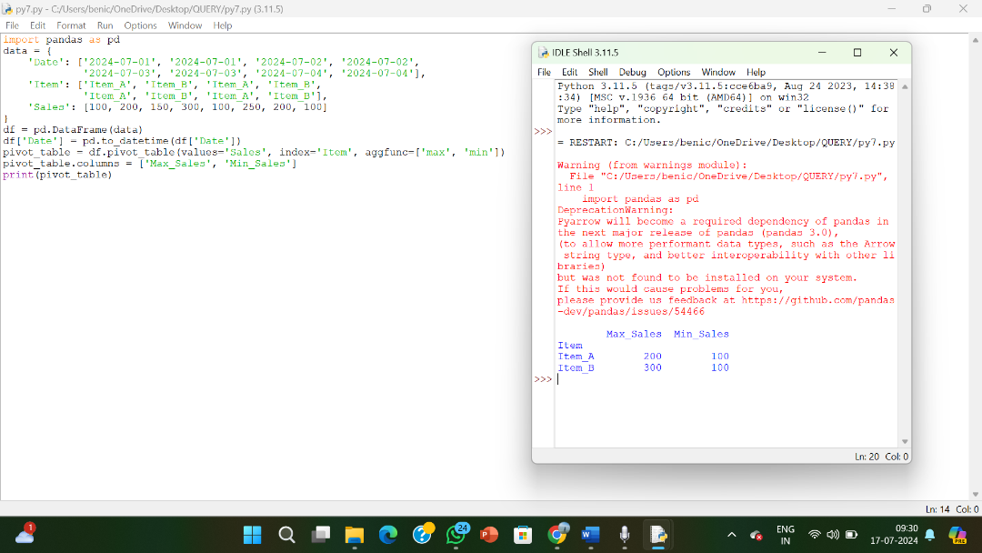

**RESULT:**

The pythonprogram to create a Pivot table and find the maximum and minimum sale value of the items is executed and verified.