**EXPERIMENT-8**

**AIM:**

To computea Pandas program to create a Pivot table and find the item wise unit sold.

**PROGRAM:**

import pandas as pd

data = {

'TransactionID': [1, 2, 3, 4, 5, 6],

'Item': ['Item_A', 'Item_B', 'Item_A', 'Item_C', 'Item_B', 'Item_A'],

'UnitsSold': [10, 5, 7, 3, 6, 8],

'PricePerUnit': [2.5, 5.0, 2.5, 7.0, 5.0, 2.5]

}

df = pd.DataFrame(data)

pivot_table = pd.pivot_table(df, values='UnitsSold', index='Item', aggfunc='sum')

print(pivot_table)

**OUTPUT:**

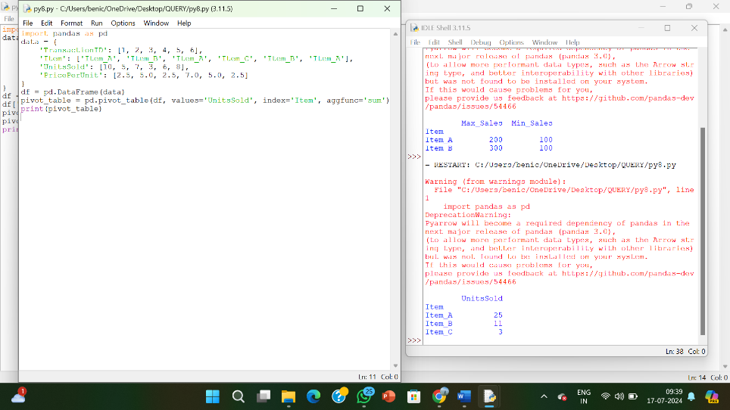

**RESULT:**

The pythonprogram to create a Pivot table and find the item wise unit sold.

is executed and verified.