**EXPERIMENT-9**

**AIM:**

To computea Pandas program to create a Pivot table and find the total sale amount region wise, manager wise, sales man wise.

**PROGRAM:**

import pandas as pd

data = {

'OrderDate': ['1-6-18', '1-23-18', '2-9-18', '2-26-18', '3-15-18', '4-1-18', '4-18-18', '5-5-18', '5-22-18', '6-8-18',

'6-25-18', '7-12-18', '7-29-18', '8-15-18', '9-1-18', '9-18-18', '10-5-18', '10-22-18'],

'Region': ['East', 'Central', 'Central', 'Central', 'West', 'East', 'Central', 'Central', 'West', 'East',

'Central', 'East', 'East', 'East', 'Central', 'East', 'Central', 'East'],

'Manager': ['Martha', 'Hermann', 'Hermann', 'Timothy', 'Timothy', 'Martha', 'Martha', 'Hermann', 'Douglas', 'Martha',

'Hermann', 'Martha', 'Douglas', 'Martha', 'Douglas', 'Martha', 'Hermann', 'Martha'],

'SalesMan': ['Alexander', 'Shelli', 'Luis', 'David', 'Stephen', 'Alexander', 'Steven', 'Luis', 'Michael', 'Alexander',

'Sigal', 'Diana', 'Karen', 'Alexander', 'John', 'Alexander', 'Sigal', 'Alexander'],

'Item': ['Television', 'Home Theater', 'Television', 'Cell Phone', 'Television', 'Home Theater', 'Television', 'Television',

'Television', 'Home Theater', 'Television', 'Home Theater', 'Home Theater', 'Television', 'Desk', 'Video Games',

'Home Theater', 'Cell Phone'],

'Units': [95, 50, 36, 27, 56, 60, 75, 90, 32, 60, 90, 29, 81, 35, 2, 16, 28, 64],

'Unit_price': [1198.00, 500.00, 1198.00, 225.00, 1198.00, 500.00, 1198.00, 1198.00, 1198.00, 500.00, 1198.00, 500.00,

500.00, 1198.00, 125.00, 58.50, 500.00, 225.00],

'Sale_amt': [113810.00, 25000.00, 43128.00, 6075.00, 67088.00, 30000.00, 89850.00, 107820.00, 38336.00, 30000.00,

107820.00, 14500.00, 40500.00, 41930.00, 250.00, 936.00, 14000.00, 14400.00]

}

df = pd.DataFrame(data)

pivot_table = pd.pivot_table(

df,

values='Sale_amt',

index=['Region', 'Manager', 'SalesMan'],

aggfunc='sum'

)

print(pivot_table)

**OUTPUT:**

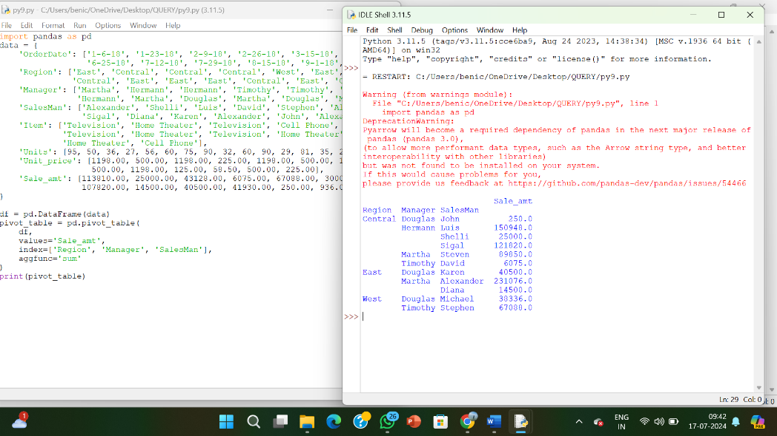

**RESULT:**

The pythonprogram to create a Pivot table and find the total sale amount region wise, manager wise, sales man wise is executed and verified.