**H1B visa dataset**

**BIG DATA - HADOOP**

SRIBALAJI S |Professional Diploma in Digital Transformation – Big Data with Hadoop |

Tools : Apache Hadoop Framework – HDFS, MapReduce, Hive, Pig, Sqoop, MySql and MS Excel for Data Visualization

S180030100254

NIIT

JANUARY 2018

**H1B visa Data set Analysis**

**A PROJECT REPORT**

***Submitted by***

***SRIBALAJI S***

***in the partial fulfillment for the award of the course***

***of***

**PROFESSIONAL DIPLOMA**

***in***

**BIG DATA WITH HADOOP**

**NIIT, CHENNAI**

**JANUARY 2018**

**ACKNOWLEDGEMENT**

I find immense pleasure to convey my sincere and grateful thanks to **NIIT** and the management for providing necessary facilities in carrying out this project.

I greatly indebted to my Tech Mentor **Ms. Amirtha,** the batch instructor **Mr. Annusharma** and the SLT faculty **Mr. Sandeep** for constant support throughout the course and also for useful suggestions, constant encouragement and kind advice in bringing out this project as a success.

I express my regards and sincere thanks to the Academic Leader **Mr.Oliver** for providing all necessary resource to complete the project. I extend my thanks to all staff members of NIIT for their kind co-operation for the completion of the project successfully. I am grateful to thank my family and all my friends for their valuable feedback, encouragement and suggestions.

**BIGDATA OVERVIEW**

“90% of the world’s data was generated in the last few years.”

Due to the advent of new technologies, devices, and communication means like social networking sites, the amount of data produced by mankind is growing rapidly every year. The amount of data produced by us from the beginning of time till 2003 was 5 billion gigabytes. If you pile up the data in the form of disks it may fill an entire football field. The same amount was created in every two days in 2011, and in every ten minutes in 2013. This rate is still growing enormously. Though all this information produced is meaningful and can be useful when processed, it is being neglected.

**BIGDATA**

Big Data is a collection of large datasets that cannot be processed using traditional computing techniques. It is not a single technique or a tool, rather it involves many areas of business and technology.

**WHAT COMES UNDER BIG DATA?**

Big data involves the data produced by different devices and applications. Given below are some of the fields that come under the umbrella of Big Data.

* Black Box Data: It is a component of helicopter, airplanes, and jets, etc. It captures voices of the flight crew, recordings of microphones and earphones, and the performance information of the aircraft.
* Social Media Data: Social media such as Facebook and Twitter hold information and the views posted by millions of people across the globe.
* Stock Exchange Data: The stock exchange data holds information about the ‘buy’ and ‘sell’ decisions made on a share of different companies made by the customers.
* Power Grid Data: The power grid data holds information consumed by a particular node with respect to a base station.
* Transport Data: Transport data includes model, capacity, distance and availability of a vehicle.
* Search Engine Data: Search engines retrieve lots of data from different databases.

Thus Big Data includes huge volume, high velocity, and extensible variety of data. The data in it will be of three types.

* Structured data: Relational data.
* Semi Structured data: XML data.
* Unstructured data: Word, PDF, Text, Media Logs.

**BIG DATA CHALLENGES**

The major challenges associated with big data are as follows:

* Capturing data
* Storage
* Searching
* Sharing
* Transfer
* Analysis

**HADOOP**

Hadoop is an Apache open source framework written in java that allows distributed processing of large datasets across clusters of computers using simple programming models. The Hadoop framework application works in an environment that provides distributed storage and computation across clusters of computers. Hadoop is designed to scale up from single server to thousands of machines, each offering local computation and storage. At its core, Hadoop has two major layers namely:

* Processing/Computation layer (MapReduce),
* Storage layer (Hadoop Distributed File System).

**ADVANTAGES OF HADOOP**

* Scalable
* Cost Effective
* Flexible
* Fast
* Resilient to failure
* Compatible on all the platforms since it is Java based.

**HADOOP ECOSYSTEM**

**HDFS**

The Hadoop Distributed File System (HDFS) is based on the Google File System (GFS) and provides a distributed file system that is designed to run on commodity hardware. It has many similarities with existing distributed file systems. However, the differences from other distributed file systems are significant. It is highly fault-tolerant and is designed to be deployed on low-cost hardware. HDFS holds very large amount of data and provides easier access. To store such huge data, the files are stored across multiple machines. These files are stored in redundant fashion to rescue the system from possible data losses in case of failure. HDFS also makes applications available to parallel processing.

Apart from the above-mentioned two core components, Hadoop framework also includes the following two modules:

* **Hadoop Common:** These are Java libraries and utilities required by other Hadoop modules.
* **Hadoop YARN:** This is a framework for job scheduling and cluster resource management.

**MAPREDUCE**

MapReduce is a parallel programming model for writing distributed applications devised at Google for efficient processing of large amounts of data (multi-terabyte data-sets), on large clusters (thousands of nodes) of commodity hardware in a reliable, fault-tolerant manner. The MapReduce program runs on Hadoop which is an Apache open-source framework.

**YARN**

**Apache Yarn** – “**Y**et **A**nother **R**esource **N**egotiator” is the resource management layer of **Hadoop**. The Yarn was introduced in Hadoop 2.x. Yarn allows different data processing engines like graph processing, interactive processing, stream processing as well as batch processing to run and process data stored in**HDFS** (Hadoop Distributed File System).

**HIVE**

Hive is a data warehouse infrastructure tool to process structured data in Hadoop. It resides on top of Hadoop to summarize Big Data, and makes querying and analyzing easy. It provides SQL type language for querying called HiveQL or HQL. It stores schema in a database and processed data into HDFS. Traditional SQL queries must be implemented in the [MapReduce](https://en.wikipedia.org/wiki/MapReduce) Java API to execute SQL applications and queries over distributed data. Hive provides the necessary SQL abstraction to integrate SQL-like queries ([HiveQL](https://en.wikipedia.org/wiki/HiveQL)) into the underlying Java without the need to implement queries in the low-level Java API. Since most data warehousing applications work with SQL-based querying languages, Hive aids portability of SQL-based applications to Hadoop.

**PIG**

Pig is a high level programming language useful for analyzing large data sets. Pig uses PigLatinlanguage. Pig was a result of development effort at Yahoo! Pig enables people to focus more on **analyzing bulk data sets and to spend less time in writing Map-Reduce programs.** Similar to Pigs, who eat anything, the Pig programming language is designed to work upon any kind of data. That's why the name, Pig!

Pig has two execution modes:

* Local mode : In this mode, Pig runs in a single JVM and makes use of local file system. This mode is suitable only for analysis of small data sets using Pig.
* Map Reduce mode: In this mode, queries written in Pig Latin are translated into MapReduce jobs and are run on a Hadoop cluster (cluster may be pseudo or fully distributed). MapReduce mode with fully distributed cluster is useful of running Pig on large data sets.

**HBase**

HBase is a distributed column-oriented database built on top of the Hadoop file system. It is an open-source project and is horizontally scalable. HBase is a data model that is similar to Google’s big table designed to provide quick random access to huge amounts of structured data. It leverages the fault tolerance provided by the Hadoop File System (HDFS). One can store the data in HDFS either directly or through HBase. Data consumer reads/accesses the data in HDFS randomly using HBase. HBase sits on top of the Hadoop File System and provides read and write access.

**Sqoop**

Sqoop imports data from external sources into Hadoop components like HDFS, HBase and Hive. It also exports data from Hadoop to other sources. Sqoop works with relational databases such as Teradata, Netezza, Oracle, MySQL, Postgres etc.

**Flume**

Flume is a distributed, reliable, and available service for efficiently collecting, aggregating, and moving large amounts of log data. It has a simple and flexible architecture based on streaming data flows. It is robust and fault tolerant with tunable reliability mechanisms and many failover and recovery mechanisms. It uses a simple extensible data model that allows for online analytic application.

**Other Components**

* **Ambari**– A web-based tool for provisioning, managing, and monitoring Apache Hadoop clusters which includes support for Hadoop HDFS, Hadoop MapReduce, Hive, HCatalog, HBase, ZooKeeper, Oozie, Pig, and Sqoop.
* **Avro**– A data serialization system.
* **HCatalog**- Helps data processing tools read and write data on the grid. It supports MapReduce and Pig.
* **Mahout**– A scalable machine learning and data mining library.
* **Oozie** - Workflow scheduler that was developed as part of the Apache Hadoop project. It manages how workflows start and execute, and also controls the execution path.
* **Zookeper**– A high-performance coordination service for distributed applications.

**HADOOP INSTALLATION**

Hadoop is supported by GNU/Linux platform and its flavors. Therefore, we have to install a Linux operating system for setting up Hadoop environment. In case you have an OS other than Linux, you can install a Virtualbox software in it and have Linux inside the Virtualbox.

**Installing Java**

Java is the main prerequisite for Hadoop.0

**user@laptop(local directory):~$** **sudo apt-get update**

**user@laptop:~$** **sudo apt-get install default-jdk**

**user@laptop:~$ java -version**

**java version "1.7.0_65"**

**Adding a dedicated Hadoop user**

**user@laptop:~$ sudo addgroup hadoop**

**Adding group `hadoop' (GID 1002) ...**

**Done.**

**user@laptop:~$ sudo adduser --ingroup hadoop hduser**

**Adding user `hduser' ...**

**Adding new user `hduser' (1001) with group `hadoop' ...**

**Creating home directory `/home/hduser' ...**

**Installing SSH**

**ssh** has two main components:

1. **ssh** : The command we use to connect to remote machines - the client.
2. **sshd** : The daemon that is running on the server and allows clients to connect to the server.

The **ssh** is pre-enabled on Linux, but in order to start **sshd** daemon, we need to install **ssh** first. Use this command to do that :

**user@laptop:~$ sudo apt-get install ssh**

This will install ssh on our machine. If we get something similar to the following, we can think it is setup properly:

**user@laptop:~$ which ssh**

**/usr/bin/ssh**

**user@laptop:~$ which sshd**

**/usr/sbin/sshd**

**Create and Setup SSH Certificates**

Hadoop requires SSH access to manage its nodes, i.e. remote machines plus our local machine. For our single-node setup of Hadoop, we therefore need to configure SSH access to localhost.

**user@laptop:~$ su hduser**

**Password:**

**hduser@laptop:/home/user$ cd ~**

**hduser@laptop:~$ ssh-keygen -t rsa -P ""**

**Your public key has been saved in /home/hduser/.ssh/id_rsa.pub.**

**hduser@laptop:~$ cat $HOME/.ssh/id_rsa.pub >> $HOME/.ssh/authorized_keys**

The second command adds the newly created key to the list of authorized keys so that Hadoop can use ssh without prompting for a password

**Install Hadoop**

**hduser@laptop:~$ su hduser**

**wget http://archive.apache.org/dist/hadoop/common/hadoop-2.6.0/hadoop-2.6.0.tar.gz**

**hduser@laptop:~$ tar xvzf hadoop-2.6.0.tar.gz**

**a folder would be created by the name of hadoop-2.6.0**

**rename this folder to hadoop**

**mv hadoop-2.6.0 hadoop**

We want to move the Hadoop installation to the **/usr/local/hadoop** directory using the following command:

**hduser@laptop:~$ sudo mv hadoop /usr/local/**

**[sudo] password for hduser:**

**hduser is not in the sudoers file. This incident will be reported.**

This error can be resolved by logging in as a root user, and then add **hduser** to **sudo**:

**hduser@laptop:~/hadoop-2.6.0$ su user (root user)**

**Password:**

**user@laptop:/home/hduser$ sudo adduser hduser sudo**

**[sudo] password for user:**

**Adding user `hduser' to group `sudo' ...**

**Adding user hduser to group sudo**

**Done.**

Now, the **hduser** has root priviledge, we can move the Hadoop installation to the**/usr/local/hadoop** directory without any problem.

**user@laptop:/home/hduser$ sudo su hduser**

**cd ~**

**hduser@laptop:~$ sudo mv hadoop /usr/local/**

**hduser@laptop:~$ sudo chown -R hduser:hadoop /usr/local/hadoop**

**Setup Configuration Files**

**1. ~/.bashrc:**

Before editing the **.bashrc** file in our home directory, we need to find the path where Java has been installed to set the **JAVA_HOME** environment variable using the following command:

**hduser@laptop update-alternatives --config java**

**There is only one alternative in link group java (providing /usr/bin/java): /usr/lib/jvm/java-7-openjdk-amd64/jre/bin/java**

**Nothing to configure.**

Now we can append the following to the end of **~/.bashrc**:

**hduser@laptop:~$ nano ~/.bashrc OR gedit ~/.bashrc**

**#HADOOP VARIABLES START**

**export JAVA_HOME=/usr/lib/jvm/java-7-openjdk-amd64**

**export HADOOP_INSTALL=/usr/local/hadoop**

**export PATH=$PATH:$HADOOP_INSTALL/bin**

**export PATH=$PATH:$HADOOP_INSTALL/sbin**

**export HADOOP_MAPRED_HOME=$HADOOP_INSTALL**

**export HADOOP_COMMON_HOME=$HADOOP_INSTALL**

**export HADOOP_HDFS_HOME=$HADOOP_INSTALL**

**export YARN_HOME=$HADOOP_INSTALL**

**export HADOOP_COMMON_LIB_NATIVE_DIR=$HADOOP_INSTALL/lib/native**

**export HADOOP_OPTS="-Djava.library.path=$HADOOP_INSTALL/lib"**

**#HADOOP VARIABLES END**

**hduser@laptop:~$ source ~/.bashrc**

note that the JAVA_HOME should be set as the path just before the '.../bin/':

**hduser@laptop:~$ javac -version**

**javac 1.7.0_75**

**2. /usr/local/hadoop/etc/hadoop/hadoop-env.sh**

We need to set JAVA**_**HOME by modifying hadoop-env.sh file.

**hduser@laptop:~$ nano /usr/local/hadoop/etc/hadoop/hadoop-env.sh**

**export JAVA_HOME=/usr/lib/jvm/java-7-openjdk-amd64**

**3. /usr/local/hadoop/etc/hadoop/core-site.xml**:

The /usr/local/hadoop/etc/hadoop/core-site.xml file contains configuration properties that Hadoop uses when starting up.   
This file can be used to override the default settings that Hadoop starts with.

**hduser@laptop:~$ sudo mkdir -p /app/hadoop/tmp**

**hduser@laptop:~$ sudo chown -R hduser:hadoop /app/hadoop/tmp**

**hduser@laptop:~$ nano /usr/local/hadoop/etc/hadoop/core-site.xml**

**<configuration>**

**<property>**

**<name>hadoop.tmp.dir</name>**

**<value>/app/hadoop/tmp</value>**

**<description>A base for other temporary directories.</description>**

**</property>**

**<property>**

**<name>fs.default.name</name>**

**<value>hdfs://localhost:54310</value>**

**<description>The name of the default file system. A URI whose**

**scheme and authority determine the FileSystem implementation. The**

**uri's scheme determines the config property (fs.SCHEME.impl) naming**

**the FileSystem implementation class. The uri's authority is used to**

**determine the host, port, etc. for a filesystem.</description>**

**</property>**

**</configuration>**

**4. /usr/local/hadoop/etc/hadoop/mapred-site.xml**

By default, the /usr/local/hadoop/etc/hadoop/ folder contains   
/usr/local/hadoop/etc/hadoop/mapred-site.xml.template   
file which has to be renamed/copied with the name mapred-site.xml:

**hduser@laptop:~$ cp /usr/local/hadoop/etc/hadoop/mapred-site.xml.template /usr/local/hadoop/etc/hadoop/mapred-site.xml**

**hduser@laptop:~$ nano /usr/local/hadoop/etc/hadoop/mapred-site.xml**

The mapred-site.xml file is used to specify which framework is being used for MapReduce.

**<configuration>**

**<property>**

**<name>mapred.job.tracker</name>**

**<value>localhost:54311</value>**

**<description>The host and port that the MapReduce job tracker runs**

**at. If "local", then jobs are run in-process as a single map**

**and reduce task.**

**</description>**

**</property>**

**</configuration>**

**5. /usr/local/hadoop/etc/hadoop/hdfs-site.xml**

The /usr/local/hadoop/etc/hadoop/hdfs-site.xml file needs to be configured for each host in the cluster that is being used.   
It is used to specify the directories which will be used as the namenode and thedatanode on that host.

Before editing this file, we need to create two directories which will contain the namenode and the datanode for this Hadoop installation.   
This can be done using the following commands:

**hduser@laptop:~$ sudo mkdir -p /usr/local/hadoop_store/hdfs/namenode**

**hduser@laptop:~$ sudo mkdir -p /usr/local/hadoop_store/hdfs/datanode**

**hduser@laptop:~$ sudo chown -R hduser:hadoop /usr/local/hadoop_store**

**hduser@laptop:~$ nano /usr/local/hadoop/etc/hadoop/hdfs-site.xml**

**<configuration>**

**<property>**

**<name>dfs.replication</name>**

**<value>1</value>**

**<description>Default block replication.**

**The actual number of replications can be specified when the file is created.**

**The default is used if replication is not specified in create time.**

**</description>**

**</property>**

**<property>**

**<name>dfs.namenode.name.dir</name>**

**<value>file:/usr/local/hadoop_store/hdfs/namenode</value>**

**</property>**

**<property>**

**<name>dfs.datanode.data.dir</name>**

**<value>file:/usr/local/hadoop_store/hdfs/datanode</value>**

**</property>**

**</configuration>**

**Format the New Hadoop Filesystem**

Now, the Hadoop file system needs to be formatted so that we can start to use it. The format command should be issued with write permission since it creates **current** directory   
under **/usr/local/hadoop_store/hdfs/namenode** folder:

**hduser@laptop:~$ hadoop namenode -format**

Note that hadoop namenode -format command should be executed once before we start using Hadoop. If this command is executed again after Hadoop has been used, it'll destroy all the data on the Hadoop file system.

**Starting Hadoop**

Now it's time to start the newly installed single node cluster.   
We can use **start-all.sh** or (**start-dfs.sh** and **start-yarn.sh**)

**hduser@laptop:~$ start-all.sh**

**This script is Deprecated. Instead use start-dfs.sh and start-yarn.sh**

**15/04/18 16:43:13 WARN util.NativeCodeLoader: Unable to load native-hadoop library for your platform... using builtin-java classes where applicable**

**Starting namenodes on [localhost]**

**localhost: starting namenode, logging to /usr/local/hadoop/logs/hadoop-hduser-namenode-laptop.out**

**localhost: starting datanode, logging to /usr/local/hadoop/logs/hadoop-hduser-datanode-laptop.out**

**Starting secondary namenodes [0.0.0.0]**

**0.0.0.0: starting secondarynamenode, logging to /usr/local/hadoop/logs/hadoop-hduser-secondarynamenode-laptop.out**

**15/04/18 16:43:58 WARN util.NativeCodeLoader: Unable to load native-hadoop library for your platform... using builtin-java classes where applicable**

**starting yarn daemons**

**starting resourcemanager, logging to /usr/local/hadoop/logs/yarn-hduser-resourcemanager-laptop.out**

**localhost: starting nodemanager, logging to /usr/local/hadoop/logs/yarn-hduser-nodemanager-laptop.out**

We can check if it's really up and running:

**hduser@laptop:~$ jps**

**9026 NodeManager**

**7348 NameNode**

**9766 Jps**

**8887 ResourceManager**

**7507 DataNode**

**7350 Secondary Namenode**

**Stopping Hadoop**

We run **stop-all.sh** or (**stop-dfs.sh** and **stop-yarn.sh**) to stop all the daemons running on our machine:

**hduser@laptop:/usr/local/hadoop/sbin$ stop-all.sh**

**This script is Deprecated. Instead use stop-dfs.sh and stop-yarn.sh**

**15/04/18 15:46:31 WARN util.NativeCodeLoader: Unable to load native-hadoop library for your platform... using builtin-java classes where applicable**

**Stopping namenodes on [localhost]**

**localhost: stopping namenode**

**localhost: stopping datanode**

**Stopping secondary namenodes [0.0.0.0]**

**0.0.0.0: no secondarynamenode to stop**

**15/04/18 15:46:59 WARN util.NativeCodeLoader: Unable to load native-hadoop library for your platform... using builtin-java classes where applicable**

**stopping yarn daemons**

**stopping resourcemanager**

**localhost: stopping nodemanager**

**no proxyserver to stop**

**http://127.0.0.1:50070/ - web UI of the NameNode daemon**

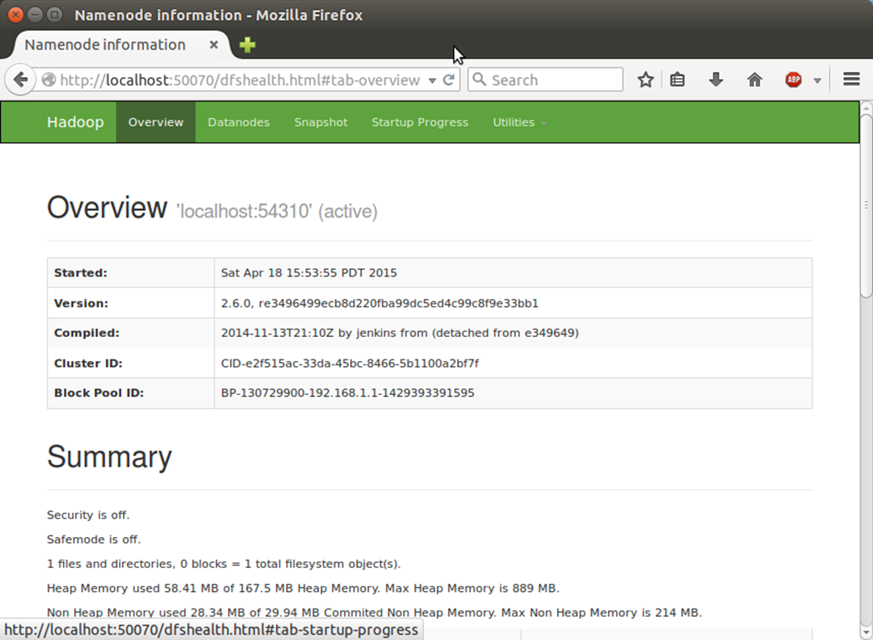

**PROJECT: H1-B Case Study**

The H1B is an employment-based, non-immigrant visa category for temporary foreign workers in the United States. For a foreign national to apply for H1B visa, an US employer must offer a job and petition for H1B visa with the US immigration department. This is the most common visa status applied for and held by international students once they complete college/ higher education (Masters, Ph.D.) and work in a full-time position. The data set has nearly 3 million records.

In the data, few columns are enclosed by double quotes and also we have comma’s in a single column and the column is enclosed by double quotes. So we have used hive csv serve to load the data. In the quoteChar, we have given **“(**double quote**).**So this will take the column value in between the double quotes.

We will be performing analysis on the H1B visa applicants between the years 2011-2016. We need to cleanse the dataset first to analyse it easier.

The dataset description is as follows:

The columns in the dataset include:

* CASE_STATUS: Status associated with the last significant event or decision. Valid values include “Certified,” “Certified-Withdrawn,” Denied,” and “Withdrawn”.
* Certified
* Certified withdrawn
* Denied
* Withdrawn
* Pending quality and compliance review
* Invalidated
* Rejected
* NA
* EMPLOYER_NAME: Name of employer submitting labour condition application.
* SOC_NAME: the Occupational name associated with the SOC_CODE. SOC_CODE is the occupational code associated with the job being requested for temporary labour condition, as classified by the Standard Occupational Classification (SOC) System.
* JOB_TITLE: Title of the job
* FULL_TIME_POSITION: Y = Full Time Position; N = Part Time Position
* PREVAILING_WAGE: Prevailing Wage for the job being requested for temporary labour condition. The wage is listed at annual scale in USD. The prevailing wage for a job position is defined as the average wage paid to similarly employed workers in the requested occupation in the area of intended employment. The prevailing wage is based on the employer’s minimum requirements for the position.
* YEAR: Year in which the H1B visa petition was filed
* WORKSITE: City and State information of the foreign worker’s intended area of employment
* lon: longitude of the Worksite
* lat: latitude of the Worksite

Let’s create a table to load the h1b applicant’s data as shown below.

CREATE TABLE h1b_applications(s_no int,case_status string,

employer_name string, soc_name string, job_title string,

full_time_position string,prevailing_wage bigint,year string, worksite

string, longitute double, latitute double )

ROW FORMAT SERDE 'org.apache.hadoop.hive.serde2.OpenCSVSerde'

WITH SERDEPROPERTIES (

"separatorChar" = ",",

"quoteChar" = "\""

) STORED AS TEXTFILE;

load data local inpath '/home/hduser/h1b.csv' overwrite into table h1b_applications;

select * from h1b_applications limit 3;

"1","CERTIFIED-WITHDRAWN","UNIVERSITY OF MICHIGAN","BIOCHEMISTS AND BIOPHYSICISTS","POSTDOCTORAL RESEARCH FELLOW","N",36067,2016,"ANN ARBOR, MICHIGAN",-83.7430378,42.2808256

"2","CERTIFIED-WITHDRAWN","GOODMAN NETWORKS, INC.","CHIEF EXECUTIVES","CHIEF OPERATING OFFICER","Y",242674,2016,"PLANO, TEXAS",-96.6988856,33.0198431

"3","CERTIFIED-WITHDRAWN","PORTS AMERICA GROUP, INC.","CHIEF EXECUTIVES","CHIEF PROCESS OFFICER","Y",193066,2016,"JERSEY CITY, NEW JERSEY",-74.0776417,40.7281575

INSERT OVERWRITE TABLE h1b_app2 SELECT regexp_replace(s_no, "\t", ""),

regexp_replace(case_status, "\t", ""), regexp_replace(employer_name,

"\t", ""), regexp_replace(soc_name, "\t", ""),

regexp_replace(job_title, "\t", ""),

regexp_replace(full_time_position, "\t", ""), prevailing_wage,

regexp_replace(year, "\t", ""), regexp_replace(worksite, "\t", ""),

regexp_replace(longitute, "\t", ""), regexp_replace(latitute, "\t",

"") FROM h1b_applications where case_status != "NA";

CREATE TABLE h1b_final(s_no int,case_status string, employer_name

string, soc_name string, job_title string, full_time_position

string,prevailing_wage bigint,year string, worksite string, longitute

double, latitute double )

row format delimited

fields terminated by '\t'

STORED AS TEXTFILE;

INSERT OVERWRITE TABLE h1b_final SELECT s_no,

case when trim(case_status) = "PENDING QUALITY AND COMPLIANCE REVIEW - UNASSIGNED" then "DENIED"

when trim(case_status) = "REJECTED" then "DENIED"

when trim(case_status) = "INVALIDATED" then "DENIED"

else case_status end,

employer_name, soc_name, job_title, full_time_position,

case when prevailing_wage is null then 100000

else prevailing_wage end,

year, worksite, longitute, latitute

FROM h1b_app2;

select case_status, count(*) from h1b_final group by case_status;

CERTIFIED-WITHDRAWN 202659

WITHDRAWN 89799

CERTIFIED 2615623

DENIED 94364

total records : 3002445

After analyzing the data, we can derive the following facts.

**1a) Is the number of petitions with Data Engineer job title increasing over time?**

import java.io.*;

import org.apache.hadoop.io.*;

import org.apache.hadoop.mapreduce.*;

import org.apache.hadoop.conf.*;

import org.apache.hadoop.fs.*;

import org.apache.hadoop.mapreduce.lib.input.*;

import org.apache.hadoop.mapreduce.lib.output.*;

public class petinc {

public static class MapClass extends Mapper<LongWritable,Text,Text,Text>

{

public void map(LongWritable key, Text value, Context context)

{

try{

String[] arrval = value.toString().split("\t");

String jobtitle = arrval[4];

if(arrval[4].equals("DATA ENGINEER"))

context.write(new Text(arrval[7]),new Text (jobtitle));

}

catch(Exception e)

{

System.out.println(e.getMessage());

}

}

}

public static class ReduceClass extends Reducer<Text,Text,Text,LongWritable>

{

public void reduce(Text key, Iterable<Text> values,Context context) throws IOException, InterruptedException {

long count = 0;

for (Text val : values)

{

{ count++;

}

}

context.write(key,new LongWritable(count));

//context.write(key, new LongWritable(sum));

}

}

public static void main(String[] args) throws Exception {

Configuration conf = new Configuration();

//conf.set("name", "value")

//conf.set("mapreduce.input.fileinputformat.split.minsize", "134217728");

Job job = Job.getInstance(conf, "growth of dataengineer");

job.setJarByClass(petinc.class);

job.setMapperClass(MapClass.class);

job.setReducerClass(ReduceClass.class);

job.setNumReduceTasks(1);

job.setMapOutputKeyClass(Text.class);

job.setMapOutputValueClass(Text.class);

job.setOutputKeyClass(Text.class);

job.setOutputValueClass(LongWritable.class);

FileInputFormat.addInputPath(job, new Path(args[0]));

FileOutputFormat.setOutputPath(job, new Path(args[1]));

System.exit(job.waitForCompletion(true) ? 0 : 1);

}

**Output:**

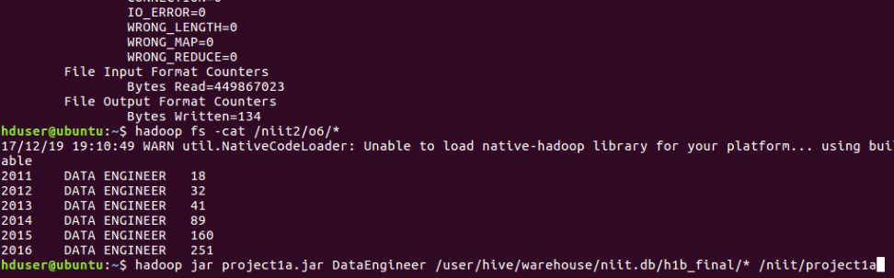

**1b) Find top 5 job titles who are having highest avg growth in applications.**

data = LOAD '/user/hive/warehouse/project.db/h1b_final/*' USING PigStorage() as (s_no:int,case_status:chararray,employer_name:chararray,soc_name:chararray,job_title:chararray,full_time_position:chararray,prevailing_wage:int,year:chararray,

worksite:chararray,

longitute:double,

latitute:double);

--dump data

t= filter data by $7 == '2011';

--dump t;

a= group t by $4;

--dump a;

add= foreach a generate group,COUNT($1);

--dump add;

t1= filter data by $7 == '2012';

--dump t1;

a= group t1 by $4;

--dump a;

add1= foreach a generate group,COUNT($1);

--dump add1;

t2= filter data by $7 == '2013';

--dump t2;

a= group t2 by $4;

--dump a;

add3= foreach a generate group,COUNT($1);

--dump add3;

t3= filter data by $7 == '2014';

--dump t3;

a= group t3 by $4;

--dump a;

add4= foreach a generate group,COUNT($1);

--dump add4;

t4= filter data by $7 == '2015';

--dump t4;

a= group t4 by $4;

--dump a;

add5= foreach a generate group,COUNT($1);

--dump add5;

t5= filter data by $7 == '2016';

--dump t5;

a= group t5 by $4;

--dump a;

add6= foreach a generate group,COUNT($1);

--dump add6;

joined= join add by $0, add1 by $0, add3 by $0, add4 by $0, add5 by $0, add6 by $0;

--dump joined;

yearwise= foreach joined generate $0,$1,$3,$5,$7,$9,$11;

--dump yearwise;

growth= foreach yearwise generate $0,

(float)($6-$5)*100/$5,

(float)($5-$4)*100/$4,

(float)($4-$3)*100/$3,

(float)($3-$2)*100/$2,

(float)($2-$1)*100/$1;

--dump growth;

avg= foreach growth generate $0,($1+$2+$3+$4+$5)/5;

--dump avg;

avggrowth= order avg by $1 desc;

--dump avggrowth;

end = limit avggrowth 5;

--dump end;

store end into '/project1b';

**output:**

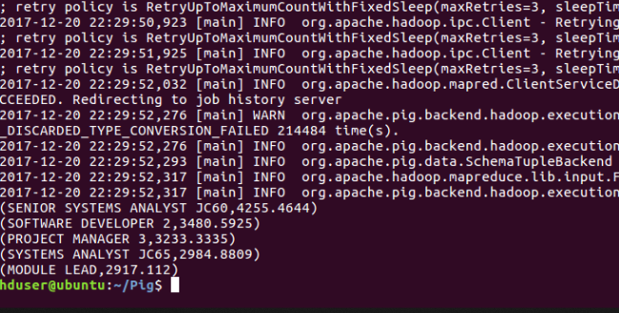

**2a) Which part of the US has the most Data Engineer jobs for each year?**

import java.io.*;

import java.util.TreeMap;

import org.apache.hadoop.io.NullWritable;

import org.apache.hadoop.io.Text;

import org.apache.hadoop.io.LongWritable;

import org.apache.hadoop.mapreduce.Job;

import org.apache.hadoop.mapreduce.Mapper;

import org.apache.hadoop.mapreduce.Partitioner;

import org.apache.hadoop.mapreduce.Reducer;

import org.apache.hadoop.conf.*;

import org.apache.hadoop.fs.*;

import org.apache.hadoop.mapreduce.lib.input.*;

import org.apache.hadoop.mapreduce.lib.output.*;

public class dataengjob {

public static class MapClass extends Mapper<LongWritable,Text,Text,Text>

{

public void map(LongWritable key, Text value, Context context)

{

try{

String[] str = value.toString().split("\t");

if((str[4].equals("DATA ENGINEER"))&&(str[1].equals("CERTIFIED")))

{

String c = str[4]+"\t"+str[7];

context.write(new Text(str[8]),new Text(c));

}

}

catch(Exception e)

{

System.out.println(e.getMessage());

}

}

}

public static class yearPartitioner extends Partitioner<Text,Text>

{

public int getPartition(Text key, Text values, int numReduceTasks) {

//String b[]="";

String[] b=values.toString().split("\t");

if(b[1].equals("2011"))

{

return 0;

}

else if(b[1].equals("2012"))

{

return 1;

}

else if(b[1].equals("2013"))

{

return 2;

}

else if(b[1].equals("2014"))

{

return 3;

}

else if(b[1].equals("2015"))

{

return 4;

}

else

{

return 5;

}

}

}

public static class ReduceClass extends Reducer<Text, Text, NullWritable, Text>

{

public TreeMap<Long, Text> tm = new TreeMap<Long, Text>();

public void reduce(Text key, Iterable<Text> values, Context con) throws IOException, InterruptedException

{

long count=0;

//String year="";

//String job="";

String myVal="";

for(Text val:values)

{

String[] str = val.toString().split("\t");

count++;

myVal = str[1]+"\t"+key+"\t"+str[0];

}

String myValue = myVal+"\t"+count;

tm.put(new Long(count), new Text(myValue));

if(tm.size()>1)

{

tm.remove(tm.firstKey());

}

}

public void cleanup(Context con) throws IOException, InterruptedException

{

for(Text t:tm.descendingMap().values())

{

con.write(NullWritable.get(), t);

}

}

}

public static void main(String[] args) throws Exception {

Configuration conf = new Configuration();

//conf.set("name", "value")

//conf.set("mapreduce.input.fileinputformat.split.minsize", "134217728");

Job job = Job.getInstance(conf, "job Count");

job.setJarByClass(dataengjob.class);

job.setMapperClass(MapClass.class);

job.setPartitionerClass(yearPartitioner.class);

//job.setCombinerClass(ReduceClass.class);

job.setReducerClass(ReduceClass.class);

job.setNumReduceTasks(6);

job.setMapOutputKeyClass(Text.class);

job.setMapOutputValueClass(Text.class);

job.setOutputKeyClass(NullWritable.class);

job.setOutputValueClass(Text.class);

FileInputFormat.addInputPath(job, new Path(args[0]));

FileOutputFormat.setOutputPath(job, new Path(args[1]));

System.exit(job.waitForCompletion(true) ? 0 : 1);

}

}

**Output:**

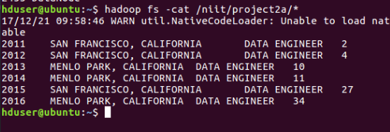

**2b) find top 5 locations in the US who have got certified visa for each year.**

select worksite,count(case_status) as a,year from h1b_final where year ='2011' and case_status='CERTIFIED' group by worksite,year order by a desc limit 5;

select worksite,count(case_status) as b,year from h1b_final where year ='2012' and case_status='CERTIFIED' group by worksite,year order by b desc limit 5;

select worksite,count(case_status) as c,year from h1b_final where year ='2013' and case_status='CERTIFIED' group by worksite,year order by c desc limit 5;

select worksite,count(case_status) as d,year from h1b_final where year ='2014' and case_status='CERTIFIED' group by worksite,year order by d desc limit 5;

select worksite,count(case_status) as e,year from h1b_final where year ='2015' and case_status='CERTIFIED' group by worksite,year order by e desc limit 5;

select worksite,count(case_status) as f,year from h1b_final where year ='2016' and case_status='CERTIFIED' group by worksite,year order by f desc limit 5;

**output:**

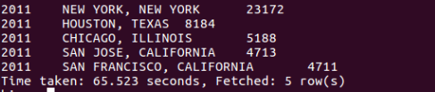

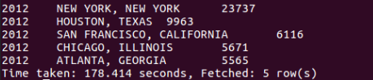

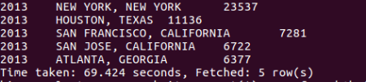

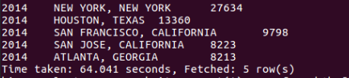

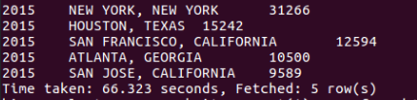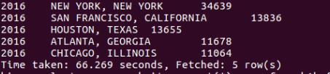

**3)Which industry(SOC_NAME) has the most number of Data Scientist positions?[certified]**

import java.io.IOException;

import java.util.TreeMap;

import org.apache.hadoop.conf.Configuration;

import org.apache.hadoop.fs.Path;

import org.apache.hadoop.io.LongWritable;

import org.apache.hadoop.io.NullWritable;

import org.apache.hadoop.io.Text;

import org.apache.hadoop.mapreduce.Job;

import org.apache.hadoop.mapreduce.Mapper;

import org.apache.hadoop.mapreduce.Reducer;

import org.apache.hadoop.mapreduce.lib.input.FileInputFormat;

import org.apache.hadoop.mapreduce.lib.output.FileOutputFormat;

public class industry

{

public static class MapClass extends Mapper<LongWritable, Text, Text, Text>

{

private Text myKey = new Text();

private Text myValue = new Text();

public void map(LongWritable key, Text values, Context con) throws IOException, InterruptedException

{

String[] str = values.toString().split("\t");

myKey.set(str[3]);

myValue.set(str[1]+"\t"+str[4]);

con.write(myKey, myValue);

}

}

public static class ReduceClass extends Reducer<Text, Text, NullWritable, Text>

{

public TreeMap<Long, Text> tm = new TreeMap<Long, Text>();

public void reduce(Text key, Iterable<Text> values, Context con) throws IOException, InterruptedException

{

long count=0;

String jobTitle="";

String caseStatus="";

String KeyVal = "";

for(Text val:values)

{

String[] str = val.toString().split("\t");

caseStatus = str[0];

jobTitle = str[1];

if((caseStatus.equals("CERTIFIED")) && (jobTitle.equals("DATA SCIENTIST")))

{

count++;

KeyVal = key+"\t"+jobTitle;

}

}

//String myVal = key+"\t"+jobTitle+"\t"+count;

String myVal = KeyVal+"\t"+count;

tm.put(new Long(count), new Text(myVal));

if(tm.size()>1)

{

tm.remove(tm.firstKey());

}

//con.write(key, new Text(myVal));

}

public void cleanup(Context con) throws IOException, InterruptedException

{

for(Text t:tm.descendingMap().values())

{

con.write(NullWritable.get(), t);

}

}

}

public static void main(String[] args) throws Exception

{

Configuration conf = new Configuration();

Job job = Job.getInstance(conf,"Most Data Scientist");

job.setJarByClass(industry.class);

job.setMapperClass(MapClass.class);

job.setReducerClass(ReduceClass.class);

job.setNumReduceTasks(1);

job.setMapOutputKeyClass(Text.class);

job.setMapOutputValueClass(Text.class);

job.setOutputKeyClass(NullWritable.class);

job.setOutputValueClass(Text.class);

FileInputFormat.addInputPath(job, new Path(args[0]));

FileOutputFormat.setOutputPath(job, new Path(args[1]));

System.exit(job.waitForCompletion(true) ? 0 : 1);

}

}

**Output:**

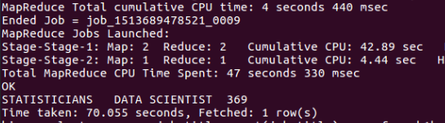

**4)Which top 5 employers file the most petitions each year? - Case Status - ALL**

import java.io.IOException;

import java.util.TreeMap;

import org.apache.hadoop.conf.Configuration;

import org.apache.hadoop.fs.Path;

import org.apache.hadoop.io.LongWritable;

import org.apache.hadoop.io.NullWritable;

import org.apache.hadoop.io.Text;

import org.apache.hadoop.mapreduce.Job;

import org.apache.hadoop.mapreduce.Mapper;

import org.apache.hadoop.mapreduce.Partitioner;

import org.apache.hadoop.mapreduce.Reducer;

import org.apache.hadoop.mapreduce.lib.input.FileInputFormat;

import org.apache.hadoop.mapreduce.lib.output.FileOutputFormat;

public class petition

{

public static class MapClass extends Mapper<LongWritable, Text, Text, Text>

{

public void map(LongWritable key, Text values, Context con) throws IOException, InterruptedException

{

String[] str = values.toString().split("\t");

con.write(new Text(str[2]), new Text(values));

}

}

public static class YearPartitioner extends Partitioner<Text, Text>

{

public int getPartition(Text key, Text values, int numReduceTasks)

{

String[] str = values.toString().split("\t");

long year = Long.parseLong(str[7]);

if(year==2011)

{

return 0;

}

else if(year==2012)

{

return 1;

}

else if(year==2013)

{

return 2;

}

else if(year==2014)

{

return 3;

}

else if(year==2015)

{

return 4;

}

else

{

return 5;

}

}

}

public static class ReduceClass extends Reducer<Text,Text,NullWritable,Text>

{

private TreeMap<Long, Text> tm = new TreeMap<Long, Text>();

public void reduce(Text key, Iterable<Text> values, Context con) throws IOException, InterruptedException

{

long count=0;

String year="";

for(Text val:values)

{

String[] str = val.toString().split("\t");

year = str[7];

count++;

}

String myValue = year+"\t"+key+"\t"+count;

tm.put(new Long(count), new Text(myValue));

if(tm.size()>5)

{

tm.remove(tm.firstKey());

}

}

protected void cleanup(Context con) throws IOException, InterruptedException

{

for(Text t:tm.descendingMap().values())

{

con.write(NullWritable.get(), t);

}

}

}

public static void main(String[] args) throws Exception

{

Configuration conf = new Configuration();

Job job = Job.getInstance(conf, " Top petition");

job.setJarByClass(petition.class);

job.setMapperClass(MapClass.class);

job.setPartitionerClass(YearPartitioner.class);

job.setReducerClass(ReduceClass.class);

job.setNumReduceTasks(6);

job.setMapOutputKeyClass(Text.class);

job.setMapOutputValueClass(Text.class);

job.setOutputKeyClass(NullWritable.class);

job.setOutputValueClass(Text.class);

FileInputFormat.addInputPath(job, new Path(args[0]));

FileOutputFormat.setOutputPath(job, new Path(args[1]));

System.exit(job.waitForCompletion(true) ? 0 : 1);

}

}

**Output:**

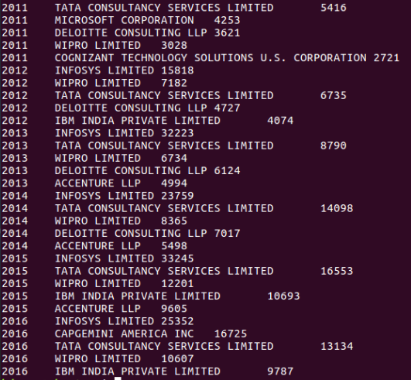

**5) Find the most popular top 10 job positions for H1B visa applications for each year? a) for all the applications**

--5) Find the most popular top 10 job positions for H1B visa applications for each year?

--all applications

select job_title,year,count(case_status ) as a from h1b_final where year = 2011 group by job_title,year order by a desc limit 10;

select job_title,year,count(case_status ) as b from h1b_final where year = 2012 group by job_title,year order by b desc limit 10;

select job_title,year,count(case_status ) as c from h1b_final where year = 2013 group by job_title,year order by c desc limit 10;

select job_title,year,count(case_status ) as d from h1b_final where year = 2014 group by job_title,year order by d desc limit 10;

select job_title,year,count(case_status ) as e from h1b_final where year = 2015 group by job_title,year order by e desc limit 10;

select job_title,year,count(case_status ) as f from h1b_final where year = 2016 group by job_title,year order by f desc limit 10;

**output:**

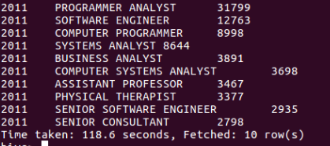

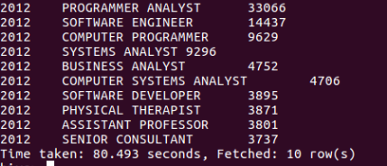

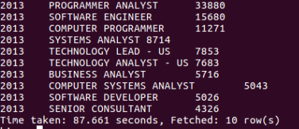

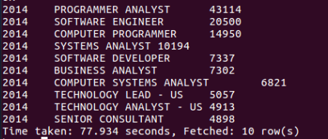

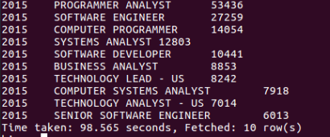

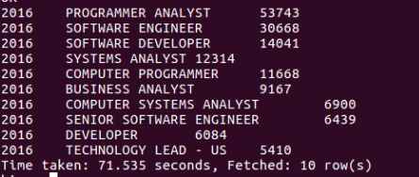

**5) Find the most popular top 10 job positions for H1B visa applications for each year?b) for only certified applications.**

5b) Find the most popular top 10 job positions for H1B visa applications for each year?b) for only certified applications.

select job_title,year,count(case_status ) as a from h1b_final where year = 2011 and case_status='CERTIFIED' group by job_title,year order by a desc limit 10;

select job_title,year,count(case_status ) as a from h1b_final where year = 2012 and case_status='CERTIFIED' group by job_title,year order by a desc limit 10;

select job_title,year,count(case_status ) as a from h1b_final where year = 2013 and case_status='CERTIFIED' group by job_title,year order by a desc limit 10;

select job_title,year,count(case_status ) as a from h1b_final where year = 2014 and case_status='CERTIFIED' group by job_title,year order by a desc limit 10;

select job_title,year,count(case_status ) as a from h1b_final where year = 2015 and case_status='CERTIFIED' group by job_title,year order by a desc limit 10;

select job_title,year,count(case_status ) as a from h1b_final where year = 2016 and case_status='CERTIFIED' group by job_title,year order by a desc limit 10;

**output:**

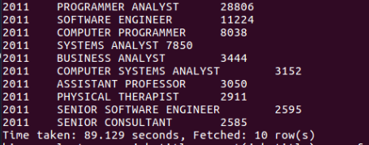

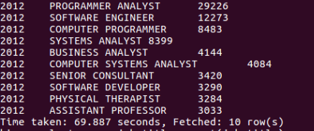

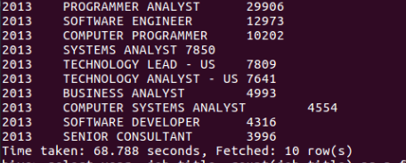

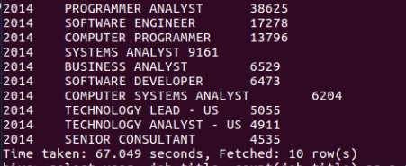

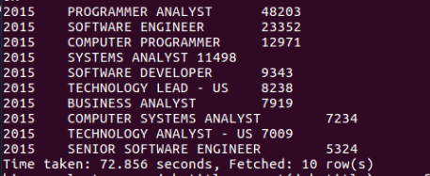

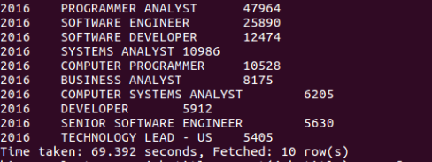

**6) Find the percentage and the count of each case status on total applications for each year. Create a line graph depicting the pattern of All the cases over the period of time.**

data = LOAD '/user/hive/warehouse/project.db/h1b_final/*' USING PigStorage() as (s_no:int,case_status:chararray,employer_name:chararray,soc_name:chararray,job_title:chararray,full_time_position:chararray,prevailing_wage:int,year:chararray,

worksite:chararray,longitute:double,latitute:double);

--dump data;

t= group data by $7;

--dump t;

t1= group data by ($7,$1);

--dump t1;

total= foreach t generate group,COUNT(data.$1);

--dump total;

year= foreach t1 generate group,group.$0,COUNT($1);

--dump year;

joined= join year by $1,total by $0;

--dump joined;

end= foreach joined generate FLATTEN($0),(float)($2*100)/$4,$2;

--dump end;

store end into '/project6';

**output:**

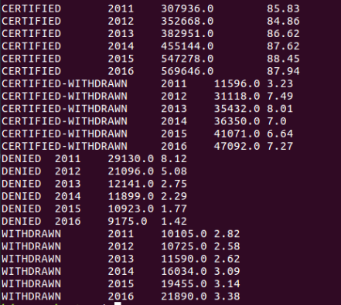

**7) Create a bar graph to depict the number of applications for each year.**

--7) Create a bar graph to depict the number of applications for each year

select year,count(*) from h1b_final group by year order by year;

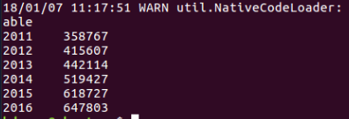

**8) Find the average Prevailing Wage for each Job for each Year (take part time and full time separate). Arrange the output in descending order.**

--8) Find the average Prevailing Wage for each job for each year (take part time and full time separate). Arrange output in descending order

select job_title, full_time_position, year, avg(prevailing_wage) as average from h1b_final where full_time_position ='Y' and year='2011' group by job_title,full_time_position,year order by average desc;

select job_title, full_time_position, year, avg(prevailing_wage) as average from h1b_final where full_time_position ='N' and year='2011' group by job_title,full_time_position,year order by average desc;

select job_title, full_time_position, year, avg(prevailing_wage) as average from h1b_final where full_time_position ='Y' and year='2012' group by job_title,full_time_position,year order by average desc;

select job_title, full_time_position, year, avg(prevailing_wage) as average from h1b_final where full_time_position ='N' and year='2012' group by job_title,full_time_position,year order by average desc;

select job_title, full_time_position, year, avg(prevailing_wage) as average from h1b_final where full_time_position ='Y' and year='2013' group by job_title,full_time_position,year order by average desc;

select job_title, full_time_position, year, avg(prevailing_wage) as average from h1b_final where full_time_position ='N' and year='2013' group by job_title,full_time_position,year order by average desc;

select job_title, full_time_position, year, avg(prevailing_wage) as average from h1b_final where full_time_position ='Y' and year='2014' group by job_title,full_time_position,year order by average desc;

select job_title, full_time_position, year, avg(prevailing_wage) as average from h1b_final where full_time_position ='N' and year='2014' group by job_title,full_time_position,year order by average desc;

select job_title, full_time_position, year, avg(prevailing_wage) as average from h1b_final where full_time_position ='Y' and year='2015' group by job_title,full_time_position,year order by average desc;

select job_title, full_time_position, year, avg(prevailing_wage) as average from h1b_final where full_time_position ='N' and year='2015' group by job_title,full_time_position,year order by average desc;

select job_title, full_time_position, year, avg(prevailing_wage) as average from h1b_final where full_time_position ='Y' and year='2016' group by job_title,full_time_position,year order by average desc;

select job_title, full_time_position, year, avg(prevailing_wage) as average from h1b_final where full_time_position ='N' and year='2016' group by job_title,full_time_position,year order by average desc;

**output:**

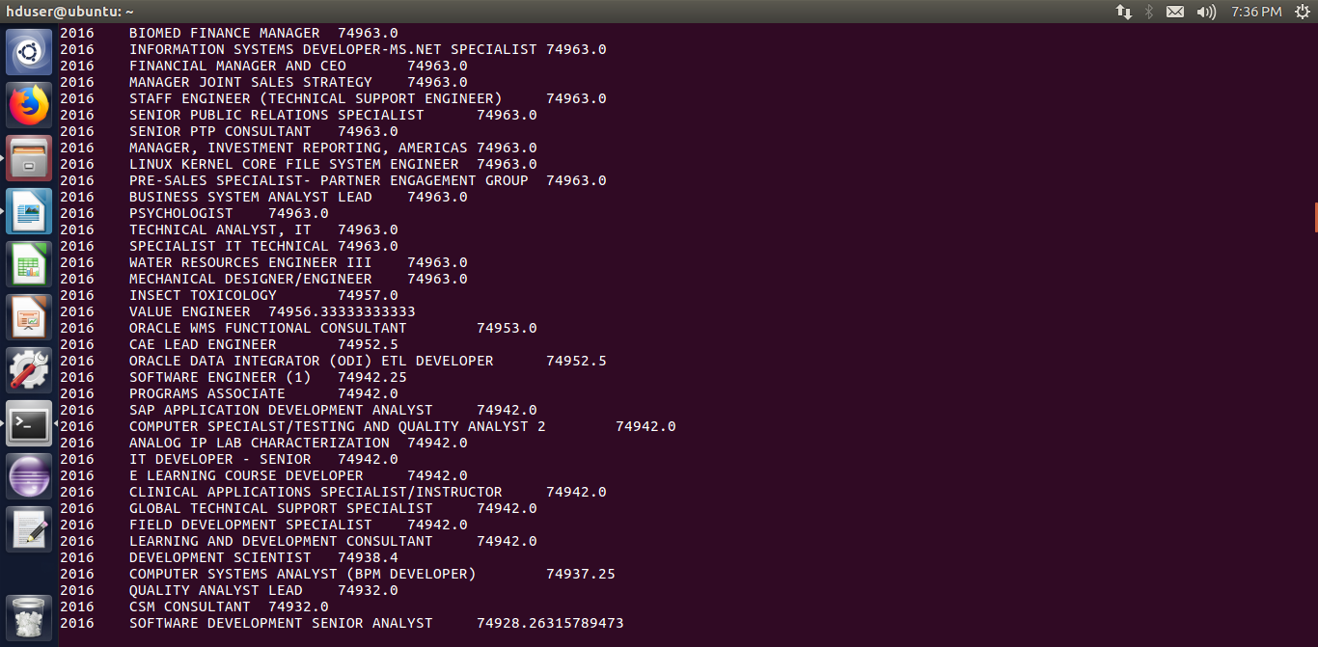

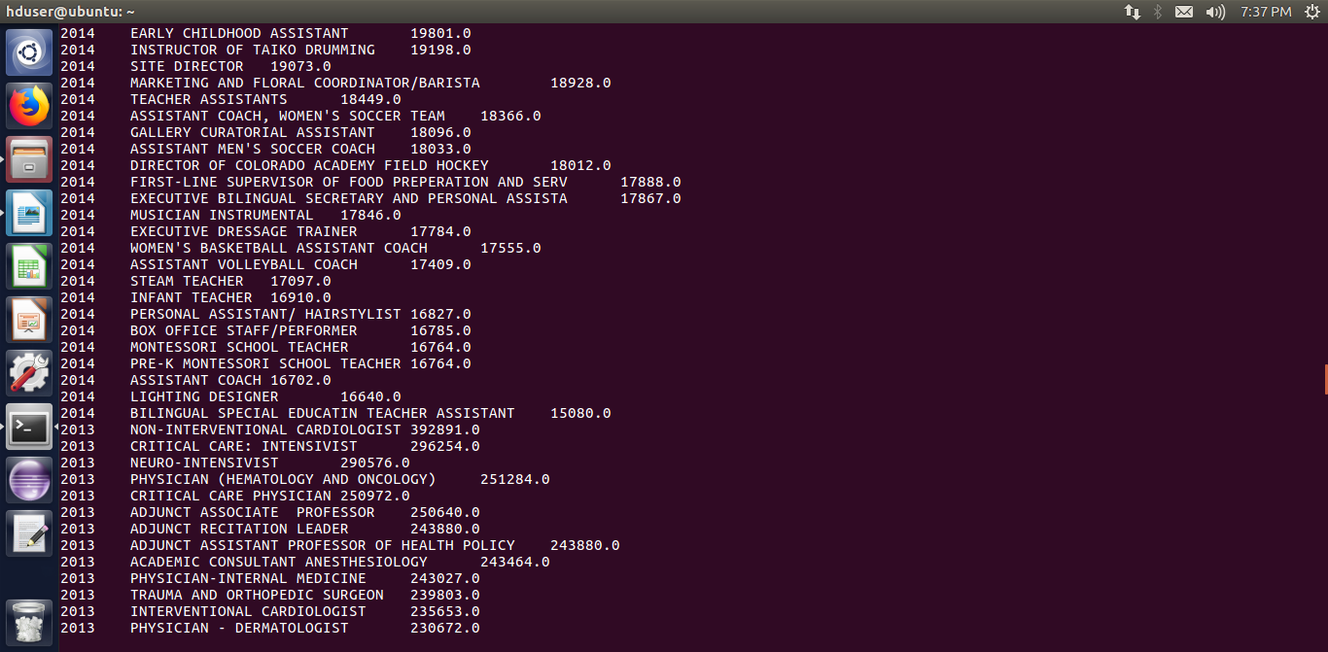

**9) Which are the employers along with the number of petitions who have the success rate more than 70% in petitions. (total petitions filed 1000 OR more than 1000) ?**

data = LOAD '/user/hive/warehouse/project.db/h1b_final/*' USING PigStorage() as (s_no:int,case_status:chararray,employer_name:chararray,soc_name:chararray,job_title:chararray,full_time_position:chararray,prevailing_wage:int,

year:chararray,

worksite:chararray,longitute:double,latitute:double);

--dump data;

t= group data by $2;

--dump t;

tot= foreach t generate group,COUNT(data.$1);

--dump tot;

certified= filter data by $1 == 'CERTIFIED';

--dump certified;

t1= group certified by $2;

--dump t1;

totcer= foreach t1 generate group,COUNT(certified.$1);

--dump totcer;

certified= filter data by $1 == 'CERTIFIED-WITHDRAWN';

--dump certified;

t2= group certified by $2;

--dump t2;

withdrawn= foreach t2 generate group,COUNT(certified.$1);

--dump withdrawn;

joined= join totcer by $0,withdrawn by $0,tot by $0;

dump joined;

separate= foreach joined generate $0,$1,$3,$5;

--dump separate;

add= foreach separate generate $0,(float)($1+$2)*100/($3),$3;

--dump add;

add1= filter add by $1>70 and $2>1000;

--dump add1;

ans= order add1 by $1 DESC;

dump ans;

**output:**

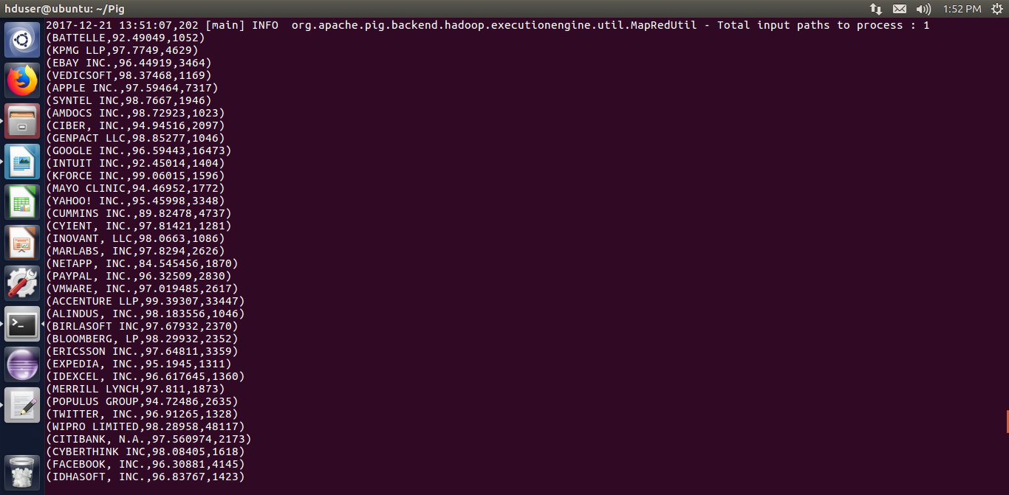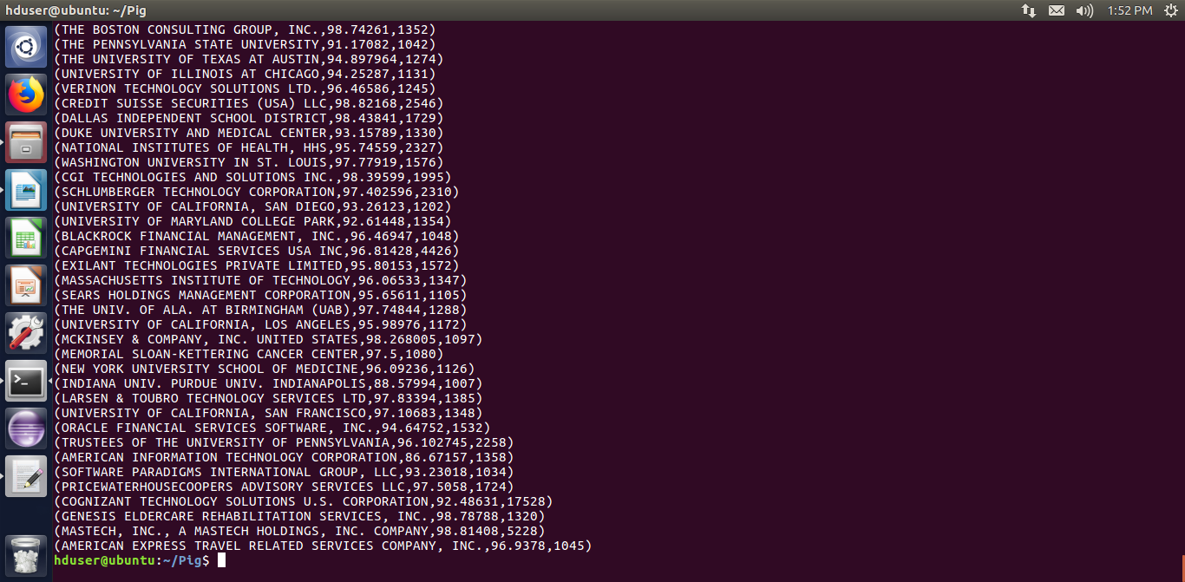

**10) Which are the job positions along with the number of petitions which have the success rate more than 70% in petitions (total petitions filed 1000 OR more than 1000)?**

data = LOAD '/user/hive/warehouse/project.db/h1b_final/*' USING PigStorage() as (s_no:int,case_status:chararray,employer_name:chararray,soc_name:chararray,job_title:chararray,full_time_position:chararray,prevailing_wage:int,

year:chararray,

worksite:chararray,longitute:double,latitute:double);

--dump data;

a= group data by $4;

--dump a;

tot= foreach a generate group,COUNT(data.$1);

--dump tot;

a1= filter data by $1 == 'CERTIFIED';

--dump a1;

t1= group a1 by $4;

--dump t1;

certified= foreach t1 generate group,COUNT(a1.$1);

--dump certified;

a2= filter data by $1 == 'CERTIFIED-WITHDRAWN';

--dump a2;

t2= group a2 by $4;

--dump t2;

withdrawn= foreach t2 generate group,COUNT(a2.$1);

--dump withdrawn;

joined= join certified by $0,withdrawn by $0,tot by $0;

--dump joined;

separate= foreach joined generate $0,$1,$3,$5;

--dump separate;

add= foreach separate generate $0,(float)($1+$2)*100/($3),$3;

--dump add;

add1= filter add by $1>70 and $2>1000;

--dump add1;

end= order add1 by $1 DESC;

dump end;

store end into '/project';

**output:**

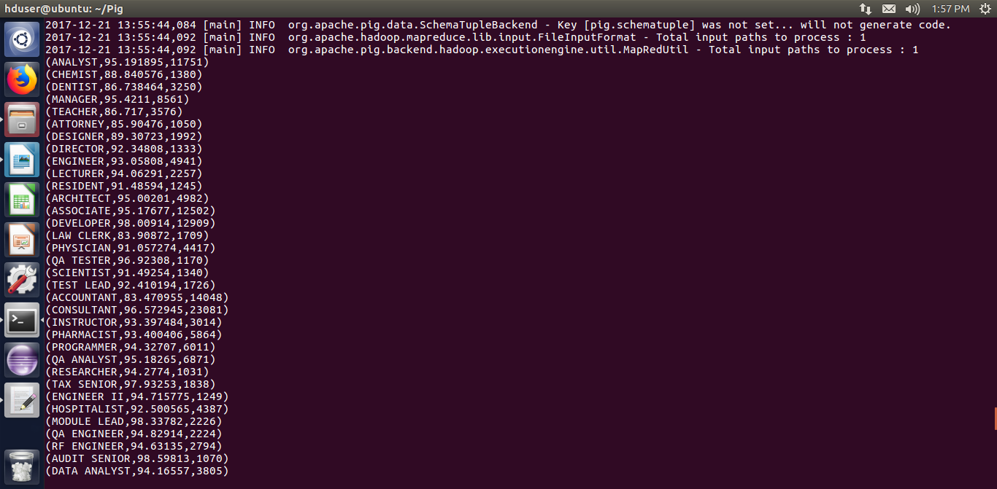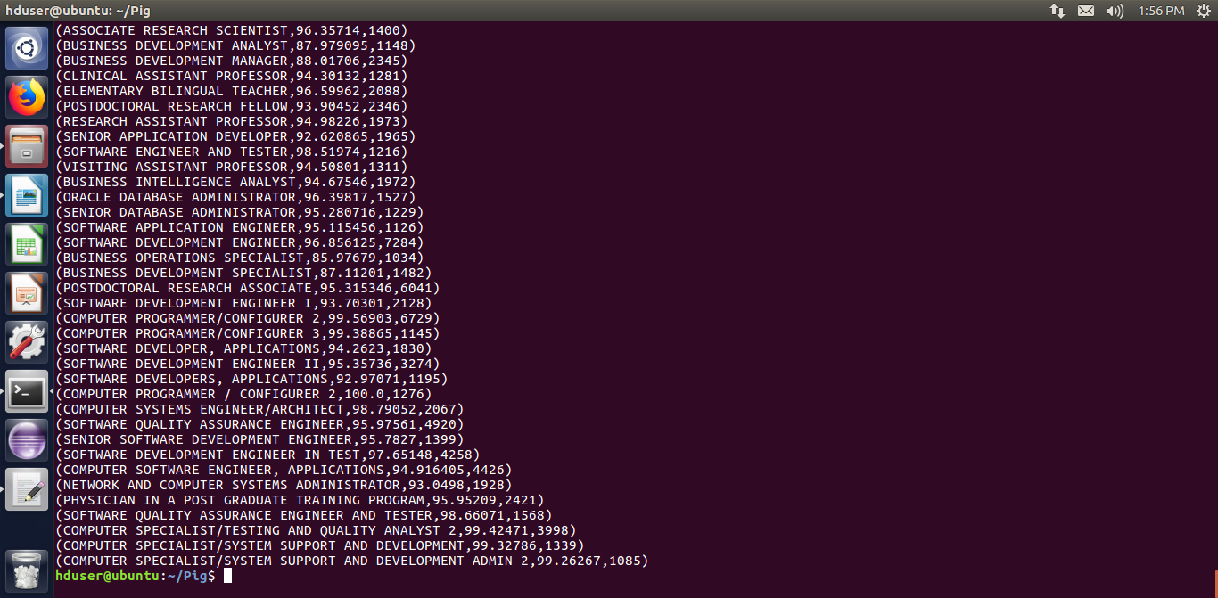

**11) Export result for question no 10 to MySql database.**

Performed by using Sqoop

Before exporting the data from HDFS to MySQL, a table must be created in MySQL.

use project;

create table employer (job_title VARCHAR(100) NOT NULL,percentage FLOAT NOT NULL, total INT NOT NULL,PRIMARY KEY(job_title));

sqoop export --connect jdbc:mysql://localhost/project --username root --P --table employer --update-mode allowinsert --update-key job_title --export-dir /niit/project --input-fields-terminated-by '\t'

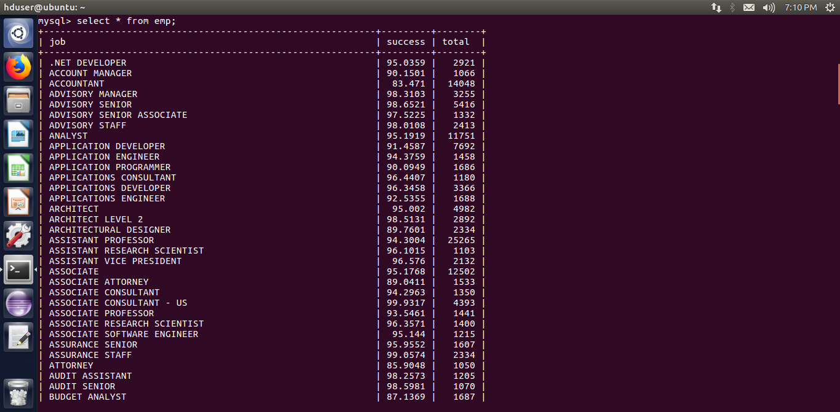

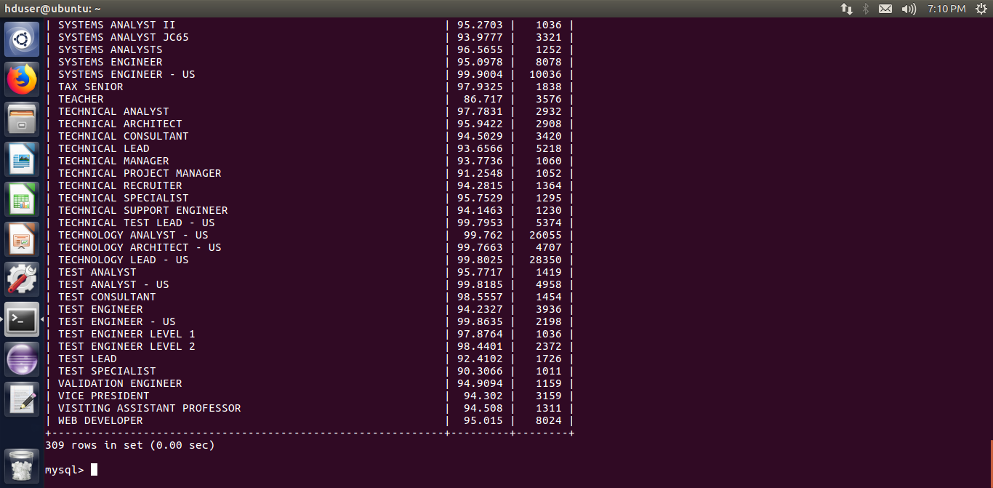

Project is a menu based one. Using shell script created a Menu based project

#!/bin/bash

show_menu()

{

NORMAL=`echo "\033[m"`

MENU=`echo "\033[36m"` #Blue

NUMBER=`echo "\033[33m"` #yellow

FGRED=`echo "\033[41m"`

RED_TEXT=`echo "\033[31m"`

ENTER_LINE=`echo "\033[33m"`

echo -e "${MENU}**********************APP MENU***********************${NORMAL}"

echo -e "${MENU}**${NUMBER} 1)${MENU} Question 1a ${NORMAL}"

echo -e "${MENU}**${NUMBER} 2)${MENU} Question 1b ${NORMAL}"

echo -e "${MENU}**${NUMBER} 3)${MENU} Question 2a ${NORMAL}"

echo -e "${MENU}**${NUMBER} 4)${MENU} Question 2b ${NORMAL}"

echo -e "${MENU}**${NUMBER} 5)${MENU} Question 3 ${NORMAL}"

echo -e "${MENU}**${NUMBER} 6)${MENU} Question 4 ${NORMAL}"

echo -e "${MENU}**${NUMBER} 7)${MENU} Question 5a ${NORMAL}"

echo -e "${MENU}**${NUMBER} 8)${MENU} Question 5b ${NORMAL}"

echo -e "${MENU}**${NUMBER} 9)${MENU} Question 6 ${NORMAL}"

echo -e "${MENU}**${NUMBER} 10)${MENU} Question 7 ${NORMAL}"

echo -e "${MENU}**${NUMBER} 11)${MENU} Question 8 ${NORMAL}"

echo -e "${MENU}**${NUMBER} 12)${MENU} Question 9 ${NORMAL}"

echo -e "${MENU}**${NUMBER} 13)${MENU} Question 10 ${NORMAL}"

echo -e "${MENU}**${NUMBER} 14)${MENU} Question 11 ${NORMAL}"

echo -e "${MENU}*********************************************${NORMAL}"

echo -e "${ENTER_LINE}Please enter a menu option and enter or ${RED_TEXT}enter to exit. ${NORMAL}"

read opt

}

function option_picked()

{

COLOR='\033[01;31m' # bold red

RESET='\033[00;00m' # normal white

MESSAGE="$1" #modified to post the correct option selected

echo -e "${COLOR}${MESSAGE}${RESET}"

}

function getpinCodeBank(){

echo "in getPinCodebank"

echo $1

echo $2

#hive -e "Select * from AppData where PinCode = $1 AND Bank = '$2'"

}

clear

show_menu

while [ opt != '' ]

do

if [[ $opt = "" ]]; then

exit;

else

case $opt in

1) clear;

option_picked "1a) Is the number of petitions with Data Engineer job title increasing over time?";

bash /home/hduser/1a.sh

show_menu;

;;

2) clear;

option_picked "1b) Find top 5 job titles who are having highest avg growth in applications.";

pig /home/hduser/niitproject/fin1b.pig

show_menu;

;;

3) clear;

option_picked "2a) Which part of the US has the most Data Engineer jobs for each year?";

bash /home/hduser/2a.sh

show_menu;

;;

4) clear;

option_picked "2b) find top 5 locations in the US who have got certified visa for each year";

echo "Enter the year"

read year

echo "You've selected ${year}"

hive -e "select worksite,count(case_status) as a,year from h1b_final where year =$year and case_status='CERTIFIED' group by worksite,year order by a desc limit 5";

show_menu;

;;

5) clear;

option_picked "3)Which industry(SOC_NAME) has the most number of Data Scientist positions?";

bash -e /home/hduser/3.sh

show_menu;

;;

6) clear;

option_picked "4)Which top 5 employers file the most petitions each year?";

bash /home/hduser/4.sh

show_menu;

;;

7) clear;

option_picked "5) Find the most popular top 10 job positions for H1B visa applications for each year?a) for all the applications";

echo "Enter the year"

read year

echo "You've selected ${year}"

hive -e "select job_title,year,count(case_status ) as a from h1b_final where year =$year group by job_title,year order by a desc limit 10";

show_menu;

;;

8) clear;

option_picked "5) Find the most popular top 10 job positions for H1B visa applications for each year?b) for only certified applications.";

echo "Enter the year"

read year

echo "You've selected ${year}"

hive -e "select job_title,year,count(case_status ) as a from h1b_final where year = $year and case_status='CERTIFIED' group by job_title,year order by a desc limit 10";

show_menu;

;;

9) clear;

option_picked "6) Find the percentage and the count of each case status on total applications for each year. Create a line graph depicting the pattern of All the cases over the period of time.";

pig /home/hduser/niitproject/fin6.pig

show_menu;

;;

10) clear;

option_picked "7) Create a bar graph to depict the number of applications for each year";

hive -e "select year,count(*) from h1b_final group by year order by year";

show_menu;

;;

11) clear;

option_picked "8) Find the average Prevailing Wage for each Job for each Year (take part time and full time separate). Arrange the output in descending order";

echo -e "${MENU}Select Full Time Job or Part Time Job ${NORMAL}"

echo -e "${MENU}**${NUMBER} 1)${MENU} Full Time Job ${NORMAL}"

echo -e "${MENU}**${NUMBER} 2)${MENU} Part Time Job ${NORMAL}"

read job

case $job in

1) echo "FULL TIME JOB SELECTED"

echo "Enter the year"

read year

echo "You've selected ${year}"

hive -e "select job_title, full_time_position, year, avg(prevailing_wage) as average from h1b_final where full_time_position ='Y' and year=$year group by job_title,full_time_position,year order by average desc";

;;

2) echo "PART TIME JOB SELECTED"

echo "Enter the year"

read year

echo "You've selected ${year} "

hive -e "select job_title, full_time_position, year, avg(prevailing_wage) as average from h1b_final where full_time_position ='N' and year=$year group by job_title,full_time_position,year order by average desc";

;;

*) echo "Please Select one among the option[1-2]";;

esac

show_menu;

;;

12) clear;

option_picked "9) Which are the employers along with the number of petitions who have the success rate more than 70% in petitions. (total petitions filed 1000 OR more than 1000) ?";

pig /home/hduser/niitproject/fin9.pig

show_menu;

;;

13) clear;

option_picked "10) Which are the job positions along with the number of petitions which have the success rate more than 70% in petitions (total petitions filed 1000 OR more than 1000)?";

pig /home/hduser/niitproject/fin10.pig

show_menu;

;;

14) clear;

option_picked "11) Export result for question no 10 to MySql database.";

sqoop export --connect jdbc:mysql://localhost/project --username root --P --table employer --update-mode allowinsert --update-key job --export-dir /project --input-fields-terminated-by '\t' ;

show_menu;

;;

\n) exit;

;;

*) clear;

option_picked "Pick an option from the menu";

show_menu;

;;

esac

fi

done

hduser@ubuntu:~$ ./menu.sh

**********************APP MENU***********************

** 1) Question 1a

** 2) Question 1b

** 3) Question 2a

** 4) Question 2b

** 5) Question 3

** 6) Question 4

** 7) Question 5a

** 8) Question 5b

** 9) Question 6

** 10) Question 7

** 11) Question 8

** 12) Question 9

** 13) Question 10

** 14) Question 11

*********************************************

Please enter a menu option and enter or enter to exit.