23BD1A050Y
GAYATHRI
WEEK-1
EC2 INSTANCE CREATION AND CONNECTION
Amazon EC2 Dashboard
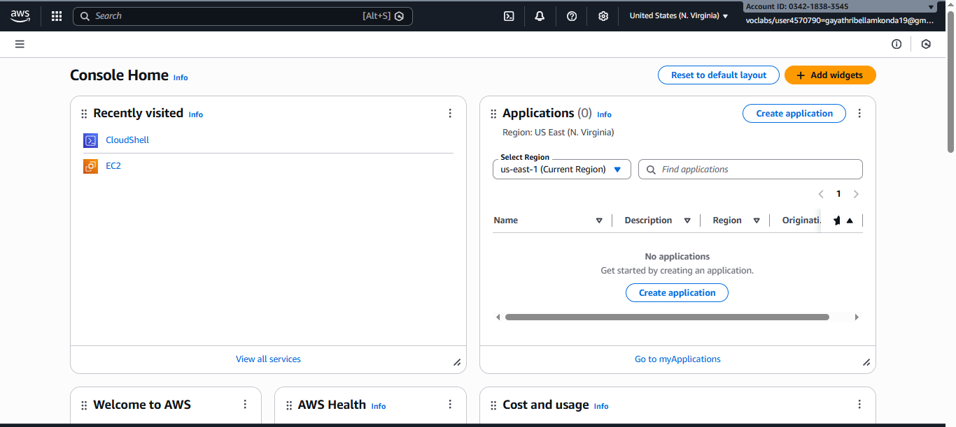
EC2 Instances page that no instances are currently running in the selected region
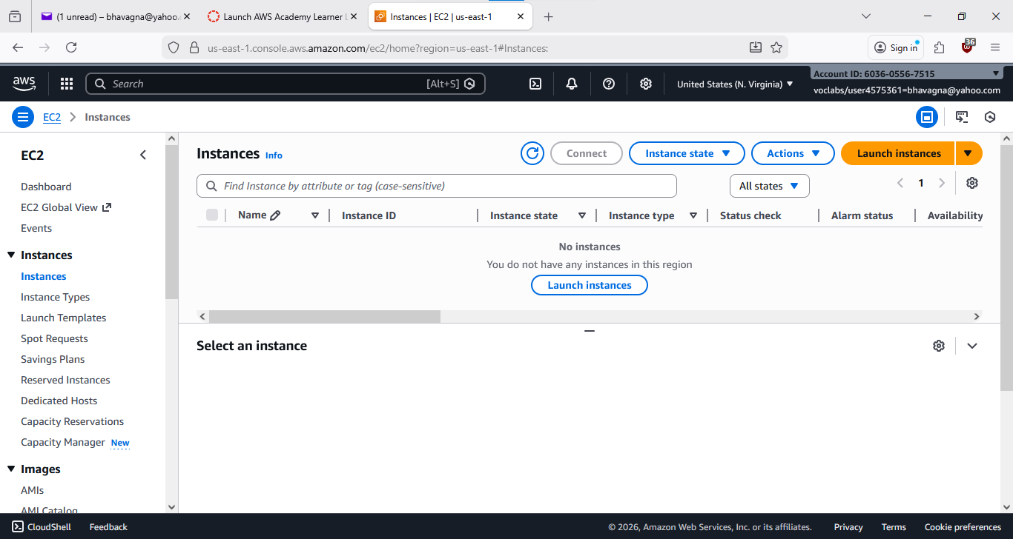
Ubuntu instance connection by browser method
Launch Instance page where the instance name to identify the instance (ex:Linux-ec2)
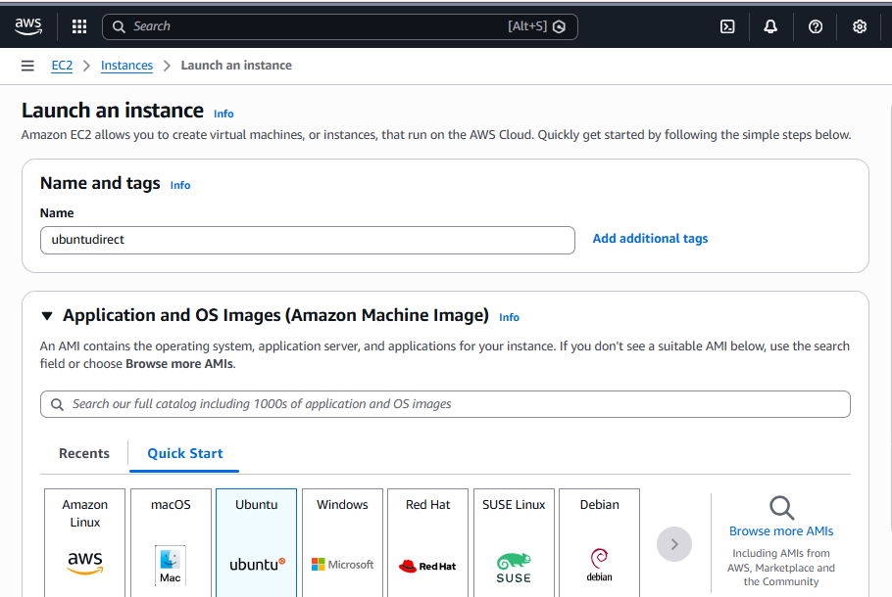

AMI is Region specific ,AMI ID changes with the region
Select the Instance type ,By default t3.micro chosen as a free-tier eligible instance
Key pair creation used to generate an RSA key pair for secure SSH access.Key can be .pem .Its get downloaded automatically
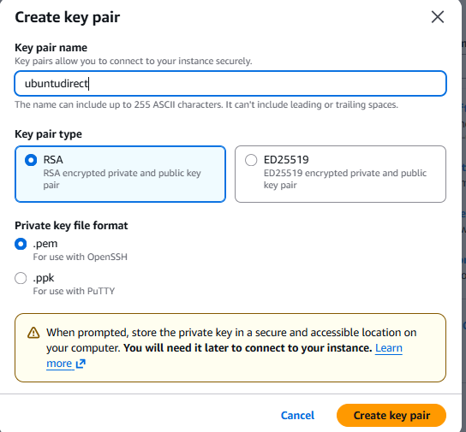

Network settings configuration showing VPC, subnet, and security group rules (Linux allow ssh,windows allow rdp for connection)
Lanuch the instance by clicking on lanuch Instance .now Aws create the ec2 with the specified configuration and region
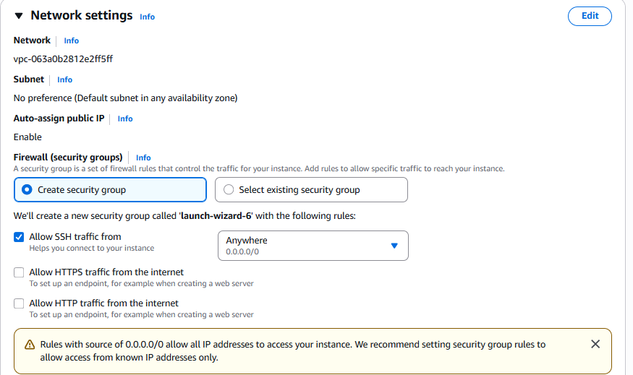

Now the instance is successfully created Now we can connect to the ec2 instance
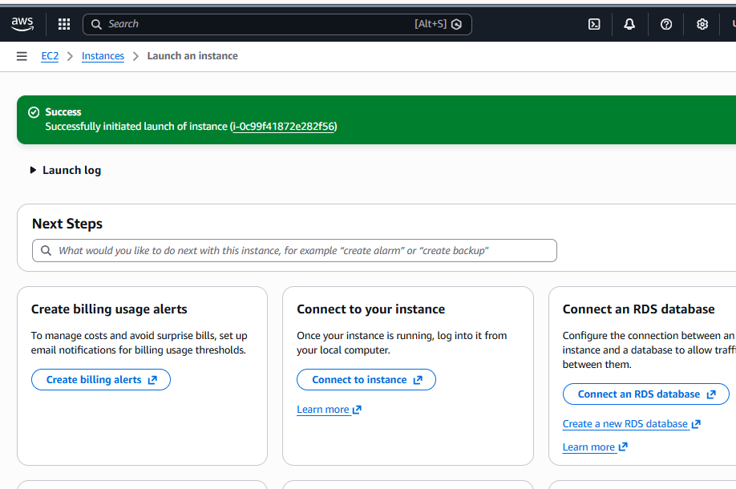
EC2 Connection Methods
1)EC2 connect method(Browser based method)
2)Linux Instance
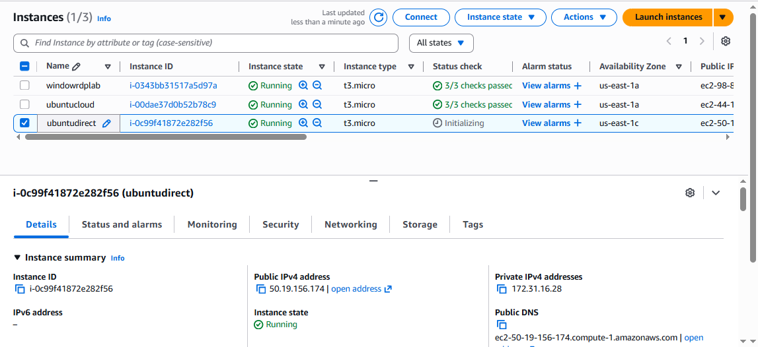

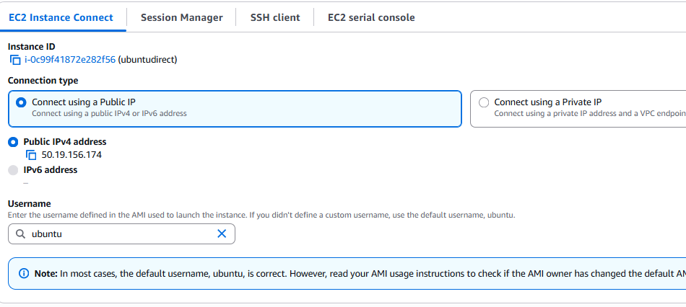
Successfully connected to ec2 instance by browser based method
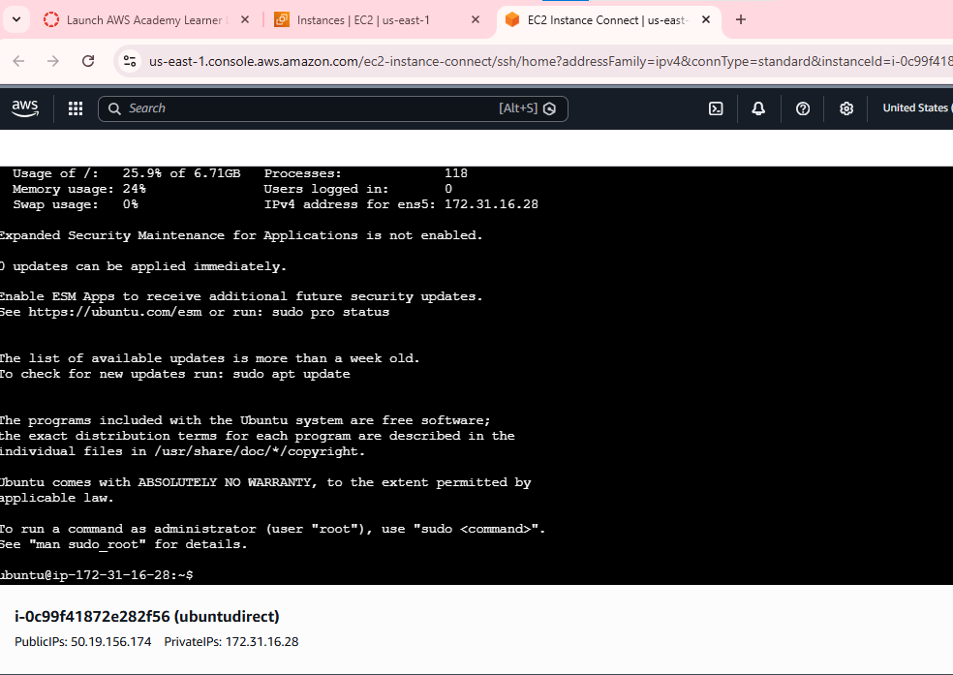

Ubuntu connection with ppk file using PuTTY software
Before starting the process we need download the PuTTY software
Go to official site to download the software and download exe file
Create the Ubuntu instance .Provide the name of the instance
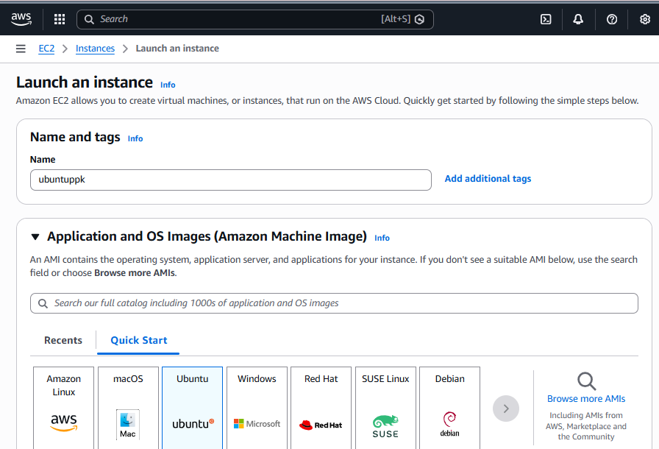

Create a key pair by selecting the key file format as ppk
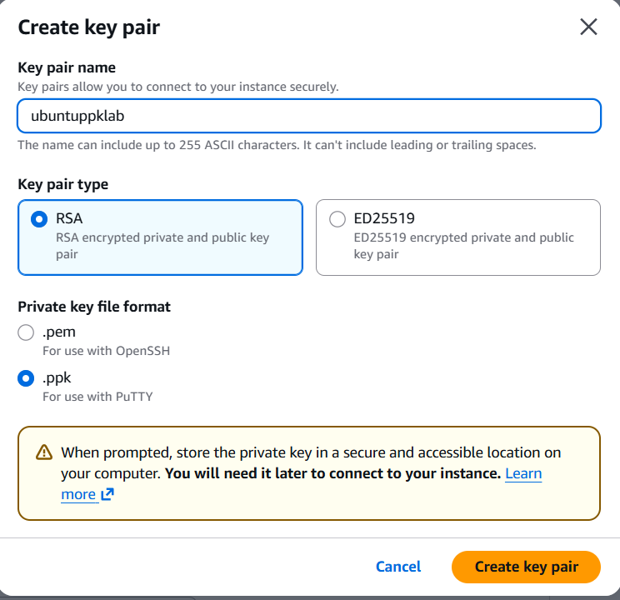

Allow SSH traffic
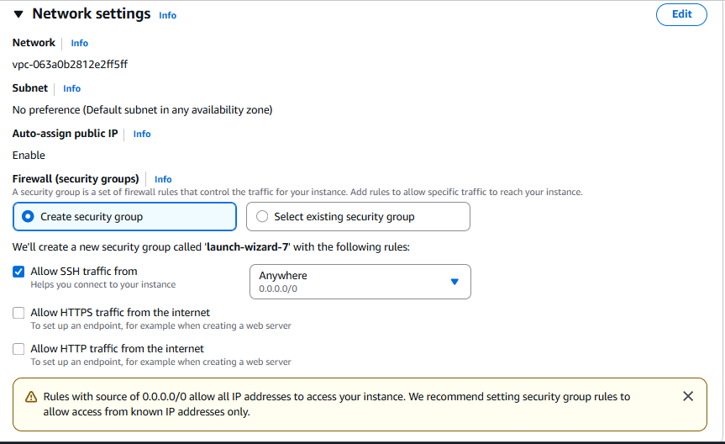

Click on launch instance the instance will get created successfully
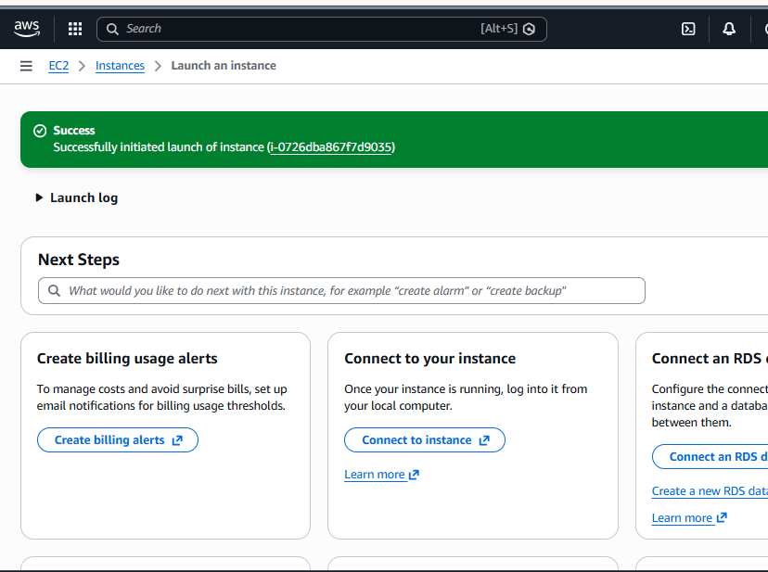

Select the Ubuntu instance and connect to copy the ip address
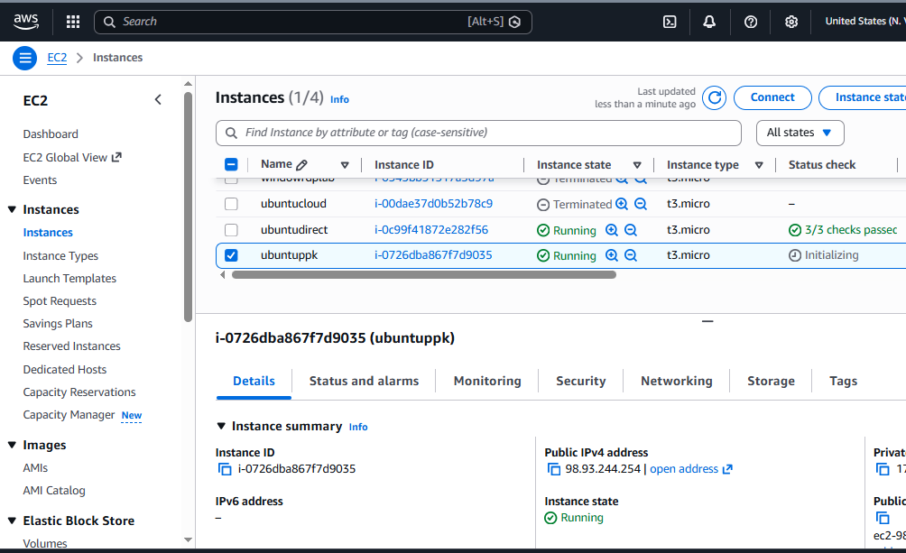

Now open the PuTTY to connect to EC2 instance
Paste the copied ip address in host name
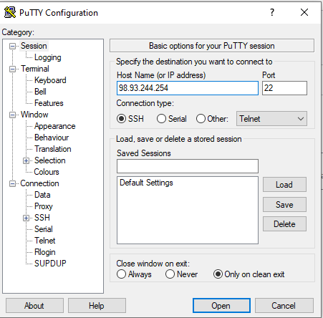

Select the ppk which is generated in the above step and click on open to establish connection
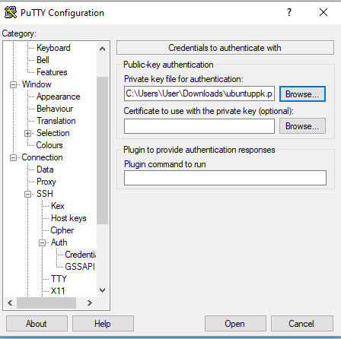
Type ubuntu at the login as because we chosen linux AMI
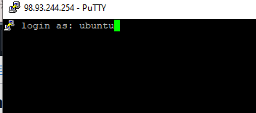

We have successfully connected to EC2 instance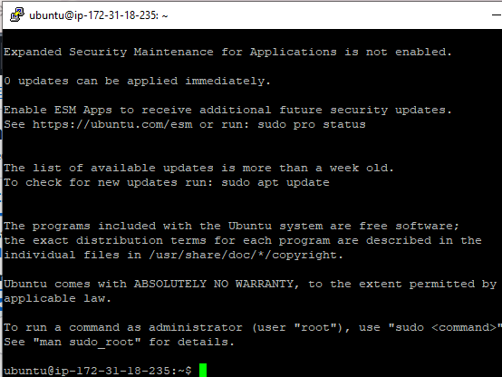

Ubuntu instance with pem file using puttygen software
Download the puttygen software from the browser
Create a Ubuntu instance with pem file
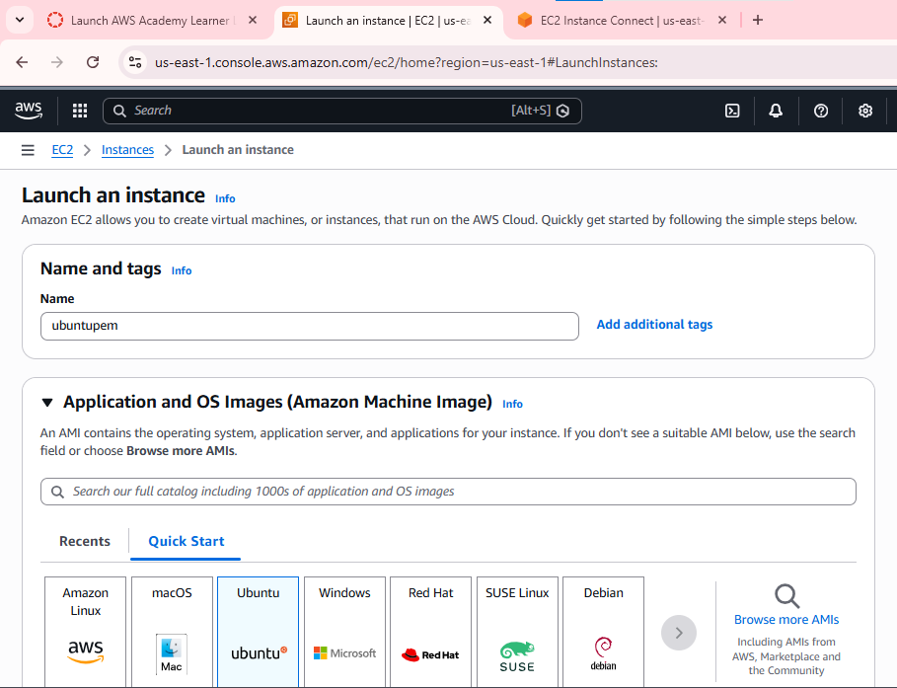
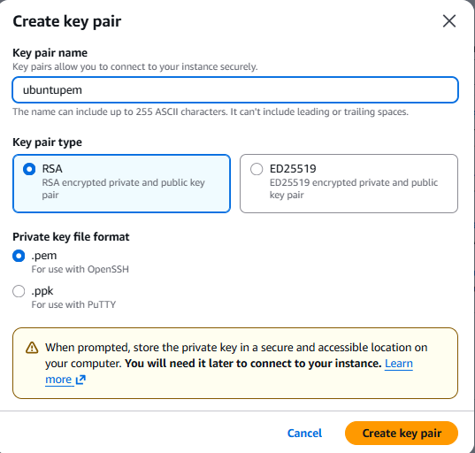
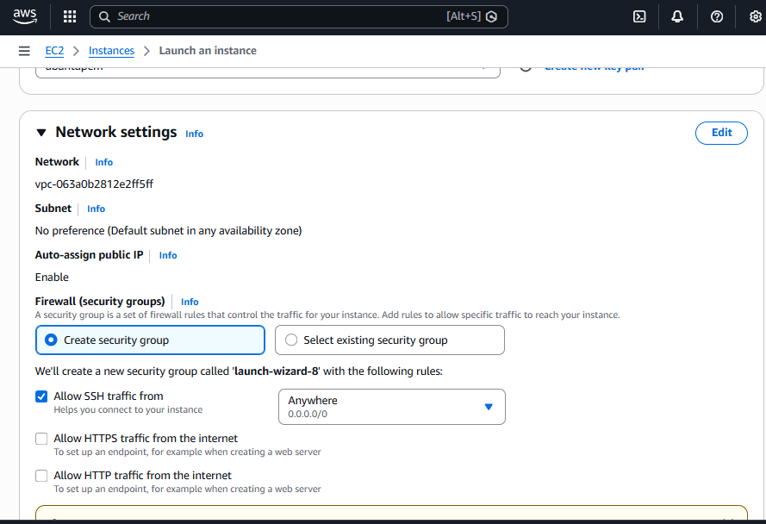
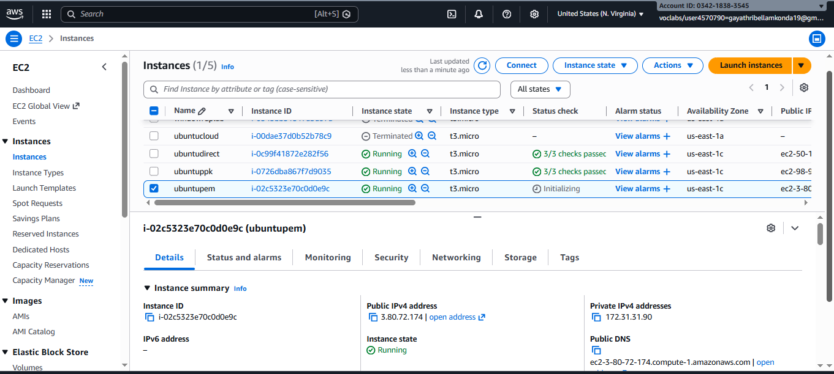

Open the puttygen, To connect using PuTTY we need ppk , to convert the pem to ppk we need PuTTY gen.
Load the pem file to PuTTY gen from the local machine
Click on save private key to get ppk file from the pem file save the ppk file on local machine
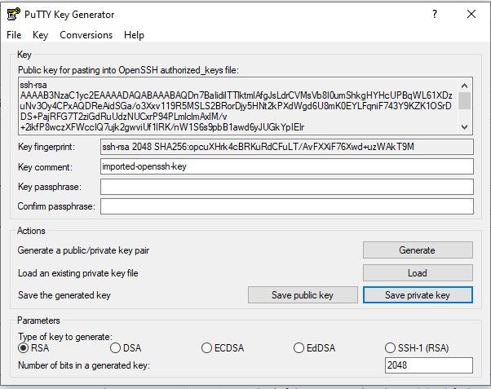

Now open the PuTTY to connect to EC2 instance .
Copy the public Ip address of the instance to connect .
Paste the copied ip address in host name
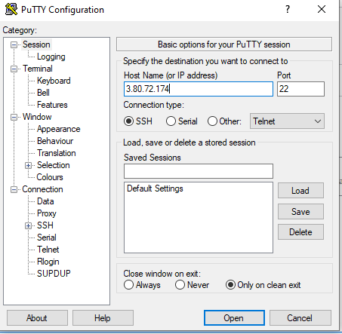

Select the ppk which is generated in the above step and click on open to establish connection
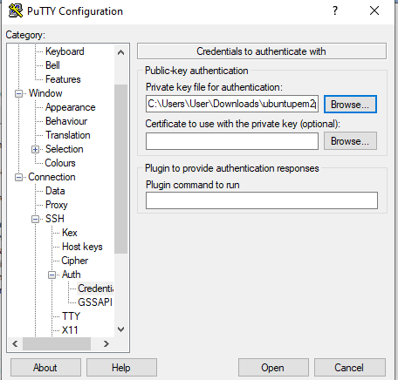
Type ubunu at the login as because we choosen linux AMI
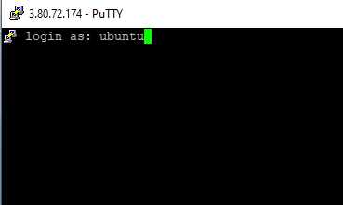

We have successfully connected to EC2 instance.
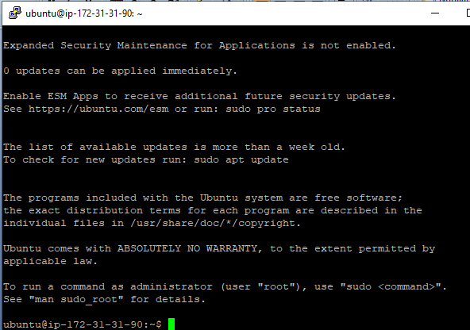

Ubuntu with cloud shell
Create the Ubuntu instance
Provide the name to the instance and select Ubuntu as operating system
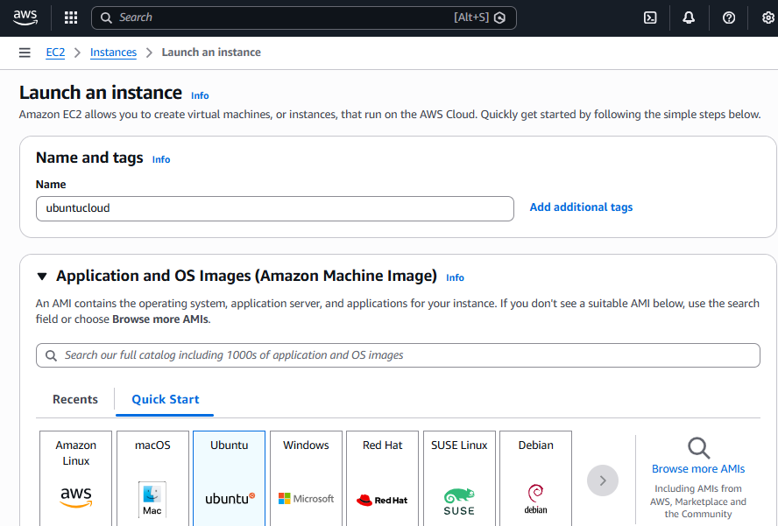

Create a key value pair or use the existing one ,select the key file format as pem
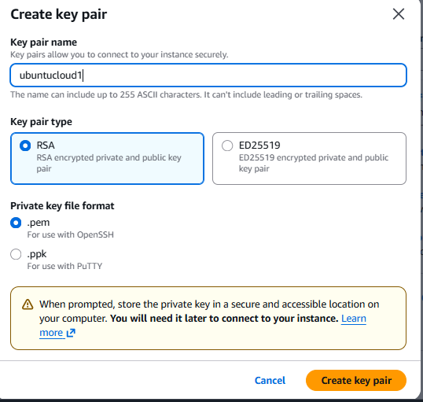

Allow the ssh traffic and click on launch the instance.
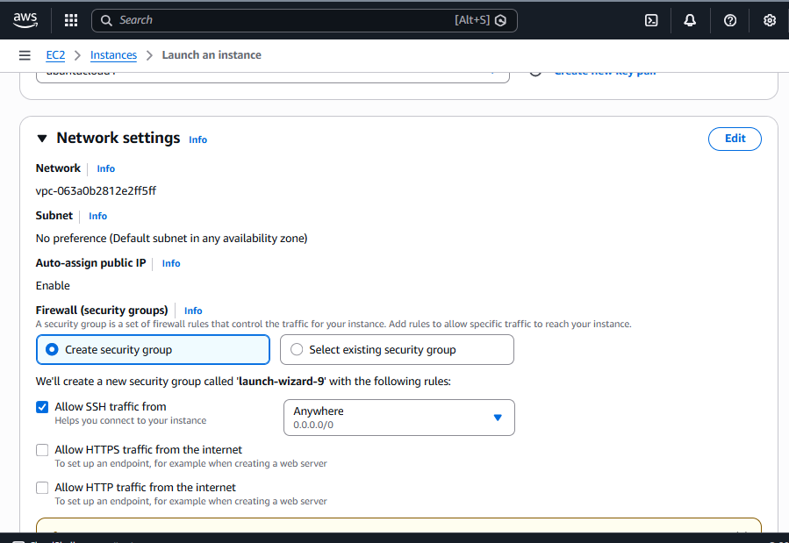

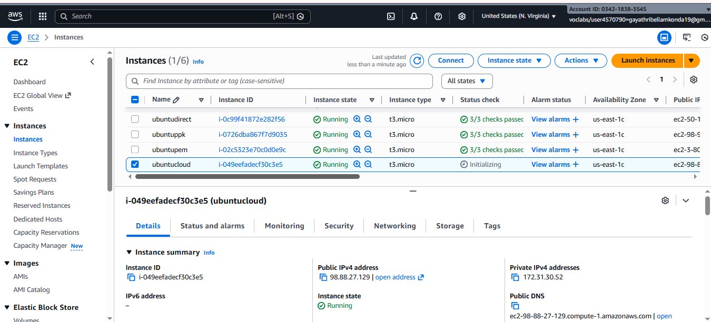

Search for the cloud shell in aws console or beside the search icon
Upload the downloaded .pem to the cloud shell to connect using actions button
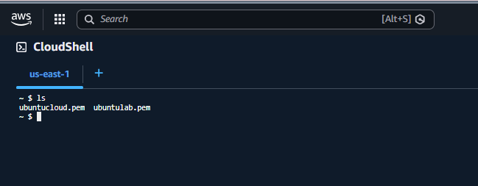
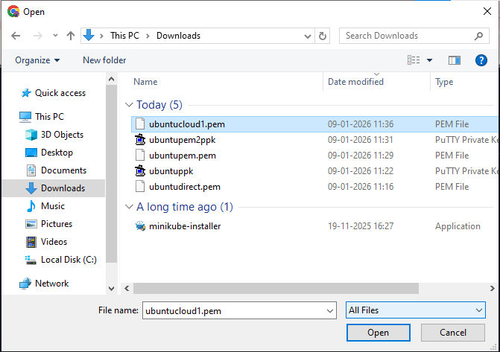

Verify the uploaded key using the command(ex : ls)
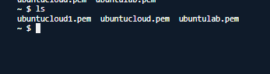

Now connect the ec2 instance using the command(ssh -i "key-ec2.pem" <username>@<public-ip-or-dns>)
If any pop ups paste the command ( chmod 400 “ubuntucloud1.pem”) to change the permissions
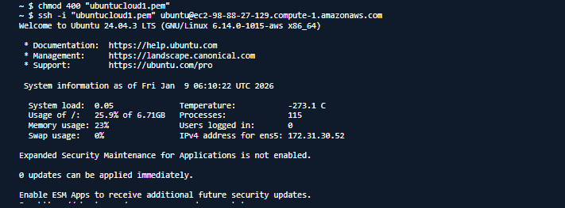
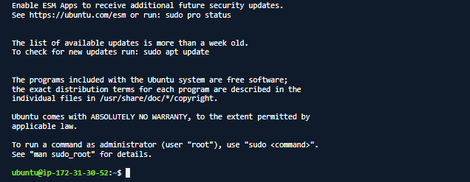

Windows instance
Lets configure the instance
Provide a name for the instance
Select the windows operating system
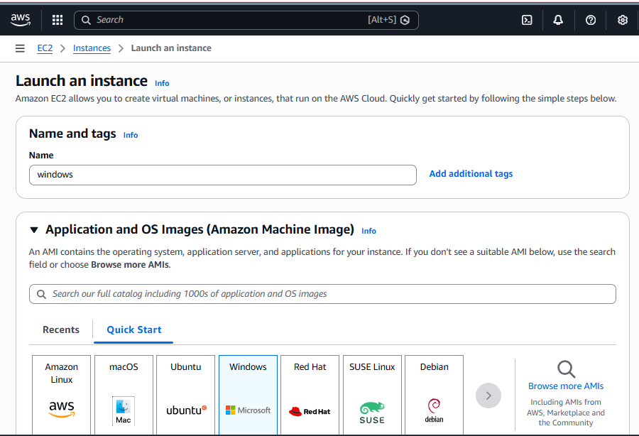

Select the windows operating system
Create a key pair or use already existing key pair by selecting the key file format as pem

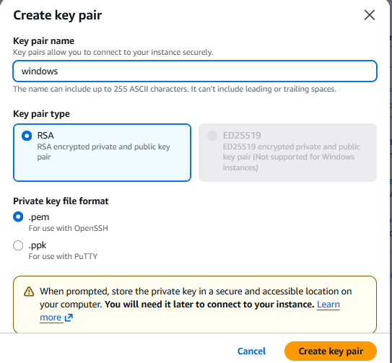

Configure the network setting like vpn,subnet and enable RDP port to connect the instance
Click on the launch instance button
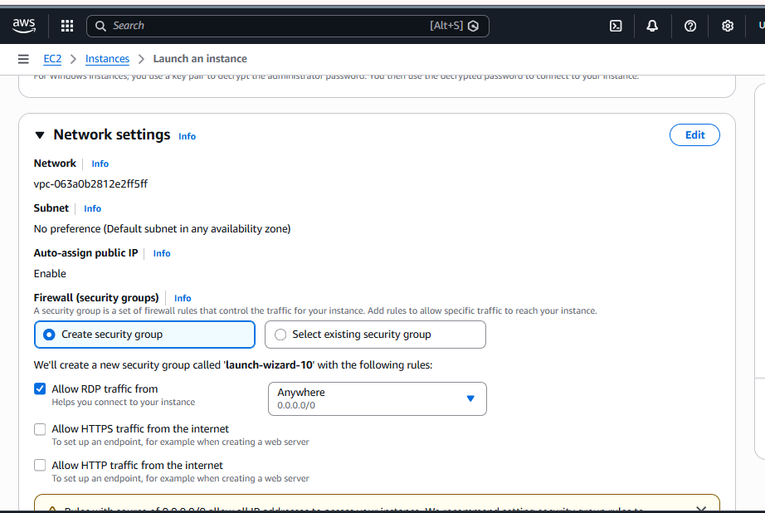

Now select the windows instance and click on the connect button and select RDP client
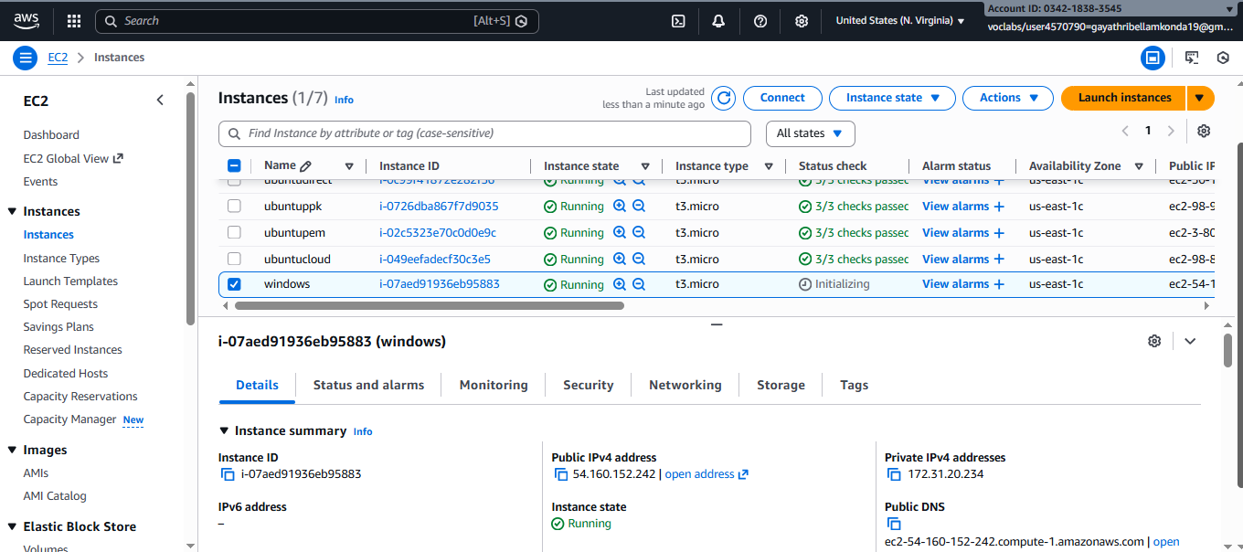
Click on download remote desktop file to install the remote desktop
Now click on get password
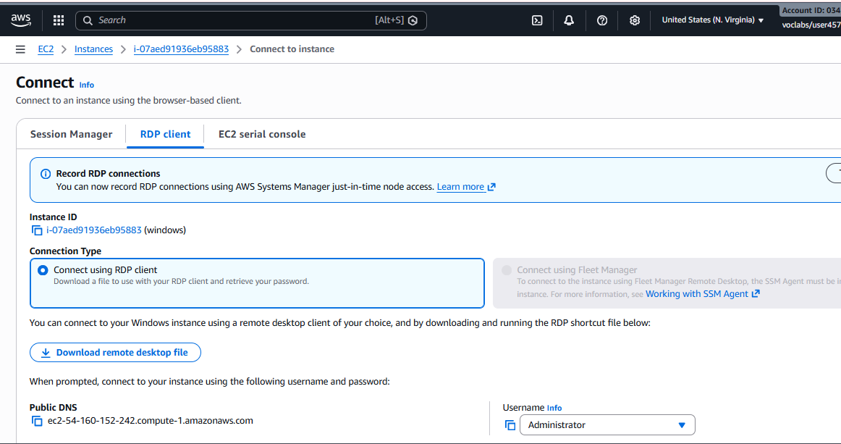

Upload the private key file
Click on decrypt password
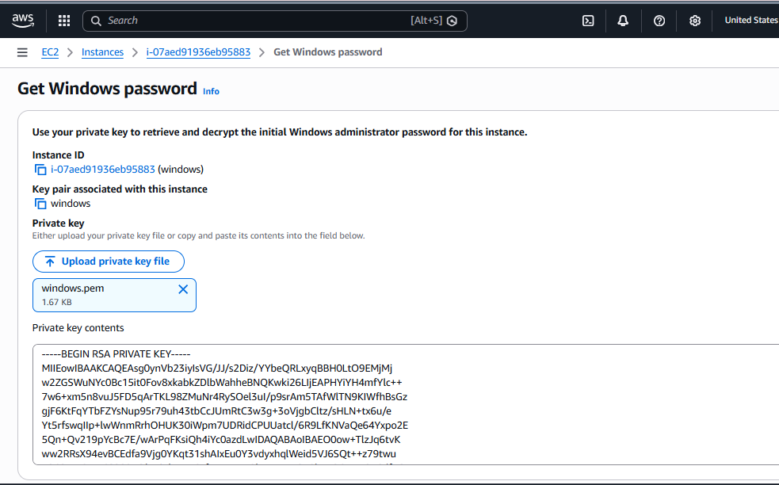

Open the remote desktop connection on local machine
Copy the password generated from the key pair
Click on “ok”
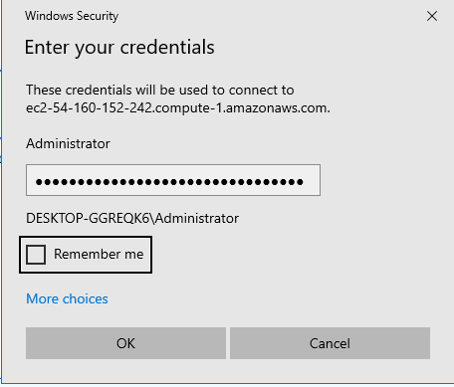

Successfully connected to the windows instance
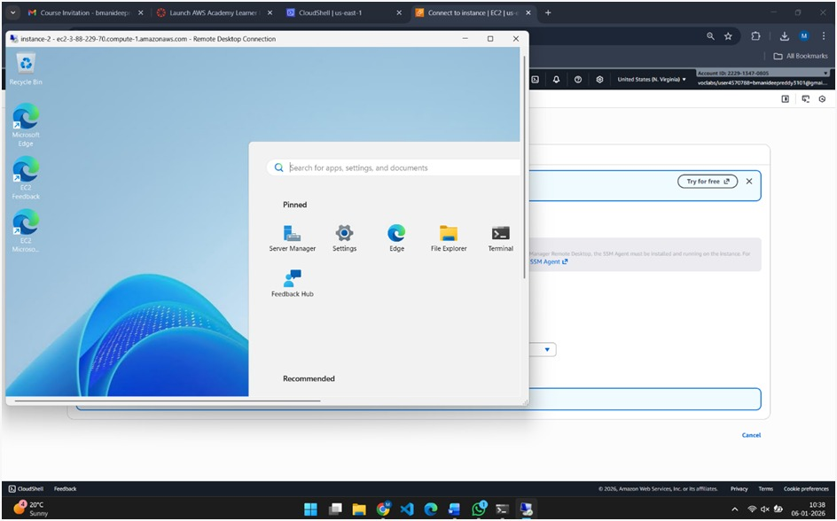

Docker Image pushing into docker hub
Build Docker Image and push to docker hub from the cloud shell
Login to root user(using sudo su command)
Check for docker and git version
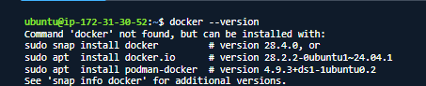
Update the system using the following command (sudo apt-get update)
And install the docker usinf command (sudo apt-get install docker.io)
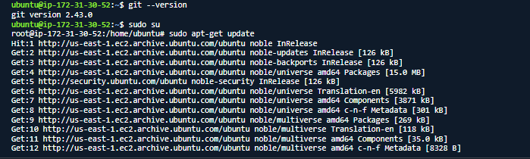
Update the system using the following command (sudo apt-get update)
Copy the repository link to clone the project
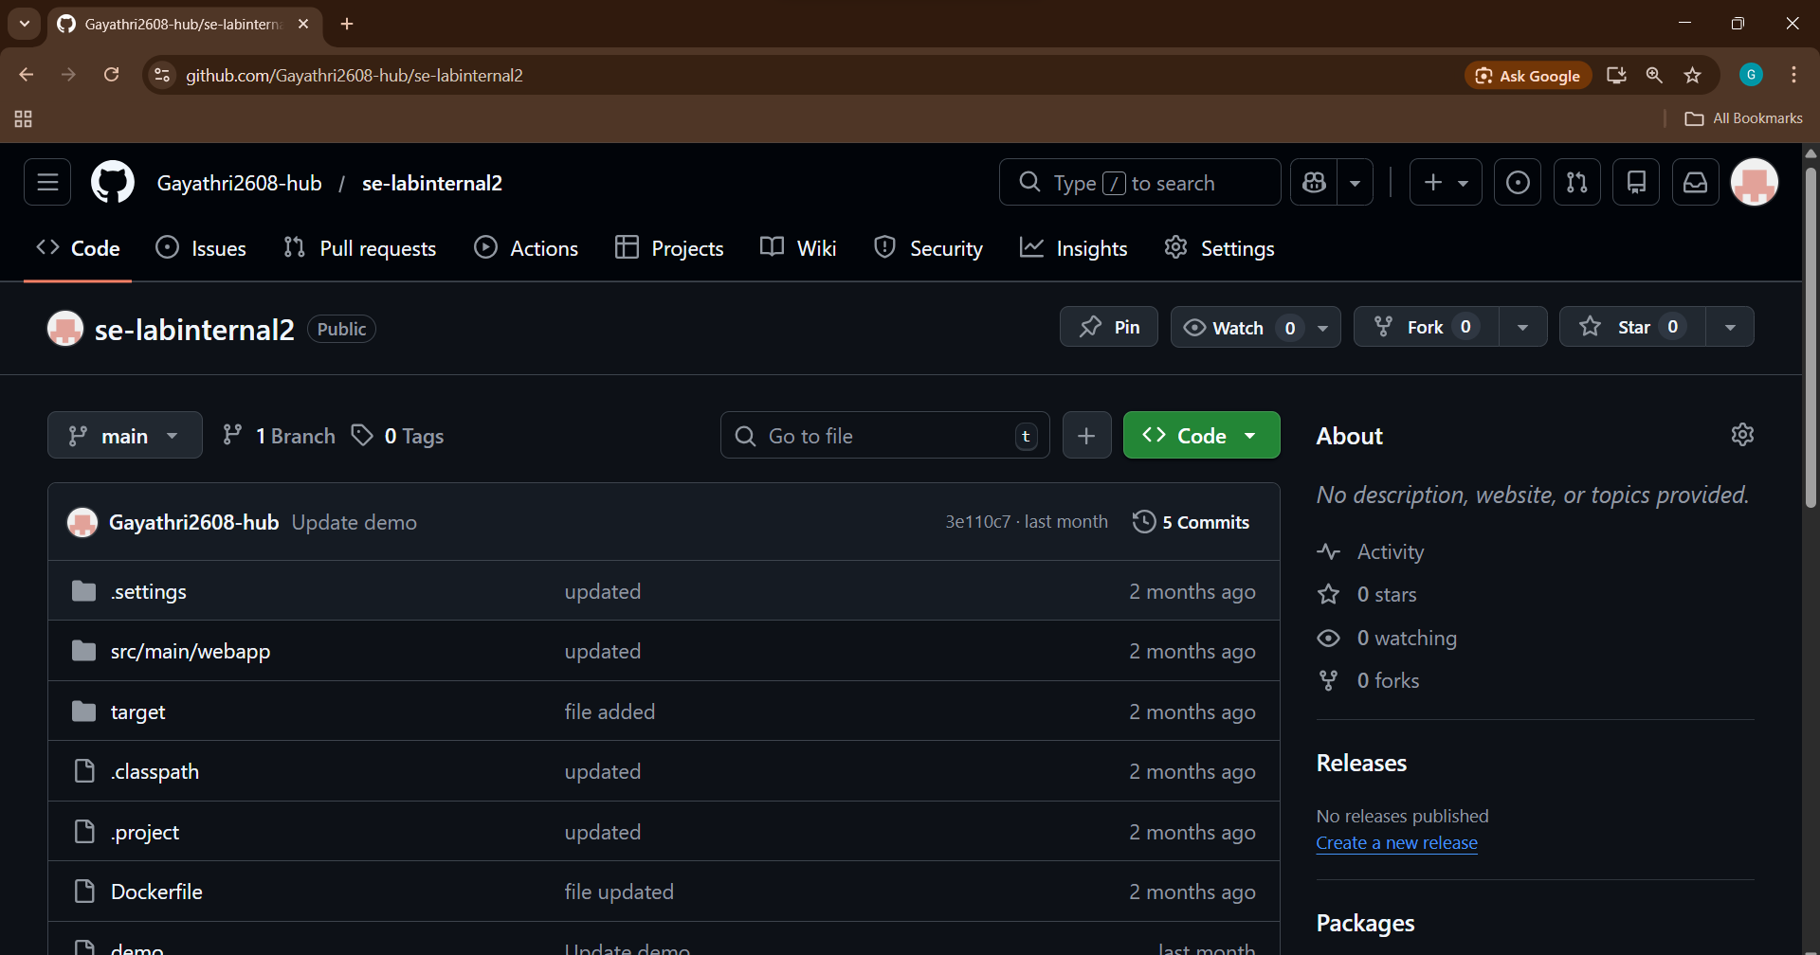
Clone the project using git clone command
Redirect to the cloned directory
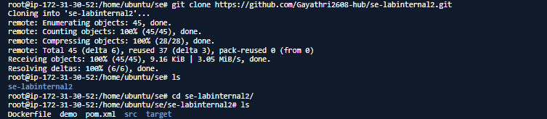

Build the docker image using the docker file in the project (using sudo docker built -t image .)
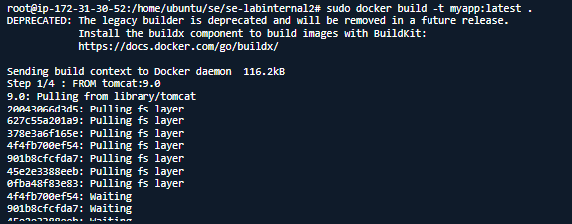
Check whether the got created by using docker images command
And run the docker image
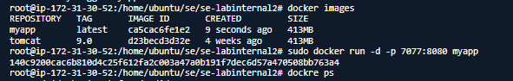
Login to docker hub (using docker login command)
Authenicate using the code provided on the display.
After login ,Tag the docker image using command (sudo docker tag myapp gayathri062/myapp:latest)
Push the docker image into docker hub using command (sudo docker push gayathri062/myapp)
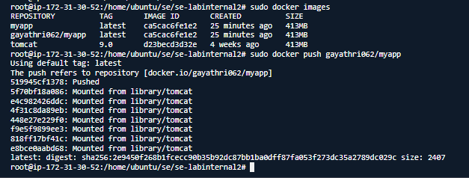

Verify the Docker hub after pushing the image .
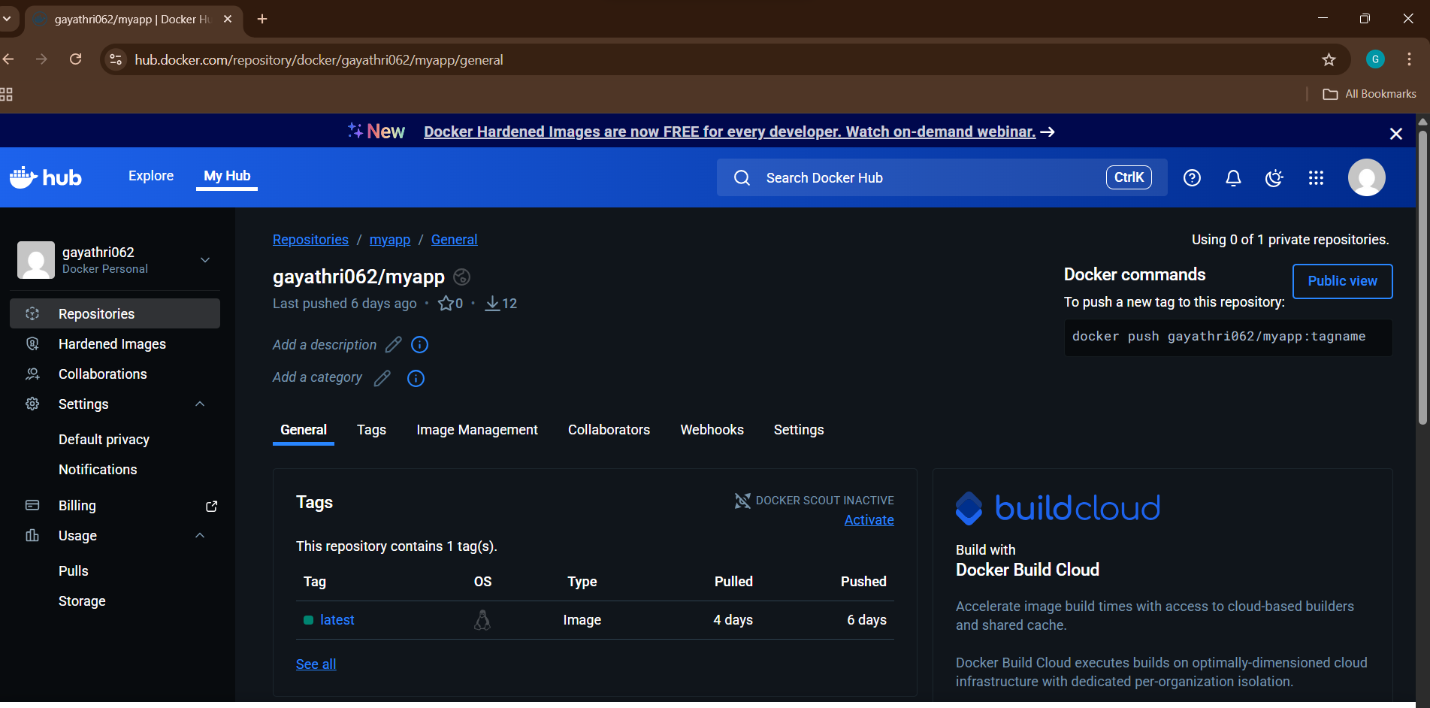

Scenario-Based Questions

1. First-time Linux EC2 → Why is a key pair mandatory? What if you skip it?
Why mandatory:
- A key pair is used for SSH authentication (public key on EC2, private key with you).
- Linux EC2 instances do not have passwords by default.
If you skip it:
- You cannot SSH into the instance.
- The instance is running, but unusable.
- Only recovery options: Session Manager, attach root volume to another instance, or terminate & relaunch.

2. SSH connection times out → What security group issues to check?
Check these first:
- Inbound rule exists
  - Port: 22
  - Protocol: TCP
- Source IP is allowed
  - Your public IP or trusted CIDR
- Not using 0.0.0.0/0 in production
- Security group is attached to the correct instance

3. Allow only office IP for SSH → How & why?
How to configure:
Inbound Rule:
Type: SSH
Port: 22
Source: <Office_Public_IP>/32
Why important:
- Prevents brute-force attacks
- Limits access to trusted network
- Follows least privilege principle

4. Windows EC2 → RDP connection
Port to open:
- 3389 (TCP)
Why NOT 0.0.0.0/0:
- RDP is a common attack target
- Exposes instance to password-guessing attacks
- Should be restricted to your IP only

5. PuTTY on Windows → Why convert .pem to .ppk?
- AWS provides .pem (OpenSSH format)
- PuTTY uses .ppk (PuTTY Private Key format)
- Conversion is done using PuTTYgen
Without conversion, PuTTY cannot authenticate.

6. Amazon Linux AMI → What does AMI contain?
An AMI (Amazon Machine Image) contains:
- Operating System
- Preinstalled packages
- Boot configuration
- Default users & permissions
Effect on instance:
- Determines OS behavior
- Determines package manager (yum, dnf)
- Determines default user (ec2-user)

7. Need multiple identical EC2 instances → Best approach?
Create a custom AMI
Steps:
- Install software on one EC2
- Create AMI from it
- Launch multiple EC2s using that AMI
Ensures consistency & speed

8. Can’t use local machine → How to connect to EC2?
Use AWS Systems Manager – Session Manager
Why:
- No SSH/RDP needed
- No open inbound ports
- Works via IAM role
- Ideal for corporate network restrictions

9. Deleted inbound SSH rule → Impact on existing connections?
- New SSH connections fail
- Existing SSH sessions remain active
- Once disconnected → cannot reconnect

10. Production EC2 → Why avoid default security group?
Default SG issues:
- Allows traffic from any instance using same SG
- Too permissive
- Poor visibility & control
Production requires custom, tightly controlled security groups

11. Windows EC2 → RDP fails (key pair issues?)
Possible causes:
- Wrong key pair selected at launch
- Password not decrypted correctly
- Key pair file lost or corrupted
- Instance reboot needed after password reset
Windows uses key pair to decrypt admin password

12. Automate EC2 creation with same OS & software
AMI
Why:
- Standardizes OS, disk size, software
- Ensures repeatability
- Used in Auto Scaling & automation

13. Wrong AMI launched → Can you change it?
You cannot change AMI after launch
What to do instead:
- Terminate instance
- Launch new instance with correct AMI
- Or create AMI after converting (not recommended)

14. SSH from anywhere in prod → Why dangerous? Fix?
Danger:
- Exposed to internet-wide attacks
- Brute-force login attempts
- Security compliance violation
Fix:
- Restrict SSH to trusted IPs
- Use Session Manager
- Use bastion host

15. Migrate EC2 setup to another region
Steps:
- Create AMI of instance
- Copy AMI to target region
- Launch EC2 from copied AMI
- Recreate security groups & key pairs
- Update DNS / Load Balancer

