Inventory Management System

The application Inventory Management System is created using spring boot, rest api.

It has the following API’s.

1. To view the list of products available in the system
2. To create a product
3. To update the product
4. To delete the product from the system
5. To get the stock / quantity information of the product

IDE used: Visual studio code

Extension added : GitHub copilot

Copilot has made the task easy to write required API implementation, test cases.

Without manually writing the logic, copilot has implemented the required logic based on the method names.

**Output:**

1. **To view the list of products available in the system**

1. **To create a product**

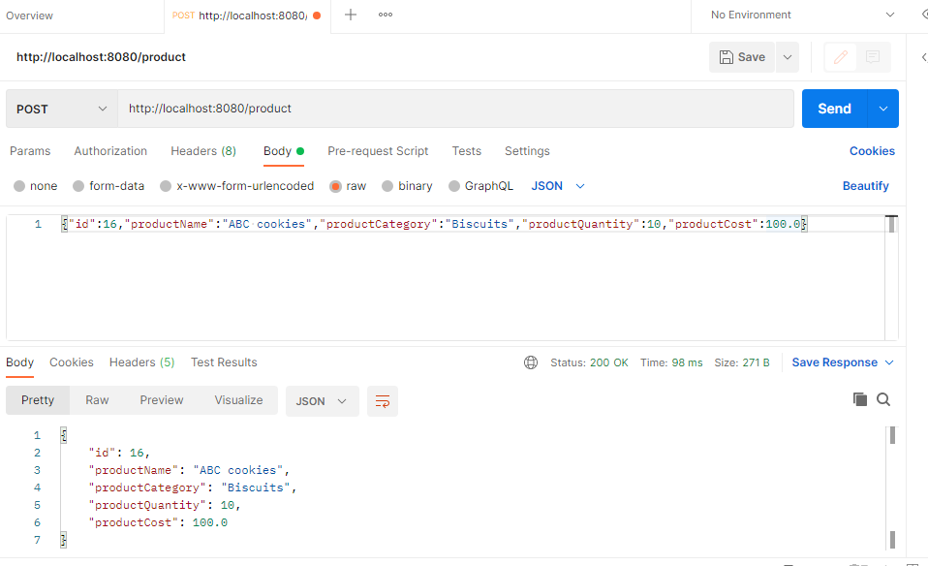

Product with id – 16 has been added successfully, the same is shown in the list of products retrieved below

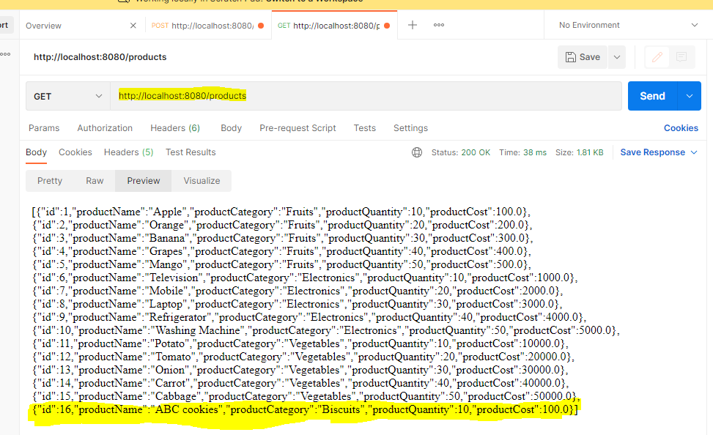

1. **To update the product**

The product quantity for product id :6 is updated to zero.

1. **To delete the product from the system**

Currently in the System Product id:9, Refrigerator is available.

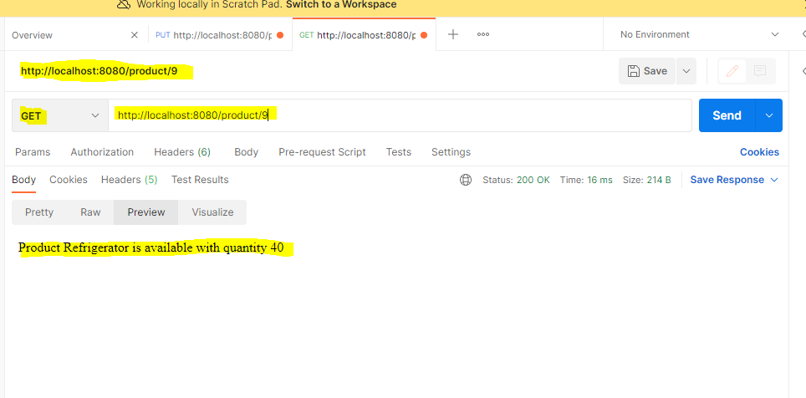

Delete the product id:9, Refrigerator.

After hitting the API, the product has been deleted.

1. **To get the stock / quantity information of the product**

Stock / inventory information for product : 5, Mangoes

Response: Product Mango is available with quantity 50

Stock / inventory information for product : 16

Response: Product ABC cookies is out of stock

