Supporting Information

Determination of carboxylesterase 2 by fluorescence probe to guide pancreatic adenocarcinoma profiling

Meng-meng Zhang,^{1.2} Peng Li³ ，Feng Hai,*⁴ and Yan Jia*¹

CONTENT
Experimental Section 1
The Synthesis of NI-MO 2
Figure S1 3
Figure S2 4
Figure S3 5
Figure S4 6
Figure S5 7
Table S1 8
Figure S6 9
Figure S7 10
Figure S8 11
Figure S9 12
Figure S10 13
Figure S11 14
Table S2 15

Experimental Section
Reagents and instruments
All reagents for the cell culture were purchased from Gibco Life Technologies (Grand Island, NY, USA), unless otherwise stated. And all compounds are >95% pure by HPLC analysis. Lyso-Tracker Red was purchased from Beyotime. Boric acid borax buffer was purchased from Xincheng Shengwu. Phospholipase and alkaline phosphatase were purchased from Yuanye Shanghai. Acetylcholin esterase was purchased from Solarbio. Carboxylesterase 1 and carboxylesterase 2 were purchased from Cypex. Liver microsome was purchased from XENOTECH. The inhibition library was purchased from MedChemExpress. Chemical characterization was performed by Bruker 400M NMR spectrometer (AVANCE III 400 MHz) and Q-TOF 6540 chromatography. Confocal fluorescence images were observed with Olympus FV1000 confocal laser-scanning microscope with an objective lens. 96-well plate fluorescence was detected by Thermo Scientific Microplate Reader.

Data mining
Raw counts of RNA-sequencing data and corresponding clinical information were obtained from The Cancer Genome Atlas (TCGA) dataset (https://portal.gdc.cancer.gov/), in which the method of acquisition and application complied with the guidelines and policies. All analytical methods above and R packages were performed using GEPIA2 analysis^{[1]}. p < 0.05 was considered as statistically significant.

Synthesis of NI-MO
The synthesis route of probe is shown in Scheme S1, Supporting Information. The compound NBOH was synthesized in our lab previously^{[2]}. All compounds are >95% pure by HPLC analysis. Detailed protocols for synthesis of compound and its NMR and HPLC-MS characterization can be found below (Figure S1-2). To a solution of NBOH (269mg, 1mmol) in CH₂Cl₂ (10.0ml) was added 4-morpholineacetyl chloride (326mg, 2mmol) and triethylamine (303mg, 3mmol). The mixture was stirred at room temperature for 18 hours. The mixture was concentrated under reduced pressure. The mixture was purified by silica gel column chromatography (CH3OH: CH₂Cl₂=1:20), and the target was obtained as a light yellow solid by recrystallization of dichloromethane and diethyl ether (132mg, 0.33mmol, 33% yield). ¹H NMR (400 MHz, Chloroform-d): δ 8.61 (t, J = 8.4 Hz, 2H), 8.23 (d, J = 8.4 Hz, 1H), 7.78 (t, J = 7.9 Hz, 1H), 7.58 (d, J = 8.1 Hz, 1H), 4.18 (t, J = 7.4 Hz, 2H), 3.82 (t, J = 4.5 Hz, 4H), 3.71 (s, 2H), 2.77 (t, J = 4.4 Hz, 4H), 1.71 (p, J = 7.5 Hz, 2H), 1.45 (h, J = 7.3 Hz, 2H), 0.98 (t, J = 7.3 Hz, 3H).¹³C NMR (101 MHz, CDCl3): δ 167.87, 163.97, 163.42, 151.00, 131.69, 131.67, 129.37, 127.41, 127.32, 125.09, 123.07, 120.67, 119.32, 77.33, 77.22, 77.02, 76.70, 66.81, 59.46, 53.32, 40.32, 30.20, 20.38, 13.84.
LC-MS: m/z, 397.1729 [M+H]⁺(calculated:396.1685).

Molecular Simulation
In the study, we performed molecular simulation to investigated binding modes of the probe and carboxylesterase 2. The detail of carboxylesterase 1 (CES1) crystal structure (ID: 1ya4) was obtained from the structure in protein data bank (http://www.rcsb.org/pdb/home/home. do). Since carboxylesterase 2 (CES2) does not have a crystal structure model, homology modeling was performed by Swiss-Model, an online homology modeling tool^{[3]}. The virtual screening was done by AutoDock Vina^{[4]}.

Verification was performed by Liquid chromatography mass spectrometry analysis. A solution of the probe (10 μM) was incubated with or without carboxylesterase 2 in 50 mM Boric acid and borax (BB, pH=5.0) for 15 min at 37°C set up control test. The release of the probe was quantified via HPLC. The MS of the probe-treated mixture system were recorded to estimate the metabolism of the probe, the fragment ion m/z ratios was set to 397.1763 (the probe), and the fragment ion m/z ratio was set to 270.1119 for the detection of the production.

Carboxylesterase 2 Activity Assay
NI-MO was dissolved in DMSO prepared a 10 mM stock solution, and enzymes were diluted in 50 mM BB buffer pH 5.0. For spectral measurements, the enzymes were pre-incubated for 5 min and all reactions (V_{final} 200μl) were carried out in 50 mM BB (pH=5.0) in 96-well plates at 37°C. The final concentration of probe is 10 μM (2%DMSO). Unless otherwise noted, the probe was diluted to 0.5 mM. The sample were incubated with NI-MO for 30 min and the fluorescent intensity was measured (ex/em=450nm/560nm). The limit of detection was calculated at different concentrations of carboxylesterase 2 (5 μg/ml*1-10 fold) by fluorescence changes. Michaelis-Menten parameters for the hydrolysis of NI-MO in carboxylesterase 2 (50 μg/ml) were estimated by varying the substrate concentration from 0.5 to 50 μM. All samples were corrected for background, and the residual enzyme activity was calculated based on the fluorescence signal from the controls. Fluorescence signals were plotted against time or concentration and processed in GraphPad.

Carboxylesterase 2 Inhibition Screening Assay
The screening, using the optimized conditions as described above, was conducted in a 96-well black-bottom plate (Corning) with reaction volumes set at 200μl. Concentration of the drugs during the screen was 25 μM and the optimum signal was obtained using probe (10 μM, ex/em= 450/560nm). Resulting fluorescence signals were processed as described above. Enzyme assays of inhibitor were carried out as previously described, and inhibition by selected drugs was assessed. The inhibition activity was measured by the released NBOH from NI-MO in the presence of carboxylesterase 2 and the inhibitor. Carboxylesterase 2 (20 μg/ml) was pre-incubated with the inhibitor (2.5 - 900 μM) and NI-MO (10 μΜ) was added for 30 min at 37°C. The data obtained were fitted to the Michaelis-Menten equation using GraphPad to determine the enzyme inhibition parameters.

Cell culture and imaging
The Panc-1 and HPDE6-C7 cell line were purchased from the American Type Culture Collection (ATCC, Manassas, VA, USA). Panc-1 cells and HPDE6-C7 were seed on 35-mm glass-bottom dishes and cultured overnight. Following this, the medium was removed and the cells were washed three times with PBS (PH7.4).
The probe (10 μΜ, 2%DMSO) solution was added to one set of petri dish, while another set of petri dishes served as a control. Then incubation was continued under the same conditions. Each sample was imaged live on a confocal microscope. The cells were excited using the 405 nm line of a laser. For the inhibitor assay, the cells were incubated in parecoxib (100μM), erdosteine (100μM) and nitisinone(100μM)[2%DMSO] at 37°C under 5% CO₂ in air for 30 min, and the medium was removed and the cells were washed three times with PBS (PH7.4). Then the cells were cultured with probe (10 μΜ, 2%DMSO) solution for 30 min. Fluorescence images were captured with a confocal fluorescence microscope. For cellar co-location experiment, the cells were treated with the probe (10 μM, ex/em=405/500-560nm) and Lyso-Tracker Red (50 nM, ex/em=543/575-635nm) at 37 °C for lysosome staining. Images were captured with a laser confocal scanning microscope.

Statistical analysis
Plotting and statistical analysis were performed in GraphPad Prism software. All quantitative data were presented as the mean SEM (standard error of the mean) or the mean SD (standard deviation) as indicated of at least three independent experiments. And comparisons between two groups were analyzed using two-tailed t-tests. p < 0.05 was defined as significant.

Scheme S1

Scheme S1 The synthetic route of NI-MO.

Figure S1
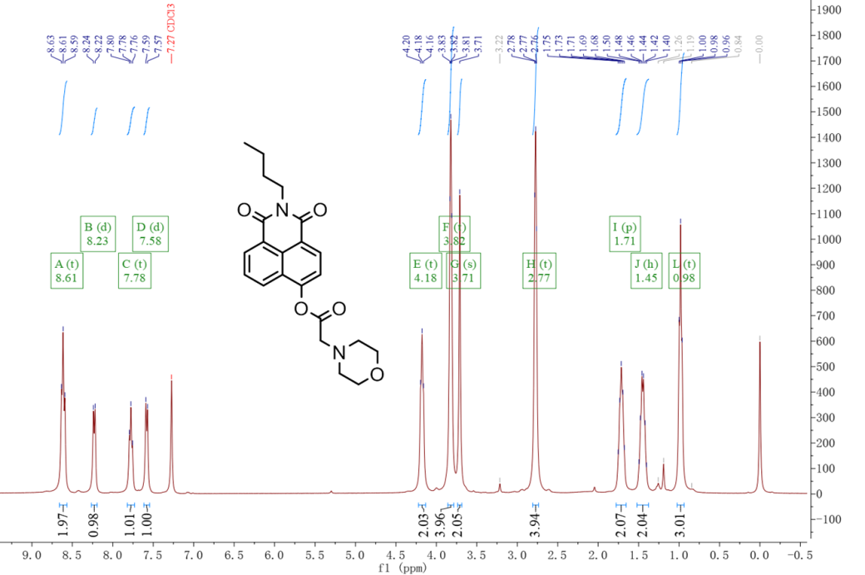
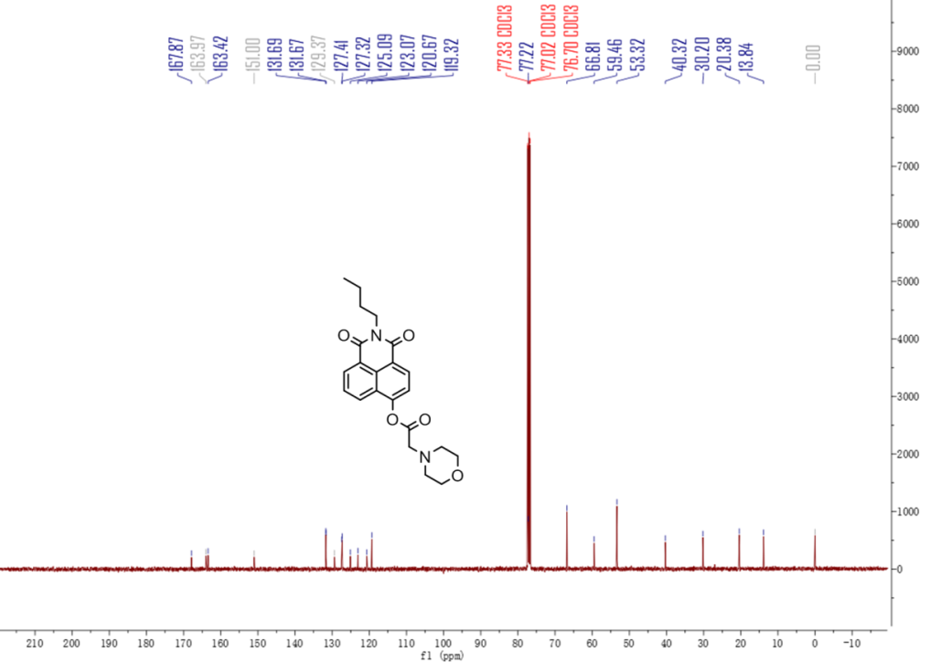
Figure S1. The ¹H NMR and ¹³C NMR of NI-MO.

Figure S2
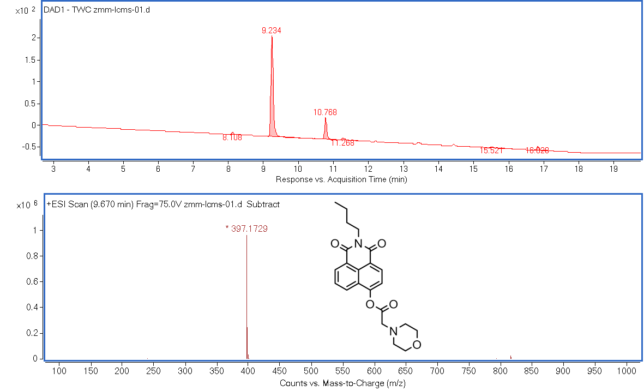
Figure S2.The LC-MS of NI-MO.

Figure S3
Figure S3. Calculated configuration involved in the vertical excitation (S₀) of the NI-MO and NBOH.

Table S1
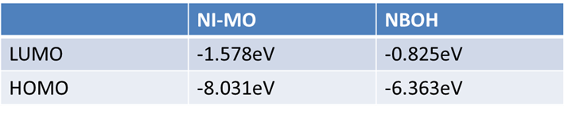
Table S1. Calculated frontal MOs involved in the vertical excitation (S₀) of the NI-MO and NBOH.

Figure S4
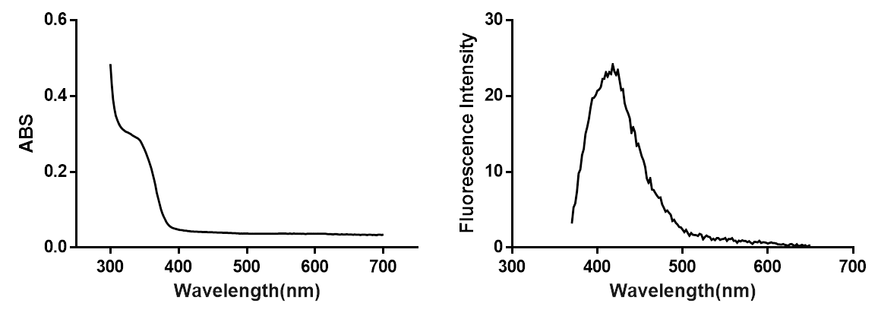
Figure S4. The absorption(left) and emission(right) spectrum of NI-MO(10 μM)(Ex=340nm).

Figure S5
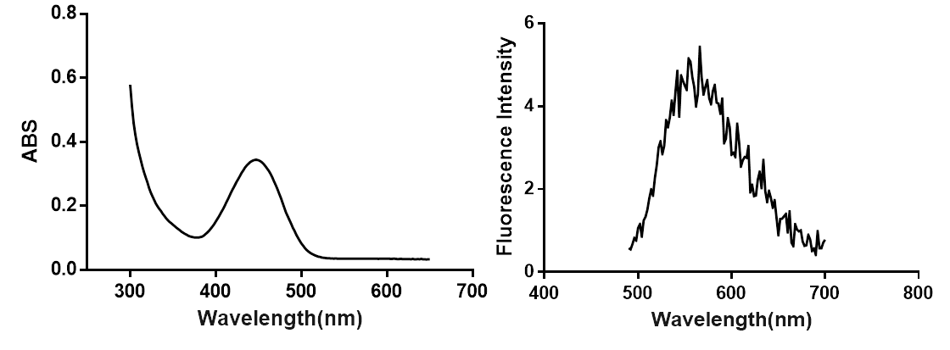
Figure S5. The absorption and emission spectrum of NBOH (10 μM)(Ex=450nm).

Figure S6
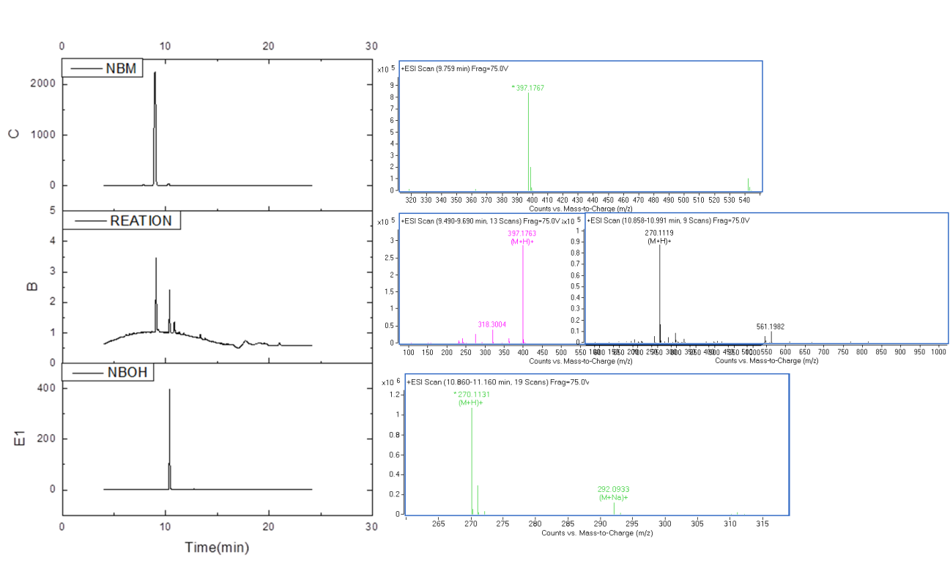
Figure S6. HPLC and QTOF-MS validation of carboxylesterase 2 (50 μg/ml)-catalyzed NI-MO(10 μM) metabolism.

Figure S7
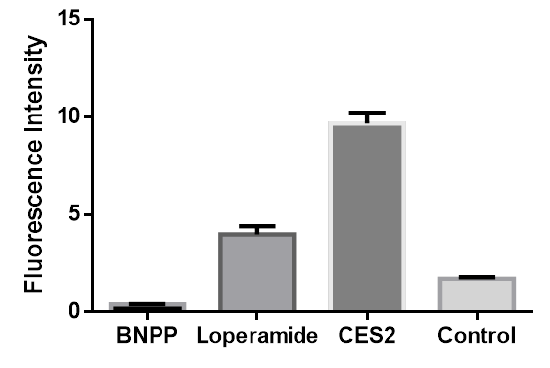
Figure S7. Fluorescence intensities of inhibitor (BNPP and loperamide, 200 μM) detected by NI-MO (10 μM) with carboxylesterase 2 (50 ug/ml). The intensity of NI-MO (10 μM) with carboxylesterase 2 in BB (pH=5.0) was set as reaction.

Figure S8
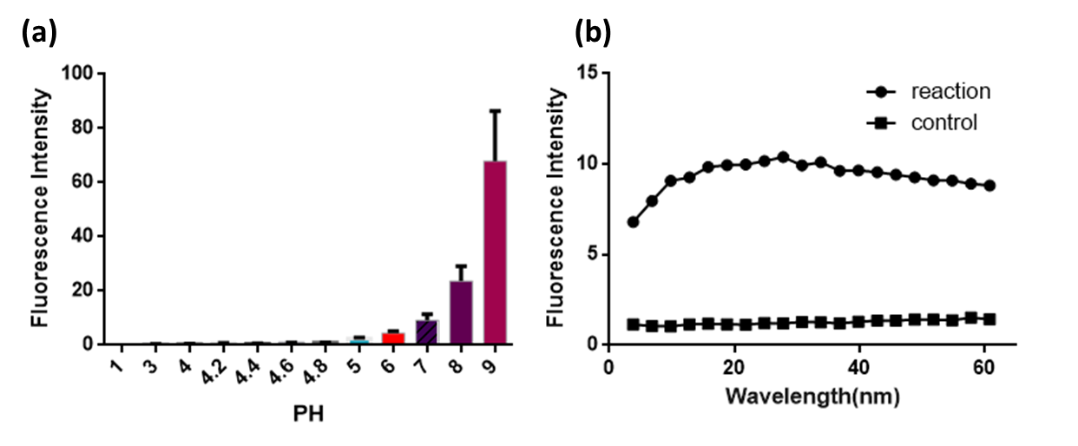
Figure S8. (a) Fluorescence of NI-MO (10 μM) in the BB at different PH (Ex/Em=450nm/560nm). (b) Photostability detection of NI-MO (10 μM) and its reaction towards carboxylesterase 2 (50 μg/ml) for 60 min in BB (pH 5.0).

Figure S9
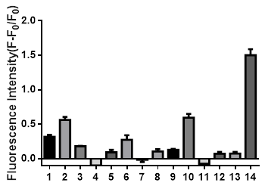
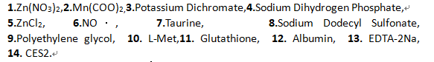
Figure S9: The fluorescence changes of NI-MO (10 μM) toward various analytes:1.Zn(NO₃)₂,2.Mn(COO)_{2,}3.Potassium Dichromate,4.Sodium Dihydrogen Phosphate,5.ZnCl₂, 6.NO·, 7.Taurine, 8.Sodium Dodecyl Sulfonate, 9.Polyethylene glycol, 10. L-Met,11. Glutathione, 12. Albumin, 13. EDTA-2Na, (From No. 1-13: the concentration : 2mM) 14. CES2 (50ug/ml) .

Figure S10

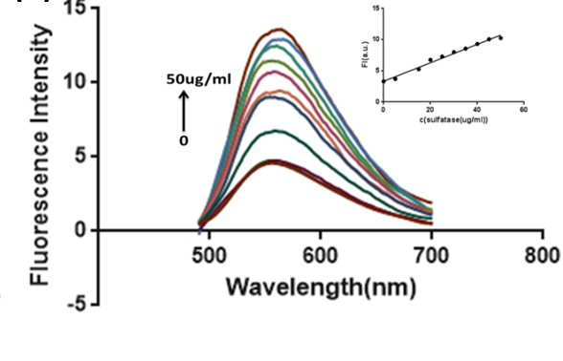
Figure S10. Limit of detection of fluorescence spectrum changes of NI-MO(10 μM) in the presence of carboxylesterase 2 at pH 5.0 (Ex=450nm, R²=0.9846).

Figure S11
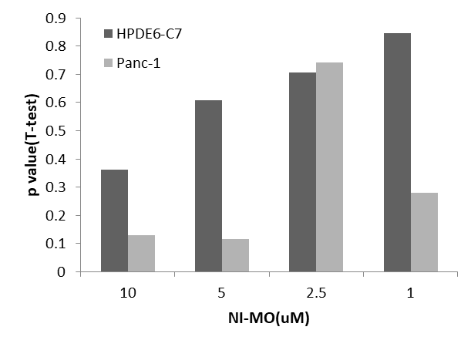
Figure s11. Cytotoxicity test of probe NI-MO from 1-10 uM by CCK8 test.

Reference
[1] Zefang T , Boxi K , Chenwei L , et al. GEPIA2: an enhanced web server for large-scale expression profiling and interactive analysis[J]. Nucleic Acids Research, 2019(W1):W1.
[2] Zhang M M , Ma Y H , Li P , et al. Detection of atherosclerosis-related hypochlorous acid produced in foam cells with a localized endoplasmic reticulum probe[J]. Chemical Communications, 2020, 56.
[3] Biasini M, Bienert S, Waterhouse A, et al. SWISS-MODEL: modelling protein tertiary and quaternary structure using evolutionary information[J]. Nucleic acids research, 2014, 42(W1): W252-W258
[4] Trott, Oleg, Olson, et al. AutoDock Vina: Improving the speed and accuracy of docking with a new scoring function, efficient optimization, and multithreading[J]. J. Comput. Chem. 2009, 31(2):NA-NA.

