Supporting Information for
Detection of carboxylesterase 1 and carbamates with a novel fluorescent protein chromophore based probe
Jianan Dai ^{a,1}, Yu Zhao ^{b,1}, Yadan Hou ª, Guoyan Zhong ª, Rui Gao ª, Jichun Wu ª, Baoxing Shen ^{a,} *, Xing Zhang ^{a,} *
ª School of Food Science and Pharmaceutical Engineering, Nanjing Normal University, Nanjing, Jiangsu 210023, China
^{b} Department of Food Science, Cornell University, Ithaca, NY 14853, United States
Corresponding author E-mail address: shenbx@njnu.edu.cn; zhangxing@njnu.edu.cn
¹ They contribute equally to this work and should be considered as co-first author.
Table of Contents
1. Synthesis
2. Cell experiment.
3. Quantum yield measurement
4. Detection limit measurement
5. Characterization spectrums
6. Cluster analysis results and hydrophobic interactions of molecular docking study
7. DTF calculation results
8. LC-MS spectrometry of CBZ-FP hydrolysate
9. Absorption and fluorescence properties of CBZ-FP before and after metabolism
10. The effects of classic CES1 inhibitors on the CBZ-FP
11. The details of molecular docking study between hydrolyzed CBZ-FP and CES1
12. Imaging of cells pretreated with CES1 inhibitors
13. Comparison with reported work
14. The activity and sources of all enzymes

- Synthesis
Compound 1: Glycine tert-butyl ester hydrochloride (1.50 g, 8.96 mmol), ethyl aceimide hydrochloride (1.11 g, 8.96 mmol) and potassium carbonate (1.24 g, 8.96 mmol) were dissolved in 15 mL deionized water in a ground conical bottle, and then 20 mL diethyl ether was added in the mixture. The mixture was stirred at maximum speed for six minutes at room temperature. During the reaction process, the stopper should be pressured tightly due to ether evaporation. Then the reaction mixture was transferred to separation funnel. The top organic phase was collected, and the aqueous phase with extracted with 25 mL ether for 3 times. The organic fraction was combined and dried with anhydrous sodium sulfate. The ether was then removed under reduced pressure to afford a colorless oily liquid (compound 1). Compound 1 was used directly in the next step without further purification.
Compound 2: Glycine tert-butyl ester hydrochloride (0.83 g, 4.93 mmol) and sodium hydroxide (0.18 g, 4.48 mmol) were dissolved in 50 mL tertiary butanol and the mixture was stirred at room temperature for 1 h. After the reaction mixture became clear and transparent, 9- ethyl-9H-carbazole-3-carbaldehyde (1.00 g, 4.48 mmol) was added in the mixture for overnight reaction. The freshly prepared compound 1 was added dropwisely into the faint yellow reaction mixture, which was stirred overnight. Water was poured into the deep yellow reaction mixture to quench the reaction. Dichloromethane (25 mL) was used to extract the reaction mixture for three times and the combined organic phase was dried with anhydrous sodium sulfate. After the solvent was removed in vacum, the product was further purified by flash chromatography (50% petroleum ether and 50% ethyl acetate) to yield yellow solid compound 2 (1.04 g). ¹H NMR (400 MHz, DMSO) δ 8.95 (s, 1H), 8.51 (dd, J = 8.7, 1.2 Hz, 1H), 8.16 (d, J = 7.7 Hz, 1H), 7.68 (q, J = 16.6, 8.5 Hz, 2H), 7.51 (t, J = 7.7 Hz, 1H), 7.28 (t, J = 7.4 Hz, 1H), 7.23 (s, 1H), 4.48 (d, J = 7.1 Hz, 2H), 4.43 (s, 2H), 2.35 (s, 3H), 1.45 (s, 9H), 1.34 (s, 3H). ¹³C NMR (101 MHz, DMSO) δ 169.94, 167.85, 161.62, 141.12, 140.57, 136.24, 130.55, 128.14, 126.85, 125.81, 125.52, 123.01, 122.76, 120.95, 120.21, 110.20, 110.06, 82.67, 42.40, 37.73, 28.13, 15.69, 15.68, 15.67, 14.28. [M+⁺ Calcd: 418.2, Obsd: 418.2.
CBZ-FP: Methyl 4-formylbenzoate (0.16 g, 0.96 mmol) and compound 2 (0.20 g, 0.48 mmol) were dissolved in 1, 4-dioxane (8 mL) and the mixture was refluxed overnight. Upon the reaction temperature dropped to 50 ℃, ZnCl₂ (6.42 mg, 0.05 mmol) was added into the mixture, which was further refluxed overnight. The reaction prgress was monitored by TLC. After the reaction was finished, the solvent was removed under vacum, and the product was purified by flash chromatography (75% petroleum ether: 25% ethyl acetate) to yield an orange solid compound 3 (40.80 mg). ¹H NMR (400 MHz, DMSO) δ 9.08 (s, 1H), 8.62 (d, J = 8.6 Hz, 1H), 8.29 (d, J = 7.7 Hz, 1H), 8.16 (d, J = 15.8 Hz, 1H), 8.05 (s, 1H), 7.75 (d, J = 8.8 Hz, 1H), 7.69 (d, J = 8.3 Hz, 1H), 7.56 – 7.49 (m, 1H), 7.42 (d, J = 15.8 Hz, 1H), 7.35 – 7.28 (m, 2H), 4.69 (s, 1H), 4.51 (q, J = 7.1 Hz, 2H), 3.89 (s, 3H), 1.43 (s, 9H), 1.36 (s, 3H). ¹³C NMR (101 MHz, DMSO) δ 170.06, 167.80, 166.29, 157.99, 141.31, 140.60, 140.27, 138.43, 136.78, 131.17, 130.67, 130.13, 129.08, 128.94, 126.93, 126.17, 125.89, 123.20, 122.77, 121.28, 120.33, 117.14, 110.19, 82.48, 52.77, 42.40, 37.74, 28.10, 14.26. [M+H]⁺ Calcd: 564.2, Obsd: 564.3.

- Cell experiment.
Cells from HepG-2 cell line was used in fluorescence imaging experiment. HepG-2 cells were incubated in DMEM supplemented with 10% (v/v) fetal bovine serum, penicillin (100 μg/mL), and streptomycin (100 μg/mL) using the standard method at 37 °C in a 5% CO₂ incubator. Then, the cells were spilt into a 35 mm diameter confocal dishes before imaging experiments, the density of cells should keep around 3 × 10⁵ cells in each dish, then incubated in DMEM medium for 24 h. As for the experimental group, cells were pretreated with 5 μM carbaryl for 10 min. After that, both experimental and control group were further incubated with 10 μM CBZ-FP in FBS-free DMEM at 37 °C for another 30 min. Before imaging, the samples were washed with PBS buffer for three times.
The cytotoxic effects of probe CBZ-FP were investigated by standard MTT (3-(4, 5-dimethyl-2-thiazolyl)-2, 5-diphenyl-2-H-tetrazolium bromide) method. The results were converted into bar graph (Figure S1).
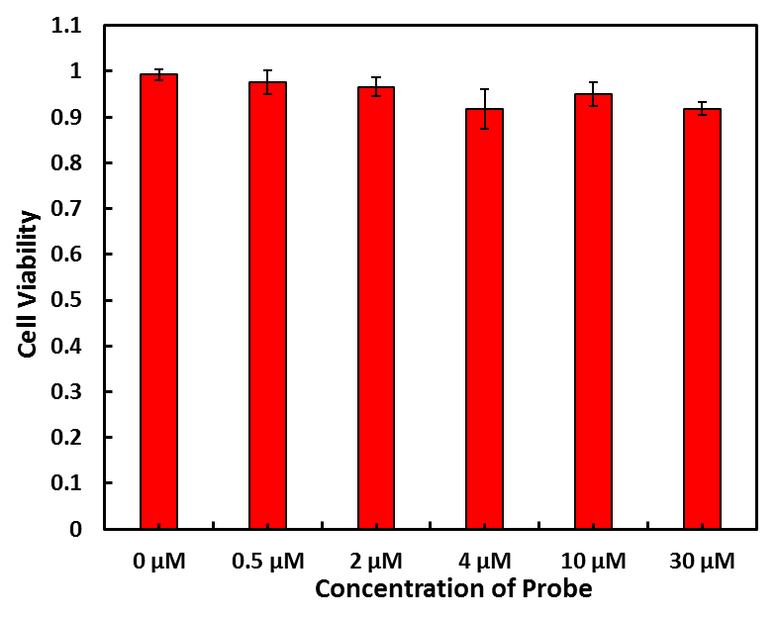
Figure S1. The cytotoxicity of CBZ-FP.
- Quantum yield measurement
Quantum yield measurements followed the standard protocol. Rhodamine B was used as quantum yield standards. The standard samples were prepared in Ethanol. The stock solutions of probe CBZ-FP was prepared in DMSO. The test concentration of probe was 5 µM in 50% PBS buffer-50% CH₃CN. A serial dilution was made (5µM, 4 µM, 3 µM, 2 µM 1 µM) to get a concentration gradient. The emission spectra were recorded using the excitation wavelength 473 nm to get the full spectrum of probe CBZ-FP. The absorbance spectrum was recorded. The peak area of emission spectrum was integrated of five different concentration samples respectively to generate the quantum yields. The calculation equation is as follows:
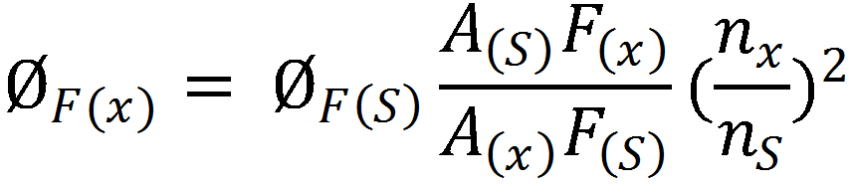
Where Ø_{F} is the fluorescence quantum yield, A is the absorbance at the excitation wavelength, F is the area under the emission curve, and n is the refractive index of the solvents used. Subscripts S and X refer to the standard and to the test samples, respectively.

- Detection limit measurement
The detection limit was calculated according to equation: 3σ/k, where σ is the standard deviation of the blank probe (the number of independent experiment is n = 10), k is the slope of titration experiment.

- Characterization spectrums
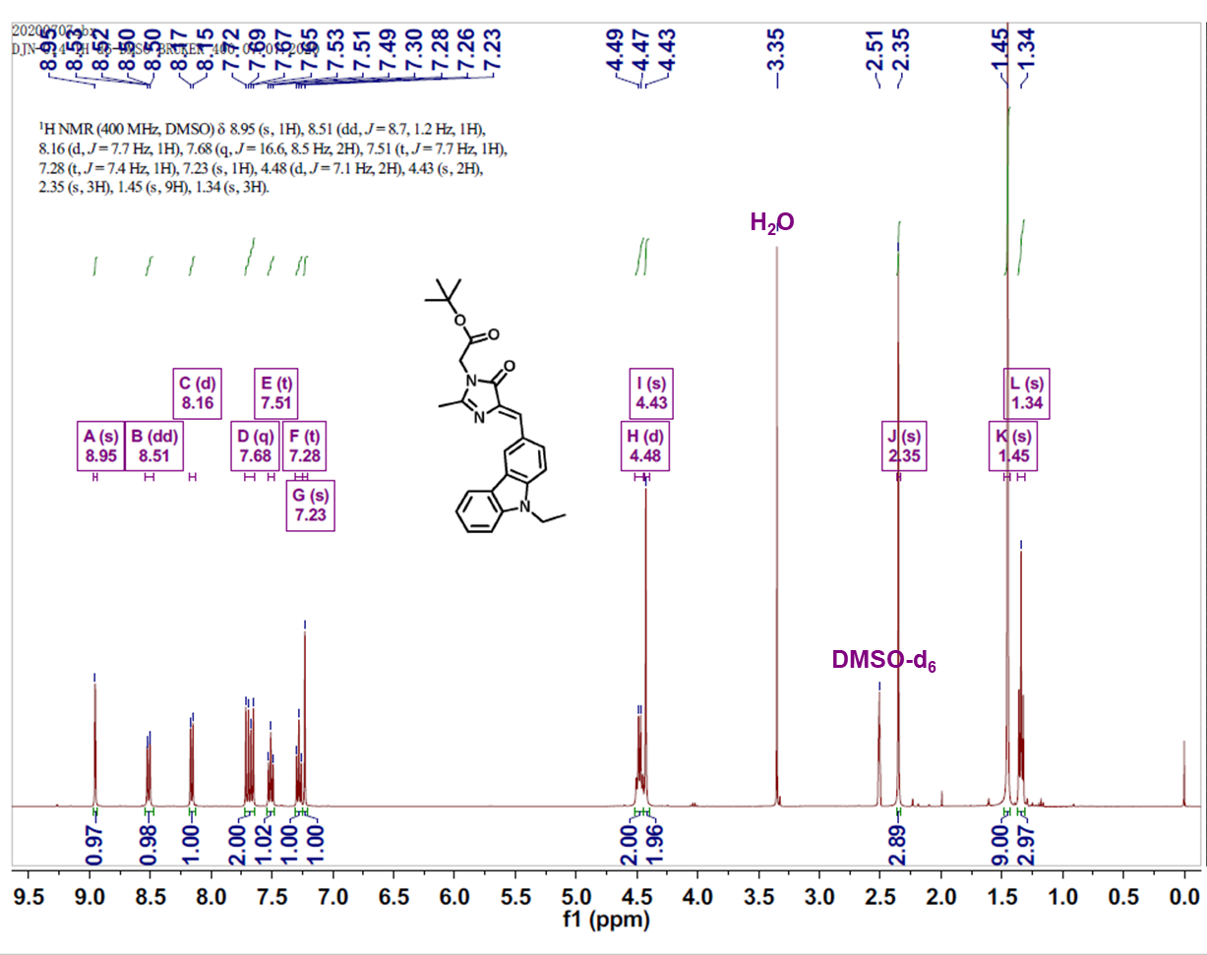
Figure S2. ¹H NMR of Compound 2.
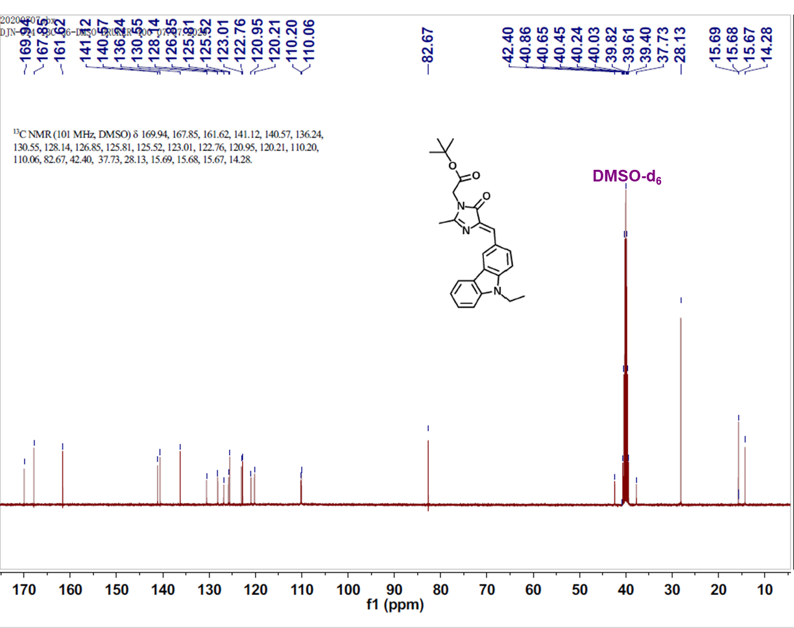
Figure S3. ¹³C NMR of Compound 2.
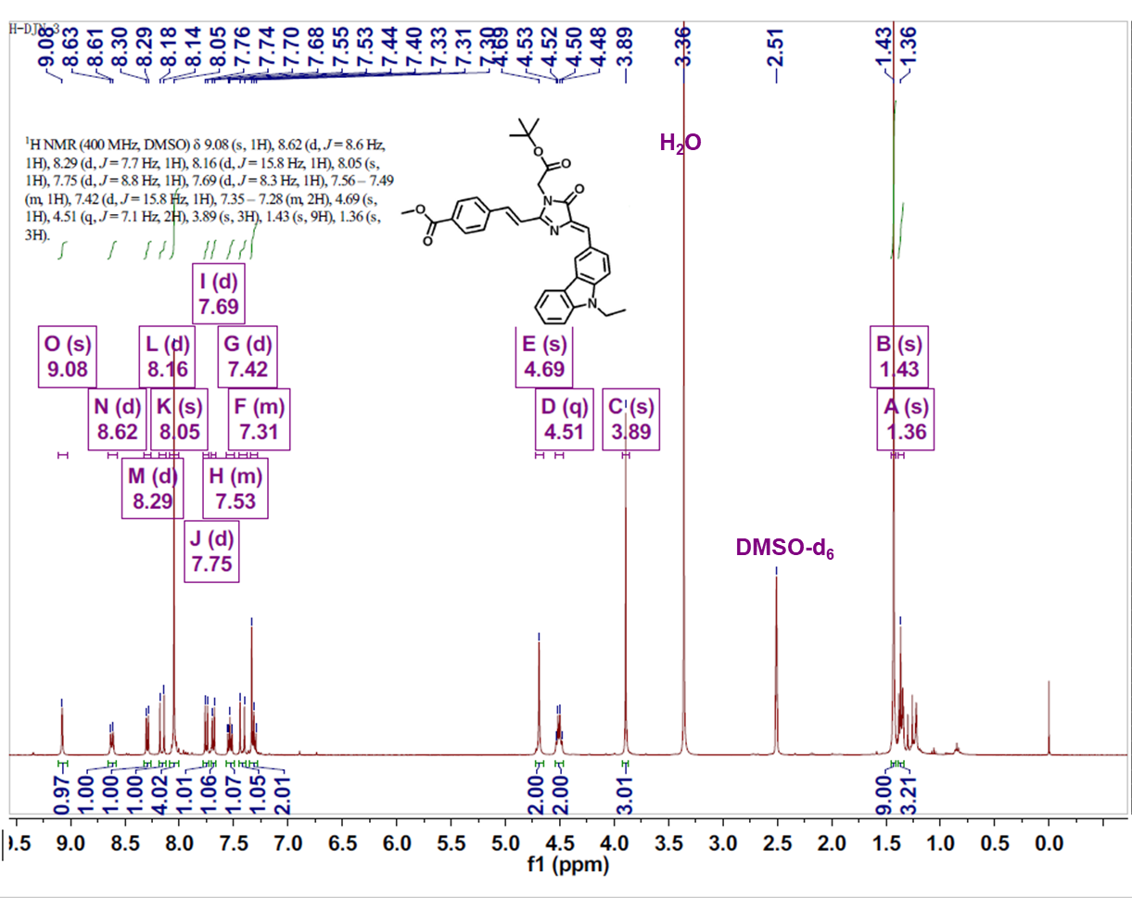
Figure S4. ¹H NMR of probe CBZ-FP.
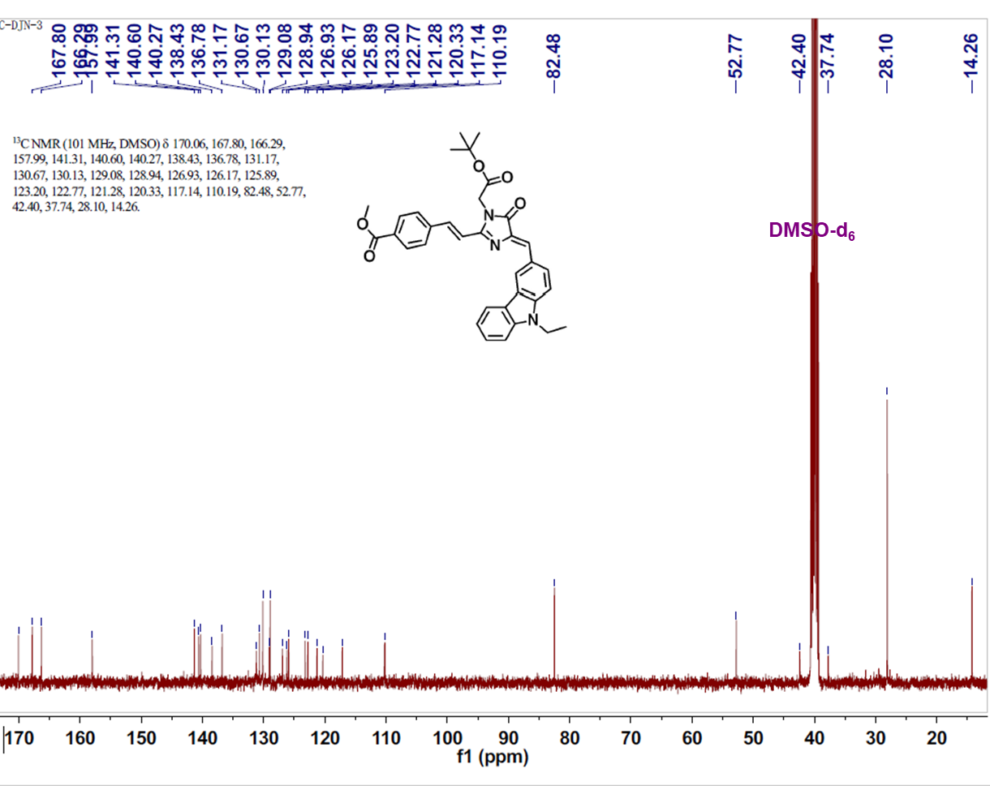
Figure S5. ¹³C NMR of CBZ-FP.
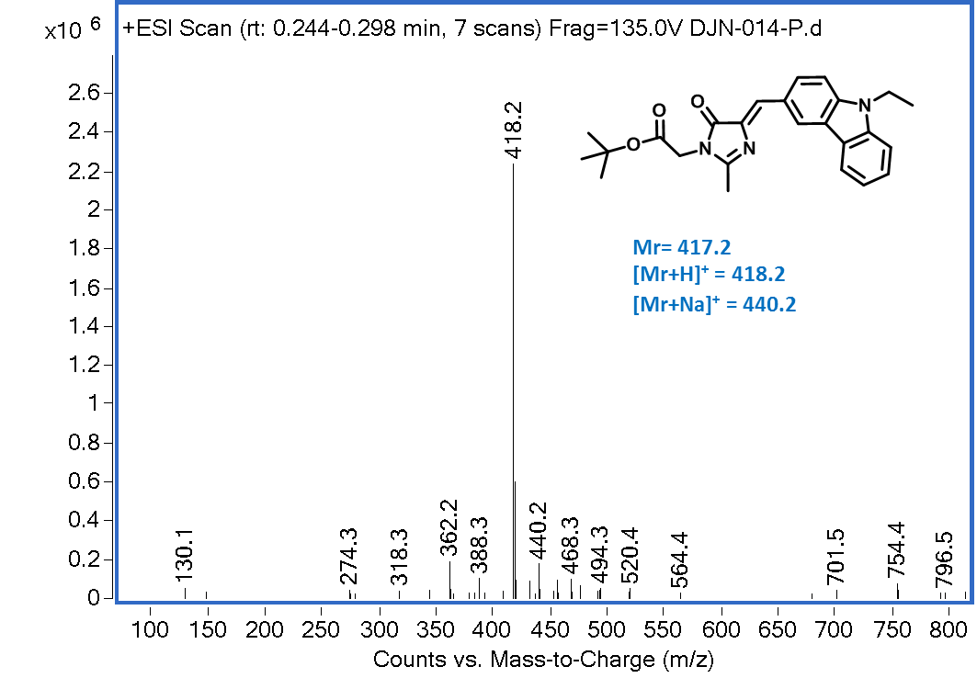
Figure S6. Mass spectrum of Compound 2.

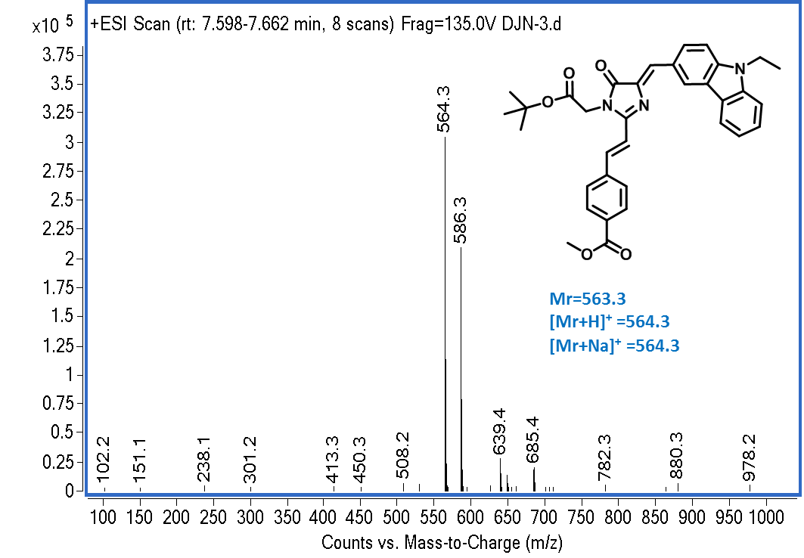
Figure S7. Mass spectrum of CBZ-FP.

- Cluster analysis results and hydrophobic interactions of molecular docking study
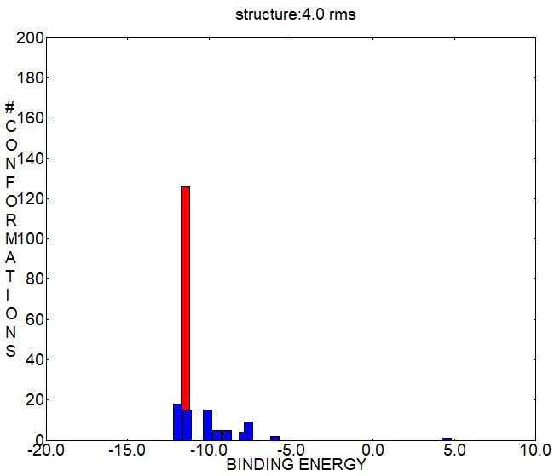
Figure S8. Cluster analysis results of CBZ-FP with CES1 after 200 independent dockings.
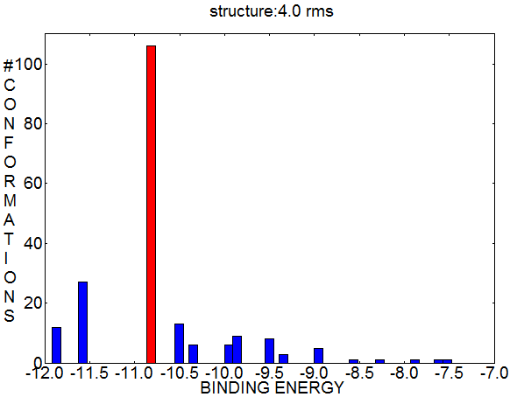
Figure S9. Cluster analysis results of CBZ-FP with CES2 after 200 independent dockings.
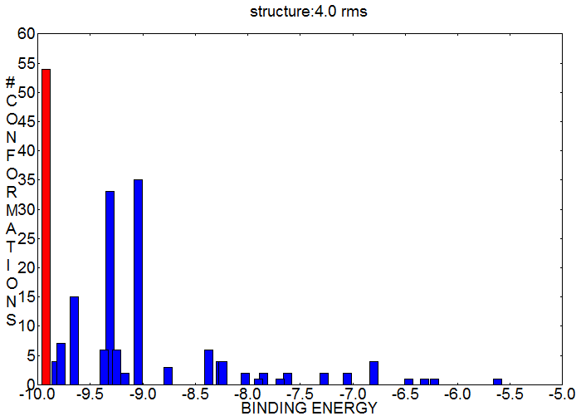
Figure S10. Cluster analysis results of CBZ-FP with Hb after 200 independent dockings.

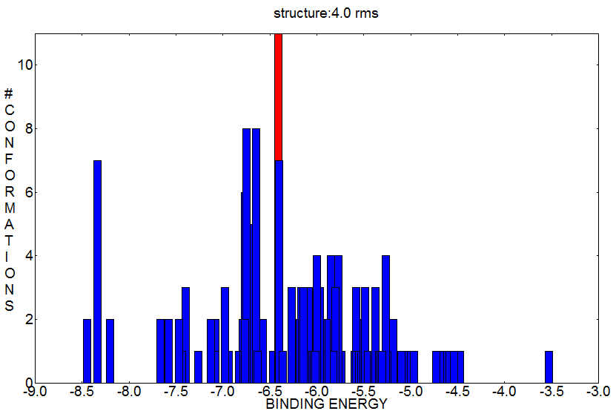
Figure S11. Cluster analysis results of CBZ-FP with BSA after 200 independent dockings.
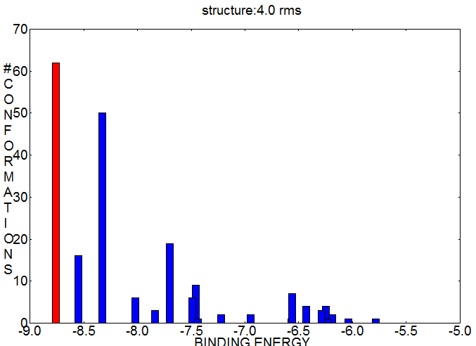
Figure S12. Cluster analysis results of CBZ-FP with HSA after 200 independent dockings.

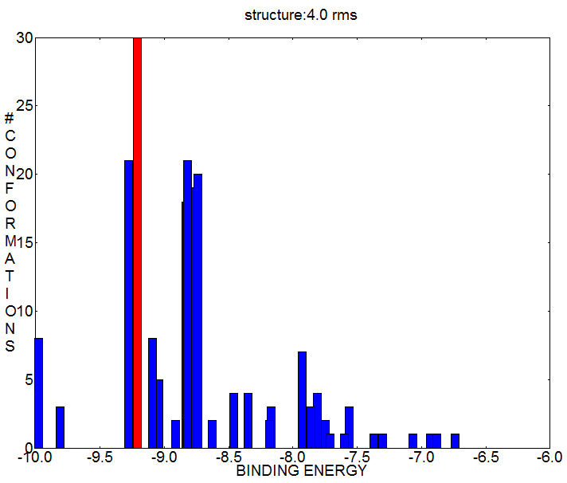
Figure S13. Cluster analysis results of CBZ-FP with BuchE after 200 independent dockings.
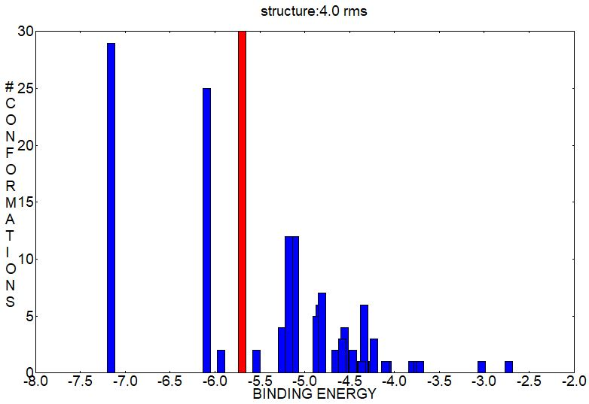
Figure S14. Cluster analysis results of CBZ-FP with Lipase after 200 independent dockings.
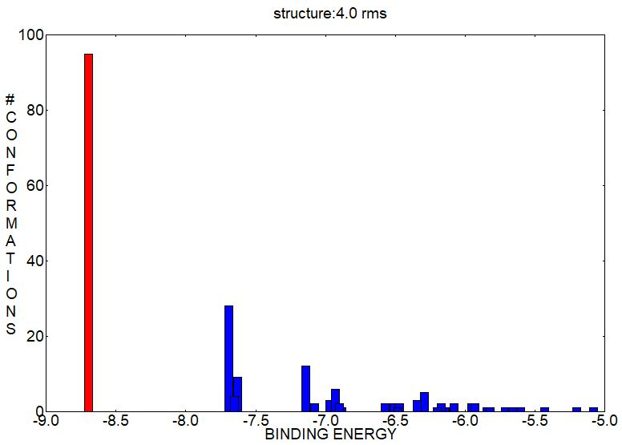
Figure S15. Cluster analysis results of CBZ-FP with Papain after 200 independent dockings.
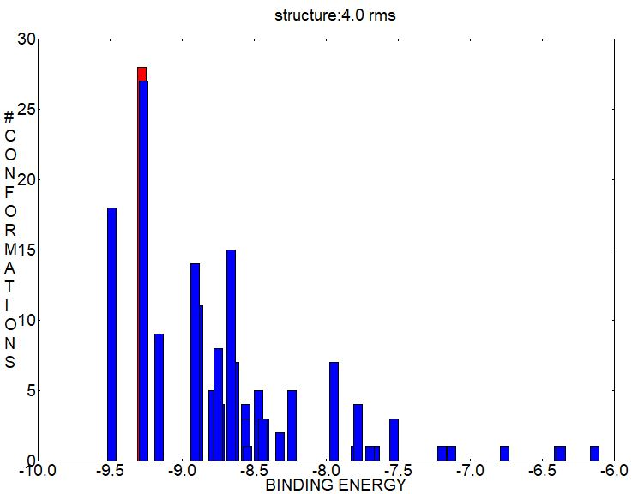
Figure S16. Cluster analysis results of CBZ-FP with Lysozyme after 200 independent dockings.
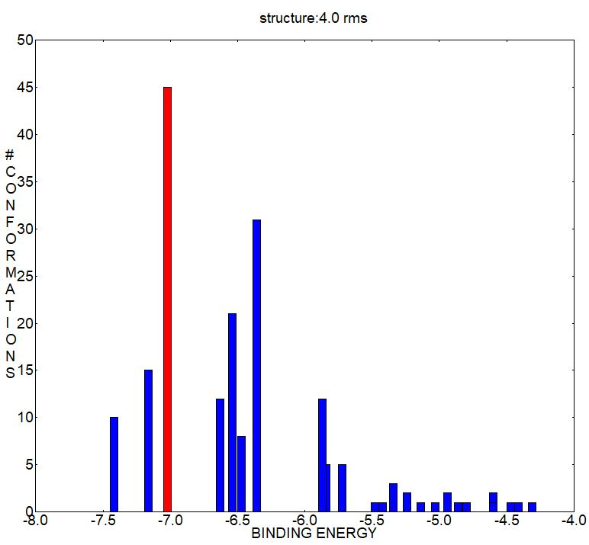
Figure S17. Cluster analysis results of CBZ-FP with Chymotrypsin after 200 independent dockings.
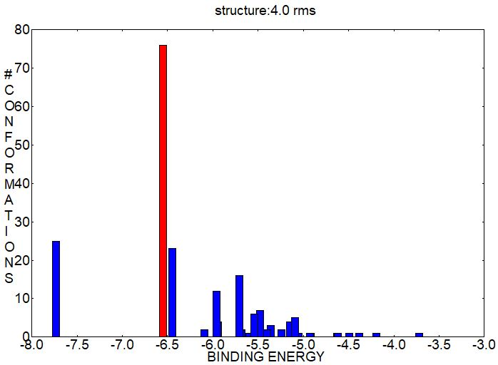
Figure S18. Cluster analysis results of CBZ-FP with Proteinase K after 200 independent dockings.

Table S1. The PDB numbers of each enzyme
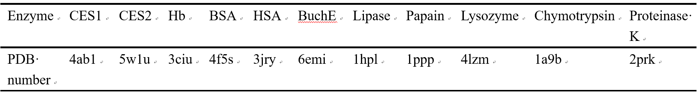

Table S2. The hydrophobic interactions between CBZ-FP and CES1.
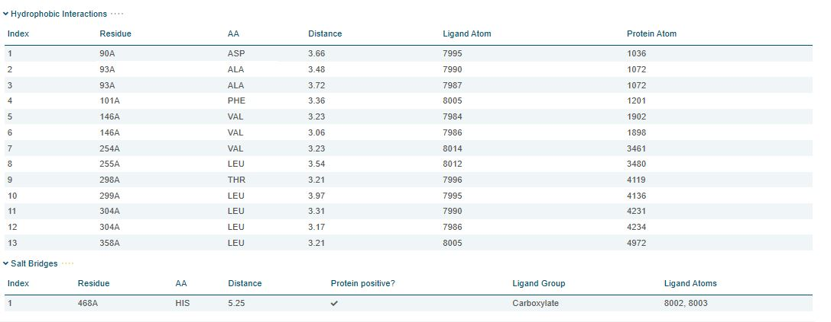

Table S3. The hydrophobic interactions between CBZ-FP and CES2.
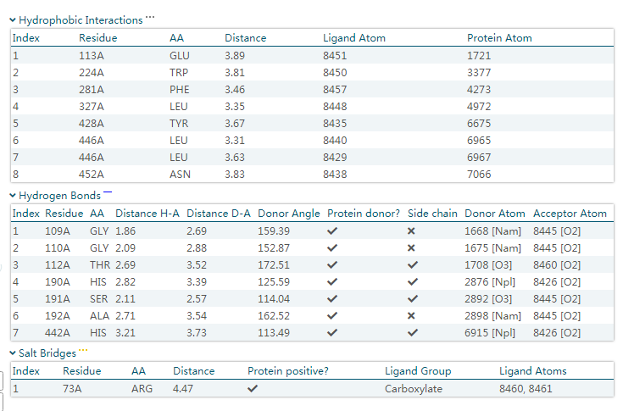

Table S4. The hydrophobic interactions between CBZ-FP and Hb.
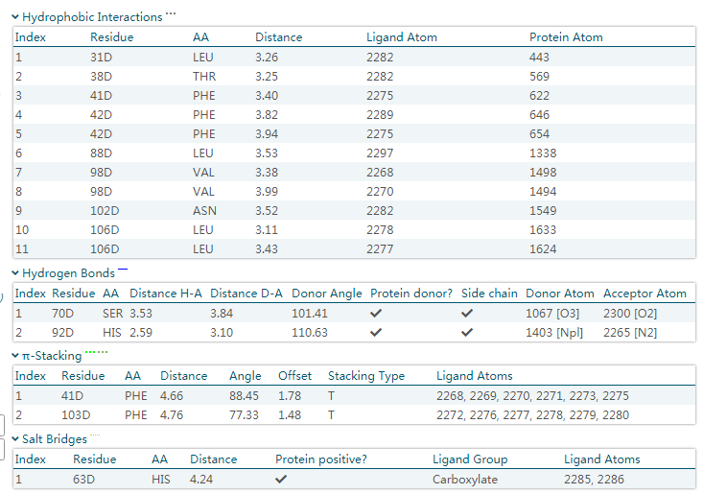
Table S5. The hydrophobic interactions between CBZ-FP and BSA.
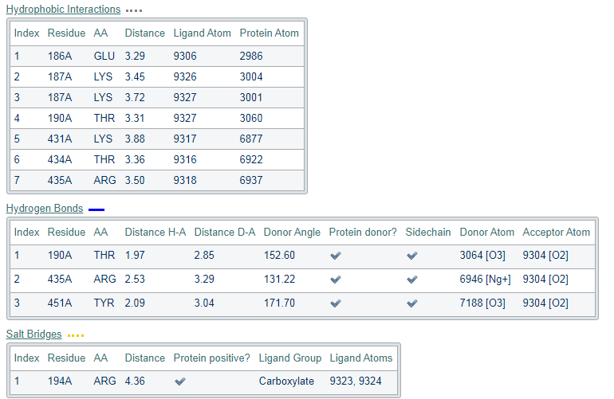

Table S6. The hydrophobic interactions between CBZ-FP and HSA.
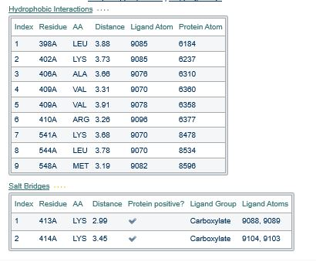
Table S7. The hydrophobic interactions between CBZ-FP and BuchE.
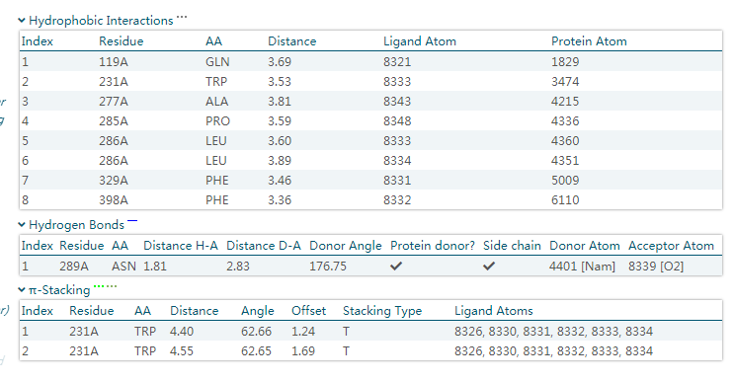

Table S8. The hydrophobic interactions between CBZ-FP and Lipase.
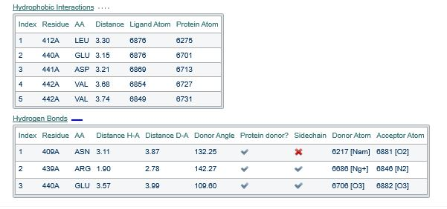

Table S9. The hydrophobic interactions between CBZ-FP and Papain.
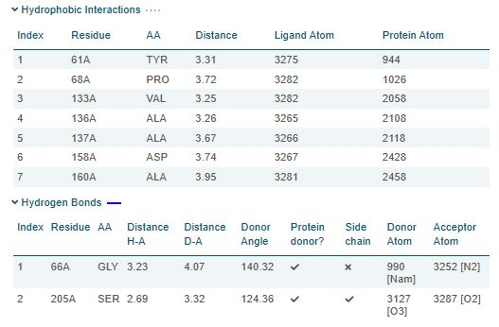

Table S10. The hydrophobic interactions between CBZ-FP and Lysozyme.
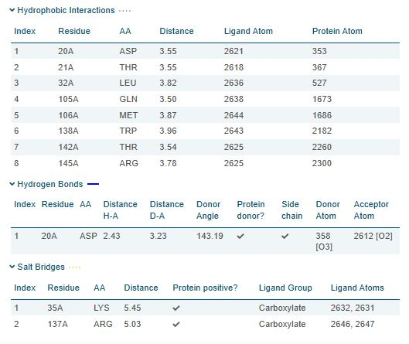
Table S11. The hydrophobic interactions between CBZ-FP and Chymotrypsin.
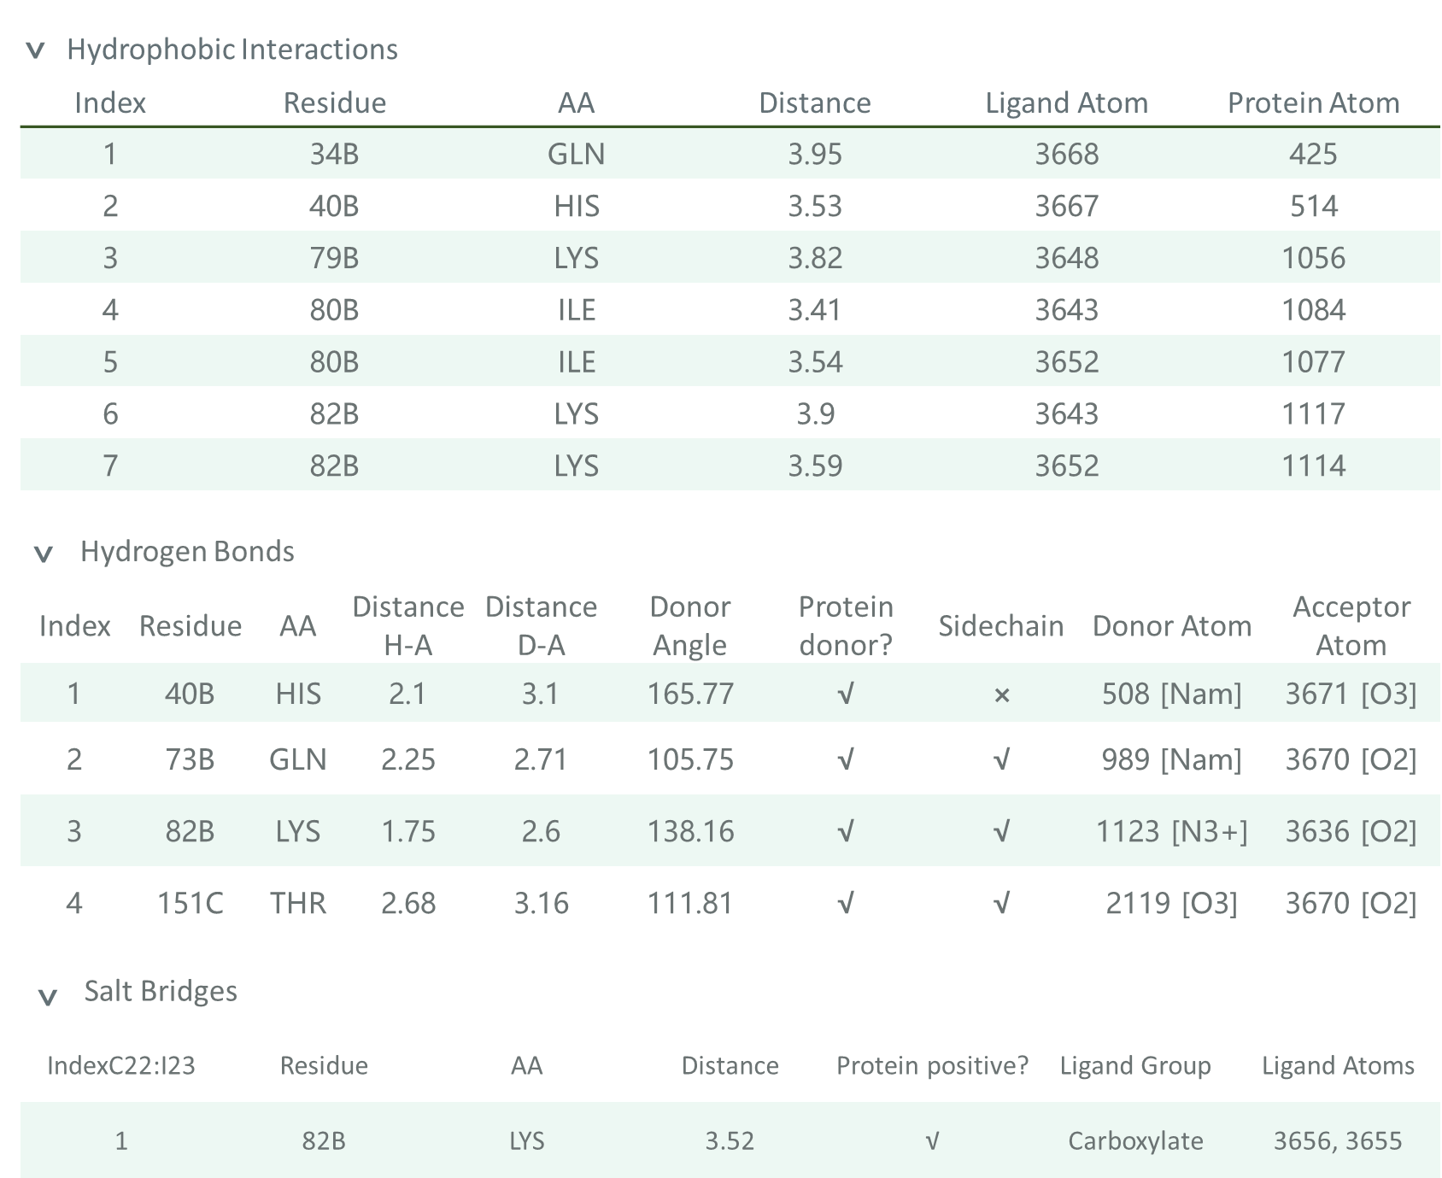

Table S12. The hydrophobic interactions between CBZ-FP and Proteinase K.
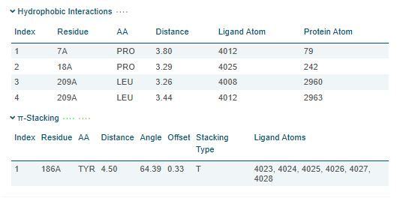
- DTF calculation results
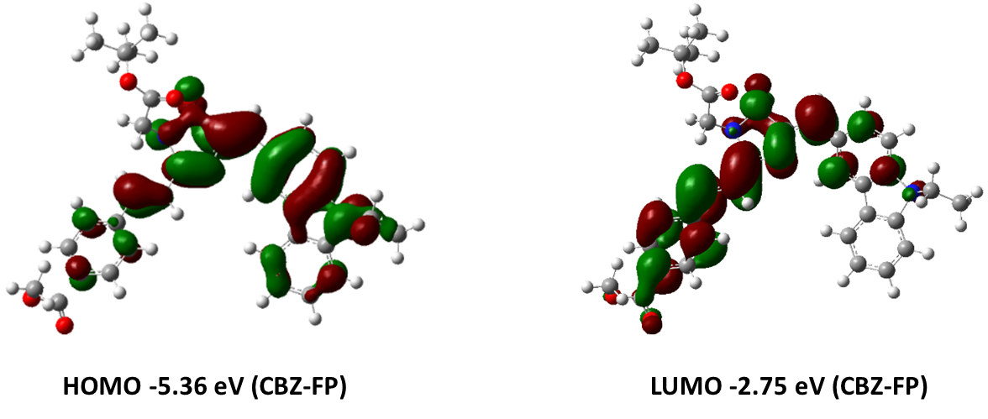
Figure S19. Density functional theory (DFT) calculation of CBZ-FP.
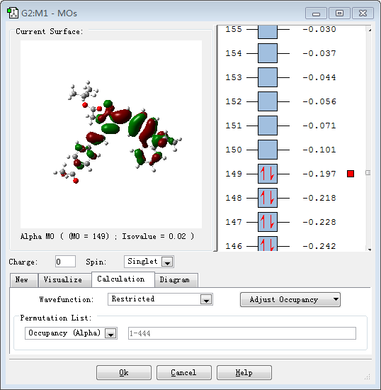
Figure S20. Detailed calculation results of CBZ-FP HOMO orbital.
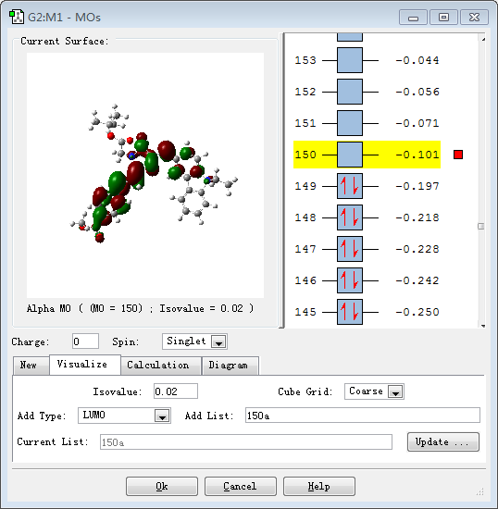
Figure S21. Detailed calculation results of CBZ-FP LUMO orbital.

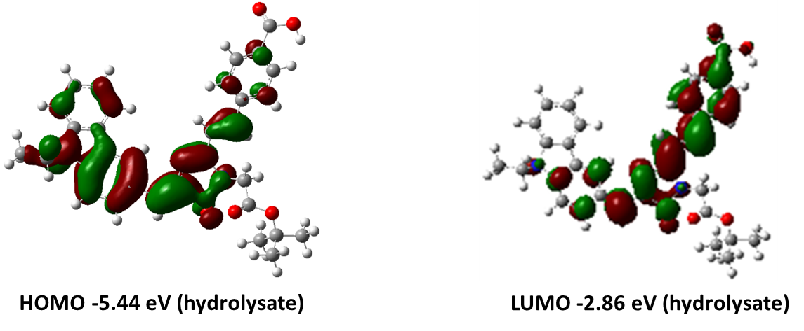
Figure S22. Density functional theory (DFT) calculation of hydrolysates of CBZ-FP.
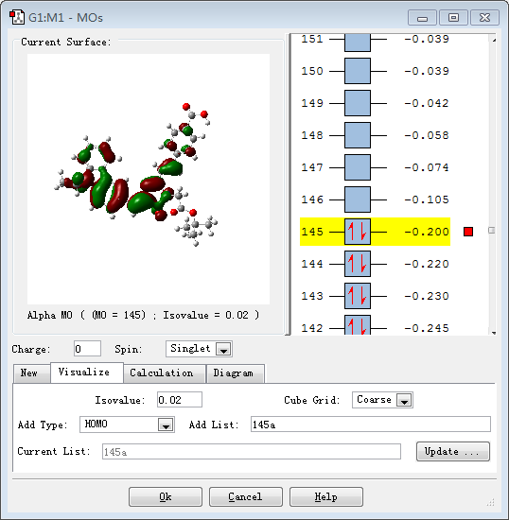
Figure S23. Detailed calculation results of CBZ-FP hydrolysates HOMO orbital.

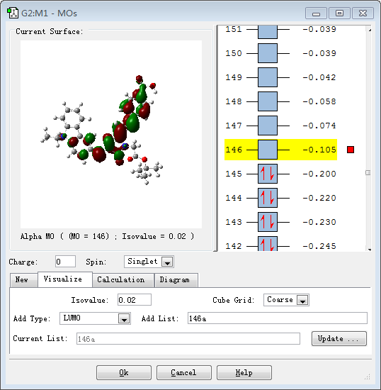
Figure S24. Detailed calculation results of CBZ-FP hydrolysates LUMO orbital.

- LC-MS spectrometry of CBZ-FP hydrolysate
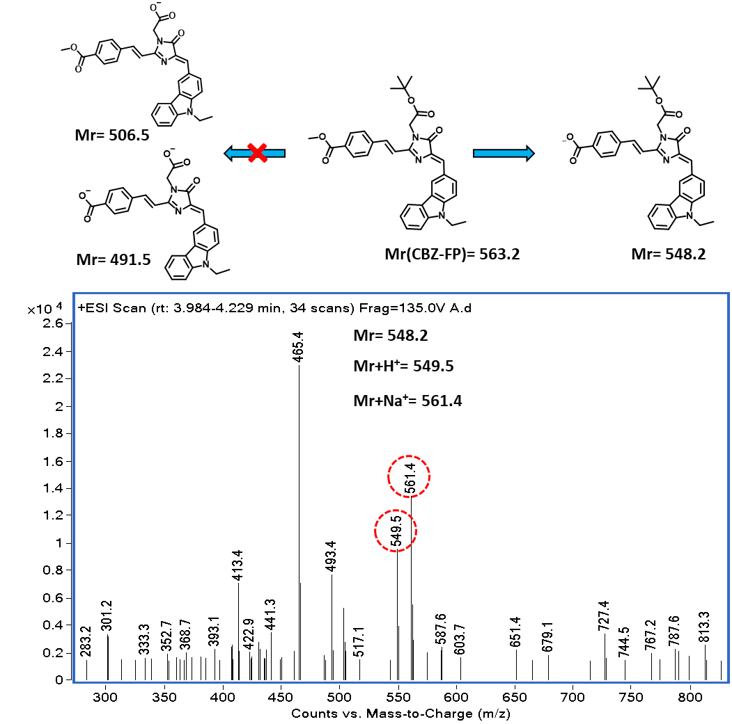
Figure S25. The mass spectrometry of CBZ-FP hydrolysate.

- Absorption and fluorescence properties of CBZ-FP before and after metabolism
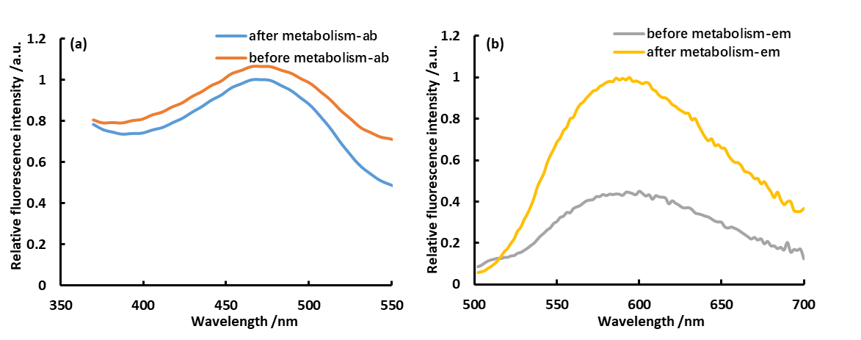
Figure S26. The changes of fluorescence spectrums before and after metabolism.
- The effects of classic CES1 inhibitors on the CBZ-FP
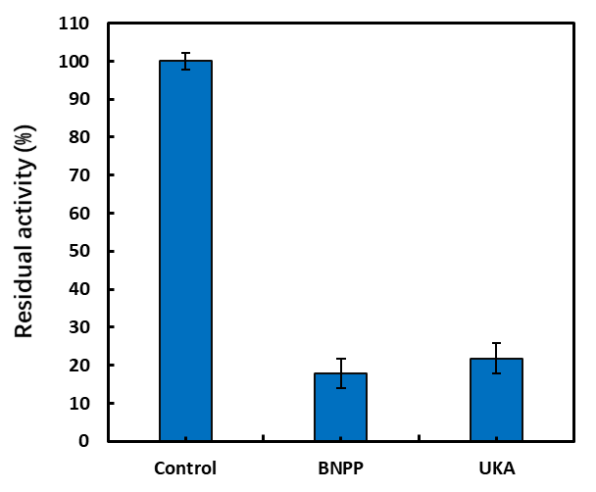
Figure S27. The inhibitory effects on the hydrolysis of CBZ-FP by using hydrolase inhibitors including bis-p-nitrophenyl phosphate (BNPP) and 3-O-(β-carbox-ypropionyl)-ursolic acid (UKA).

- The details of molecular docking study between hydrolyzed CBZ-FP and CES1
Table S13. The hydrophobic interactions between hydrolyzed CBZ-FP and CES1
Hydrophobic Interactions
Index | Residue | Distance | Ligand Atom | Protein Atom
1 | THR 252 | 3.54 | 4019 | 1727
2 | VAL 254 | 3.38 | 4010 | 1740
3 | LYS 257 | 3.17 | 4012 | 1761
4 | LYS 258 | 3.78 | 4004 | 1767
5 | PRO 317 | 3.76 | 4010 | 2204
6 | THR 331 | 3.84 | 4004 | 2304
7 | PRO 332 | 3.90 | 4005 | 2310
8 | VAL 424 | 3.63 | 4032 | 2976
9 | VAL 424 | 3.19 | 4023 | 2975
10 | VAL 428 | 3.42 | 4032 | 3004
11 | VAL 428 | 3.34 | 4027 | 3005
12 | ILE 432 | 3.38 | 4028 | 3034
13 | TRP 547 | 3.55 | 4032 | 3942
14 | PHE 551 | 3.48 | 4022 | 3981
15 | PHE 551 | 3.54 | 4020 | 3983

Table S14. The hydrogen bonds between hydrolyzed CBZ-FP and CES1
Hydrogen Bonds
Index | Residue | Distance H-A | Distance D-A | Donor Angle | Donor Atom | Acceptor Atom
1 | GLN 316 | 2.09 | 2.47 | 101.07 | 4016 | 2197
2 | LEU 318 | 2.34 | 3.16 | 140.73 | 2206 | 4015

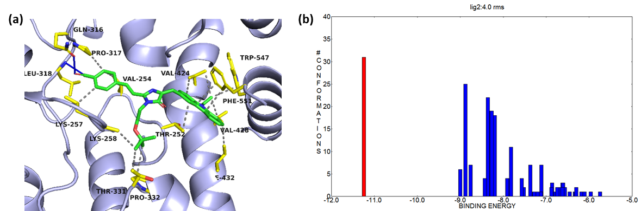

Figure S28. (a) Interaction of hydrolyzed CBZ-FP; (b) Cluster analysis results of hydrolyzed CBZ-FP after 200 independent dockings; Red bar was the binding energy between hydrolyzed CBZ-FP and CES1 under optimal conformational conditions.

- Imaging of cells pretreated with CES1 inhibitors
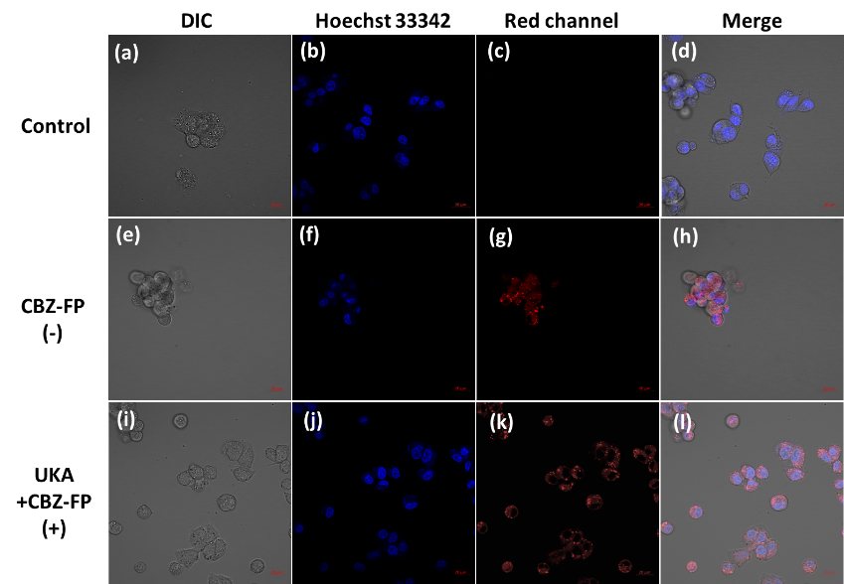
Figure S29. Living cell images of HepG2 cells. (a-c) HepG2 cells were stained by 10 µM Hoechst 33342 for 30 min and imaging under the bright, blue and red channel, respectively; (d) Merge images (a), (b) and (c); (e-g) HepG2 cells were co-stained by 10 µM Hoechst 33342 and 10 µM CBZ-FP for 30 min and imaging under the bright, blue and red channel, respectively; (h) Merge images (e), (f) and (g); (i-k) HepG2 cells were incubated with 5 μM UKA for 10 min firstly, and then co-stained with 10 µM Hoechst 33342 as well as 10 µM CBZ-FP for 30 min, then imaging under the bright, blue and red channel, respectively; (l) Merge images (i), (j) and (k); (m) The average intensity of images in red channel. Scale bar = 30 μm.

- Comparison with reported work
Table S15. Comparison the basic properties with other reported CES1 probes.
Probe | λ_{em}(nm) ^{[a]} | λ_{ex}(nm) ^{[b]} | LOD ^{[c]} | Bioimaging model ^{[d]}
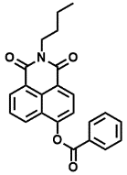  Sens. Actuators, B 2014, 205, 151-157 ^{[1]} | 564/452 | 342 | 1 μg/mL | HeLa
Biosensors and Bioelectronics, 2014, 57, 30-35 ^{[2]} | 488/368 | 304 | 0.25-4 μg/mL | HepG-2
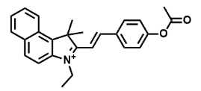  Chem. B 2019, 7, 2989-2996 ^{[3]} | 575 | 520 | 1.2×10⁻⁴ U/mL | HepG-2 / Tissues from the liver of 45-day-old Kunming mice
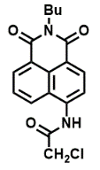  ACS Appl. Mater. Interfaces 2015, 7, 28474-28481 ^{[4]} | 542/452 | 354 | 12 ng/mL | HepG-2/ a mouse liver slice
RSC ADV. 2016, 6, 4302-4309 ^{[5]} | / | 244 | 100 ng/mL | /
CBZ-FP | 589 | 473 | 27.8 ng/mL | HepG-2
[a] the emission wavelength of probes; [b] the excitation wavelength of probes; [c] the limit of detection of probes; [d] the bioimaging models of probes.
- The activity and sources of all enzymes
Table S16. The activity and sources of all enzymes
Enzyme | Activity | Source
CES1 | / | Human
CES2 | / | Human
Hb | / | Cow
Trypsin | 250 USPu/mg | Cow
lywallzyme | 200 u/mg | Arthrobacter luteus
Snailase | Efficiency of fragmentation 90% | Snail
Chymotrypsin | 1500 u/mg | Pig
HSA | / | Human plasma
Lipase | 30000 u/g | Pig
Papain | 800 u/mg | Carieapapaya
BAS | / | Cow
lysozyme | 20000 u/mg | egg white
BuCHE | 10 u/mg | Equinum serum
AchE | 200 u/g | The head of a fly
Proteinase K | 30 u/mg | Tritirachium album

Reference:
[1] Liu Z-M, Feng L, Hou J, Lv X, Ning J, Ge G-B, et al. A ratiometric fluorescent sensor for highly selective detection of human carboxylesterase 2 and its application in living cells. Sensors and Actuators B: Chemical. 2014;205:151-7.
[2] Liu ZM, Feng L, Ge GB, Lv X, Hou J, Cao YF, et al. A highly selective ratiometric fluorescent probe for in vitro monitoring and cellular imaging of human carboxylesterase 1. Biosens Bioelectron. 2014;57:30-5.
[3] Zhou H, Tang J, Zhang J, Chen B, Kan J, Zhang W, et al. A red lysosome-targeted fluorescent probe for carboxylesterase detection and bioimaging. Journal of Materials Chemistry B. 2019;7(18):2989-96.
[4] Jin Q, Feng L, Wang DD, Dai ZR, Wang P, Zou LW, et al. A Two-Photon Ratiometric Fluorescent Probe for Imaging Carboxylesterase 2 in Living Cells and Tissues. ACS Appl Mater Interfaces. 2015;7(51):28474-81.
[5] Lv X, Wang D-D, Feng L, Wang P, Zou L-W, Hao D-C, et al. A highly selective marker reaction for measuring the activity of human carboxylesterase 1 in complex biological samples. RSC Advances. 2016;6(6):4302-9.

