Sean Richardson

Lab 3 Report

For this lab I based the two scripts off of some of the programs seen on the angr-doc/examples pages. Both of the scripts are very similar and follow a similar pattern to get the string that is desired.

Program 1:

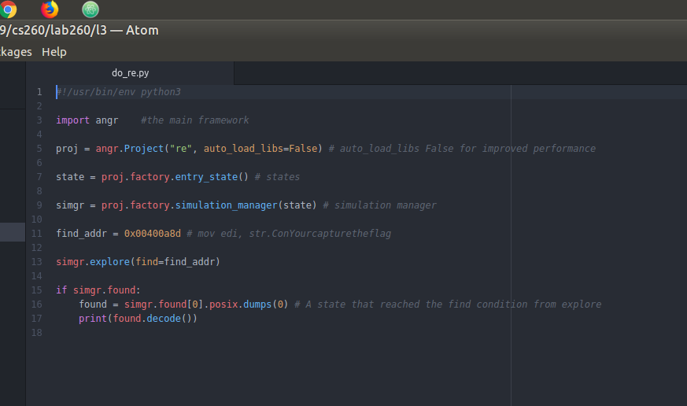
The first step is to import angr and load the binary into the angr project. By turning off auto_load_libs this should make the execution faster.

proj = angr.Project("re", auto_load_libs=False)

the next step is to create the entry state and simulation manager.

state = proj.factory.entry_state() # states
simgr = proj.factory.simulation_manager(state) # simulation manager

This is what is used to represent the state of the program as it is executed.

The next step is to find the target address to direct the execution towards. I did this by analyzing the disassembly with radare2 to find the desired location point.

The desired location in this case is 0x00400a8d where the string is loaded into edi. This is the location to target the angr script to try and get to.

simgr.explore(find=find_addr)

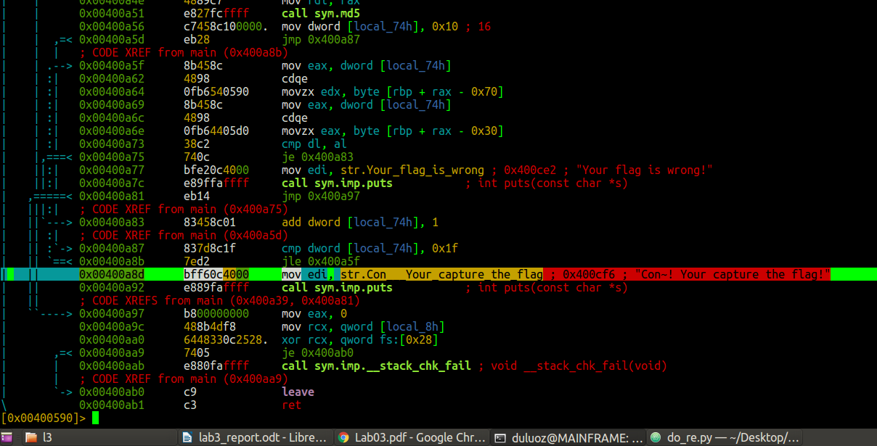

The script should at this point be able to explore and reach the target location if the find_addr.

Next if the address is reached found should be true so at this point the flag can be printed.

if simgr.found:
found = simgr.found[0].posix.dumps(0) # A state that reached the find condition from explore
print(found.decode())

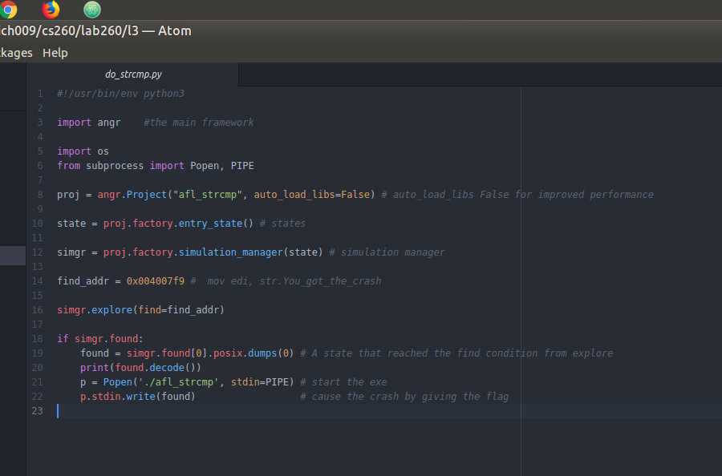
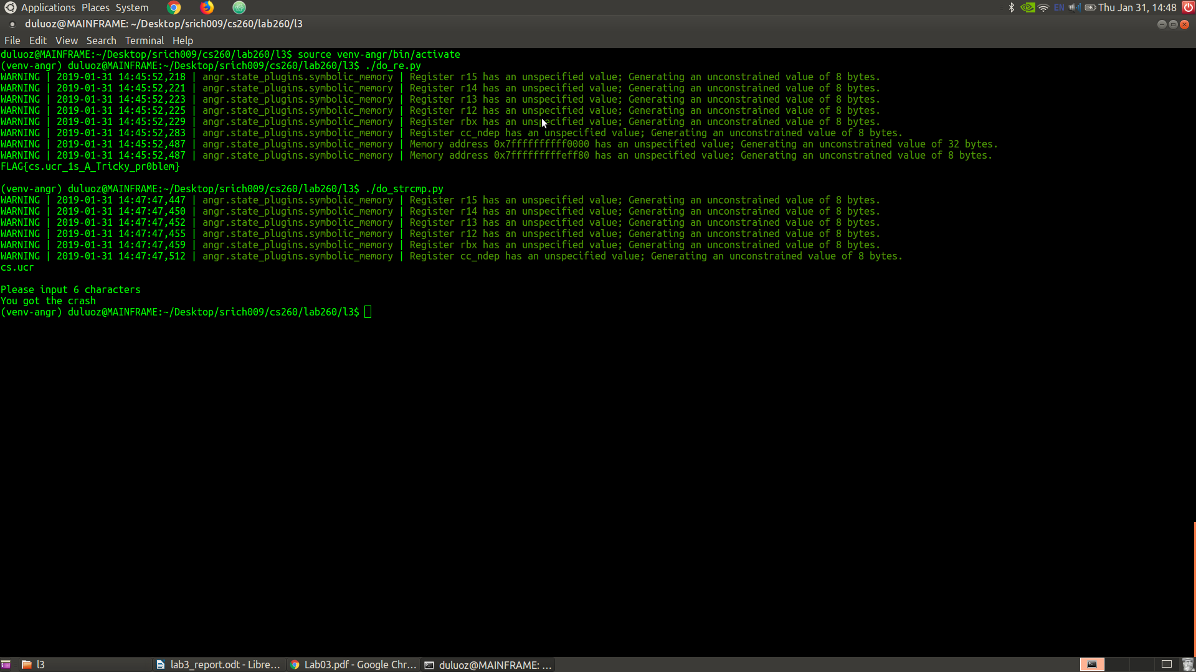
Running script on the re executable produces the flag "FLAG{cs.ucr_1s_A_Tricky_pr0blem}"

Program2:

The second script is similar to the first but the program will launch a new process when the flag is
discovered and pass that as input to the new process. This will trigger the crash.

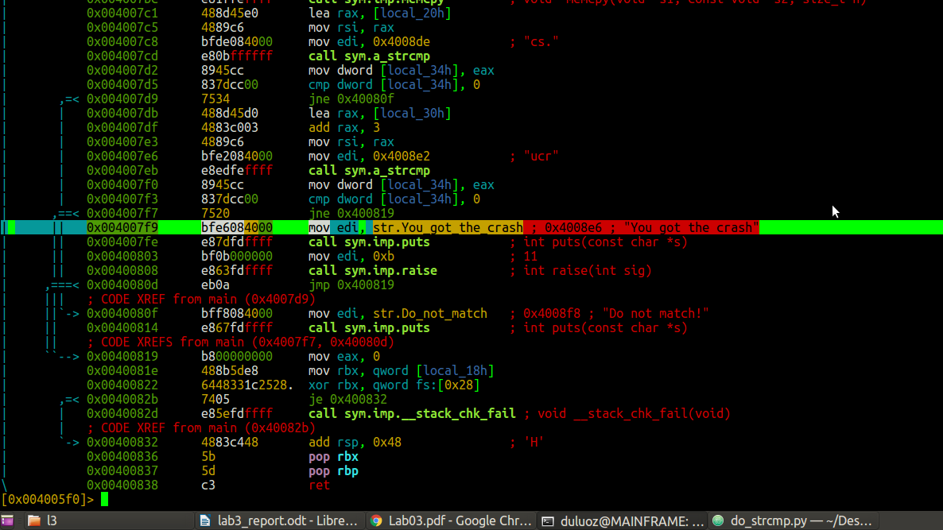

The desired location in this case is 0x004007f9 where the string is loaded into edi. This is the location to target the angr script to try and get to.

Once angr gets to this address it will have the been able to generate the flag “cs.ucr” . After that it will create a new process using Popen and pipe the flag through standard input.

The afl_strcmp program will read in the flag from standard input and it will then crash after printing out “You got the crash”

Running the angr script will automatically generate the crash below:

