Sean Richardson
Lab 1 Report

Part 1: Code Inject

Objective:

Construct an exploit input that can inject a shell code to be executed in the vulnerable program.
The shell code is appended to the end of the template. This shell code will run “ps” program to print the running processes. The start address of the shell code is be used to overflow the return address.

Steps:

Before starting ASLR must be disabled so the program does not see a randomized address layout.

While the program is loaded in gdb set a break point at IsPasswordOkay then run until the break and print Password address and examine registers

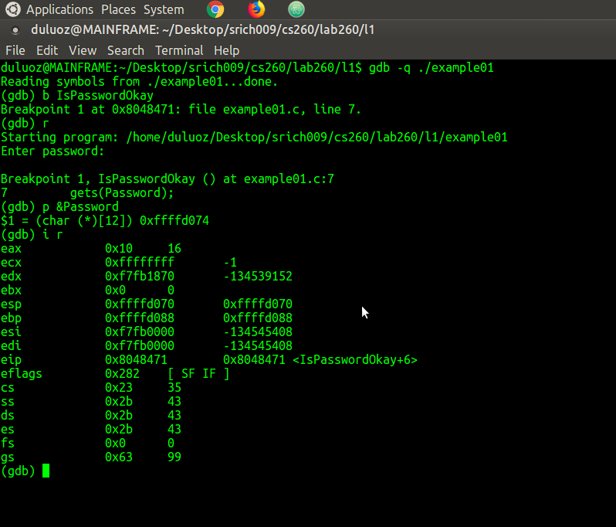

&Password = (char (*)[12]) 0xffffd094

the address of the array &Password is at ebp-0x14

trying to run with the original codeinjection.bin shell code fails
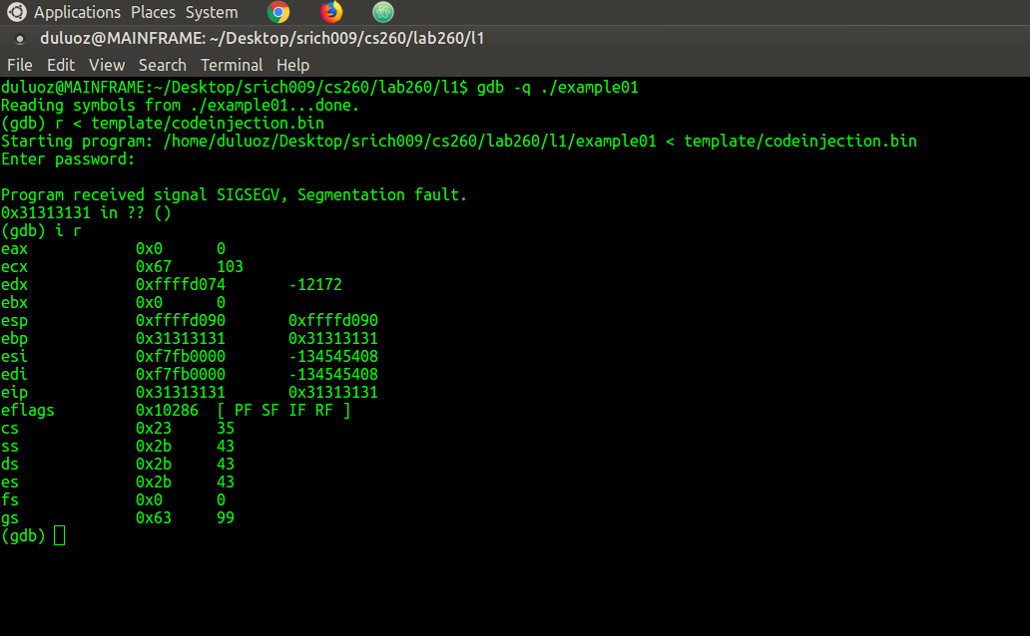

in the original codeinjection.bin shell code, the 2 groups of "31 31 31 31" affects the ebp and eip registers.

first 4 bytes changes ebp
last 4 bytes changes eip

have to write the addresses backwards so 0xffffd094 becomes 94 d0 ff ff

the beginning bytes before the sequence of 8 bytes of "31" are the offset.
the group of "90" bytes after the "31"s forms the NOP sled since the hex 90 is a no-operation code.
the actual part to launch the shell and execute ps is at the bottom of the NOP sled.

Password array is size 12, the part to change ebp will start at Password[20], and the part to change eip will start at Password[24]
The NOP sled then begins at Password[28], once execution gets there it will cycle over the NOPs and eventually execute the PS command

&Password = 0xffffd094
&Password[20] = 0xffffd0a8
&Password[24] = 0xffffd0ac
&Password[28] = 0xffffd0b0

the goal is to locate the start of the NOP sled and change the eip to go there
so the last 4 bytes in the group of "31"s is changed to B0 D0 FF FF

Modified shell code:

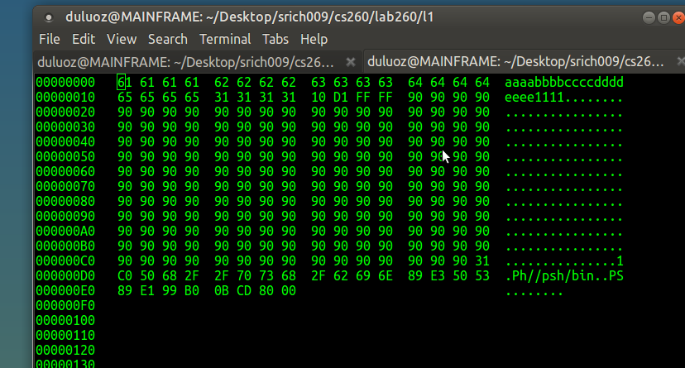

Note:

the modified shell code has to take into account that the difference of the location on the stack is affected by the environment variables. The exploit running in gdb will have a slightly different offset than when running out of the debugger. The location in gdb of 0xFFFFD0B0 will be 0xFFFFD110
the shell code runs outside of the debugger because of the modified location now.

now when executing the modified shell code it is successful :

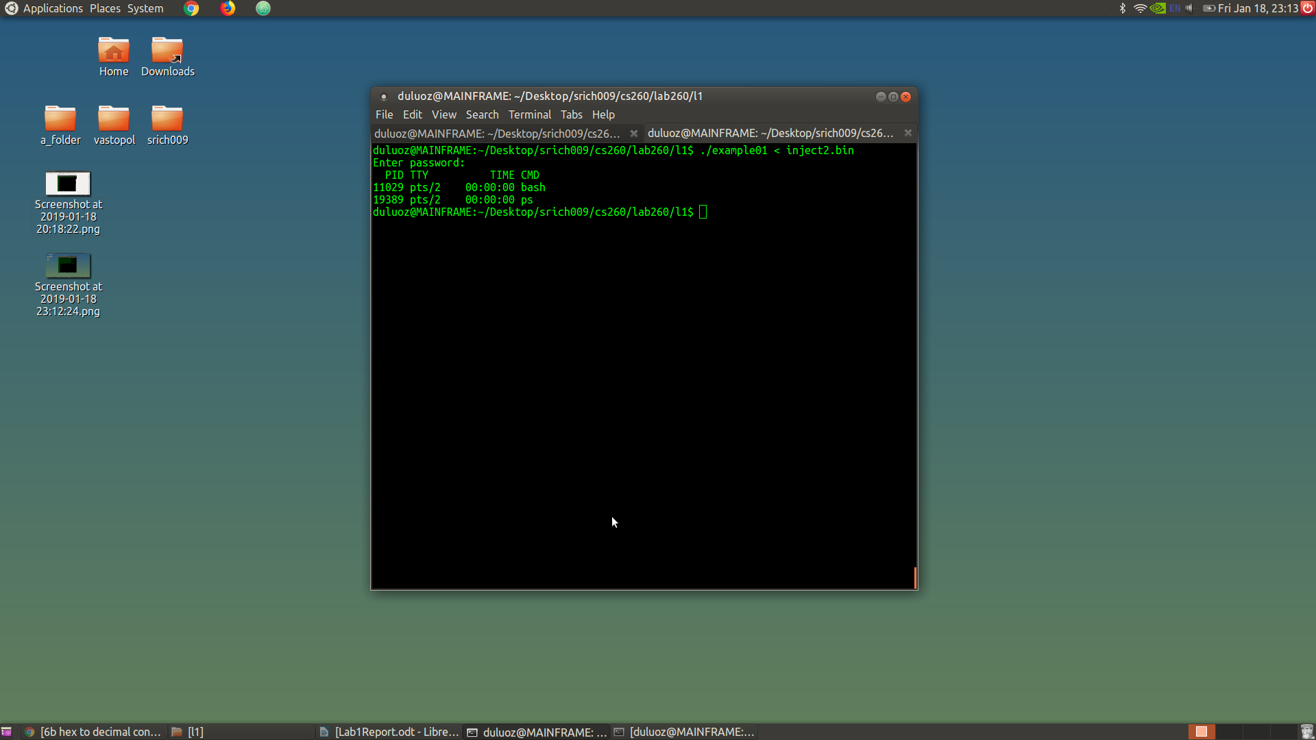

Part 2: Return to libc

Objective:
Construct an exploit input that takes advantage of the existing “system” library call in libc to achieve the same goal as in the first task to run “ps” command, without injecting any code into the stack of the vulnerable program. This will redirect the program to jump into the “system” function call.

Steps:

(gdb) display &system
&system = (<text variable, no debug info> *) 0xf7e3a940 <system>

trying to run with the original returntolibc.bin shell code fails
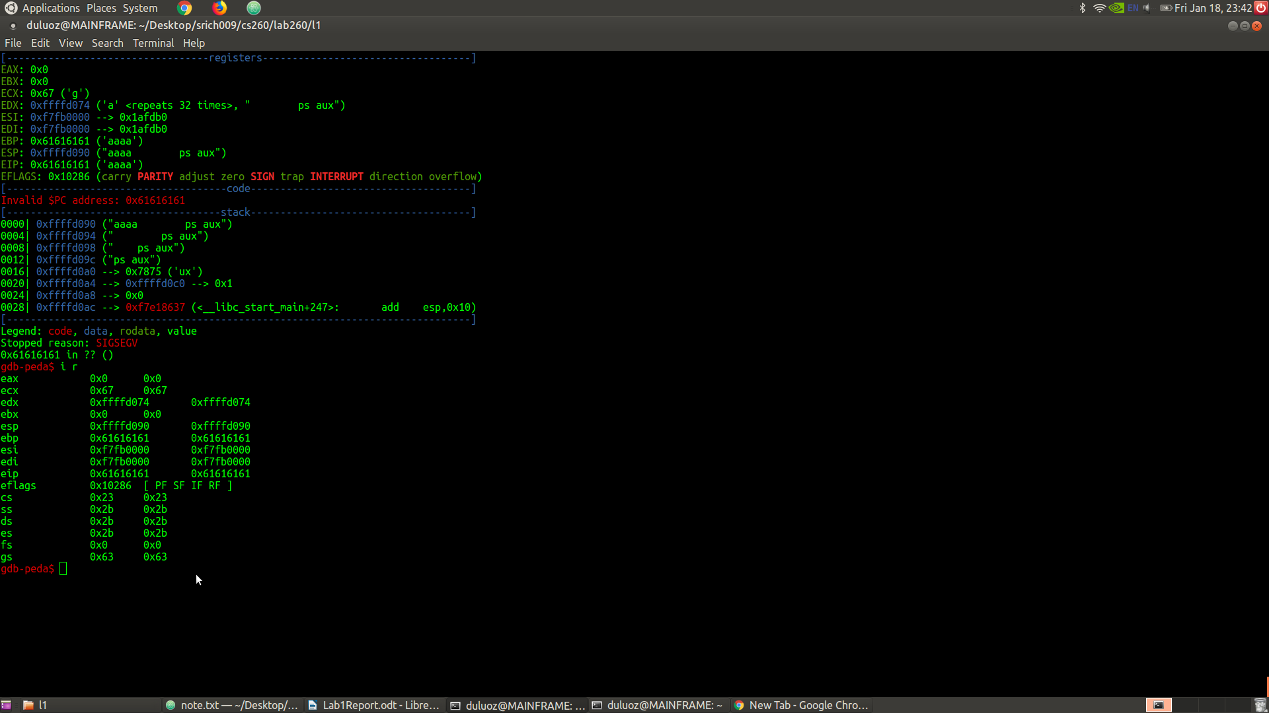

in the original returntolibc.bin shell code, there are 8 groups of "61 61 61 61" before the part for PS.

using the original shell code, it looks like some of the groups affect ebp and eip like in part 1

the 6th group of bytes changes ebp
the 7th group of bytes changes eip

&system = 0xf7e3a940
&Password = 0xffffd094
&Password[28] = 0xffffd0b0 "&system"
&Password[40] = 0xffffd09c "ps aux"

address of system goes at position 7 in the shell code

structure of shell code:

offset + &system + dummy return address + &command

aaaaaaaaaaaaaaaaaaaaaaaa + 40 a9 e3 f7 + aaaa + 9c d0 ff ff + aaaa + ps aux

modified shellcode:

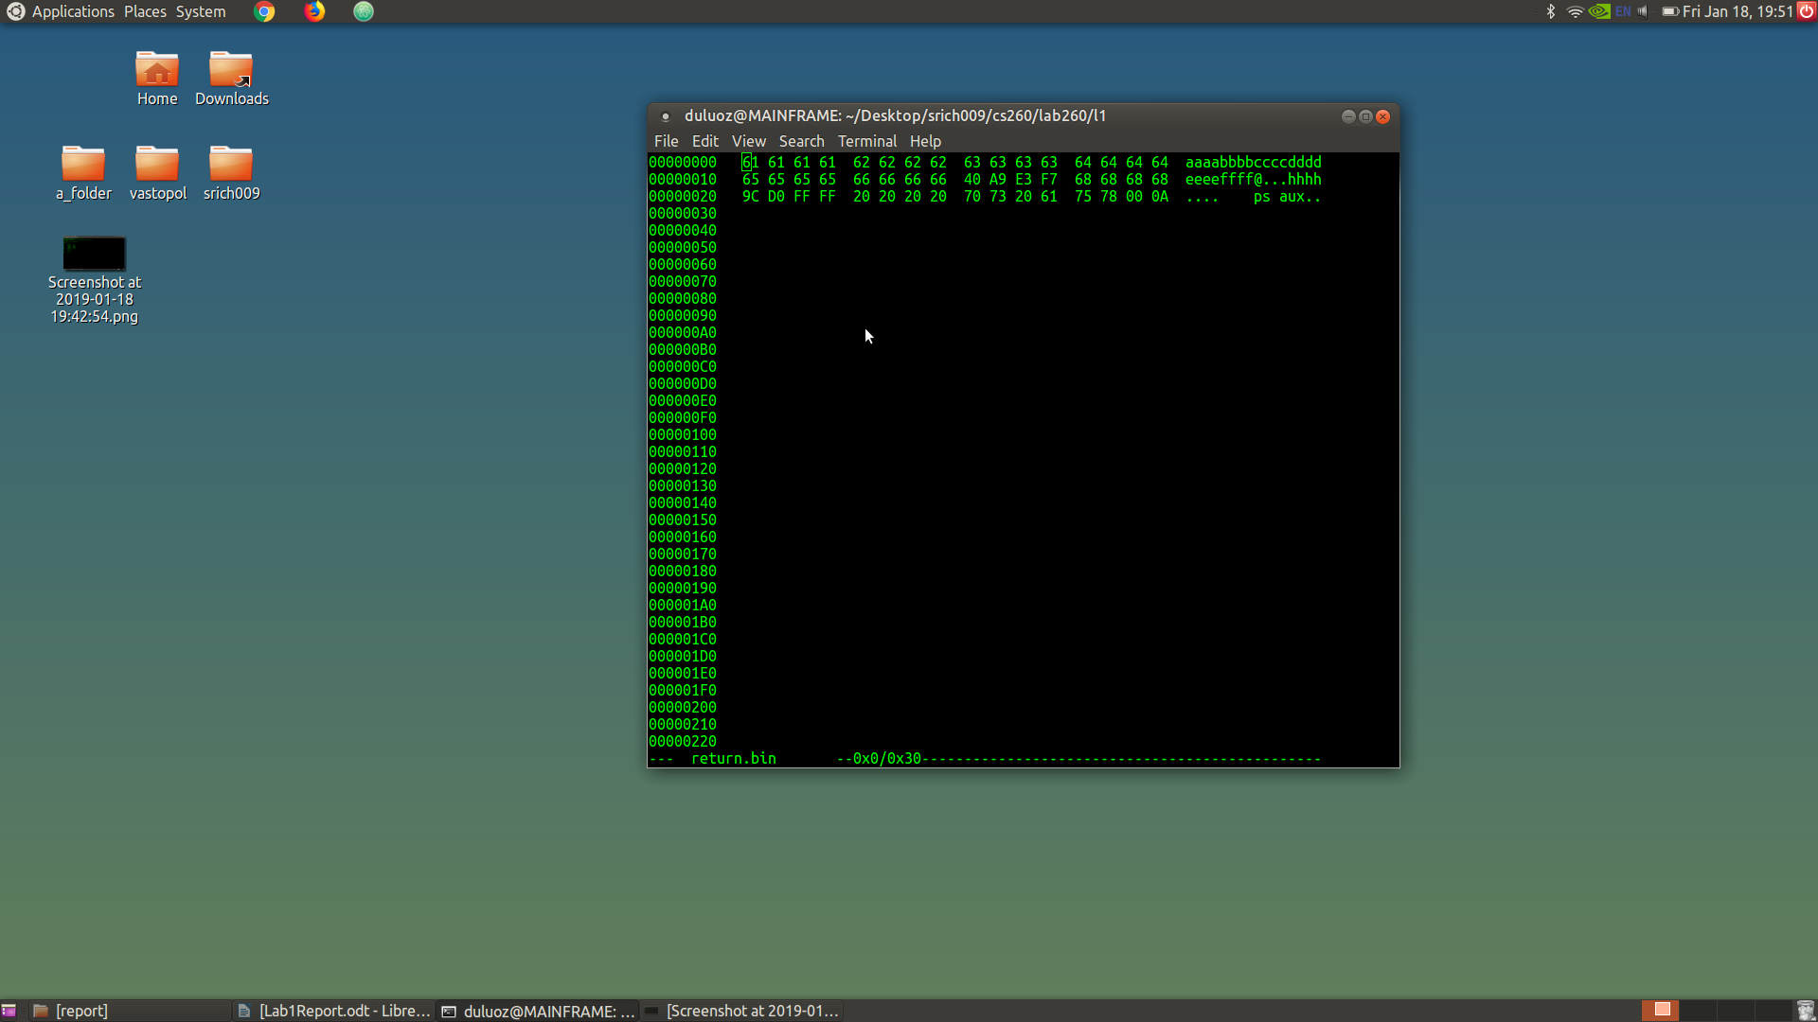
running modified shell code successfully:
