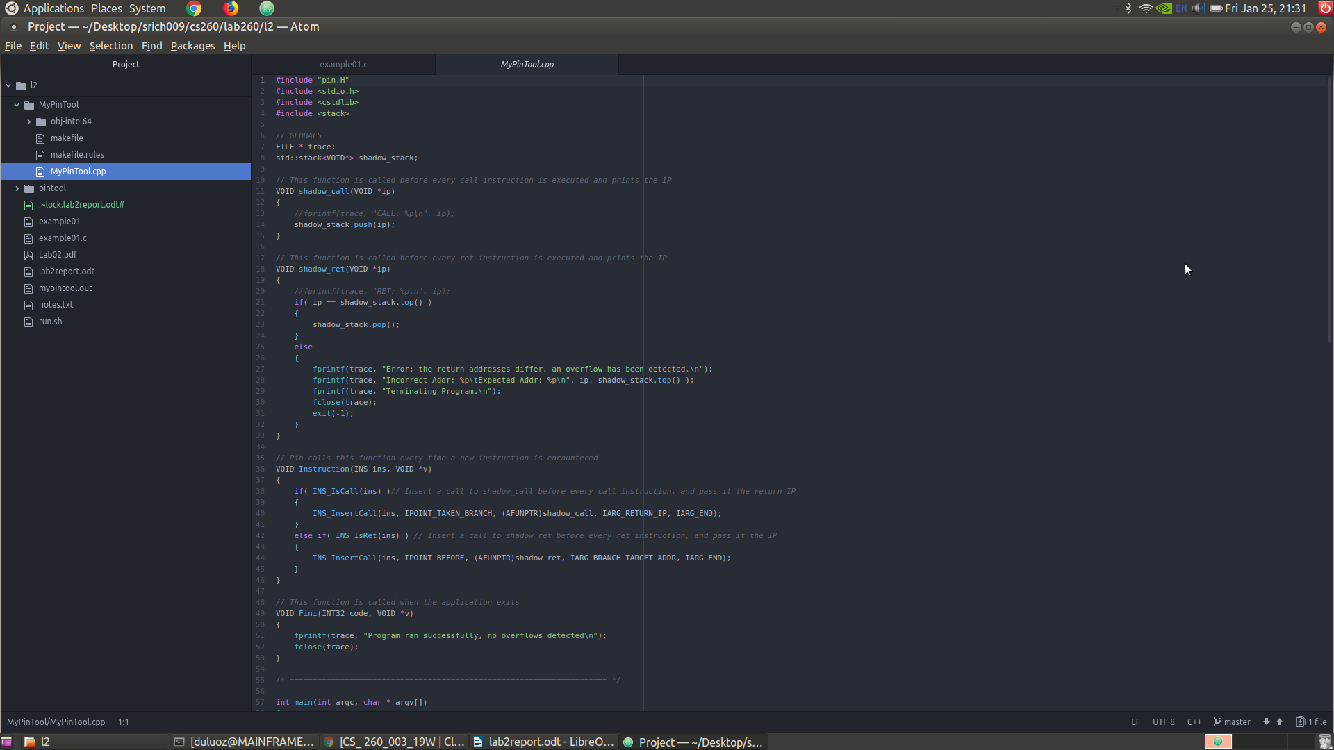
Sean Richardson

Lab 02

SOURCE CODE FOR PIN TOOL:
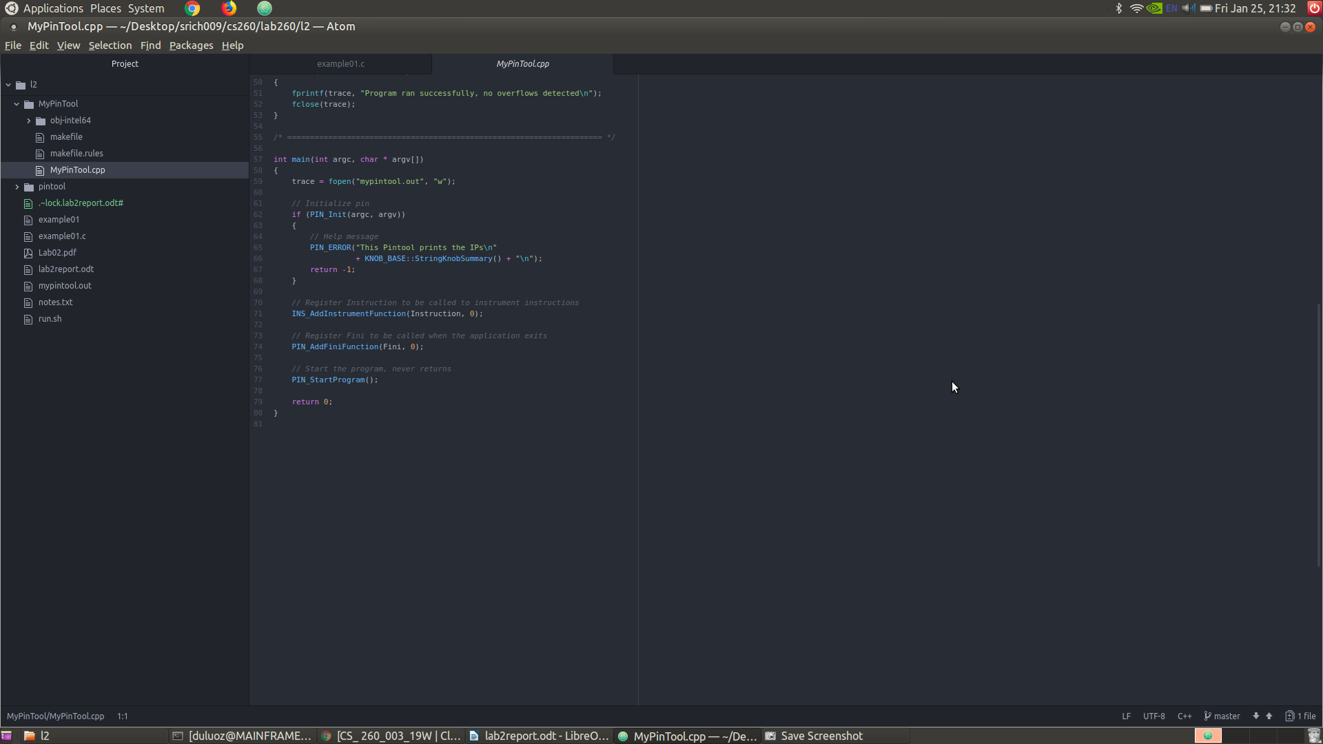

The shadow stack is implemented using the stack class available in the C++ Standard Template Library.
It holds the addresses saved which represent where the instruction pointer should be set to after the function calls return.

std::stack<VOID*> shadow_stack;

Two new functions shadow_call and shadow_ret were added to the tool, and the original Instruction function’s logic was modified to call these two functions in the appropriate situations. The tow functions act in tandem to access and modify the shadow stack which exists globally.

VOID shadow_call(VOID *ip)

VOID shadow_ret(VOID *ip)

NOTES:

I based my pintool code off of the itrace example in the manual examples.

The general algorithm for checking the instruction pointer works like described in the lab manual:
1. For each “call” instruction, identify the return address of the next instruction after the call instruction and push it onto the shadow stack;
2. For each “ret” instruction, identify the return target and see if it matches with the value on the top of the shadow stack. If so, pop up the value from the shadow stack, else report an attack.

This example does use INS_AddInstrumentFunction to instrument an instruction at a time.
The granularity needs to be at the instruction level since the semantics for what happens differs based off of the opcode type.

The Instruction() function, checks each instruction to identify call and return instructions using INS_IsCall and INS_ IsRet to determine if the specified instruction is a call or return. Depending on whether the current instruction is a call or return then the appropriate instrumentation is inserted to either push an address to the shadow stack, or to check the top address on the shadow stack.

Call instructions need to use the IPOINT_TAKEN_BRANCH since this call instruction falls under the category of the control flow branching. It is essentially an unconditional branch to the location of the function which is being called. In this case it must happen at the point taken and it will save the return instruction pointer value.

Return instructions need to use the IPOINT_BEFORE since we are checking to see if the return address has been modified or corrupted before actually retoring the value of the instruction pointer.

for a call instruction: IPOINT_TAKEN_BRANCH and IARG_RETURN_IP
for return instruction: IPOINT_BEFORE and IARG_INST_PTR

The addresses to compare technically have type of ADDRINT = unsigned long int according to documentation. However in this case they are received and treated as VOID pointers when stored to the stack and compared.

name: IARG_RETURN_IP
Type: ADDRINT
Return address for function call, valid only at the function entry point.

name: IARG_BRANCH_TARGET_ADDR
Type: ADDRINT
Target address of this branch instruction, only valid if INS_IsBranchOrCall is true.

EXAMPLE RUN THROUGH:

This is the output of the test harness being run on known good programs (ls and ps) as well as the vulnerable example code

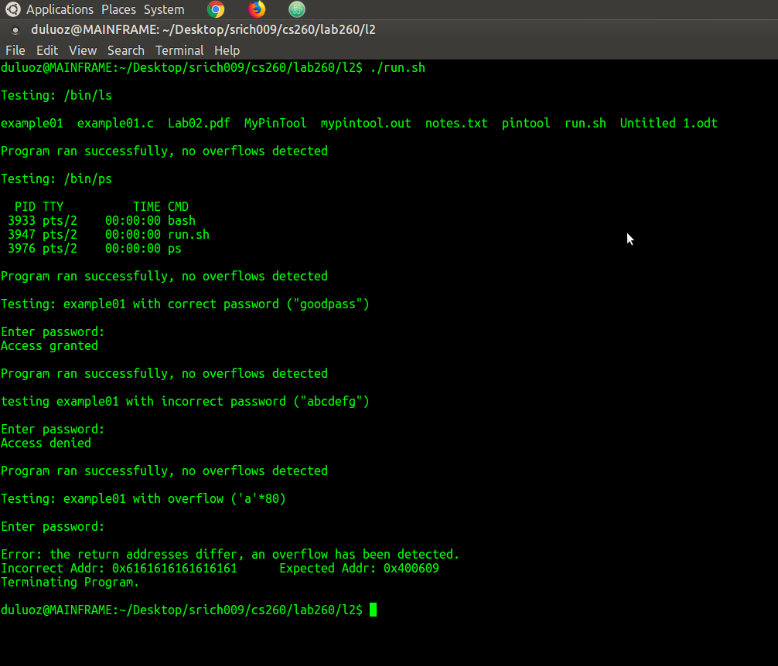

SOURCE CODE FOR TEST SCRIPT

Since the my pintool is being built outside of the main pin folder I constructed a 2 part shell script for building and testing it. It will first compile the vulnerable executable if it does not yet exist, then build the pintool if any updates have been made to the source code. The make needs to have its root re-targeted at the main pin folder to build correctly.
(make PIN_ROOT=../pintool bj-intel64/MyPinTool.so)

