Advanced Software Engineering

Tutorial 5

Team 1_2

**Student 1**

Name: Srichakradhar Reddy Nagireddy

Class ID: 32

**Student 2**

Name: Sathwik Banginimatam

Class ID: 5

**Hosting a static website on AWS S3**

## Login to the AWS console

[https://aws.amazon.com/console/](https://dev.to/samueldaviddelacruz/AWS Management Console)

Open S3

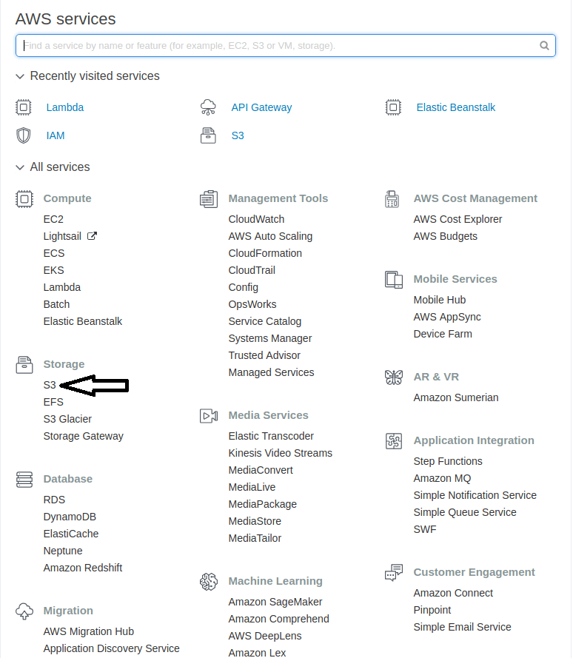

## Create a bucket

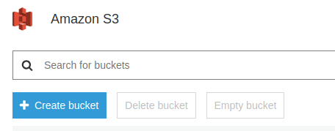

with following details...

**Name**: sce-ase

**Other settings**: default

and provide public access to the bucket.

Open the newly created bucket

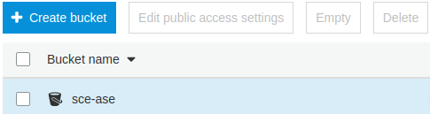

Upload the static website files to the bucket by drag and drop or choosing files and folders



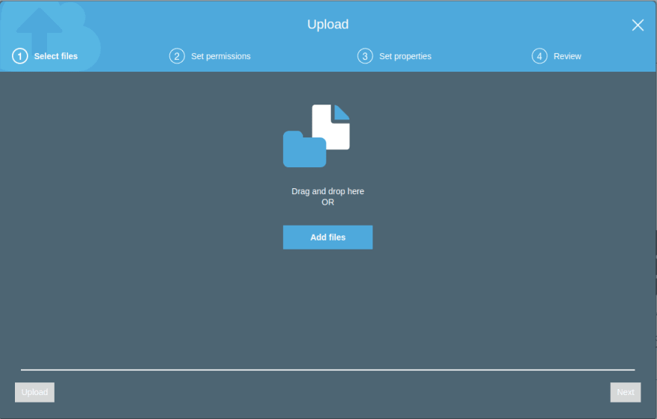

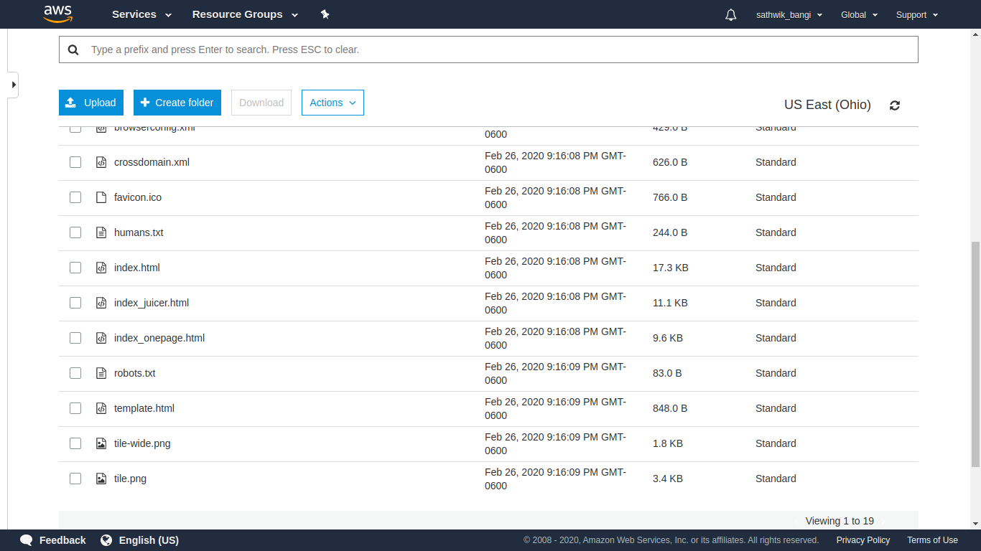

Got to **Bucket Policy** in **Permissions** tab and add the policy to provide Read-Only Permission for public users.

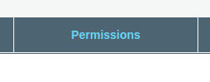



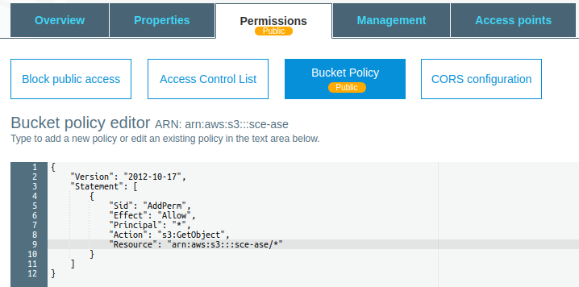

{

"Version":"2012-10-17",

"Statement":[

{

"Sid":"AddPerm",

"Effect":"Allow",

"Principal": "*",

"Action":["s3:GetObject"],

"Resource":["arn:aws:s3:::sce-ase/*"]

}

]

}

Save the bucket policy and AWS adds a **public** tag.

Go to **properties** tab and enable **Static website hosting** option

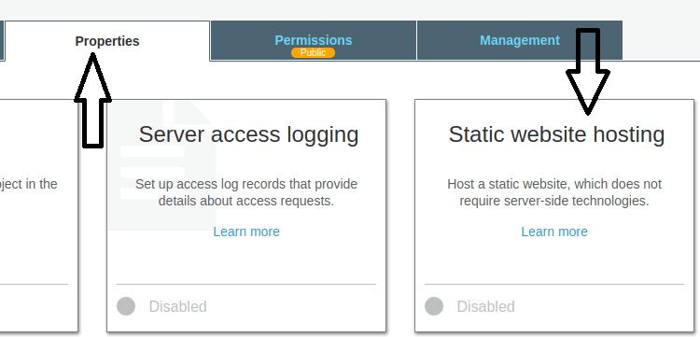

Choose Set the entry page (**index.html**) and error page and click on save.

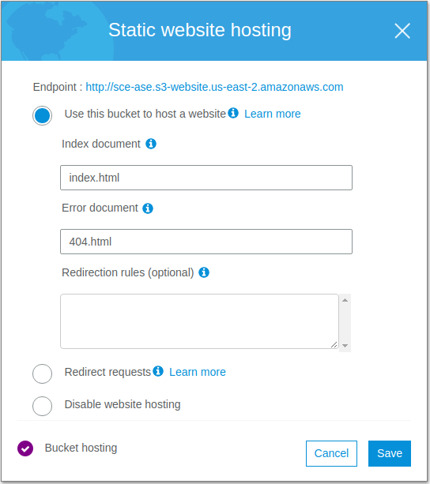

The static website can be accessed from the [link](http://sce-ase.s3-website.us-east-2.amazonaws.com/) [http://sce-ase.s3-website.us-east-2.amazonaws.com](http://sce-ase.s3-website.us-east-2.amazonaws.com/)

