Advanced Software Engineering

Tutorial 6

Team 1_2

**Student 1**

Name: Srichakradhar Reddy Nagireddy

Class ID: 32

**Student 2**

Name: Sathwik Banginimatam

Class ID: 5

**CRUD API for Customers data**

Yargs & express

This is a CRUD API for Customers data with some fields like customer_id, customer_name, customer_email etc., with methods for adding a new customer, listing all the customers, updating a customer and deleting a customer.

Storage format:

**customers-data.json**

[{ id: customer_id, name: customer_name: email: customer_email}]

Endpoints:

GET

path: ​/

List all customers

POST

path: ​/

Create a customer

GET

​path: /{id}

Get customer with ID

PUT

​path: /{id}

Update a customer

DELETE

​path: /{id}

Remove a customer

*Parameters*

id - ID of the Customer.

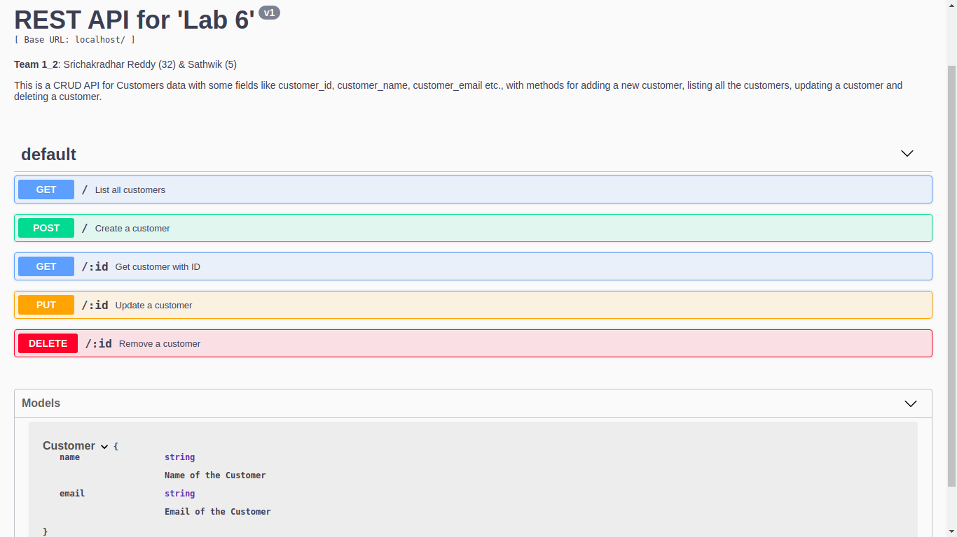

Start the app:

**srichakradhar@IdeaPad-Y480:~/ase-lab6$** node app.js  
Express app listening on port 3000!

### List all Customers

curl -X GET "http://localhost:3000/" -H "accept: application/json"

REST API Response:

[  
 {  
 "id": 2,  
 "name": "test3",  
 "email": "[test@3](mailto:test@3)"  
 }  
]

Using Yargs:

npm app.js list

Terminal Response:

Printing 1 customer(s).  
–  
ID: 2  
Name: test3  
e-Mail: [test@3](mailto:test@3)

### Create a Customer:

curl -X POST "http://localhost:3000/" -H "accept: application/json" -H "Content-Type: application/json" -d "{ \"id\": 1, \"name\": \"test1\", \"email\": \"test@1\"}"

REST API Response:

Customer 1 added.

Customer-data.json:

{ id: 1, name: 'test1', email: 'test@1' }

Using Yargs:

npm app.js add -i 1 -n test1 -e test@1

Terminal Response:

{ id: 1, name: 'test1', email: 'test@1' }  
–  
ID: 1  
Name: test1  
e-Mail: [test@1](mailto:test@1)

### Get customer details with ID

curl -X GET "http://localhost:3000/1" -H "accept: application/json"

REST API Response:

{  
 "id": 1,  
 "name": "test1",  
 "email": "[test@1](mailto:test@1)"  
}

Using Yargs:

npm app.js read -i 1

Terminal Response:

{ id: 1, name: 'test1', email: 'test@1' }  
–  
ID: 1  
Name: test1  
e-Mail: [test@1](mailto:test@1)

### Update a customer with ID

curl -X PUT "http://localhost:3000/2" -H "accept: application/json" -H "Content-Type: application/json" -d "{ \"id\": 1, \"name\": \"test2\", \"email\": \"test@2\"}"

REST API Response:

1 customer(s) updated.

Using Yargs:

npm app.js udpate -i 1 -n test2 -e test@2

Terminal Response:

{ id: 1, name: 'test2', email: 'test@2' }  
1 customer(s) updated.

### Delete a customer with ID

curl -X DELETE "http://localhost:3000/2" -H "accept: application/json"

REST API Response:

Customer was removed

Using Yargs:

npm app.js remove -i 2

Terminal Response:

Customer was removed