Advanced Software Engineering
Tutorial 5
Team 1_2

Student 1
Name: Srichakradhar Reddy Nagireddy
Class ID: 32

Student 2
Name: Sathwik Banginimatam
Class ID: 5

Hosting a static website on AWS S3

Login to the AWS console
https://aws.amazon.com/console/
Open S3
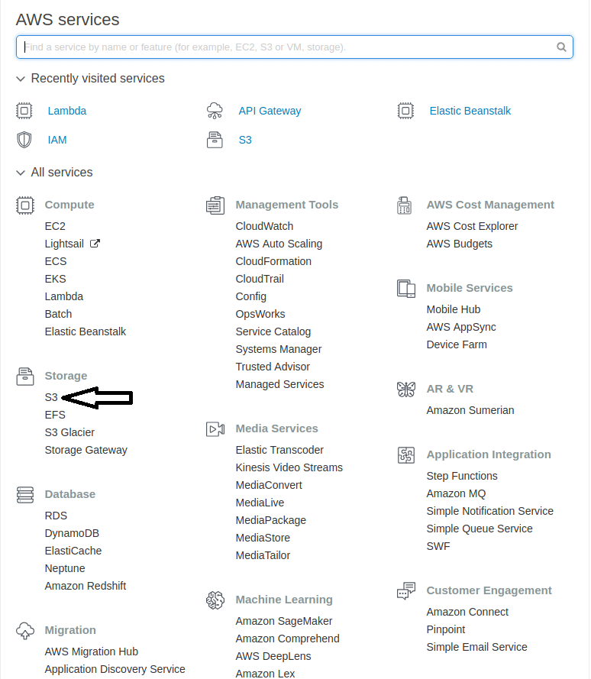

Create a bucket
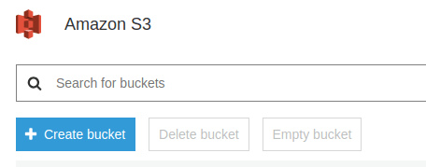
with following details...
Name: sce-ase
Other settings: default
and provide public access to the bucket.

Open the newly created bucket
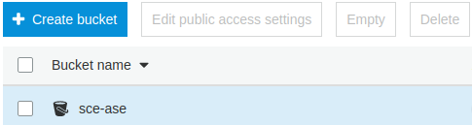

Upload the static website files to the bucket by drag and drop or choosing files and folders

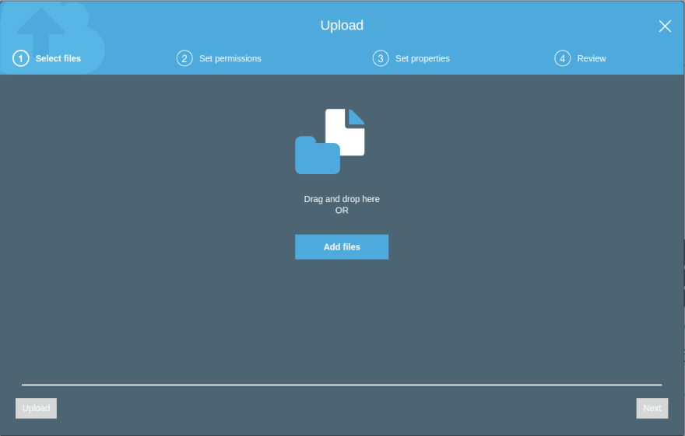

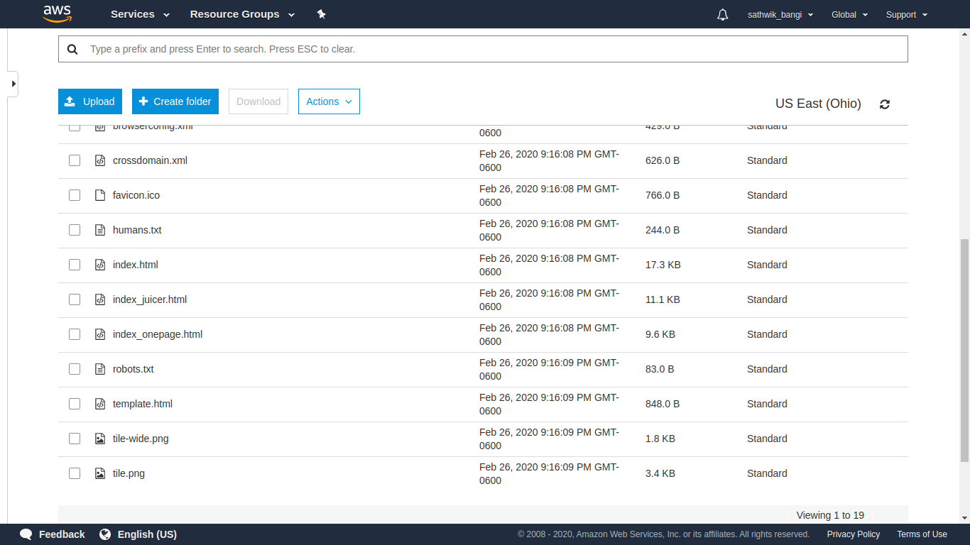
Got to Bucket Policy in Permissions tab and add the policy to provide Read-Only Permission for public users.
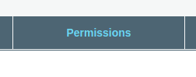

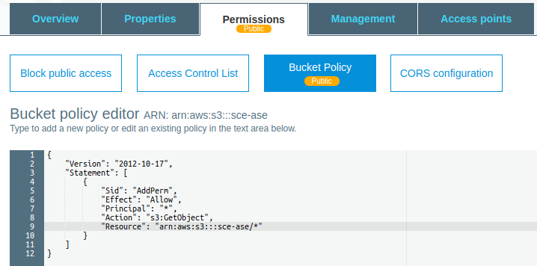
{
"Version":"2012-10-17",
"Statement":[
{
"Sid":"AddPerm",
"Effect":"Allow",
"Principal": "*",
"Action":["s3:GetObject"],
"Resource":["arn:aws:s3:::sce-ase/*"]
}
]
}
Save the bucket policy and AWS adds a public tag.
Go to properties tab and enable Static website hosting option
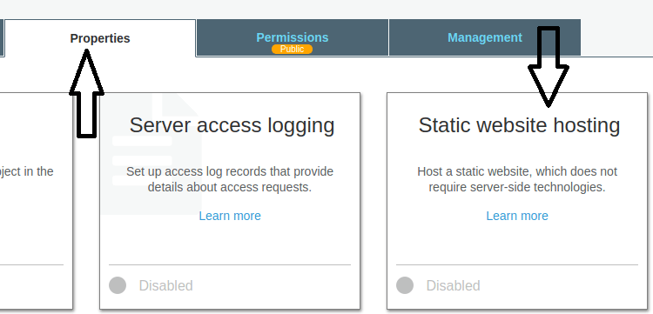
Choose Set the entry page (index.html) and error page and click on save.
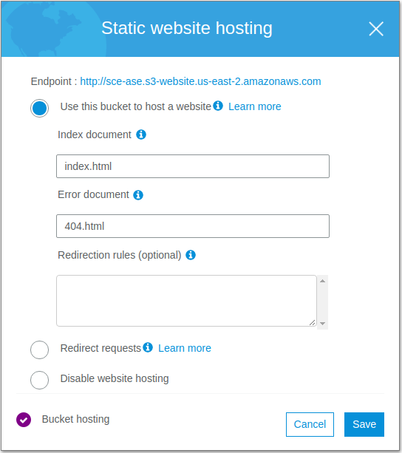

The static website can be accessed from the link http://sce-ase.s3-website.us-east-2.amazonaws.com

