Nutrition Checker
ASE – Lab 3 – Team 1_2
Srichakradhar Reddy – 32
Sathwik – 5

Sign Up page
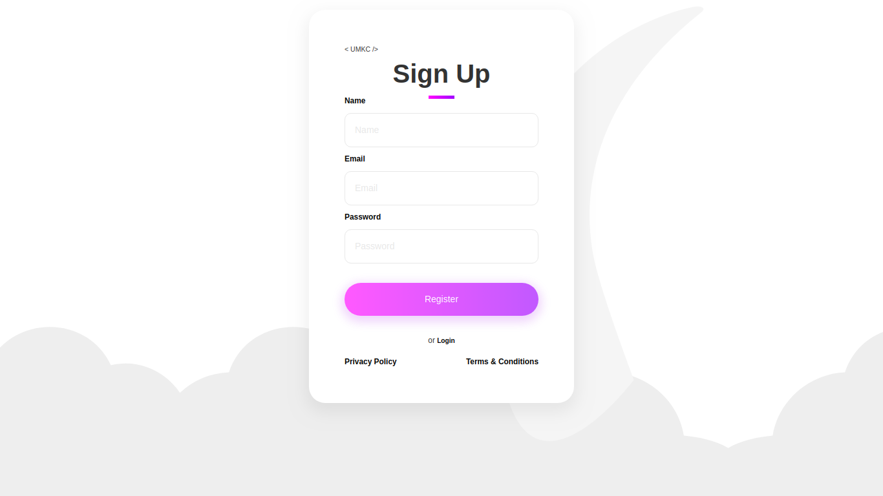
User needs to enter the details to sign up and create an account.
Only valid details are allowed else the Register button will not be active.

Login Page
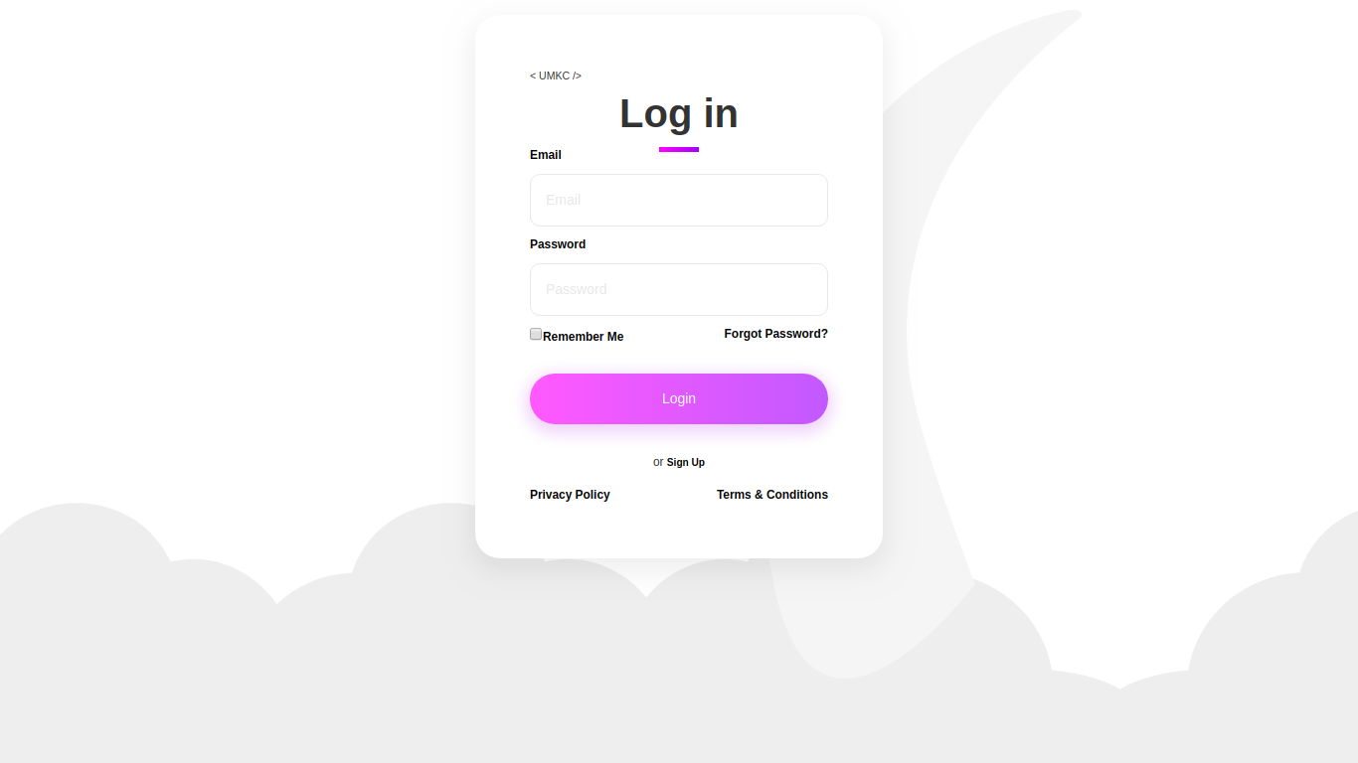
User needs to enter the details provided for registration to login to the app.
The email and password are validated before allowing the user to login.
If the user exists (is registered) he/she will be redirected to the app homepage.

Application Page

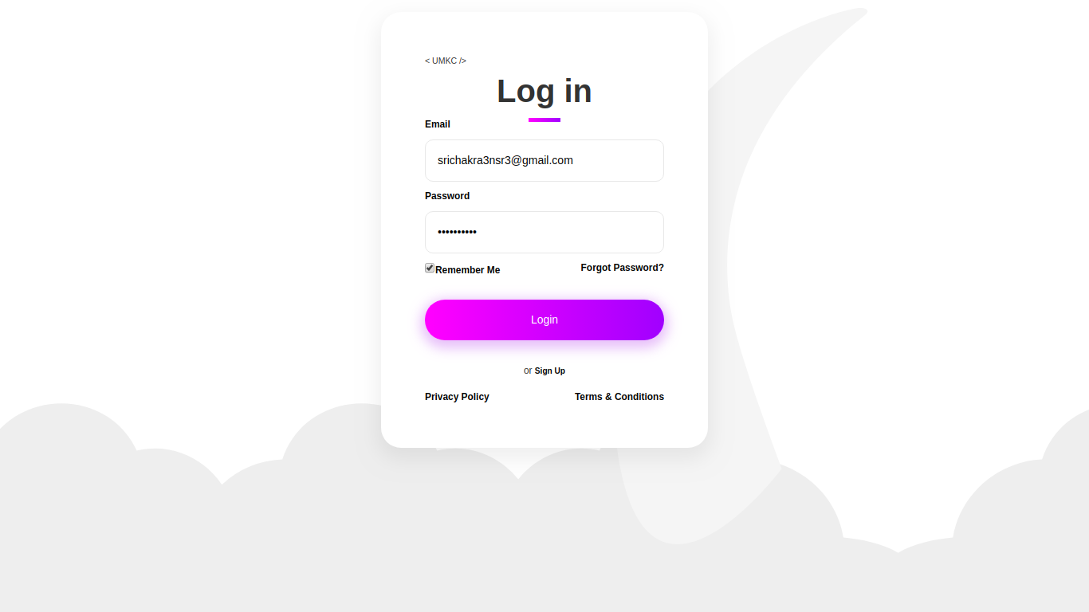
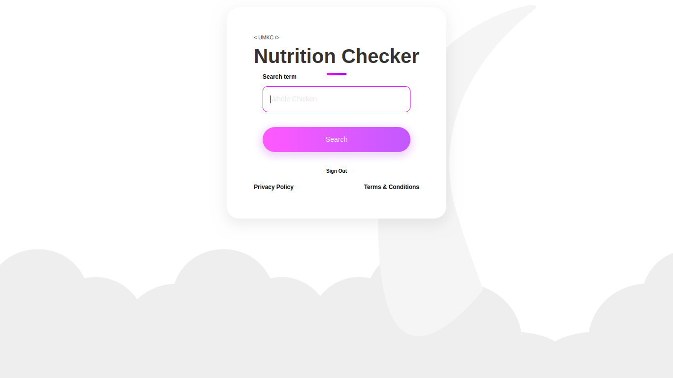
Using the Nutritionix API the nutrition details for the search term entered are displayed in a info-box.
Invalid searchTerm shows “Item not found” message to the user.

