CS5560 Knowledge Discovery and Management

Problem Set (PS-3)

February 4th 2020

Name: Srichakradhar Reddy Nagireddy

ClassID: 11

1. Given the text example below, show the following NLP operations.
   1. Triplet Extraction

Starting server with command: java -Xmx8G -cp /home/srichakradhar/stanfordnlp_resources/stanford-corenlp-full-2018-10-05/* edu.stanford.nlp.pipeline.StanfordCoreNLPServer -port 9000 -timeout 60000 -threads 5 -maxCharLength 100000 -quiet True -serverProperties corenlp_server-b2fb4e7b898c4c45.props -preload openie

Corpus: Citing high fuel prices, United Airlines said Friday it has increased fares by $ [...].

Found 5 triples in the corpus.

|- {'subject': 'United Airlines', 'relation': 'Citing', 'object': 'high fuel prices'}

|- {'subject': 'United Airlines', 'relation': 'Citing', 'object': 'fuel prices'}

|- {'subject': 'United Airlines', 'relation': 'said at_time', 'object': 'Friday'}

Text: Citing high fuel prices, United Airlines said Friday it has increased fares by $6 per round trip on flights to some cities also served by lower-cost carriers. American Airlines, a unit AMR, immediately matched the move, spokesman Tim Wagner said. United, a unit of UAL, said the increase took effect Thursday night and applies to most routes where it competes against discount carriers, such as Chicago to Dallas and Atlanta and Denver to San Francisco, Los Angeles and New York..

|- {'subject': 'United Airlines', 'relation': 'Citing', 'object': 'high fuel prices'}

|- {'subject': 'United Airlines', 'relation': 'Citing', 'object': 'fuel prices'}

|- {'subject': 'United Airlines', 'relation': 'said at_time', 'object': 'Friday'}

|- {'subject': 'United', 'relation': 'unit of', 'object': 'UAL'}

|- {'subject': 'United', 'relation': 'unit of', 'object': 'UAL'}

* 1. Patterns of Triplets Based on Parts of Speech.

[{'subject': 'United Airlines', 'subjectSpan': [5, 7], 'relation': 'Citing', 'relationSpan': [0, 1], 'object': 'high fuel prices', 'objectSpan': [1, 4]}, {'subject': 'United Airlines', 'subjectSpan': [5, 7], 'relation': 'Citing', 'relationSpan': [0, 1], 'object': 'fuel prices', 'objectSpan': [2, 4]}]

1. Summarize and draw a knowledge graph.

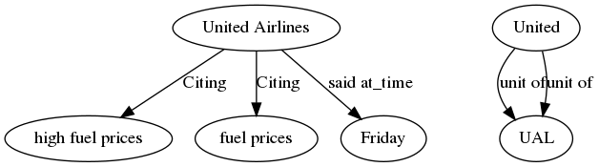

**Summary**: United Airlines cited high fuel prices and cited increased fares on Friday. United is a unit of UAL.

CHICAGO (AP) — Citing high fuel prices, United Airlines said Friday it has increased fares by $6 per round trip on flights to some cities also served by lower-cost carriers. American Airlines, a unit AMR, immediately matched the move, spokesman Tim Wagner said. United, a unit of UAL, said the increase took effect Thursday night and applies to most routes where it competes against discount carriers, such as Chicago to Dallas and Atlanta and Denver to San Francisco, Los Angeles and New York.