1)

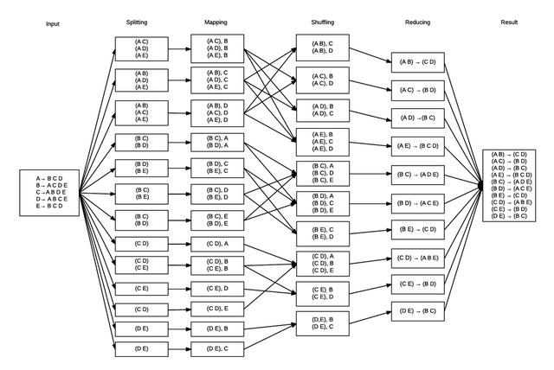

2)

int countTemp = 0;

while (values.hasNext()) {

String temp = values.next().toString();

//out log

System.out.println(temp);

logReduce.info("item:" + countTemp++ + ":" + temp);

String[] listFriend = temp.split(" ");

arr.add(listFriend);

}

HashSet<String> commonElements = new HashSet<String>();

for(String[] friends: arr){

Arrays.sort(friends);

for(String friend: friends){

if(commonElements.contains(friend))

commonFriendStr += friend + " ";

else

commonElements.add(friend);

}}

Text commonFriendText = new Text();

commonFriendText.set(commonFriendStr);

output.collect(key, commonFriendText);