Team-profiles-assignments

**Problem Statement**

The objective of this assignment is to create team profiles given as per the given below image

After the successful completion of this assignment , the participants will get hands-on the following topics

**1.**HTML5 Semantic Elements (section, article)

**2.**CSS3 Selectors

**3.**Flex Layout

4. Font-Awesome Icons

Design the page as per the image

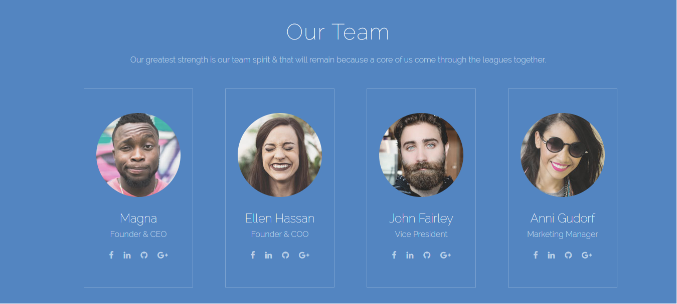

**Instructions**

**1.**Page must have title, favicon, description and meta tags

**2.**Use only HTML5 Semantic Elements , <section>,<article>

**3.**Use descriptive class names for HTML elements to apply the CSS

**4.**Use proper CSS3 selectors

**5.**Use proper indentation

**6.**Boilerplate contains the images, font-family, colors. Use them to get the exact output

7. Use Font-Awesome icons to add social media links

**Boilerplate**

<https://gitlab.com/digi-safari-assignments/html5-css3/assignment-2-image-gallery>