**Personal Portfolio Website**

**Course: Front end UI/UX**

**Institute: Christ University**

**Group Members:**

1. **Sricharan A – 2462532**
2. **Swara Madichedi – 2462533**
3. **Anirudh V O – 2462536**

**_________________________________________________________________________________________________________**

**1. Project Overview**

This project is a personal portfolio website designed to showcase academic and creative work, technical skills, projects, and contact information. The site is static, built using semantic HTML5 and modern CSS techniques including Flexbox and Grid. The goal is to create an accessible, responsive, and visually consistent personal brand presence.

**2. Objectives**

• Understand the structure of a personal portfolio.

• Apply semantic HTML and modern CSS for layout and styling.

• Develop a responsive multi-page website using only HTML and CSS.

**3. Expected Outcomes**

• Organize personal information digitally.

• Use semantic tags: header, main, nav, section, article, footer.

• Proficiency with CSS Flexbox & Grid for responsive layouts.

• Ability to design personal branding elements.

**4. Pages & Design**

Home — Introduction, profile image, featured projects.

About — Detailed biography, education, skills.

Projects — At least 3 projects: title, description, image, link.

Contact — Contact form (name, email, subject, message).

Footer — Social links and copyright.

**5. Design Choices**

• Font: Inter (Google Fonts) for modern readability.

• Color Palette: Teal accent with muted greys for text.

• Layout: CSS Grid for page composition, Flexbox used inside components.

• Accessibility: semantic tags, skip-link, proper alt text.

• Responsiveness: media queries for breakpoints at 900px and 520px.

**6. Technical Implementation**

• HTML files: index.html, about.html, projects.html, contact.html

• CSS file: css/style.css (single stylesheet for easy maintenance)

• Images in /images/ folder.

• No JavaScript used — simplifies maintenance and meets project constraints.

**7. Screenshots:**

* **Index:**

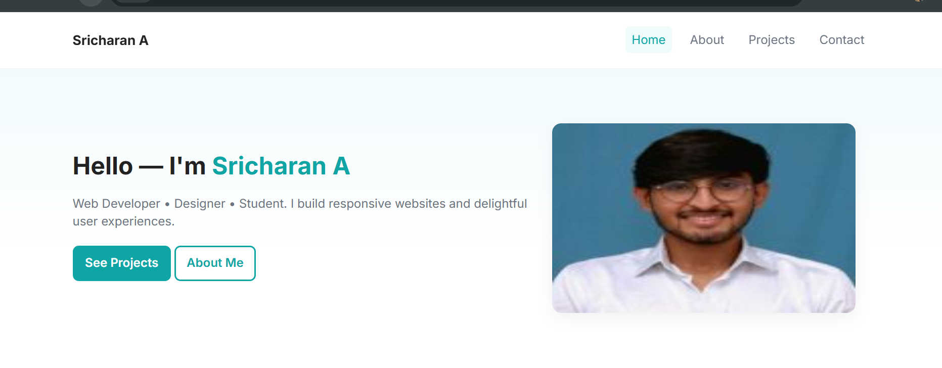

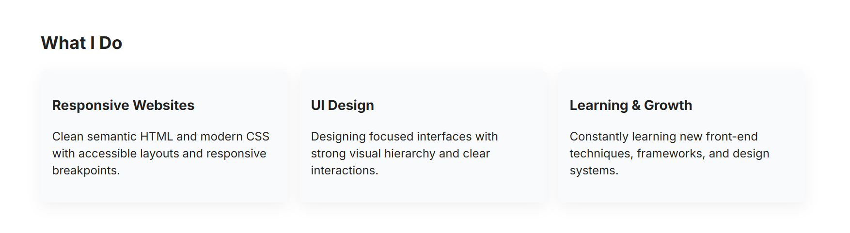

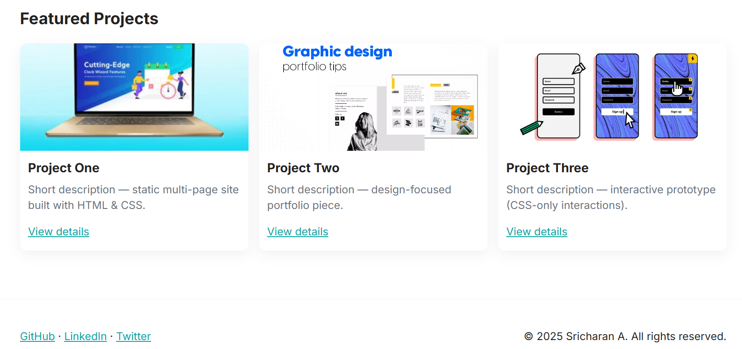

* 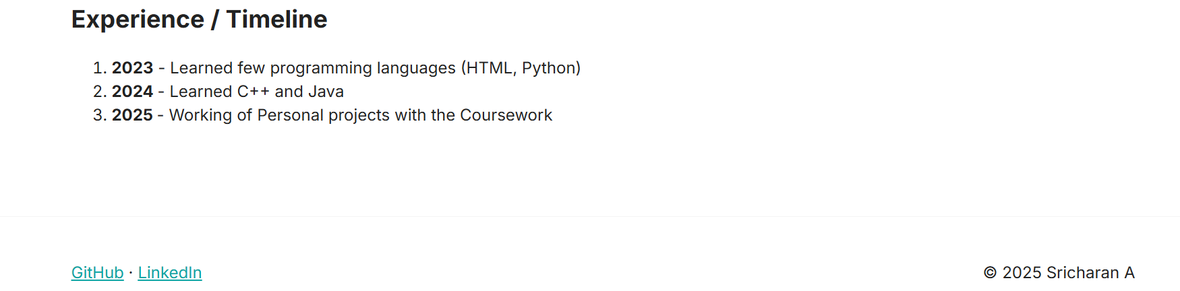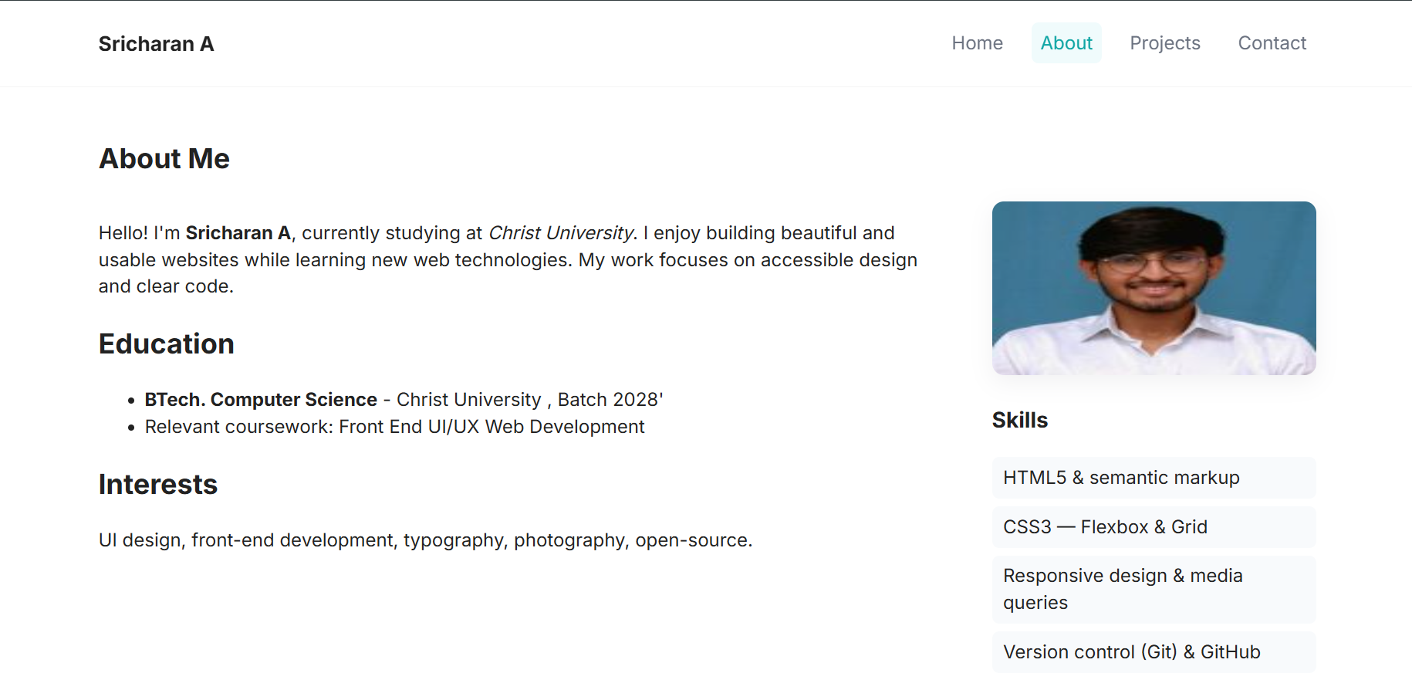**About:**
* **Projects:**

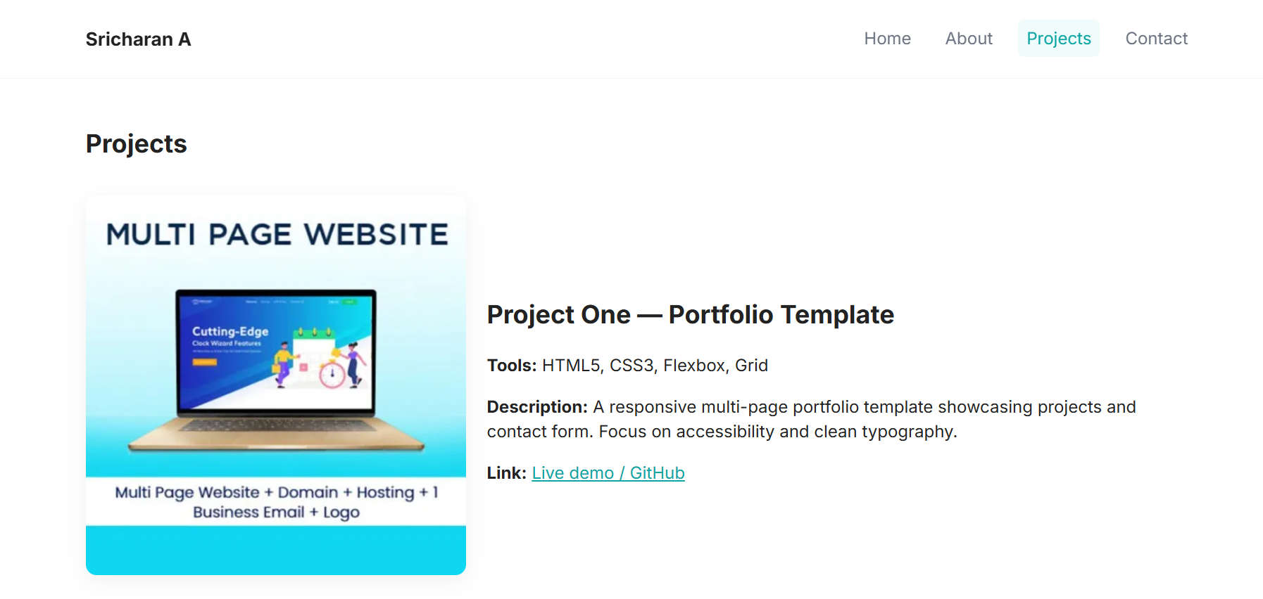

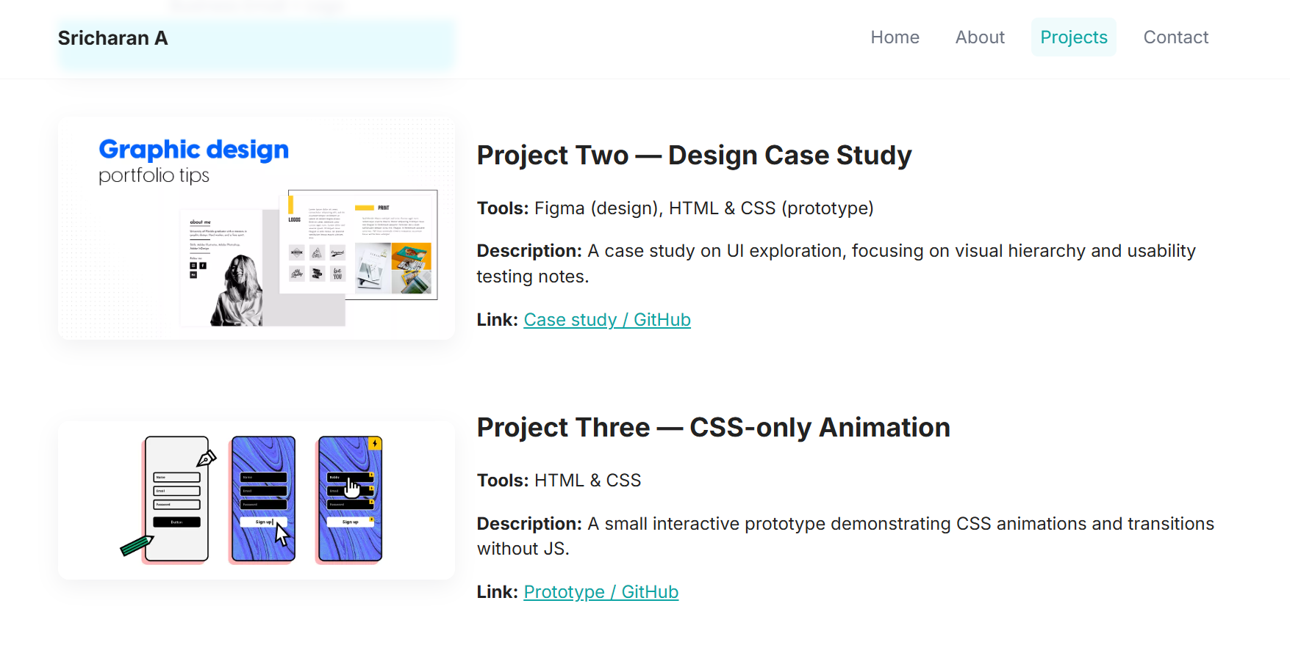

* **Contact:**

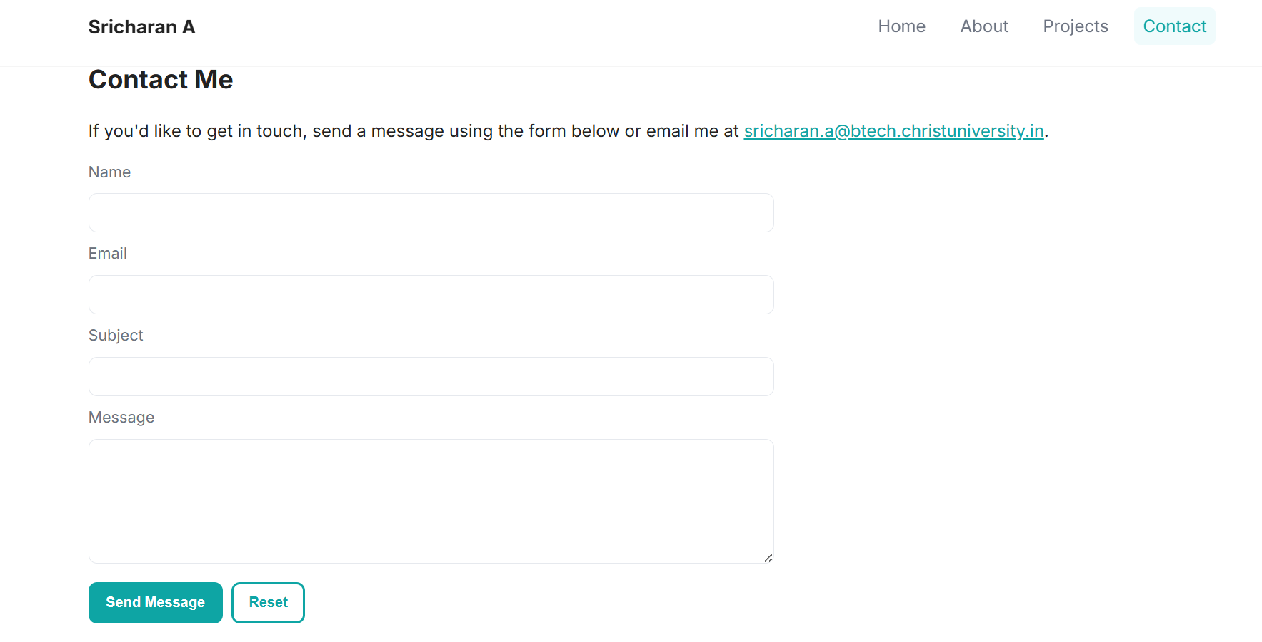

**9. Group Roles & Contribution**

Sricharan A — Program developer (HTML/CSS, layout)

Swara Madichedi — Designer (color palette, images, wireframes)

Anirudh V O — Content & report (text, screenshots, GitHub upload)

10. GitHub & Submission

**Repository:** <https://github.com/sricharan-abtech/Front-End-UI-UX-Webpage-Design>

All HTML, CSS, images, Project_Report_Personal_Portfolio.docx

11. Final Checklist

• Pages implemented: index, about, projects, contact

• Semantic HTML used

• CSS responsive design

• Project report attached in repository

• GitHub repository public and linked in spreadsheet