Views in SQL are kind of virtual tables. A view also has rows and columns as they are in a real table in the database.
We can create a view by selecting fields from one or more tables present in the database
Create VIEW:-
CREATE VIEW DetailsView AS
SELECT NAME, ADDRESS
FROM StudentDetails
CREATE VIEW CUSTOMERS_VIEW AS
SELECT name, age
FROM CUSTOMERS;
SELECT * FROM CUSTOMERS_VIEW;

Insert VIEW:

Insert into customers_view values(‘kiran’,43);

UPDATE VIEW:-

UPDATE CUSTOMERS_VIEW
SET AGE = 35
WHERE name = 'Ramesh';

Delete VIEW:-

DELETE FROM CUSTOMERS_VIEW
WHERE age = 22;

DROP VIEW CUSTOMERS_VIEW;

A JOIN clause is used to combine rows from two or more tables, based on a related column between them.

Different Types of SQL JOINs

different types of the JOINs in SQL:
- (INNER) JOIN: Returns records that have matching values in both tables
- LEFT (OUTER) JOIN: Returns all records from the left table, and the matched records from the right table
- RIGHT (OUTER) JOIN: Returns all records from the right table, and the matched records from the left table
- FULL (OUTER) JOIN: Returns all records when there is a match in either left or right table
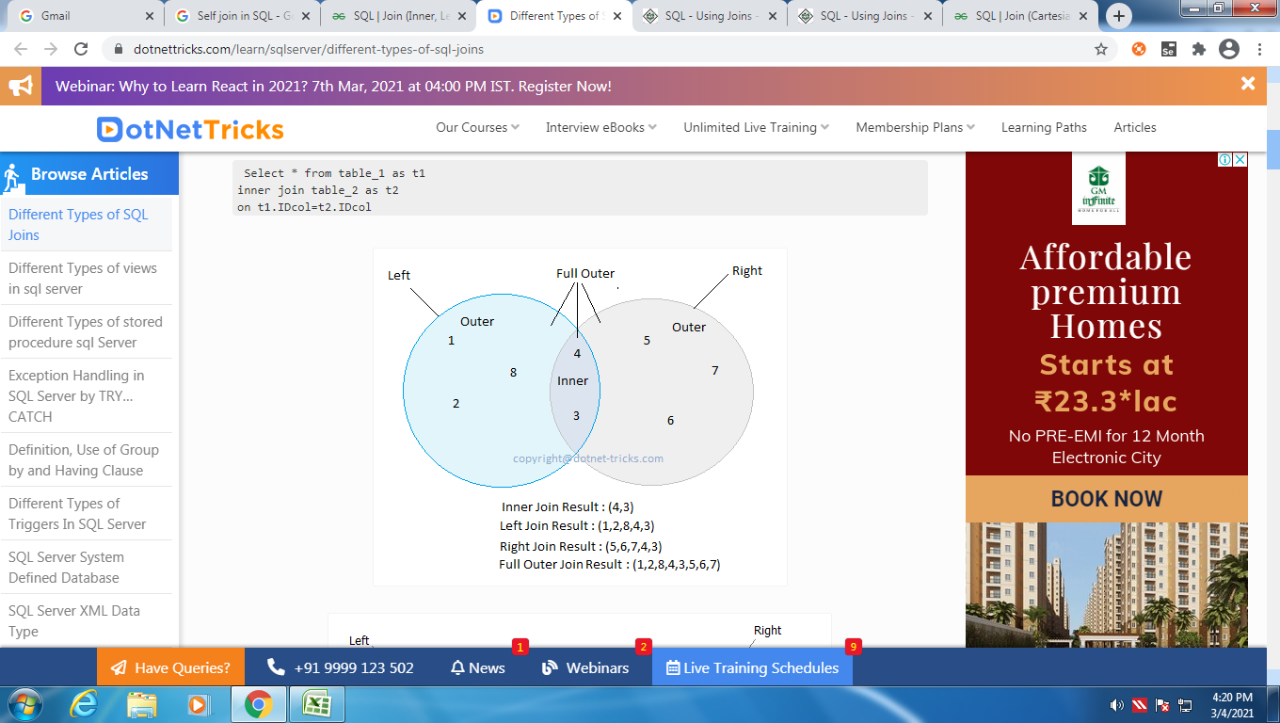

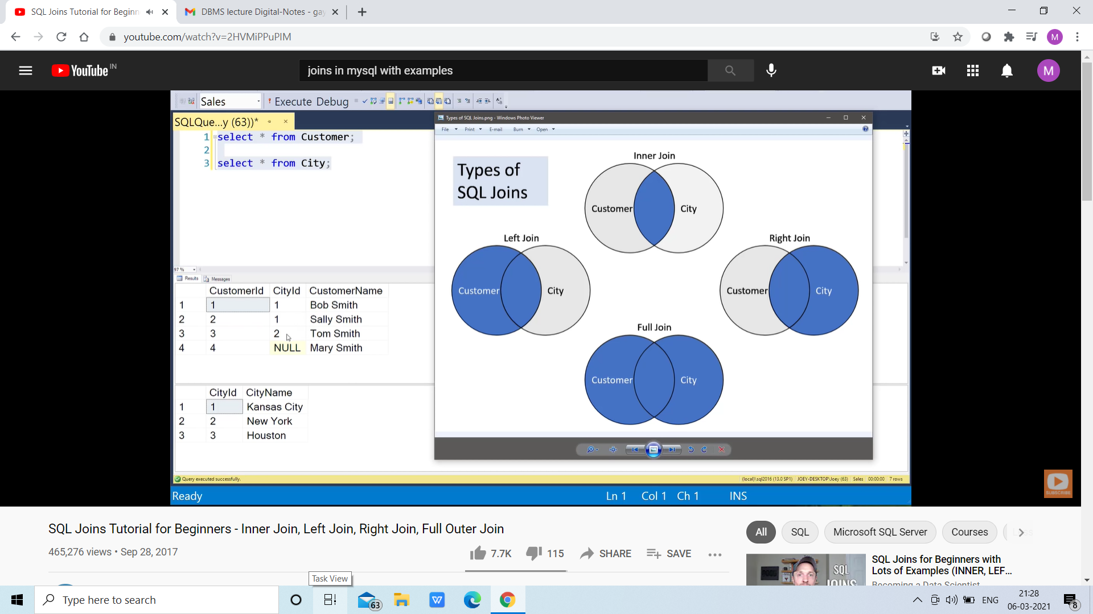
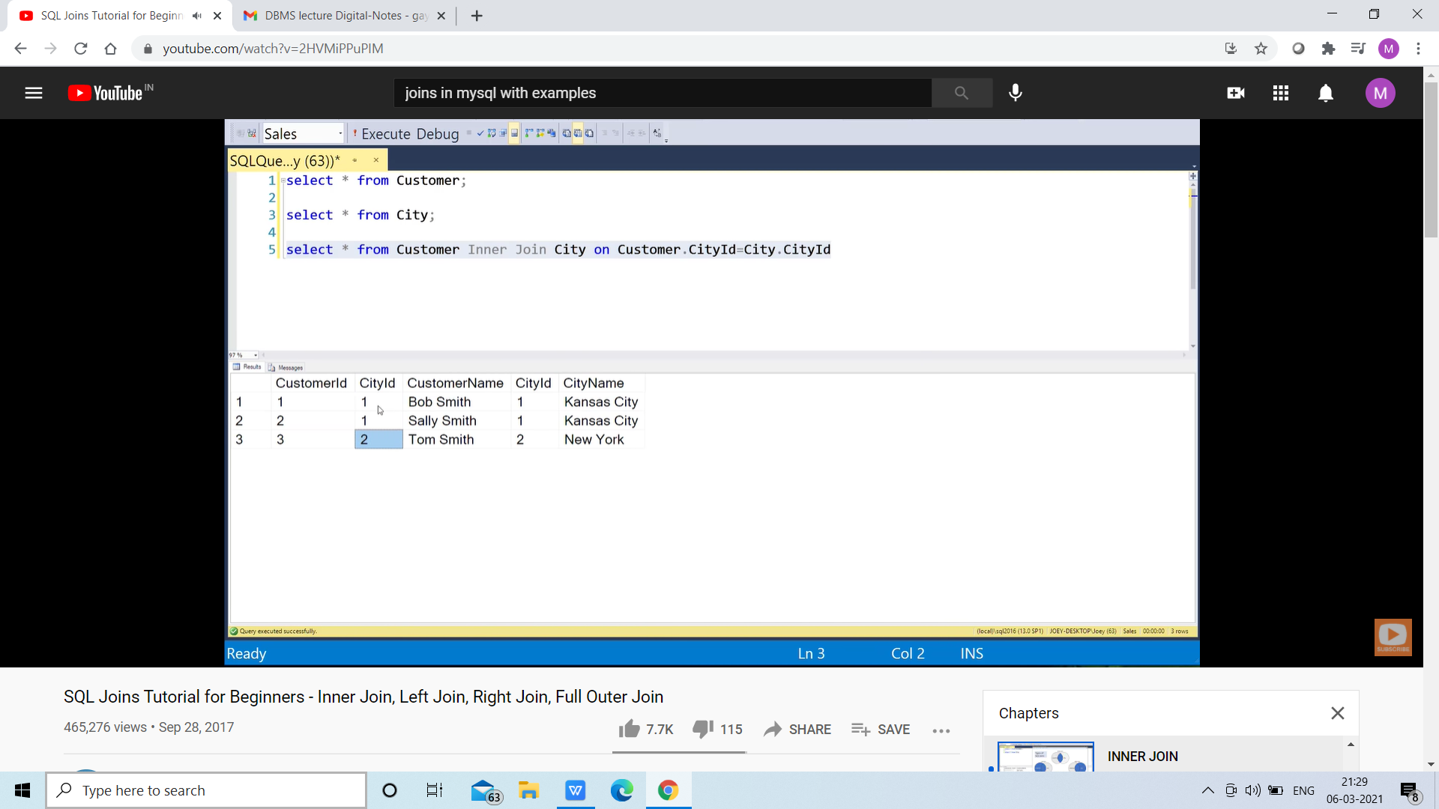
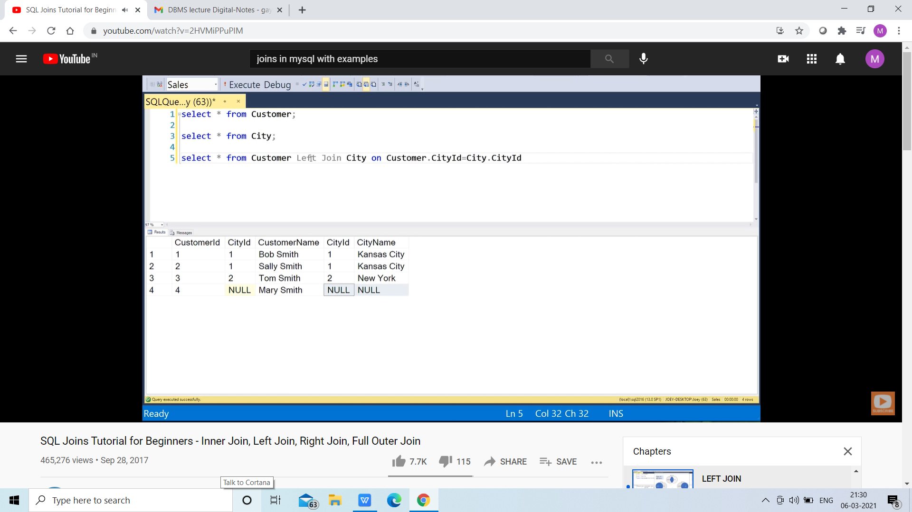
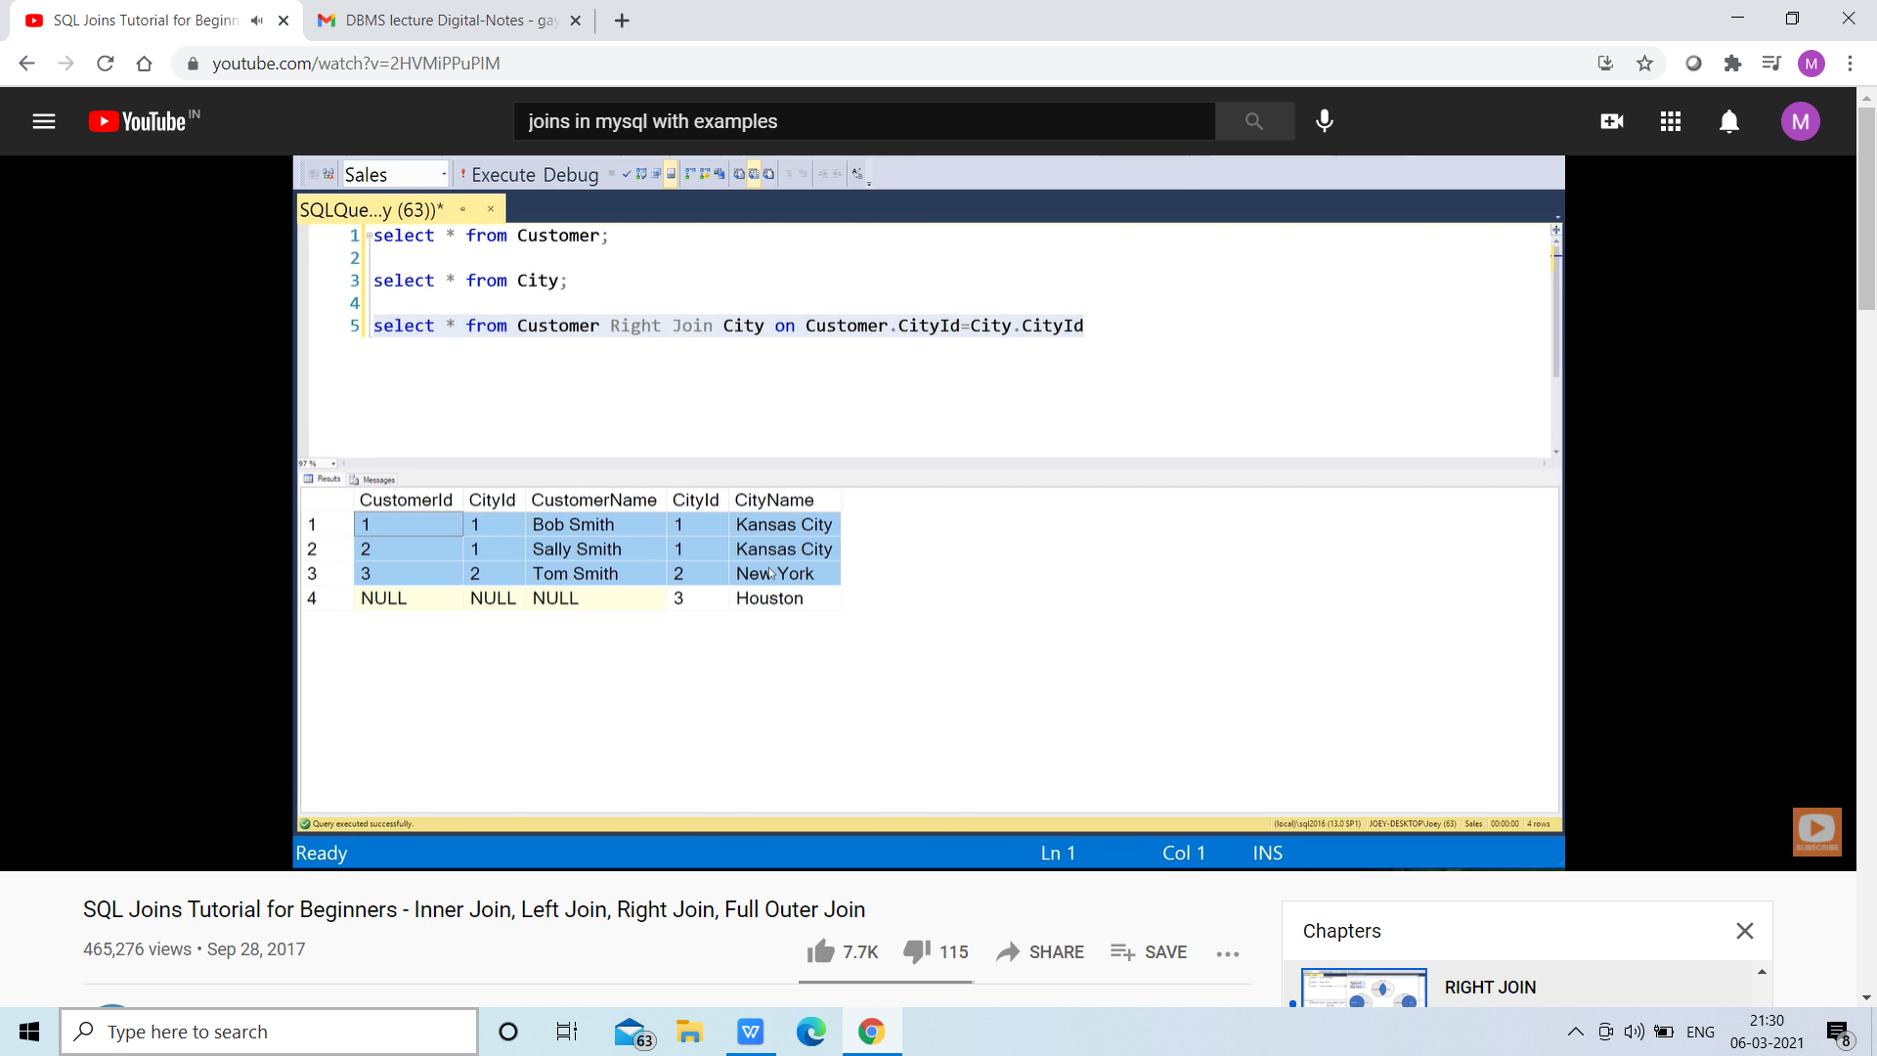
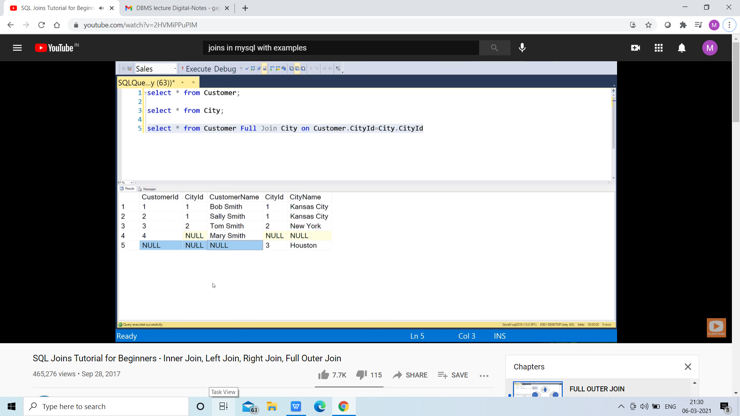
SELECT * FROM customer
LEFT JOIN city ON customer.cityid = city.cityid
UNION
SELECT * FROM customer
RIGHT JOIN city ON customer.cityid = city.cityid

NESTED QUERIES

SELECT * FROM CUSTOMER wHERE cid IN (SELECT cid FROM CUSTOMER WHERE cid>=1);

DELETE FROM customer WHERE cityid IN (SELECT cityid FROM customer WHERE cityid=2 );

SELECT emp_name, city, income FROM employees WHERE emp_id IN (SELECT emp_id FROM employees);

SELECT Name, City FROM student WHERE City NOT IN ( SELECT City FROM student2 WHERE City='Los Angeles');

SELECT emp_name, city, income FROM employees WHERE income = (SELECT MAX(income) FROM employees);

SELECT name, occupation, age FROM customer C
WHERE EXISTS (SELECT * FROM Orders O WHERE C.cust_id = O.cust_id);
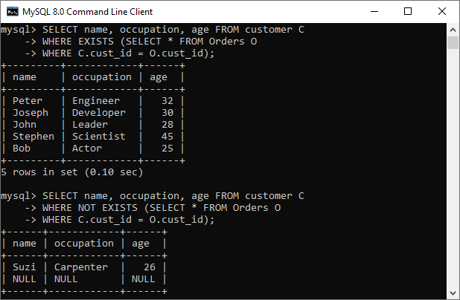

Procedure:- A stored procedure is like a function that contains a set of operations compiled together. it contains a set of operations that are commonly used in an application to do some common database task.
A stored procedure is a prepared SQL code that you can save, so the code can be reused over and over again.

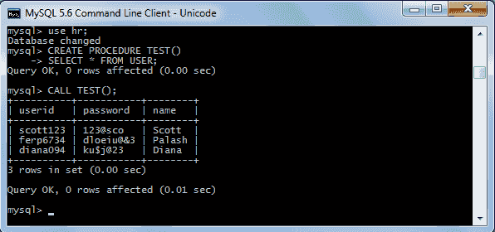
CREATE PROCEDURE stud_data()
SELECT * FROM student;
Query OK, 0 rows affected (0.00 sec)

DELIMITER $$
CREATE PROCEDURE my_procedure_User_Variables()
BEGIN
SET @x = 15;
SET @y = 10;
SELECT @x, @y, @x-@y;
END$$
Now execute the procedure :
mysql> CALL my_procedure_User_Variables() ;
+------+------+-------+
| @x | @y | @x-@y |
+------+------+-------+
| 15 | 10 | 5 |
+------+------+-------+
1 row in set (0.04 sec)
Query OK, 0 rows affected (0.05 sec)
mysql> SHOW PROCEDURE STATUS WHERE db = 'mystudentdb';
mysql> DROP PROCEDURE display_marks;

- CREATE TRIGGER: These two keywords specify that a triggered block is going to be declared.
- TRIGGER_NAME: It creates or replaces an existing trigger with the Trigger_name. The trigger name should be unique.
- BEFORE | AFTER: It specifies when the trigger will be initiated i.e. before the ongoing event or after the ongoing event.
- INSERT | UPDATE | DELETE: These are the DML operations and we can use either of them in a given trigger.
- ON[TABLE_NAME]: It specifies the name of the table on which the trigger is going to be applied.
- FOR EACH ROW: Row-level trigger gets executed when any row value of any column changes.
- TRIGGER BODY: It consists of queries that need to be executed when the trigger is called.

