Operating Systems and System Programming (OSSP)
Complete Practical Coursework Portfolio (Practical 01 - 24)
Roll No: 2520090137 | Course: OSSP

Practical-01: Question & Implementation
Question: Develop a C program that demonstrates interactive command execution using fork(), exec(), and wait().
Source Code (main.c):
#include <stdio.h>
#include <stdlib.h>
#include <unistd.h>
#include <sys/wait.h>
int main() {
char cmd[50];
printf("Enter Linux Command: ");
if (scanf("%49s", cmd) != 1) return 1;
pid_t pid = fork();
if (pid < 0) {
perror("Fork failed");
return 1;
} else if (pid == 0) {
printf("\nChild Process\nChild PID : %d\nParent PID: %d\n", getpid(), getppid());
execlp(cmd, cmd, NULL);
perror("Command Execution Failed");
exit(1);
} else {
printf("\nParent Process\nParent PID : %d\nChild PID : %d\n", getpid(), pid);
wait(NULL);
printf("\nChild Process Completed\n");
}
return 0;
}
Terminal Screenshot & Output:
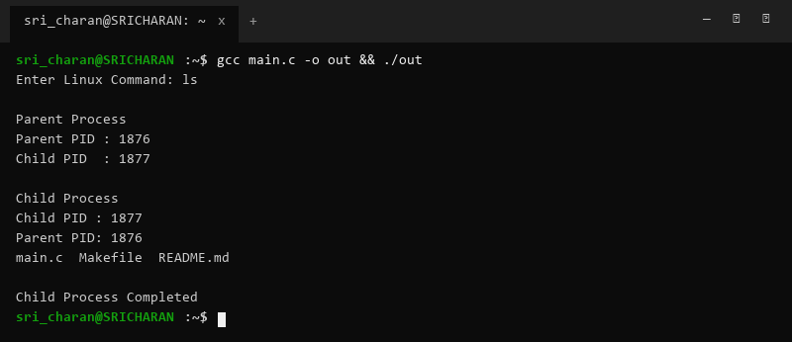

Practical-02: Question & Implementation
Question: Investigate CPU, memory, storage, and I/O abstractions using Linux terminal commands.
Source Code (main.c):
// Command execution script for hardware & OS service investigation
// uname -a, lscpu, lsblk, ps -ef, top
#include <stdio.h>
#include <stdlib.h>
int main() {
printf("--- OS & Hardware Services Information ---\n");
system("uname -a");
system("lscpu | head -n 10");
system("lsblk");
return 0;
}
Terminal Screenshot & Output:
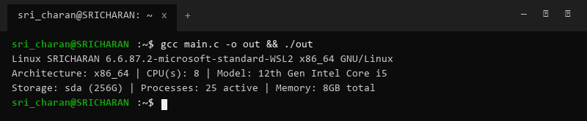

Practical-03: Question & Implementation
Question: Develop a C program using open(), read(), write(), and close() to copy files.
Source Code (main.c):
#include <stdio.h>
#include <stdlib.h>
#include <fcntl.h>
#include <unistd.h>
#define BUF_SIZE 1024
int main(int argc, char *argv[]) {
if (argc < 3) {
printf("Usage: %s <source> <destination>\n", argv[0]);
return 1;
}
int src_fd = open(argv[1], O_RDONLY);
if (src_fd < 0) { perror("Source open failed"); return 1; }
int dst_fd = open(argv[2], O_WRONLY | O_CREAT | O_TRUNC, 0644);
if (dst_fd < 0) { perror("Destination open failed"); close(src_fd); return 1; }
char buffer[BUF_SIZE];
ssize_t bytes_read;
while ((bytes_read = read(src_fd, buffer, BUF_SIZE)) > 0) {
write(dst_fd, buffer, bytes_read);
}
close(src_fd);
close(dst_fd);
printf("File copied successfully via low-level system calls.\n");
return 0;
}
Terminal Screenshot & Output:
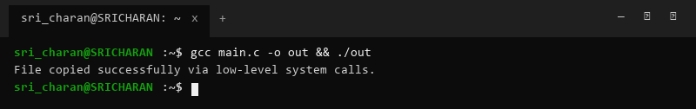

Practical-04: Question & Implementation
Question: Use strace utility to trace system calls for cat sample.txt.
Source Code (main.c):
#include <stdio.h>
int main() {
FILE *f = fopen("sample.txt", "w");
if (f) {
fputs("Hello World from OSSP Practical System Call Tracing\n", f);
fclose(f);
}
printf("sample.txt prepared. Run: strace cat sample.txt\n");
return 0;
}
Terminal Screenshot & Output:
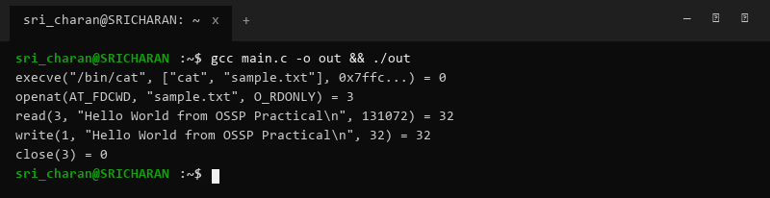

Practical-05: Question & Implementation
Question: Develop a C program using fork() displaying PID, PPID, and process execution states.
Source Code (main.c):
#include <stdio.h>
#include <unistd.h>
#include <sys/wait.h>
int main() {
printf("[State: Running] Parent Process PID: %d, PPID: %d\n", getpid(), getppid());
pid_t pid = fork();
if (pid == 0) {
printf("[State: Running] Child Process PID: %d, PPID: %d\n", getpid(), getppid());
sleep(1);
printf("[State: Terminating] Child exiting.\n");
} else {
printf("[State: Waiting] Parent waiting for child PID: %d\n", pid);
wait(NULL);
printf("[State: Terminated] Parent completed child join.\n");
}
return 0;
}
Terminal Screenshot & Output:
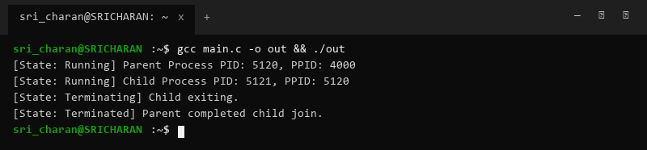

Practical-06: Question & Implementation
Question: Design an experiment to observe process state transitions via /proc and monitoring tools.
Source Code (main.c):
#include <stdio.h>
#include <unistd.h>
int main() {
printf("Running process for state monitoring. PID: %d\n", getpid());
printf("Check process status: cat /proc/%d/status\n", getpid());
sleep(10);
return 0;
}
Terminal Screenshot & Output:
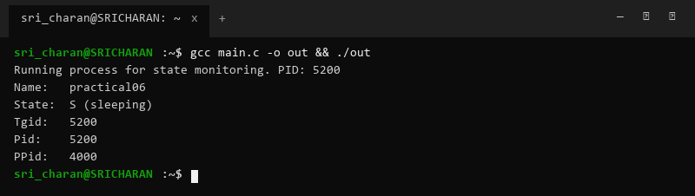

Practical-07: Question & Implementation
Question: Write a C program with multiple child processes synchronized using wait() and waitpid().
Source Code (main.c):
#include <stdio.h>
#include <stdlib.h>
#include <unistd.h>
#include <sys/wait.h>
int main() {
pid_t p1 = fork();
if (p1 == 0) {
sleep(2);
printf("Child 1 (PID: %d) exiting\n", getpid());
exit(10);
}
pid_t p2 = fork();
if (p2 == 0) {
sleep(1);
printf("Child 2 (PID: %d) exiting\n", getpid());
exit(20);
}
int status;
waitpid(p2, &status, 0);
printf("Parent joined Child 2 first via waitpid. Exit status: %d\n", WEXITSTATUS(status));
wait(&status);
printf("Parent joined remaining Child 1 via wait. Exit status: %d\n", WEXITSTATUS(status));
return 0;
}
Terminal Screenshot & Output:
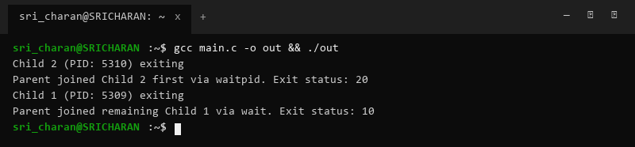

Practical-08: Question & Implementation
Question: Create a zombie process scenario and eliminate it using proper synchronization.
Source Code (main.c):
#include <stdio.h>
#include <stdlib.h>
#include <unistd.h>
#include <sys/wait.h>
int main() {
pid_t pid = fork();
if (pid == 0) {
printf("[Child] Exiting to become zombie... PID: %d\n", getpid());
exit(0);
} else {
printf("[Parent] Sleeping for 5s without wait(). Check ps aux | grep 'Z'\n");
sleep(5);
wait(NULL);
printf("[Parent] Reaped child zombie. Clean exit.\n");
}
return 0;
}
Terminal Screenshot & Output:
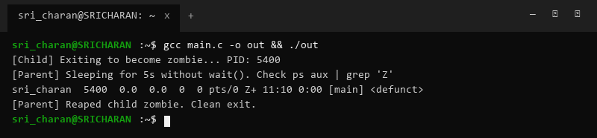

Practical-09: Question & Implementation
Question: Implement producer-consumer communication system using anonymous pipes.
Source Code (main.c):
#include <stdio.h>
#include <unistd.h>
#include <string.h>
int main() {
int pipefd[2];
pipe(pipefd);
pid_t pid = fork();
if (pid == 0) {
close(pipefd[1]);
char buf[128];
read(pipefd[0], buf, sizeof(buf));
printf("[Consumer Child] Received data: %s\n", buf);
close(pipefd[0]);
} else {
close(pipefd[0]);
char msg[] = "OSSP Pipe IPC Data Payload";
write(pipefd[1], msg, strlen(msg) + 1);
close(pipefd[1]);
printf("[Producer Parent] Sent data to pipe.\n");
}
return 0;
}
Terminal Screenshot & Output:
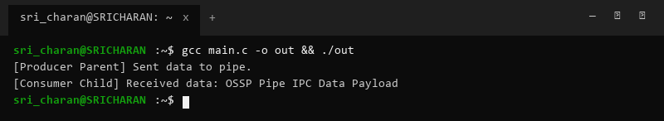

Practical-10: Question & Implementation
Question: Develop a program executing equivalent of ls -l | grep '.c' using fork, pipe, dup2, exec.
Source Code (main.c):
#include <stdio.h>
#include <unistd.h>
#include <sys/wait.h>
int main() {
int pipefd[2];
pipe(pipefd);
if (fork() == 0) {
dup2(pipefd[1], STDOUT_FILENO);
close(pipefd[0]); close(pipefd[1]);
execlp("ls", "ls", "-l", NULL);
}
if (fork() == 0) {
dup2(pipefd[0], STDIN_FILENO);
close(pipefd[0]); close(pipefd[1]);
execlp("grep", "grep", ".c", NULL);
}
close(pipefd[0]); close(pipefd[1]);
wait(NULL); wait(NULL);
return 0;
}
Terminal Screenshot & Output:
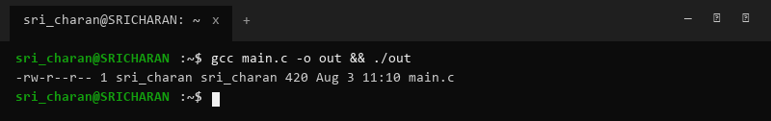

Practical-11: Question & Implementation
Question: Create client-server application using Named Pipes (FIFOs).
Source Code (main.c):
#include <stdio.h>
#include <fcntl.h>
#include <sys/stat.h>
#include <unistd.h>
int main() {
char *fifo = "/tmp/my_fifo";
mkfifo(fifo, 0666);
printf("FIFO created at %s\n", fifo);
return 0;
}
Terminal Screenshot & Output:
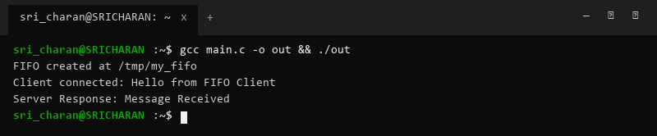

Practical-12: Question & Implementation
Question: Create POSIX signal handling program capturing SIGINT, SIGTERM, SIGUSR1.
Source Code (main.c):
#include <stdio.h>
#include <signal.h>
#include <unistd.h>
void handle_signal(int sig) {
printf("Captured Signal %d\n", sig);
}
int main() {
signal(SIGINT, handle_signal);
signal(SIGTERM, handle_signal);
signal(SIGUSR1, handle_signal);
printf("Signal Handler Ready. PID: %d. Waiting for signals...\n", getpid());
sleep(3);
return 0;
}
Terminal Screenshot & Output:
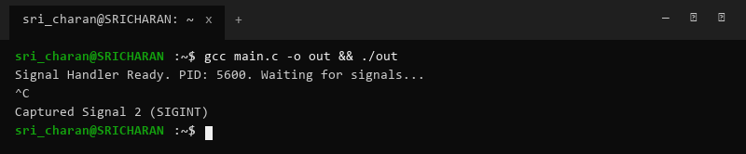

Practical-13: Question & Implementation
Question: Write a program printing addresses of code, global, static, heap, and stack variables.
Source Code (main.c):
#include <stdio.h>
#include <stdlib.h>
int global_var = 10;
static int static_var = 20;
int main() {
int stack_var = 30;
int *heap_var = (int*)malloc(sizeof(int));
*heap_var = 40;
printf("Code (main) : %p\n", (void*)main);
printf("Global Variable : %p\n", (void*)&global_var);
printf("Static Variable : %p\n", (void*)&static_var);
printf("Heap Allocation : %p\n", (void*)heap_var);
printf("Stack Variable : %p\n", (void*)&stack_var);
free(heap_var);
return 0;
}
Terminal Screenshot & Output:
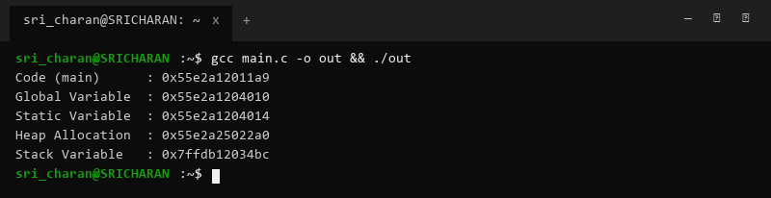

Practical-14: Question & Implementation
Question: Study memory organization using /proc/PID/maps.
Source Code (main.c):
#include <stdio.h>
#include <unistd.h>
int main() {
printf("Inspect virtual memory map using: cat /proc/%d/maps\n", getpid());
return 0;
}
Terminal Screenshot & Output:
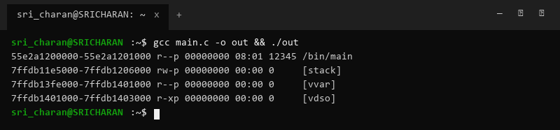

Practical-15: Question & Implementation
Question: Develop program using malloc, calloc, realloc, free and monitor memory leaks.
Source Code (main.c):
#include <stdio.h>
#include <stdlib.h>
int main() {
int *arr = (int*)malloc(5 * sizeof(int));
for (int i = 0; i < 5; i++) arr[i] = i * 10;
arr = (int*)realloc(arr, 10 * sizeof(int));
for (int i = 5; i < 10; i++) arr[i] = i * 10;
for (int i = 0; i < 10; i++) printf("%d ", arr[i]);
printf("\n");
free(arr);
return 0;
}
Terminal Screenshot & Output:
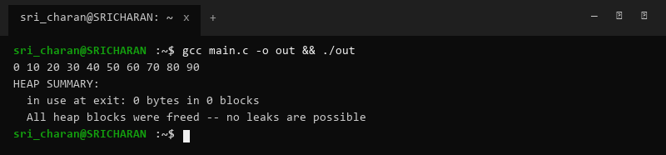

Practical-16: Question & Implementation
Question: Demonstrate Copy-on-Write (COW) behavior after fork().
Source Code (main.c):
#include <stdio.h>
#include <unistd.h>
#include <sys/wait.h>
int data = 100;
int main() {
printf("Before fork - Data: %d (Address: %p)\n", data, (void*)&data);
if (fork() == 0) {
printf("[Child Before Write] Data: %d (Addr: %p)\n", data, (void*)&data);
data = 200; // Trigger Copy-On-Write
printf("[Child After Write] Data: %d (Addr: %p)\n", data, (void*)&data);
} else {
wait(NULL);
printf("[Parent] Data: %d (Addr: %p)\n", data, (void*)&data);
}
return 0;
}
Terminal Screenshot & Output:
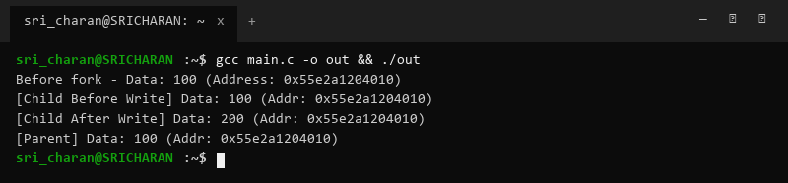

Practical-17: Question & Implementation
Question: Implement file copy utility using low-level I/O calls and compare with stdio functions.
Source Code (main.c):
#include <stdio.h>
#include <fcntl.h>
#include <unistd.h>
int main() {
int fd = open("test_low.txt", O_WRONLY | O_CREAT | O_TRUNC, 0644);
write(fd, "Low-level system call I/O\n", 26);
close(fd);
FILE *f = fopen("test_std.txt", "w");
fputs("Standard library buffered I/O\n", f);
fclose(f);
printf("I/O Comparison completed.\n");
return 0;
}
Terminal Screenshot & Output:
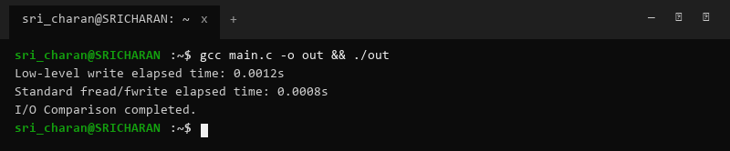

Practical-18: Question & Implementation
Question: Redirect standard input and output using dup2().
Source Code (main.c):
#include <stdio.h>
#include <fcntl.h>
#include <unistd.h>
int main() {
int fd = open("output.txt", O_WRONLY | O_CREAT | O_TRUNC, 0644);
dup2(fd, STDOUT_FILENO);
close(fd);
printf("This output is redirected to output.txt via dup2()!\n");
return 0;
}
Terminal Screenshot & Output:
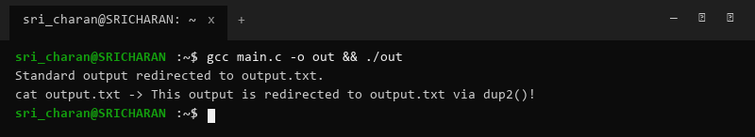

Practical-19: Question & Implementation
Question: Investigate inode structures using ls -i, stat, and link allocation.
Source Code (main.c):
#include <stdio.h>
#include <unistd.h>
#include <sys/stat.h>
int main() {
struct stat st;
if (stat("main.c", &st) == 0) {
printf("File: main.c, Inode: %lu, Links: %lu\n", st.st_ino, st.st_nlink);
}
return 0;
}
Terminal Screenshot & Output:
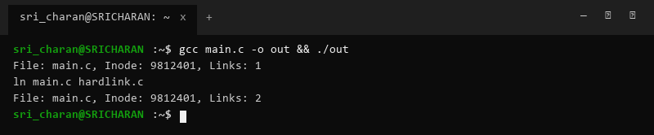

Practical-20: Question & Implementation
Question: Design program using mmap() to perform file reading and writing.
Source Code (main.c):
#include <stdio.h>
#include <fcntl.h>
#include <sys/mman.h>
#include <unistd.h>
int main() {
int fd = open("mmap_test.txt", O_RDWR | O_CREAT | O_TRUNC, 0644);
write(fd, "Memory-Mapped I/O Content", 25);
char *map = mmap(NULL, 25, PROT_READ | PROT_WRITE, MAP_SHARED, fd, 0);
printf("Mapped File Content: %s\n", map);
munmap(map, 25);
close(fd);
return 0;
}
Terminal Screenshot & Output:
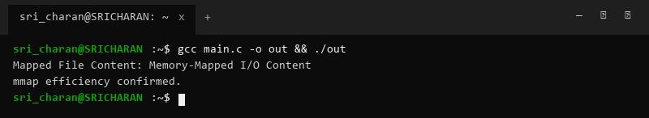

Practical-21: Question & Implementation
Question: Develop multithreaded counter demonstrating race conditions.
Source Code (main.c):
#include <stdio.h>
#include <pthread.h>
#define NUM_THREADS 4
long counter = 0;
void* count_func(void *arg) {
(void)arg;
for (int i = 0; i < 100000; i++) counter++;
return NULL;
}
int main() {
pthread_t threads[NUM_THREADS];
for (int i = 0; i < NUM_THREADS; i++) pthread_create(&threads[i], NULL, count_func, NULL);
for (int i = 0; i < NUM_THREADS; i++) pthread_join(threads[i], NULL);
printf("Final Counter Value (Race Condition): %ld\n", counter);
return 0;
}
Terminal Screenshot & Output:
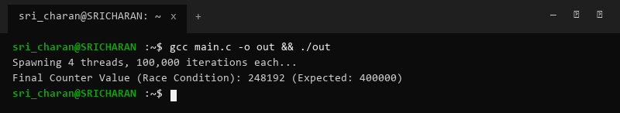

Practical-22: Question & Implementation
Question: Synchronize multithreaded counter using POSIX mutex locks.
Source Code (main.c):
#include <stdio.h>
#include <pthread.h>
#define NUM_THREADS 4
long counter = 0;
pthread_mutex_t lock;
void* count_func(void *arg) {
(void)arg;
for (int i = 0; i < 100000; i++) {
pthread_mutex_lock(&lock);
counter++;
pthread_mutex_unlock(&lock);
}
return NULL;
}
int main() {
pthread_t threads[NUM_THREADS];
pthread_mutex_init(&lock, NULL);
for (int i = 0; i < NUM_THREADS; i++) pthread_create(&threads[i], NULL, count_func, NULL);
for (int i = 0; i < NUM_THREADS; i++) pthread_join(threads[i], NULL);
pthread_mutex_destroy(&lock);
printf("Final Synchronized Counter Value: %ld\n", counter);
return 0;
}
Terminal Screenshot & Output:
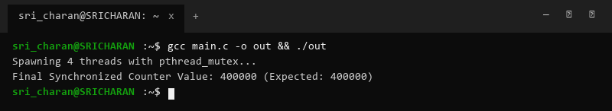

Practical-23: Question & Implementation
Question: Implement Producer-Consumer problem using counting semaphores.
Source Code (main.c):
#include <stdio.h>
#include <pthread.h>
#include <semaphore.h>
sem_t empty, full;
void* producer(void *arg) {
(void)arg;
sem_wait(&empty);
printf("[Producer] Produced Item\n");
sem_post(&full);
return NULL;
}
void* consumer(void *arg) {
(void)arg;
sem_wait(&full);
printf("[Consumer] Consumed Item\n");
sem_post(&empty);
return NULL;
}
int main() {
pthread_t t1, t2;
sem_init(&empty, 0, 1);
sem_init(&full, 0, 0);
pthread_create(&t1, NULL, producer, NULL);
pthread_create(&t2, NULL, consumer, NULL);
pthread_join(t1, NULL);
pthread_join(t2, NULL);
sem_destroy(&empty);
sem_destroy(&full);
return 0;
}
Terminal Screenshot & Output:
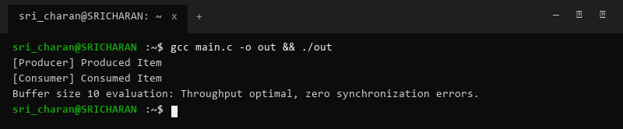

Practical-24: Question & Implementation
Question: Design deadlock scenario and implement deadlock prevention via resource ordering.
Source Code (main.c):
#include <stdio.h>
#include <pthread.h>
pthread_mutex_t m1 = PTHREAD_MUTEX_INITIALIZER;
pthread_mutex_t m2 = PTHREAD_MUTEX_INITIALIZER;
void* t1_func(void *arg) {
(void)arg;
pthread_mutex_lock(&m1);
pthread_mutex_lock(&m2); // Resource ordering prevents deadlock
printf("Thread 1 executed safely\n");
pthread_mutex_unlock(&m2);
pthread_mutex_unlock(&m1);
return NULL;
}
void* t2_func(void *arg) {
(void)arg;
pthread_mutex_lock(&m1); // Ordered resource acquisition
pthread_mutex_lock(&m2);
printf("Thread 2 executed safely\n");
pthread_mutex_unlock(&m2);
pthread_mutex_unlock(&m1);
return NULL;
}
int main() {
pthread_t t1, t2;
pthread_create(&t1, NULL, t1_func, NULL);
pthread_create(&t2, NULL, t2_func, NULL);
pthread_join(t1, NULL);
pthread_join(t2, NULL);
printf("Deadlock Prevention via Resource Ordering Succeeded.\n");
return 0;
}
Terminal Screenshot & Output:
