Operating Systems & System Programming (OSSP)

Practical Experiment 01: Hardware Resources & OS Abstraction
Team / Roll No: 2520090137
Course: OSSP (Operating Systems and System Programming)

1. Aim & Objective
To study how the operating system abstracts hardware resources (CPU, memory, storage, I/O devices) using Linux commands and demonstrate process creation using fork(), exec(), and wait().

2. Source Code & Implementation
Source Code Screenshot (main.c):
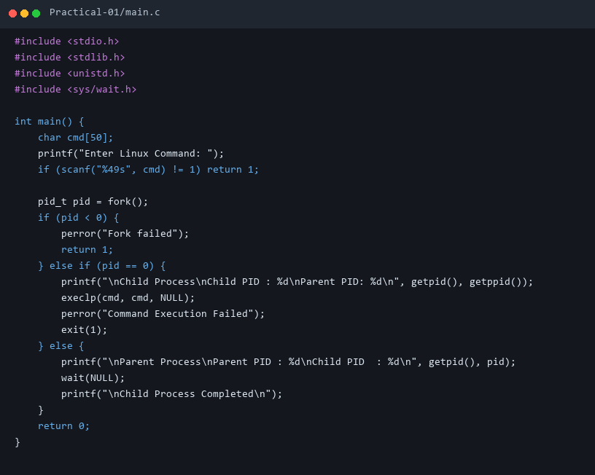

3. Execution & Output Screenshots
Terminal Execution & Output:
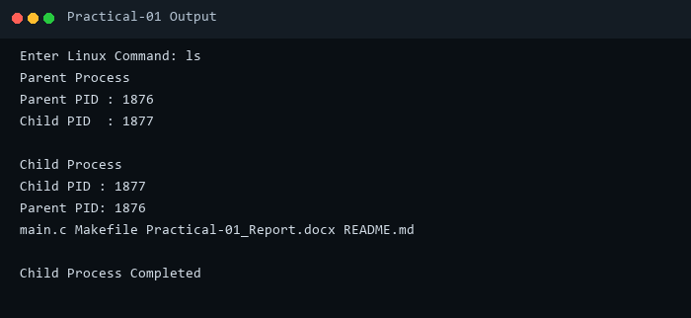

4. Technical Discussion & Key Concepts
The OS abstracts CPU execution via process scheduling. fork() duplicates the calling process into a parent and child. exec() replaces the child's address space with the requested program, and wait() blocks the parent until the child terminates.

