Operating Systems & System Programming (OSSP)

Practical Experiment 04: Parent-Child Synchronization via waitpid()
Team / Roll No: 2520090137
Course: OSSP (Operating Systems and System Programming)

1. Aim & Objective
To demonstrate selective parent waiting and synchronization with specific child processes using waitpid().

2. Source Code & Implementation
Source Code Screenshot (main.c):
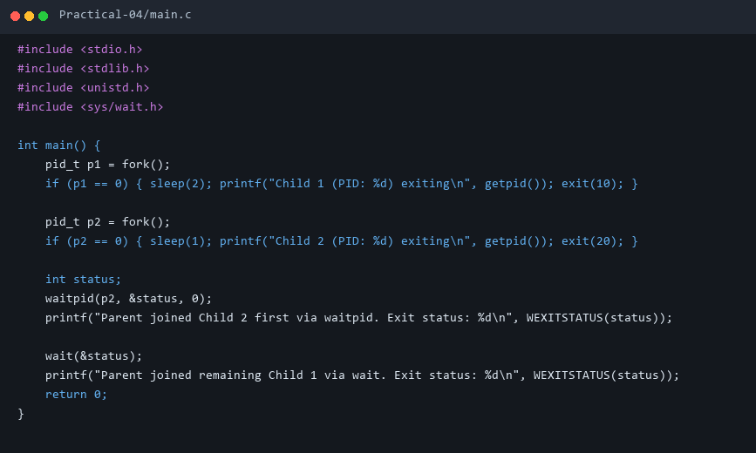

3. Execution & Output Screenshots
Terminal Execution & Output:


4. Technical Discussion & Key Concepts
waitpid() enables non-blocking or out-of-order process harvesting by targeting a specific child PID, preventing zombie process accumulation.

