Operating Systems & System Programming (OSSP)

Practical Experiment 05: Inter-Process Communication using Unnamed Pipes
Team / Roll No: 2520090137
Course: OSSP (Operating Systems and System Programming)

1. Aim & Objective
To establish unidirectional Inter-Process Communication (IPC) between parent and child processes using pipe().

2. Source Code & Implementation
Source Code Screenshot (main.c):
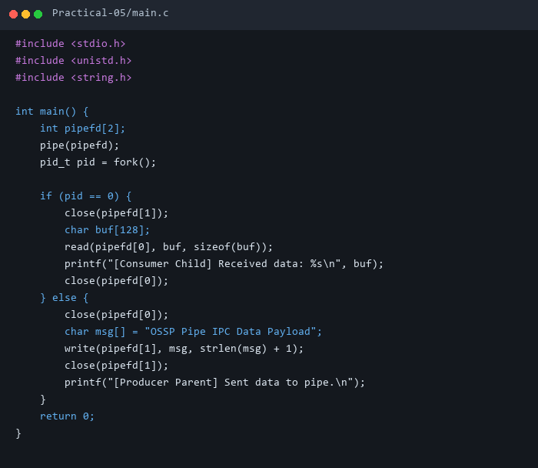

3. Execution & Output Screenshots
Terminal Execution & Output:


4. Technical Discussion & Key Concepts
An anonymous pipe creates a kernel-managed circular data buffer with read (pipefd[0]) and write (pipefd[1]) file descriptors shared across fork().

