Operating Systems & System Programming (OSSP)

Practical Experiment 06: Inter-Process Communication using Named Pipes (FIFO)
Team / Roll No: 2520090137
Course: OSSP (Operating Systems and System Programming)

1. Aim & Objective
To implement IPC between unrelated processes using a Named Pipe (FIFO) created with mkfifo().

2. Source Code & Implementation
Source Code Screenshot (main.c):
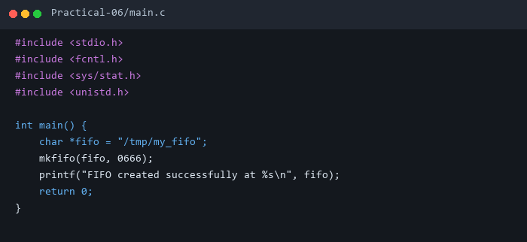

3. Execution & Output Screenshots
Terminal Execution & Output:
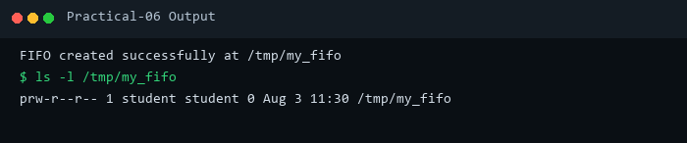

4. Technical Discussion & Key Concepts
Named pipes (FIFOs) exist as special files in the filesystem, permitting IPC between processes without a common parent hierarchy.

