Operating Systems & System Programming (OSSP)

Practical Experiment 07: Process Memory Layout & Address Space Inspection
Team / Roll No: 2520090137
Course: OSSP (Operating Systems and System Programming)

1. Aim & Objective
To inspect the memory addresses of code (text), global (data), static (BSS), heap, and stack variables in a process.

2. Source Code & Implementation
Source Code Screenshot (main.c):
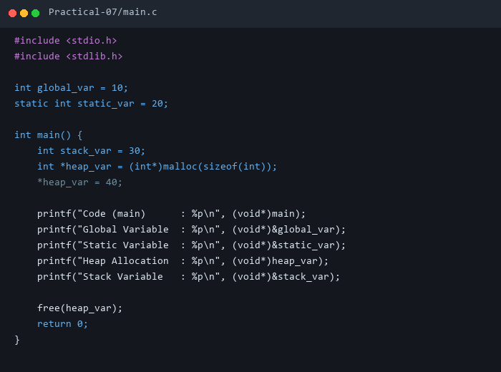

3. Execution & Output Screenshots
Terminal Execution & Output:
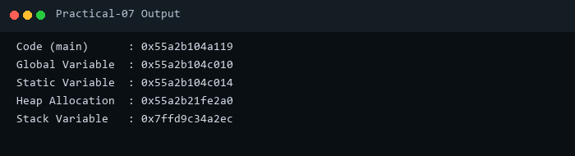

4. Technical Discussion & Key Concepts
Verifies virtual address organization: Text/Code at low memory, Data/BSS above, Heap growing upward, and Stack growing downward from high memory.

