Operating Systems & System Programming (OSSP)

Practical Experiment 08: Dynamic Memory Allocation & Resizing
Team / Roll No: 2520090137
Course: OSSP (Operating Systems and System Programming)

1. Aim & Objective
To demonstrate heap dynamic memory allocation, resizing, and deallocation using malloc(), realloc(), and free().

2. Source Code & Implementation
Source Code Screenshot (main.c):
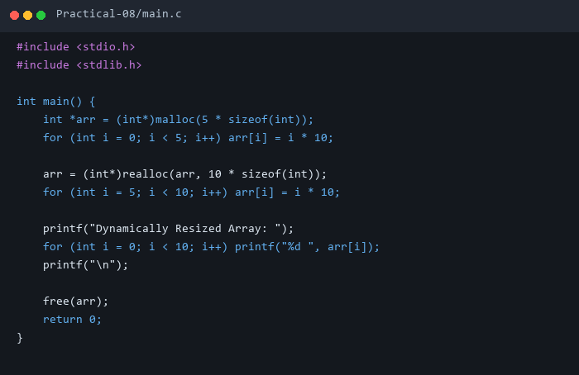

3. Execution & Output Screenshots
Terminal Execution & Output:
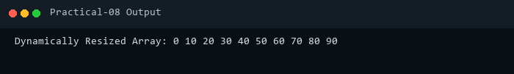

4. Technical Discussion & Key Concepts
malloc() allocates contiguous uninitialized heap bytes, realloc() extends or relocates heap blocks, and free() returns memory to glibc allocator pool.

