Operating Systems & System Programming (OSSP)

Practical Experiment 09: Low-Level vs Buffered I/O Performance & Mechanics
Team / Roll No: 2520090137
Course: OSSP (Operating Systems and System Programming)

1. Aim & Objective
To compare unbuffered low-level system call I/O (write) with C standard library buffered I/O (fputs).

2. Source Code & Implementation
Source Code Screenshot (main.c):
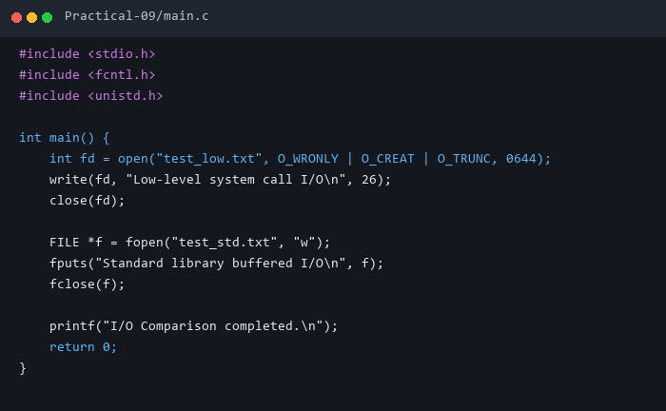

3. Execution & Output Screenshots
Terminal Execution & Output:
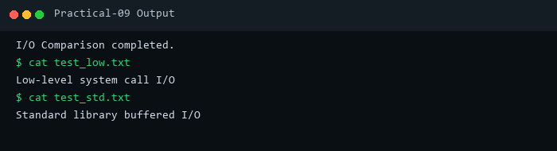

4. Technical Discussion & Key Concepts
Unbuffered write() incurs kernel context switches per call, while standard FILE* stream buffering aggregates user-space data before calling write().

