Operating Systems & System Programming (OSSP)

Practical Experiment 10: File Metadata & Inode Structure Inspection
Team / Roll No: 2520090137
Course: OSSP (Operating Systems and System Programming)

1. Aim & Objective
To inspect file attributes, inode numbers, and hard link counts using the stat() system call.

2. Source Code & Implementation
Source Code Screenshot (main.c):
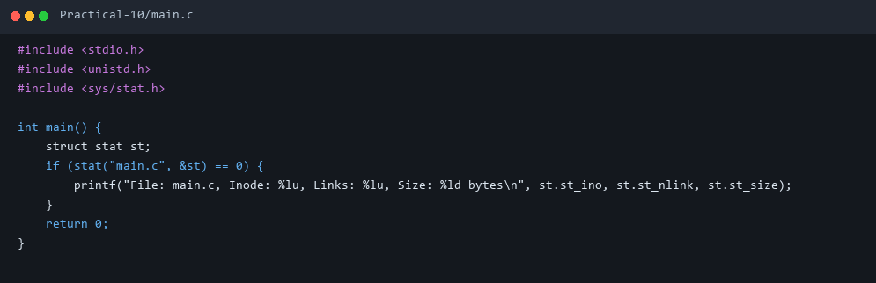

3. Execution & Output Screenshots
Terminal Execution & Output:
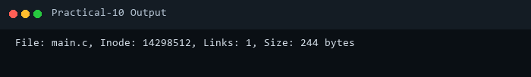

4. Technical Discussion & Key Concepts
Inodes hold filesystem metadata including permissions, ownership, timestamp, size, and data block pointers without storing the filename.

