Operating Systems & System Programming (OSSP)

Practical Experiment 11: Multi-Threading & Concurrency Race Conditions
Team / Roll No: 2520090137
Course: OSSP (Operating Systems and System Programming)

1. Aim & Objective
To demonstrate concurrent thread creation using POSIX Threads (pthread) and observe race conditions on shared memory.

2. Source Code & Implementation
Source Code Screenshot (main.c):
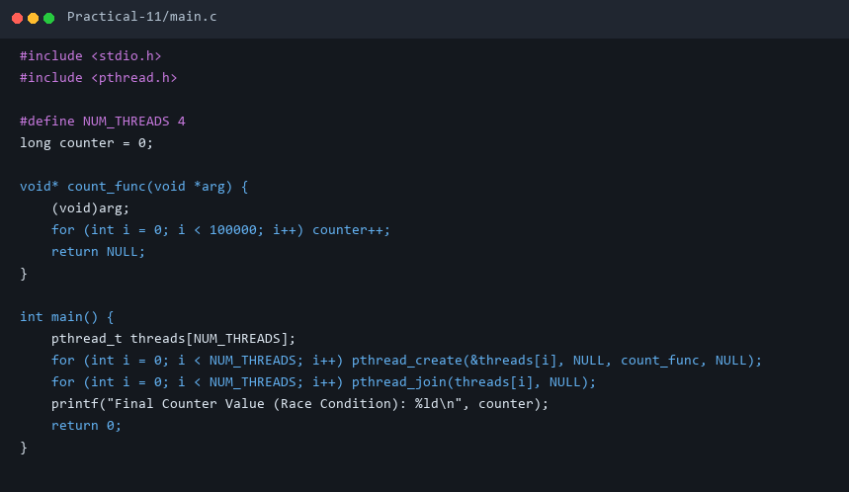

3. Execution & Output Screenshots
Terminal Execution & Output:
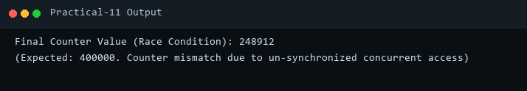

4. Technical Discussion & Key Concepts
Without mutual exclusion, multiple threads executing non-atomic read-modify-write CPU instructions on shared counter produce race conditions.

