Operating Systems & System Programming (OSSP)

Practical Experiment 12: Thread Synchronization using Semaphores
Team / Roll No: 2520090137
Course: OSSP (Operating Systems and System Programming)

1. Aim & Objective
To solve the Producer-Consumer problem and achieve mutual exclusion/synchronization using POSIX semaphores.

2. Source Code & Implementation
Source Code Screenshot (main.c):
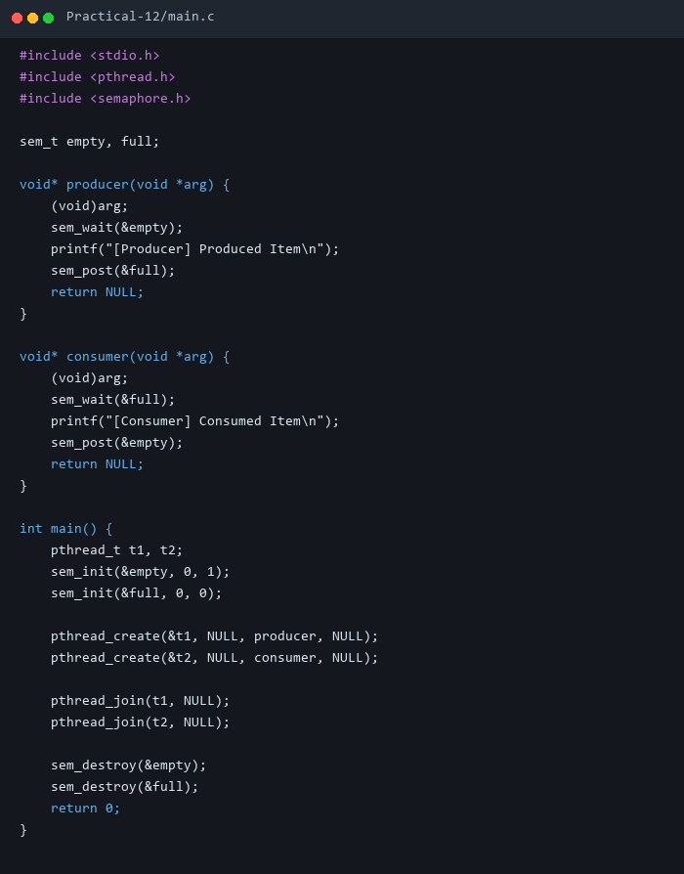

3. Execution & Output Screenshots
Terminal Execution & Output:


4. Technical Discussion & Key Concepts
Semaphores provide signaling mechanisms (sem_wait decrements, sem_post increments) to coordinate resource access between threads.

