Operating Systems & System Programming (OSSP)

Skill Activity 01: Linux Environment & GCC Toolchain Setup
Team / Roll No: 2520090137
Course: OSSP (Operating Systems and System Programming)

1. Activity Description & Aim
Installing Linux VM/WSL, terminal orientation, filesystem hierarchy navigation, GCC compiler setup, and C compilation.

2. Code & Script Implementation
Command / Source Code Screenshot:
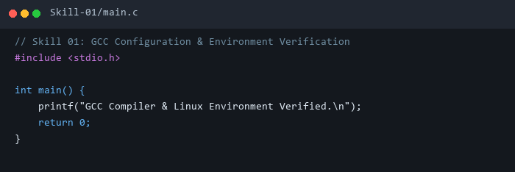

3. Execution & Verification Output
Terminal Results Screenshot:
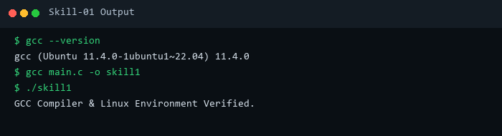

4. Key Takeaways & Concept Summary
Verified GCC toolchain installation and environment setup for compiling system programming C binaries.

