Operating Systems & System Programming (OSSP)

Skill Activity 02: Linux Shell & Directory Navigation Commands
Team / Roll No: 2520090137
Course: OSSP (Operating Systems and System Programming)

1. Activity Description & Aim
Mastering Linux shell commands: pwd, ls, cd, mkdir, rmdir, cp, mv, rm, cat, echo, find, history, and shell scripting basics.

2. Code & Script Implementation
Command / Source Code Screenshot:
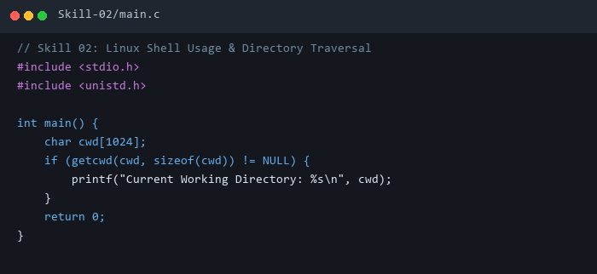

3. Execution & Verification Output
Terminal Results Screenshot:
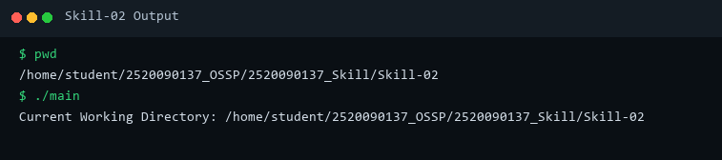

4. Key Takeaways & Concept Summary
Practiced Linux file manipulation, directory tree navigation, and standard terminal utility commands.

