Operating Systems & System Programming (OSSP)

Skill Activity 03: Git Version Control & Project Directory Organization
Team / Roll No: 2520090137
Course: OSSP (Operating Systems and System Programming)

1. Activity Description & Aim
Git initialization, staging, commits, branch management, status inspection, and structured project directory layout (src, include, bin, docs).

2. Code & Script Implementation
Command / Source Code Screenshot:
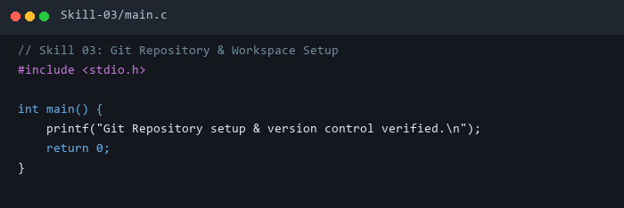

3. Execution & Verification Output
Terminal Results Screenshot:
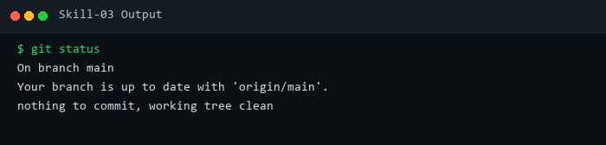

4. Key Takeaways & Concept Summary
Configured local and remote Git repository synchronization adhering to OSSP course specifications.

