Operating Systems & System Programming (OSSP)

Skill Activity 04: Shell Architecture & Makefile Automation
Team / Roll No: 2520090137
Course: OSSP (Operating Systems and System Programming)

1. Activity Description & Aim
Understanding User -> Shell -> Kernel -> Hardware architecture layers, process execution flow, and writing automated build Makefiles.

2. Code & Script Implementation
Command / Source Code Screenshot:
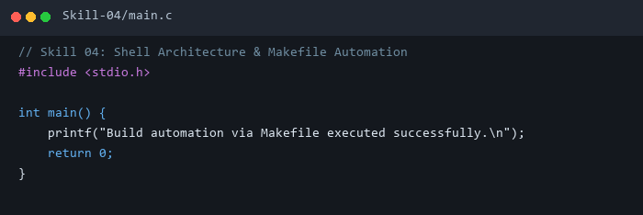

3. Execution & Verification Output
Terminal Results Screenshot:
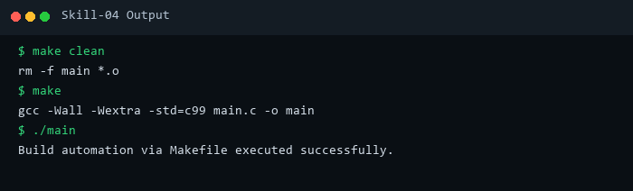

4. Key Takeaways & Concept Summary
Built modular Makefile targets (all, clean, run) to automate C compilation workflows.

