Operating Systems & System Programming (OSSP)

Skill Activity 05: Process Creation using fork()
Team / Roll No: 2520090137
Course: OSSP (Operating Systems and System Programming)

1. Activity Description & Aim
Exploring process abstraction, fork() system call mechanics, parent and child process execution, PID/PPID retrieval.

2. Code & Script Implementation
Command / Source Code Screenshot:
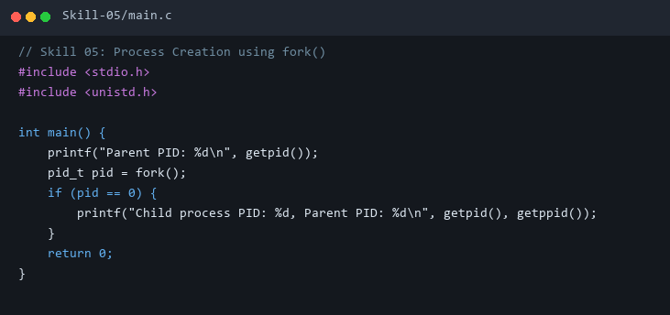

3. Execution & Verification Output
Terminal Results Screenshot:
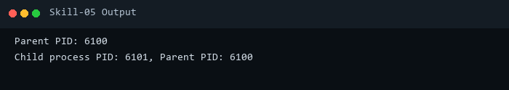

4. Key Takeaways & Concept Summary
Analyzed kernel PCB clone mechanism and address space duplication upon calling fork().

