Operating Systems & System Programming (OSSP)

Skill Activity 06: Process Replacement using the exec() Family
Team / Roll No: 2520090137
Course: OSSP (Operating Systems and System Programming)

1. Activity Description & Aim
Understanding process image replacement using execl(), execv(), execvp() family to replace process code, stack, and data.

2. Code & Script Implementation
Command / Source Code Screenshot:
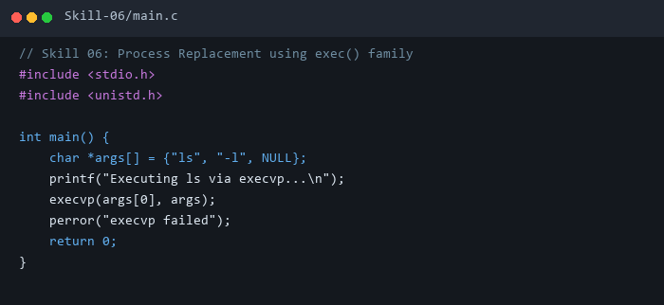

3. Execution & Verification Output
Terminal Results Screenshot:
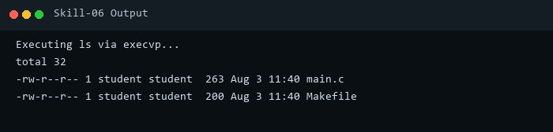

4. Key Takeaways & Concept Summary
execvp() replaces current execution context with new program binary while preserving PID.

