Operating Systems & System Programming (OSSP)

Skill Activity 07: Parent-Child Synchronization using wait() and waitpid()
Team / Roll No: 2520090137
Course: OSSP (Operating Systems and System Programming)

1. Activity Description & Aim
Implementing parent process blocking, child status collection, exit status evaluation, and termination synchronization.

2. Code & Script Implementation
Command / Source Code Screenshot:
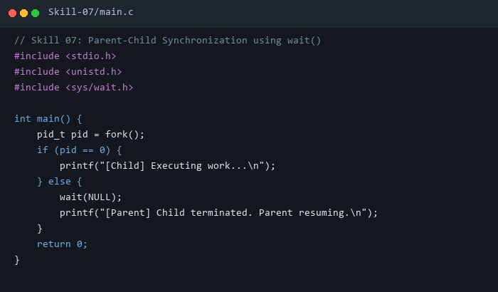

3. Execution & Verification Output
Terminal Results Screenshot:
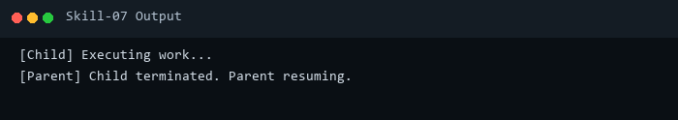

4. Key Takeaways & Concept Summary
Demonstrated synchronous process coordination preventing orphan and zombie states.

