Operating Systems & System Programming (OSSP)

Skill Activity 08: Process Tree & Hierarchy Analysis
Team / Roll No: 2520090137
Course: OSSP (Operating Systems and System Programming)

1. Activity Description & Aim
Analyzing multiple fork() calls, process hierarchy trees, PID lineage, and inspecting process trees using pstree / ps.

2. Code & Script Implementation
Command / Source Code Screenshot:
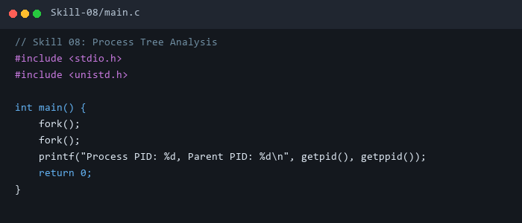

3. Execution & Verification Output
Terminal Results Screenshot:
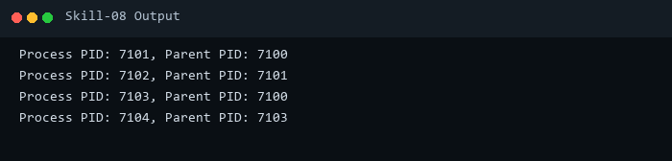

4. Key Takeaways & Concept Summary
Calculated 2^n = 4 total active processes generated by 2 sequential fork() system calls.

