Operating Systems & System Programming (OSSP)

Skill Activity 09: System Call Tracing using strace
Team / Roll No: 2520090137
Course: OSSP (Operating Systems and System Programming)

1. Activity Description & Aim
Tracing Linux binaries (ls, pwd, date) using strace, observing execve(), openat(), read(), write(), and close() system call sequences.

2. Code & Script Implementation
Command / Source Code Screenshot:
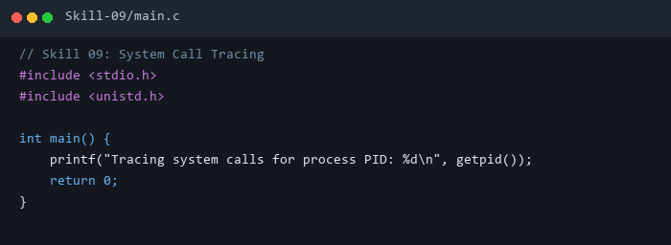

3. Execution & Verification Output
Terminal Results Screenshot:
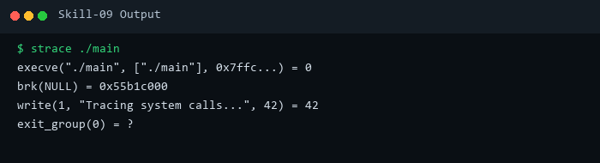

4. Key Takeaways & Concept Summary
Used strace diagnostic utility to intercept and log kernel system call invocations.

