Operating Systems & System Programming (OSSP)

Skill Activity 10: Interactive Mini Shell Program
Team / Roll No: 2520090137
Course: OSSP (Operating Systems and System Programming)

1. Activity Description & Aim
Building an interactive command line prompt accepting user commands, executing via fork(), exec(), and wait(), and printing PIDs.

2. Code & Script Implementation
Command / Source Code Screenshot:
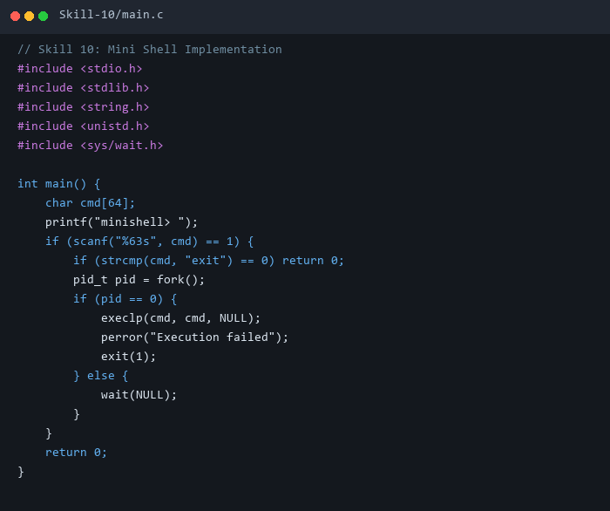

3. Execution & Verification Output
Terminal Results Screenshot:
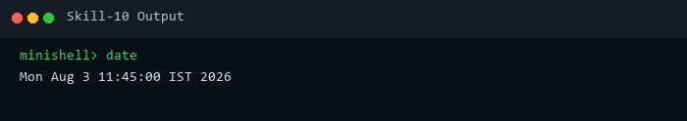

4. Key Takeaways & Concept Summary
Combined fork(), exec(), and wait() into a functional user-space shell program loop.

