ARCHITECTURE
# **Enterprise Architecture Document**
**Project:** *Spendid_project* – Brokerage Finance Operations Command Center
**Industry:** Insurance – Brokerage Finance
**Version:** 1.0 – 2026‑10‑10
**Prepared by:** Enterprise Architecture Team (EA, BA, SA, SecArch, UI/UX, QA, AI‑Transformation)
---
## 1. Document Overview
| Section | Description |
|---------|-------------|
| **1.0** | Document purpose, scope and conventions |
| **2.0** | Governance, compliance, and risk‑management framework |
| **3.0** | Non‑functional requirements (NFR) – security, scalability, auditability, etc. |
| **4.0** | **Application Architecture** – logical components, AI/agent flow, UI layers |
| **5.0** | **Technical Architecture** – platform stack, runtime, observability |
| **6.0** | **Integration Architecture** – inbound/outbound interfaces, data‑exchange patterns |
| **7.0** | **Security Architecture** – identity, data protection, secure AI usage |
| **8.0** | **Deployment Architecture** – environments, CI/CD pipeline, multi‑region scaling |
| **9.0** | Architecture diagrams (Mermaid) |
| **10.0** | References & tool‑selection rationale |
All diagrams are expressed in **Mermaid** syntax to enable version‑controlled, reproducible visual artefacts.
---
## 2. Governance, Compliance & Risk Management
| Aspect | Policy / Standard | Owner | Enforcement Mechanism |
|--------|-------------------|-------|-----------------------|
| **Enterprise Architecture Governance** | TOGAF ADM, ArchiMate 3.1 | Chief Enterprise Architect | Architecture Review Board (ARB) – quarterly |
| **Data Privacy & Protection** | GDPR, CCPA, ISO‑27001 Annex A.15 | Data Protection Officer (DPO) | Data‑flow impact analysis, DLP, encryption‑at‑rest & in‑transit |
| **Financial Controls** | SOX §404, ICAAP, internal audit charter | CFO / Finance Controls Lead | Segregation‑of‑duties (SoD) matrix, immutable audit log |
| **AI Governance** | Responsible AI Framework (IBM, EU AI Act draft) | AI Ethics Officer | Prompt‑registry, model‑card, confidence‑threshold enforcement, human‑in‑the‑loop |
| **Change Management** | ITIL Change Management v4 | Change Manager | CI/CD gate‑checks, automated policy compliance scans |
| **Incident Response** | NIST 800‑61 Rev.2 | Security Operations Center (SOC) | SIEM alerts, automated playbooks, post‑mortem reviews |
| **Vendor & Tool Approval** | Enterprise‑Approved Tool List (EATL) | Procurement Lead | Procurement workflow + security vetting checklist |
> **Compliance Scope** – The solution must satisfy **SOX**, **GDPR/CCPA**, **PCI‑DSS** (where payment data is processed), and the **EU AI Act** (risk‑based classification). All logs are retained for **7 years** (financial) and **2 years** (AI‑model usage) per regulatory mandates.
---
## 3. Non‑Functional Requirements (NFR)
| Category | Requirement | Metric / Acceptance Criteria |
|----------|-------------|------------------------------|
| **Performance** | End‑to‑end response ≤ 2 s for dashboard queries; ≤ 500 ms for AI‑copilot answer | Load‑test 10 k concurrent users, 95th percentile |
| **Scalability** | Horizontal scaling to 5× peak load (≈ 50 k concurrent sessions) | Auto‑scale policies in Kubernetes |
| **Availability** | 99.9 % SLA (≤ 43 min downtime/month) | Multi‑AZ deployment, health‑checks, fail‑over |
| **Security** | Zero‑trust network, least‑privilege IAM, encryption TLS 1.3, AES‑256 at rest | Pen‑test OWASP Top 10, SOC‑2 Type II audit |
| **Auditability** | Immutable append‑only audit trail for every financial transaction, AI decision, and user action | WORM storage, hash‑chained logs, tamper‑evidence |
| **Observability** | Full‑stack metrics, distributed tracing, log aggregation, alerting | Prometheus + Grafana, OpenTelemetry, ELK |
| **Maintainability** | Code coverage ≥ 85 %; modular micro‑service design; CI lint & static analysis | SonarQube, Semgrep |
| **Compliance** | Data residency: US‑East & EU‑West; token‑level AI usage captured | Data‑location tags, token‑omics register |
| **Disaster Recovery** | RPO ≤ 15 min, RTO ≤ 30 min | Geo‑replicated backups, automated fail‑over drills |
| **Usability** | Persona‑driven UI with WCAG 2.1 AA compliance | Accessibility audit, user‑testing score ≥ 4.5/5 |
---
## 4. Application Architecture
### 4.1 High‑Level Logical View
| Layer | Primary Responsibilities | Key Services / Components |
|-------|---------------------------|----------------------------|
| **Presentation** | Multi‑persona UI, responsive web, Copilot chat UI | React‑TS SPA, Figma‑derived component library, Streamlit/Gradio **Copilot** widget |
| **API Gateway** | Secure entry point, request routing, rate‑limiting, auth enforcement | Kong Enterprise (or Azure API Management) |
| **Domain Services** | Finance‑journey engine, Exception‑Workbench, Ledger, Forecasting, Reporting | - **FinanceJourneyService** (state machine, BPMN) <br> - **ExceptionService** (AI‑classification, clustering) <br> - **LedgerService** (synthetic ledger, double‑entry) <br> - **ForecastService** (time‑series, Prophet) |
| **AI/Agent Layer** | LLM‑driven Copilot, classification models, token‑omics tracker | LangChain orchestrator, Azure OpenAI gpt‑4o‑mini (for low‑latency), fine‑tuned proprietary model for finance‑specific taxonomy |
| **Data Access** | Repository pattern, transaction boundaries, audit logging | Spring Data JPA / TypeORM, PostgreSQL, Redis cache |
| **Infrastructure Services** | Messaging, job scheduling, secrets, observability | Kafka, Celery/Sidekiq, HashiCorp Vault, OpenTelemetry, Prometheus |
| **Security Services** | IAM, RBAC, SoD enforcement, encryption key management | Keycloak (OIDC), OPA (Open Policy Agent) for policy enforcement |
### 4.2 Component Diagram (Mermaid)
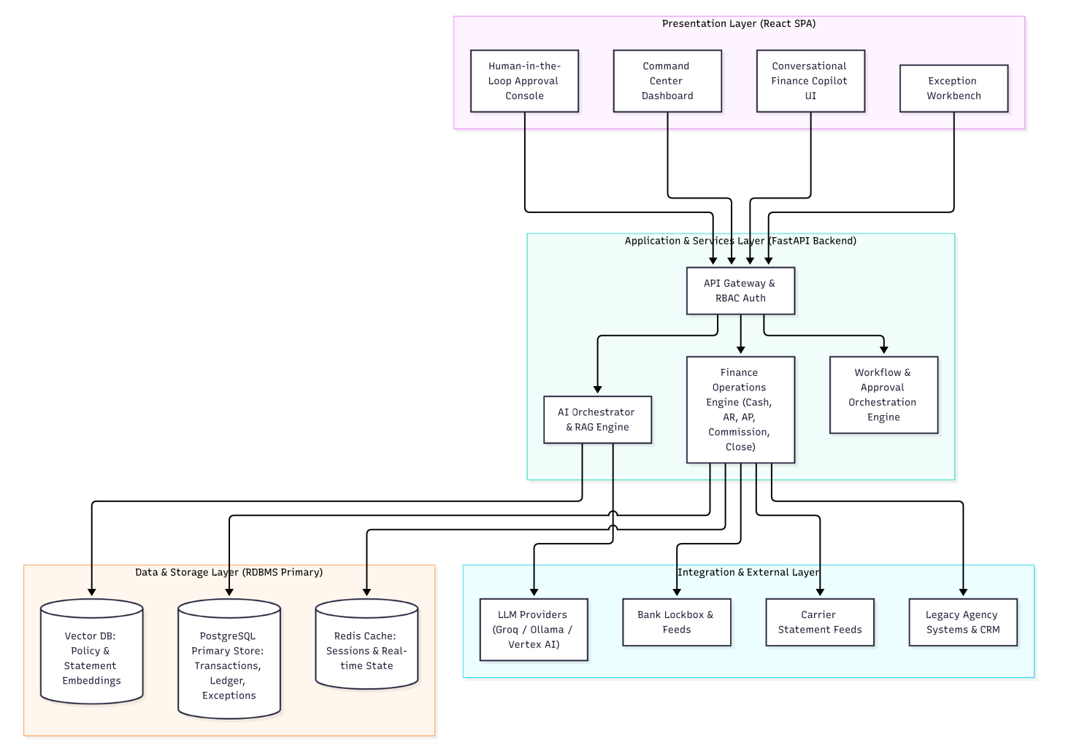
### 4.3 AI/Agent Interaction Flow (Sequence Diagram)
Key security & audit points are highlighted in the sequence: token validation, role‑based access, audit‑log write before any UI display.
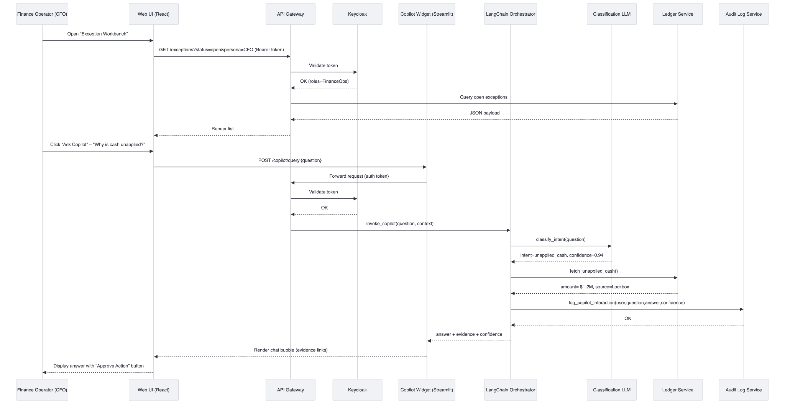
## 5. Technical Architecture
| Concern | Decision | Rationale (Tool Selection) |
|---------|----------|----------------------------|
| **Runtime** | **Kubernetes (EKS / AKS)** | Cloud‑native orchestration, auto‑scaling, pod‑security‑policies, multi‑AZ resilience |
| **Language Stack** | **Java 17 (Spring Boot) + TypeScript (React)** | Enterprise‑grade, strong typing, mature security libraries, aligns with existing Meridian stack |
| **AI Orchestration** | **LangChain (Python) running as side‑car containers** | Proven LLM workflow, easy integration with Azure OpenAI, supports tool‑use & memory |
| **Message Bus** | **Apache Kafka (Confluent Cloud)** | High‑throughput, exactly‑once semantics for finance events |
| **Cache** | **Redis (clustered)** | Low‑latency look‑ups for ledger balances, session store |
| **Search / Analytics** | **ElasticSearch + Kibana** | Full‑text search on statements, exception clustering, audit‑log exploration |
| **Observability** | **OpenTelemetry SDK** (Java & Python) → **Prometheus + Grafana** + **ELK** | End‑to‑end tracing across micro‑services, supports compliance reporting |
| **CI/CD** | **GitHub Actions + ArgoCD** | Declarative GitOps, automated security scans (Trivy, Semgrep, SonarQube) |
| **Secrets Management** | **HashiCorp Vault** (auto‑unseal via Cloud KMS) | Centralised secret rotation, least‑privilege token issuance |
| **Static Code Analysis** | **Semgrep + SonarQube Community** | Detect OWASP Top‑10, enforce coding standards |
| **Container Scanning** | **Trivy** | CVE detection, SBOM generation for supply‑chain security |
| **Synthetic Data Generator** | **Faker + custom Python scripts** (containerized) | Guarantees no PII, reproducible test data sets |
All tools are **event‑approved** (listed in the Enterprise‑Approved Tool List) and have been vetted for **no real customer data** ingestion.
---
## 6. Integration Architecture
### 6.1 Core Integration Points
| System | Direction | Protocol / Format | Frequency | Governance |
|--------|-----------|-------------------|-----------|------------|
| **Agency Core Systems** (legacy policy admin) | Inbound – transaction feeds | SFTP (CSV/EDI) → ingestion micro‑service | Near‑real‑time (batch every 5 min) | Data‑mapping contract, checksum validation |
| **Carrier Portals** | Inbound – premium statements | HTTPS (REST JSON) + optional XML | Daily at 02:00 UTC | Mutual TLS, schema validation |
| **Bank Lockbox** | Inbound – receipt files | SFTP (fixed‑width) | Event‑driven (file arrival) | File‑level encryption, PGP |
| **Payroll / Producer Compensation** | Outbound – payout instructions | ACH file (NACHA) via secure FTP | End‑of‑day batch | Dual‑control sign‑off |
| **ERP / General Ledger** | Outbound – journal entries | SOAP (XML) or REST (JSON) depending on ERP | Real‑time posting after approval | Idempotent API, audit‑trail |
| **External AI Provider** (Azure OpenAI) | Outbound – prompt/response | HTTPS (TLS 1.3) JSON | Per‑request (≤ 200 ms) | Prompt‑registry, token‑usage logging |
| **Monitoring / SIEM** | Outbound – logs & metrics | Syslog / OTLP | Continuous | Log‑retention policy, WORM storage |
### 6.2 Integration Flow Diagram (Mermaid)
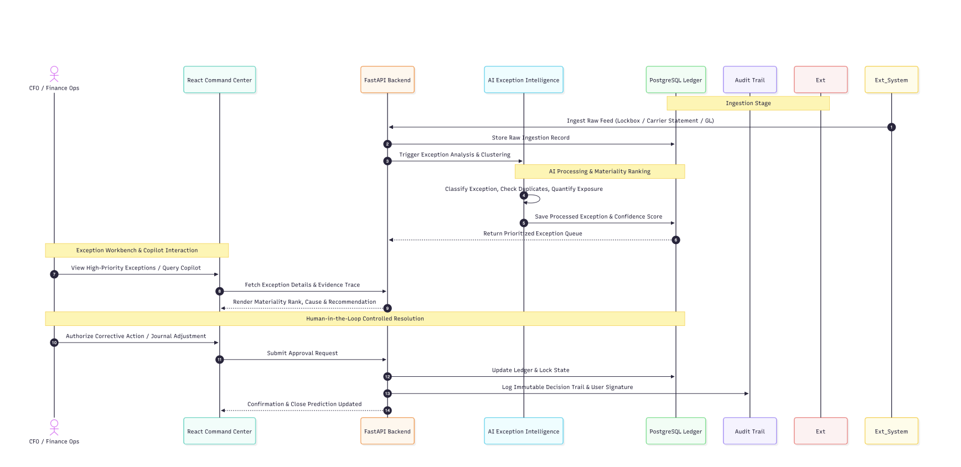
## 7. Security Architecture
### 7.1 Security Principles
1. **Zero Trust** – Verify every request, never trust network location.
2. **Least Privilege** – Role‑based access (RBAC) enforced by Keycloak + OPA policies.
3. **Defense in Depth** – Network segmentation, pod‑security‑policies, WAF, runtime security.
4. **Secure AI** – Prompt‑registry, model‑card, confidence thresholds, human‑in‑the‑loop for any monetary action.
5. **Data Protection** – Encryption‑in‑transit (TLS 1.3), encryption‑at‑rest (AES‑256), tokenization for account numbers.
### 7.2 Threat Model (STRIDE)
| Threat | Asset | Mitigation |
|--------|-------|------------|
| **Spoofing** | API calls, user sessions | OIDC with MFA, short‑lived JWTs, rotating

