Enterprise Architecture Document
Project: Spendid_project – Brokerage Finance Operations Command Center
Industry: Insurance – Brokerage Finance
Version: 1.0 – 2026‑10‑10
Prepared by: Enterprise Architecture Team (EA, BA, SA, SecArch, UI/UX, QA, AI‑Transformation)

1. Document Overview
Section | Description
1.0 | Document purpose, scope and conventions
2.0 | Governance, compliance, and risk‑management framework
3.0 | Non‑functional requirements (NFR) – security, scalability, auditability, etc.
4.0 | Application Architecture – logical components, AI/agent flow, UI layers
5.0 | Technical Architecture – platform stack, runtime, observability
6.0 | Integration Architecture – inbound/outbound interfaces, data‑exchange patterns
7.0 | Security Architecture – identity, data protection, secure AI usage
8.0 | Deployment Architecture – environments, CI/CD pipeline, multi‑region scaling
9.0 | Architecture diagrams (Mermaid)
10.0 | References & tool‑selection rationale
All diagrams are expressed in Mermaid syntax to enable version‑controlled, reproducible visual artefacts.

2. Governance, Compliance & Risk Management
Aspect | Policy / Standard | Owner | Enforcement Mechanism
Enterprise Architecture Governance | TOGAF ADM, ArchiMate 3.1 | Chief Enterprise Architect | Architecture Review Board (ARB) – quarterly
Data Privacy & Protection | GDPR, CCPA, ISO‑27001 Annex A.15 | Data Protection Officer (DPO) | Data‑flow impact analysis, DLP, encryption‑at‑rest & in‑transit
Financial Controls | SOX §404, ICAAP, internal audit charter | CFO / Finance Controls Lead | Segregation‑of‑duties (SoD) matrix, immutable audit log
AI Governance | Responsible AI Framework (IBM, EU AI Act draft) | AI Ethics Officer | Prompt‑registry, model‑card, confidence‑threshold enforcement, human‑in‑the‑loop
Change Management | ITIL Change Management v4 | Change Manager | CI/CD gate‑checks, automated policy compliance scans
Incident Response | NIST 800‑61 Rev.2 | Security Operations Center (SOC) | SIEM alerts, automated playbooks, post‑mortem reviews
Vendor & Tool Approval | Enterprise‑Approved Tool List (EATL) | Procurement Lead | Procurement workflow + security vetting checklist
Compliance Scope – The solution must satisfy SOX, GDPR/CCPA, PCI‑DSS (where payment data is processed), and the EU AI Act (risk‑based classification). All logs are retained for 7 years (financial) and 2 years (AI‑model usage) per regulatory mandates.

3. Non‑Functional Requirements (NFR)
Category | Requirement | Metric / Acceptance Criteria
Performance | End‑to‑end response ≤ 2 s for dashboard queries; ≤ 500 ms for AI‑copilot answer | Load‑test 10 k concurrent users, 95th percentile
Scalability | Horizontal scaling to 5× peak load (≈ 50 k concurrent sessions) | Auto‑scale policies in Kubernetes
Availability | 99.9 % SLA (≤ 43 min downtime/month) | Multi‑AZ deployment, health‑checks, fail‑over
Security | Zero‑trust network, least‑privilege IAM, encryption TLS 1.3, AES‑256 at rest | Pen‑test OWASP Top 10, SOC‑2 Type II audit
Auditability | Immutable append‑only audit trail for every financial transaction, AI decision, and user action | WORM storage, hash‑chained logs, tamper‑evidence
Observability | Full‑stack metrics, distributed tracing, log aggregation, alerting | Prometheus + Grafana, OpenTelemetry, ELK
Maintainability | Code coverage ≥ 85 %; modular micro‑service design; CI lint & static analysis | SonarQube, Semgrep
Compliance | Data residency: US‑East & EU‑West; token‑level AI usage captured | Data‑location tags, token‑omics register
Disaster Recovery | RPO ≤ 15 min, RTO ≤ 30 min | Geo‑replicated backups, automated fail‑over drills
Usability | Persona‑driven UI with WCAG 2.1 AA compliance | Accessibility audit, user‑testing score ≥ 4.5/5

4. Application Architecture

4.1 High‑Level Logical View
Layer | Primary Responsibilities | Key Services / Components
Presentation | Multi‑persona UI, responsive web, Copilot chat UI | React‑TS SPA, Figma‑derived component library, Streamlit/Gradio Copilot widget
API Gateway | Secure entry point, request routing, rate‑limiting, auth enforcement | Kong Enterprise (or Azure API Management)
Domain Services | Finance‑journey engine, Exception‑Workbench, Ledger, Forecasting, Reporting | - FinanceJourneyService (state machine, BPMN) <br> - ExceptionService (AI‑classification, clustering) <br> - LedgerService (synthetic ledger, double‑entry) <br> - ForecastService (time‑series, Prophet)
AI/Agent Layer | LLM‑driven Copilot, classification models, token‑omics tracker | LangChain orchestrator, Azure OpenAI gpt‑4o‑mini (for low‑latency), fine‑tuned proprietary model for finance‑specific taxonomy
Data Access | Repository pattern, transaction boundaries, audit logging | Spring Data JPA / TypeORM, PostgreSQL, Redis cache
Infrastructure Services | Messaging, job scheduling, secrets, observability | Kafka, Celery/Sidekiq, HashiCorp Vault, OpenTelemetry, Prometheus
Security Services | IAM, RBAC, SoD enforcement, encryption key management | Keycloak (OIDC), OPA (Open Policy Agent) for policy enforcement

4.2 Component Diagram (Mermaid)
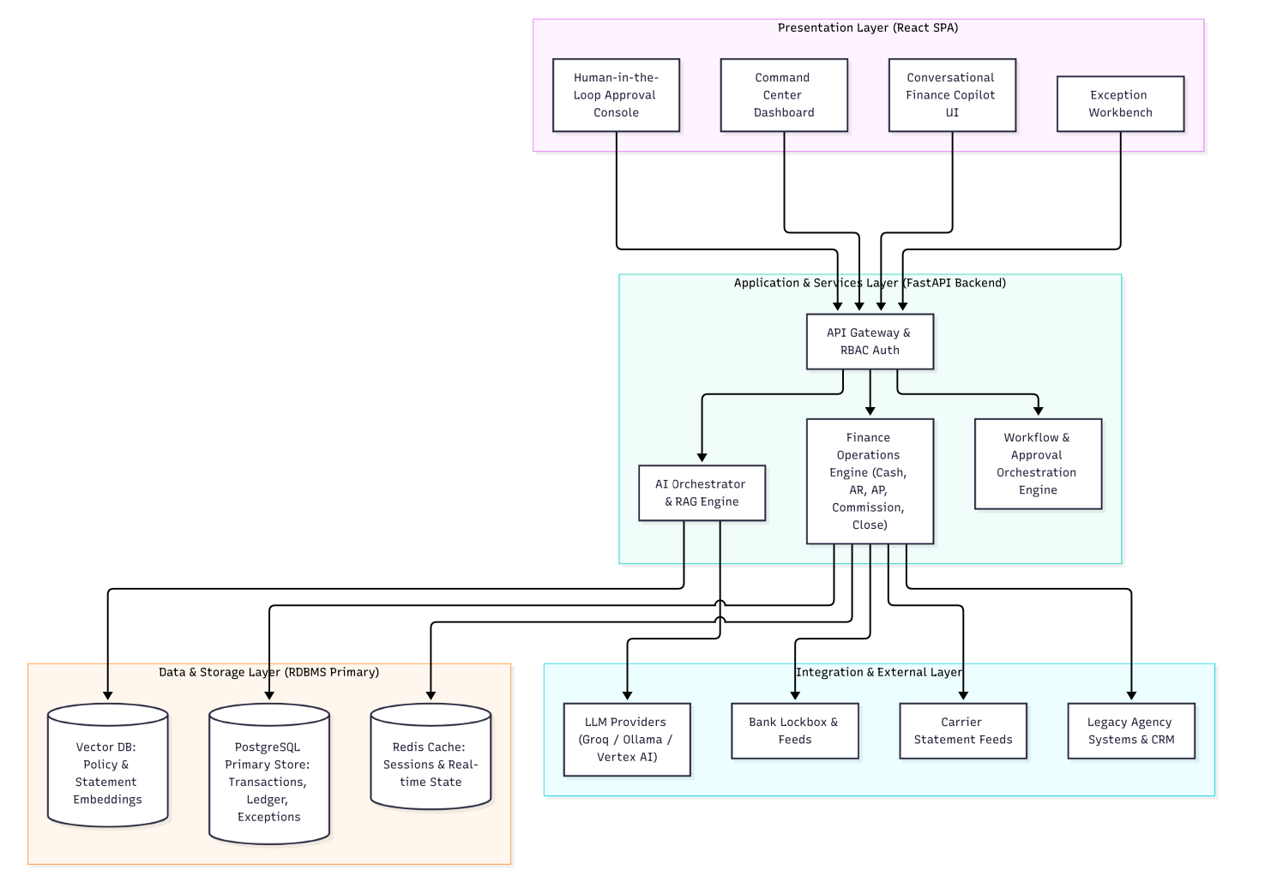

4.3 AI/Agent Interaction Flow (Sequence Diagram)
Key security & audit points are highlighted in the sequence: token validation, role‑based access, audit‑log write before any UI display.

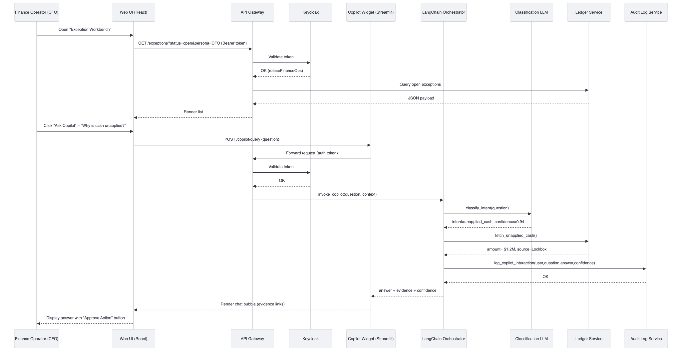

5. Technical Architecture
Concern | Decision | Rationale (Tool Selection)
Runtime | Kubernetes (EKS / AKS) | Cloud‑native orchestration, auto‑scaling, pod‑security‑policies, multi‑AZ resilience
Language Stack | Java 17 (Spring Boot) + TypeScript (React) | Enterprise‑grade, strong typing, mature security libraries, aligns with existing Meridian stack
AI Orchestration | LangChain (Python) running as side‑car containers | Proven LLM workflow, easy integration with Azure OpenAI, supports tool‑use & memory
Message Bus | Apache Kafka (Confluent Cloud) | High‑throughput, exactly‑once semantics for finance events
Cache | Redis (clustered) | Low‑latency look‑ups for ledger balances, session store
Search / Analytics | ElasticSearch + Kibana | Full‑text search on statements, exception clustering, audit‑log exploration
Observability | OpenTelemetry SDK (Java & Python) → Prometheus + Grafana + ELK | End‑to‑end tracing across micro‑services, supports compliance reporting
CI/CD | GitHub Actions + ArgoCD | Declarative GitOps, automated security scans (Trivy, Semgrep, SonarQube)
Secrets Management | HashiCorp Vault (auto‑unseal via Cloud KMS) | Centralised secret rotation, least‑privilege token issuance
Static Code Analysis | Semgrep + SonarQube Community | Detect OWASP Top‑10, enforce coding standards
Container Scanning | Trivy | CVE detection, SBOM generation for supply‑chain security
Synthetic Data Generator | Faker + custom Python scripts (containerized) | Guarantees no PII, reproducible test data sets
All tools are event‑approved (listed in the Enterprise‑Approved Tool List) and have been vetted for no real customer data ingestion.

6. Integration Architecture

6.1 Core Integration Points
System | Direction | Protocol / Format | Frequency | Governance
Agency Core Systems (legacy policy admin) | Inbound – transaction feeds | SFTP (CSV/EDI) → ingestion micro‑service | Near‑real‑time (batch every 5 min) | Data‑mapping contract, checksum validation
Carrier Portals | Inbound – premium statements | HTTPS (REST JSON) + optional XML | Daily at 02:00 UTC | Mutual TLS, schema validation
Bank Lockbox | Inbound – receipt files | SFTP (fixed‑width) | Event‑driven (file arrival) | File‑level encryption, PGP
Payroll / Producer Compensation | Outbound – payout instructions | ACH file (NACHA) via secure FTP | End‑of‑day batch | Dual‑control sign‑off
ERP / General Ledger | Outbound – journal entries | SOAP (XML) or REST (JSON) depending on ERP | Real‑time posting after approval | Idempotent API, audit‑trail
External AI Provider (Azure OpenAI) | Outbound – prompt/response | HTTPS (TLS 1.3) JSON | Per‑request (≤ 200 ms) | Prompt‑registry, token‑usage logging
Monitoring / SIEM | Outbound – logs & metrics | Syslog / OTLP | Continuous | Log‑retention policy, WORM storage

6.2 Integration Flow Diagram (Mermaid)
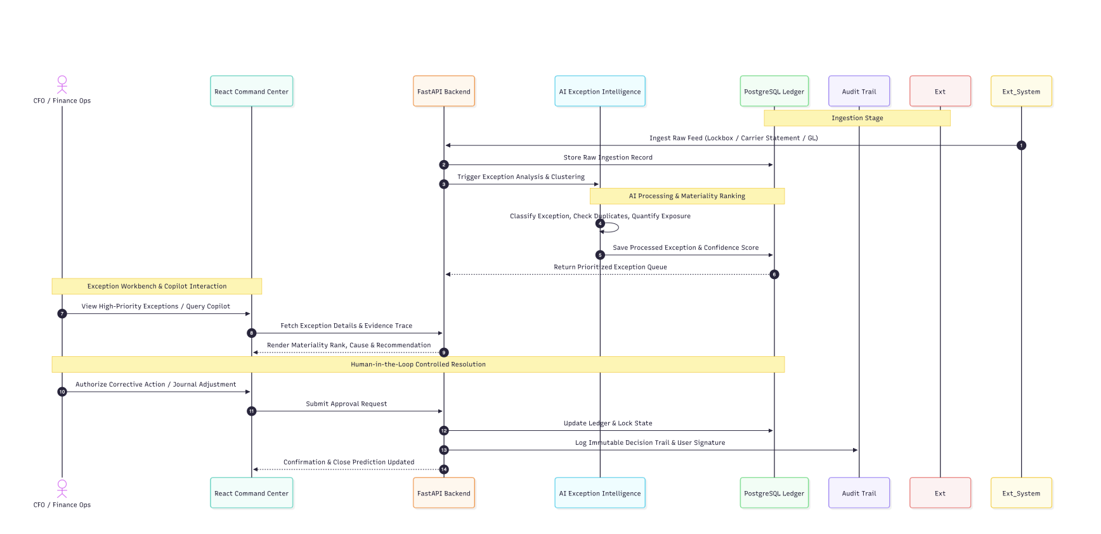
Notes
- All external connections use mutual TLS and IP allow‑lists.
- Idempotency keys are required on every inbound file to guarantee exactly‑once processing.
- Message‑level encryption (AES‑256) is applied for any PII/PCI data before entering Kafka.

7. Security Architecture

7.1 Security Principles
- Zero Trust – Verify every request, never trust network location.
- Least Privilege – Role‑based access (RBAC) enforced by Keycloak + OPA policies.
- Defense in Depth – Network segmentation, pod‑security‑policies, WAF, runtime security.
- Secure AI – Prompt‑registry, model‑card, confidence thresholds, human‑in‑the‑loop for any monetary action.
- Data Protection – Encryption‑in‑transit (TLS 1.3), encryption‑at‑rest (AES‑256), tokenization for account numbers.

7.2 Threat Model (STRIDE)
Threat | Asset | Mitigation
Spoofing | API calls, user sessions | OIDC with MFA, short‑lived JWTs, rotating

