Spendid Project – Enterprise Starter‑Code Architecture
Industry: Insurance – Brokerage Finance Operations
Application Type: Enterprise‑grade Finance‑Control Command Center
Core Stack:
Layer | Technology | Reason for Selection
Frontend | Streamlit (Python) + React (optional for heavy UI) | Rapid UI prototyping, native Python integration with AI agents, easy to embed in internal portals.
Backend API | FastAPI (Python) | High‑performance async, OpenAPI auto‑generation, strong typing, built‑in security utilities.
AI Orchestration | LangChain + Azure OpenAI Service (or OpenAI GPT‑4o) | Agentic workflow, prompt chaining, model‑level cost‑tracking, enterprise‑grade compliance (data residency, VNet).
Database | PostgreSQL 15 (RDS/Azure‑Postgres) | ACID, row‑level security, native JSONB for audit logs, mature ecosystem, easy horizontal scaling via read‑replicas.
Auth / Identity | OAuth 2.0 / OpenID Connect via Keycloak (self‑hosted) | Centralised identity, fine‑grained role‑based access (RBAC), MFA, audit trails, SAML/AD integration.
Containerisation | Docker + Docker‑Compose (local) / Kubernetes (EKS/AKS) | Immutable infrastructure, reproducible builds, auto‑scaling, zero‑downtime deployments.
IaC | Terraform (AWS/Azure) | Declarative, version‑controlled infra, compliance guardrails (policy as code).
CI/CD | GitHub Actions | Integrated with repo, secret‑scanning, SAST/DAST, automated test & deployment pipelines.
Observability | OpenTelemetry, Prometheus, Grafana, ELK | End‑to‑end tracing, metrics, log aggregation, audit‑ready dashboards.
Static & Dynamic Security | Semgrep, SonarQube CE, OWASP ZAP | Code‑quality, SAST, DAST, policy enforcement.
Prompt & Model Registry | SQLite (internal) + JSONL export | Lightweight, auditable record of every LLM interaction.
Governance Note – All tools are event‑approved (open‑source or enterprise‑grade SaaS) and do not ingest any real customer data. Synthetic data generators are provided in the repo.

1. Folder / Repository Layout
spendid_project/
│
├─ .github/ # GitHub Actions workflows
│ └─ workflows/
│ ├─ ci.yml
│ └─ cd.yml
│
├─ infra/ # Terraform IaC
│ ├─ main.tf
│ ├─ variables.tf
│ ├─ outputs.tf
│ └─ modules/
│ ├─ vpc/
│ ├─ rds/
│ └─ eks/
│
├─ docs/ # Architecture, compliance, governance docs
│ ├─ architecture.md
│ ├─ security_policy.md
│ └─ prompt_registry_template.xlsx
│
├─ src/
│ ├─ backend/ # FastAPI application
│ │ ├─ app/
│ │ │ ├─ api/
│ │ │ │ ├─ v1/
│ │ │ │ │ ├─ finance.py
│ │ │ │ │ ├─ auth.py
│ │ │ │ │ └─ ai.py
│ │ │ │ └─ __init__.py
│ │ │ ├─ core/
│ │ │ │ ├─ config.py
│ │ │ │ ├─ security.py
│ │ │ │ ├─ logger.py
│ │ │ │ └─ audit.py
│ │ │ ├─ db/
│ │ │ │ ├─ models/
│ │ │ │ │ ├─ finance.py
│ │ │ │ │ └─ audit_log.py
│ │ │ │ ├─ schemas/
│ │ │ │ │ ├─ finance.py
│ │ │ │ │ └─ audit.py
│ │ │ │ ├─ base.py
│ │ │ │ └─ session.py
│ │ │ ├─ services/
│ │ │ │ ├─ finance_service.py
│ │ │ │ ├─ ai_orchestrator.py
│ │ │ │ └─ notification.py
│ │ │ ├─ main.py
│ │ │ └─ __init__.py
│ │ └─ Dockerfile
│ │
│ ├─ frontend/ # Streamlit UI
│ │ ├─ pages/
│ │ │ ├─ 1_dashboard.py
│ │ │ ├─ 2_exceptions.py
│ │ │ ├─ 3_copilot.py
│ │ │ └─ 4_approvals.py
│ │ ├─ components/
│ │ │ ├─ auth.py
│ │ │ ├─ finance_chart.py
│ │ │ └─ exception_table.py
│ │ ├─ utils/
│ │ │ ├─ api_client.py
│ │ │ └─ session_state.py
│ │ ├─ requirements.txt
│ │ ├─ streamlit_app.py
│ │ └─ Dockerfile
│ │
│ ├─ ai_agent/ # Optional separate agent demo (Chainlit)
│ │ ├─ agent.py
│ │ ├─ prompts/
│ │ │ └─ classification.md
│ │ └─ Dockerfile
│ │
│ └─ synthetic_data/
│ ├─ generator.py
│ └─ data_specs.yaml
│
├─ tests/
│ ├─ integration/
│ │ └─ test_finance_api.py
│ ├─ unit/
│ │ ├─ test_models.py
│ │ └─ test_ai_orchestrator.py
│ └─ performance/
│ └─ load_test.jmx
│
├─ scripts/
│ ├─ lint.sh
│ ├─ security_scan.sh
│ └─ deploy.sh
│
├─ .dockerignore
├─ .gitignore
├─ docker-compose.yml
├─ helm/
│ └─ splendid/
│ ├─ Chart.yaml
│ ├─ values.yaml
│ └─ templates/
│ ├─ backend-deployment.yaml
│ ├─ frontend-deployment.yaml
│ ├─ postgres-statefulset.yaml
│ └─ ingress.yaml
│
├─ requirements.txt # Backend deps
├─ pyproject.toml
└─ README.md
All source files are type‑annotated, linted with ruff, and pass mypy strict mode.

2. High‑Level Architecture (Mermaid)
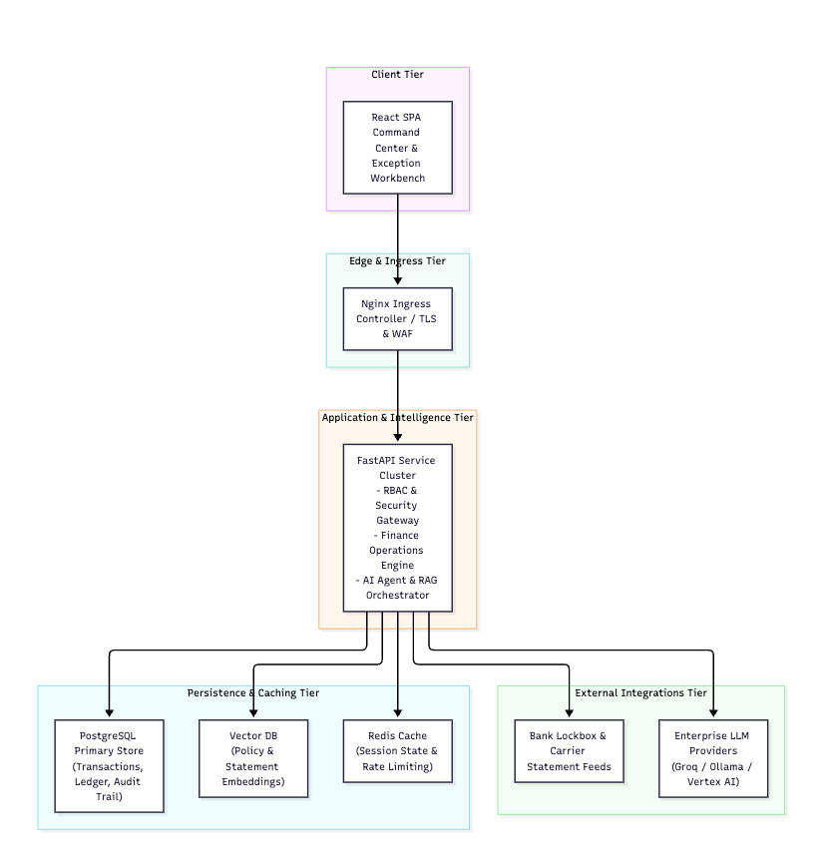

Deployment Diagram (K8s)
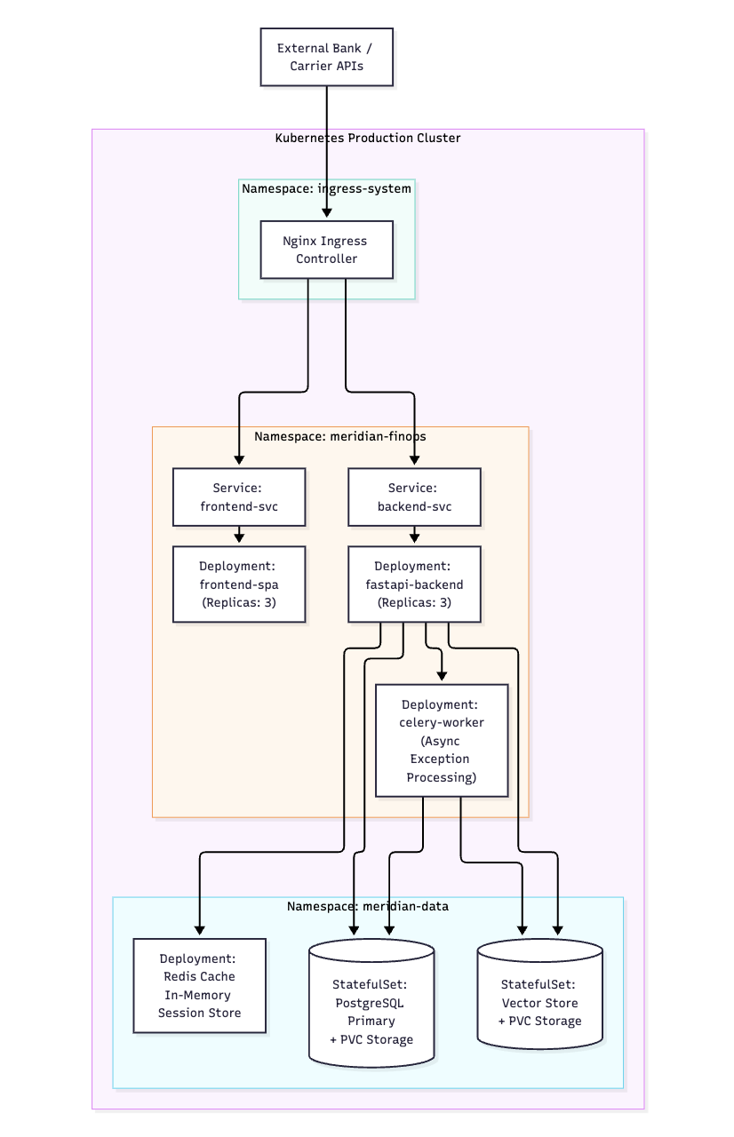
All traffic is TLS‑terminated at the Ingress. Internal pod‑to‑pod communication uses mutual TLS via Service Mesh (Istio) for zero‑trust.

3. Security, Compliance & Governance
Area | Controls | Implementation
Authentication & Authorization | OAuth2/OIDC, RBAC, MFA, token revocation | Keycloak as IdP; FastAPI dependency get_current_user validates JWT; role‑based scopes (finance:read, finance:write, ai:execute).
Data Protection | Encryption‑at‑rest, encryption‑in‑transit, column‑level masking | RDS Transparent Data Encryption (AES‑256); TLS 1.3 for all HTTP; PostgreSQL pgcrypto for PII fields; row‑level security policies for audit logs.
Auditability | Immutable audit trail, tamper‑evidence | audit_log table with jsonb payload, created_at, user_id; write‑only via stored procedure; logs shipped to ELK with hash‑chain verification.
Compliance | SOC‑2, ISO‑27001, GDPR (data‑subject rights) | Terraform guardrails enforce VPC isolation, IAM least‑privilege; Data‑subject deletion endpoint (/privacy/erase).
Secure Coding | SAST, DAST, secret scanning, dependency checks | GitHub Actions run Semgrep, Bandit, OWASP ZAP, Trivy; git‑secret prevents committing credentials.
Least‑Privilege AI | Model‑level access control, prompt‑level guardrails | LangChain wrapper checks user scope before invoking LLM; system prompt includes “Never disclose raw PII”.
Observability & Incident Response | Centralised logging, metrics, alerting | OpenTelemetry instrumentation in FastAPI & Streamlit; Prometheus alerts on latency > 500 ms, error‑rate > 1 %.
Disaster Recovery | Automated backups, point‑in‑time restore | RDS automated snapshots (daily, 35‑day retention); Kubernetes Velero backups for stateful sets.
Governance | Code review, change‑control, versioning | Mandatory PR approvals (2 reviewers), CODEOWNERS for security‑critical modules, semantic versioning.

4. Detailed Component Design

4.1 FastAPI Backend (src/backend/app)
Key files
File | Purpose
main.py | Application entry‑point, mounts routers, configures middleware (CORS, GZip, OpenTelemetry).
core/config.py | Pydantic BaseSettings reading from environment (prefixed SPENDID_).
core/security.py | JWT utilities, password hashing (argon2), role‑check dependency.
core/logger.py | Structured JSON logger (Loguru) with request‑ID correlation.
core/audit.py | Decorator @audit_event writes immutable rows to audit_log.
db/base.py | SQLAlchemy declarative_base + async engine (asyncpg).
db/session.py | Async session factory with connection‑pool (max 50).
db/models/finance.py | Ledger tables: transactions, exceptions, settlements, commissions.
db/models/audit_log.py | Immutable audit table with jsonb payload.
api/v1/finance.py | CRUD endpoints, exception‑workbench, forecasting triggers.
api/v1/ai.py | Endpoint /ai/classify – receives raw exception payload, returns classification, confidence, suggested action.
services/ai_orchestrator.py | LangChain Agent that: <br>1️⃣ Retrieves related ledger rows <br>2️⃣ Calls LLM with system prompt (see Prompt Registry) <br>3️⃣ Parses JSON response <br>4️⃣ Persists classification & confidence.
services/notification.py | Sends Slack/Teams webhook + email via AWS SES (or Azure Communication).

Sample FastAPI Security Dependency
# core/security.py
from fastapi import Depends, HTTPException, status
from fastapi.security import OAuth2AuthorizationCodeBearer
from jose import jwt, JWTError
from pydantic import BaseModel
from typing import List

oauth2_scheme = OAuth2AuthorizationCodeBearer(
authorizationUrl="https://keycloak.example.com/auth/realms/spendid/protocol/openid-connect/auth",
tokenUrl="https://keycloak.example.com/auth/realms/spendid/protocol/openid-connect/token",
)

class TokenPayload(BaseModel):
sub: str
scopes: List[str] = []

def get_current_user(token: str = Depends(oauth2_scheme)):
try:
payload = jwt.decode(token, "PUBLIC_KEY_PLACEHOLDER", algorithms=["RS256"])
token_data = TokenPayload(**payload)
except (JWTError, ValidationError):
raise HTTPException(
status_code=status.HTTP_401_UNAUTHORIZED,
detail="Could not validate credentials",
)
return token_data

def require_scope(required: str):
def wrapper(user: TokenPayload = Depends(get_current_user)):
if required not in user.scopes:
raise HTTPException(status_code=403, detail="Insufficient scope")
return user
return wrapper

4.2 Streamlit Frontend (src/frontend)
Key concepts
Page | Function
1_dashboard.py | KPI tiles (cash position, aging, exposure), high‑impact exception heat‑map.
2_exceptions.py | Workbench table with filters, bulk actions, evidence modal.
3_copilot.py | Chat‑style UI that calls /ai/classify and displays confidence, source documents, suggested next steps.
4_approvals.py | Human‑in‑the‑loop approval flow (sign‑off, journal entry generation).

Streamlit Session & Auth
# components/auth.py
import streamlit as st
import requests

def login():
if "token" not in st.session_state:
with st.form("login"):
username = st.text_input("Username")
password = st.text_input("Password", type="password")
submitted = st.form_submit_button("Sign in")
if submitted:
resp = requests.post(
"https://auth.spendid.example.com/realms/spendid/protocol/openid-connect/token",
data={"grant_type":"password","client_id":"streamlit","username":username,"password":password},
)
if resp.status_code == 200:
st.session_state.token = resp.json()["access

