Spendid_project – Requirement Traceability Matrix (RTM)
Version 1.0 – Prepared 10 Oct 2026
Req‑ID | Requirement (Brief) | User‑Story / Use‑Case Reference | Test‑Case(s) Mapping | Verification Method | Status
FR‑001 | Finance Journey Model – Define stages, controls, owners, cut‑offs, SLAs & dependencies for the seven finance processes. | US‑001 (CFO view of material exceptions) | TC‑FR‑001‑POS, TC‑FR‑001‑NEG | Functional test (unit + integration) | Draft
FR‑002 | Finance Operations Ledger – Persist synthetic receipts, invoices, statements, reconciliations, payables, disbursements, commissions, adjustments & close tasks. | US‑001, US‑002 (Exception workbench) | TC‑FR‑002‑POS, TC‑FR‑002‑NEG | Functional + DB schema validation | Draft
FR‑003 | Command‑Center Dashboard – Real‑time view of cash position, aging, settlement exposure, commission exceptions, reconciliation status & close readiness. | US‑001, US‑003 (Persona‑driven view) | TC‑FR‑003‑POS, TC‑FR‑003‑NEG, TC‑PERF‑001 | UI functional test, performance load (2 k concurrent users) | Draft
FR‑004 | Exception Workbench – Prioritised queue with evidence, classification, amount, aging, control impact, owner & decision history. | US‑001, US‑004 (Exception handling) | TC‑FR‑004‑POS, TC‑FR‑004‑NEG | Functional + audit‑trail verification | Draft
FR‑005 | AI Exception Intelligence – Auto‑classify, cluster, quantify exposure, de‑duplicate, recommend next steps. | US‑005 (AI copilot) | TC‑AI‑001‑POS, TC‑AI‑001‑NEG, TC‑AI‑002‑LOWCONF | AI model unit test, confidence‑threshold validation, explainability check | Draft
FR‑006 | Conversational Finance Copilot – Answer grounded questions, drill‑down, provide evidence, confidence, assumptions; persona‑specific. | US‑005, US‑006 (Copilot interaction) | TC‑COP‑001‑POS, TC‑COP‑001‑NEG, TC‑COP‑002‑LOWCONF | End‑to‑end functional test, LLM prompt audit, human‑in‑the‑loop approval | Draft
FR‑007 | Controlled Action Orchestration – Generate investigation tasks, notifications, journal‑support packages, approval requests & run‑book steps; enforce human approval before any ledger or payment change. | US‑007 (Controlled resolution) | TC‑CTRL‑001‑POS, TC‑CTRL‑001‑NEG, TC‑SEC‑003‑AUTH | Workflow engine test, RBAC enforcement, audit‑log verification | Draft
FR‑008 | Audit & Segregation‑of‑Duties (SoD) – Capture source‑to‑post trace, approvals, overrides, decision trail; immutable logs. | US‑008 (Auditability) | TC‑AUD‑001‑POS, TC‑AUD‑001‑NEG | Immutable log integrity test, tamper‑evidence check | Draft
FR‑009 | Synthetic Data Generator – Produce repeatable multi‑agency transactions, feeds, statements, exceptions, control events & realistic noise. | US‑009 (Synthetic data) | TC‑DATA‑001‑POS, TC‑DATA‑001‑NEG | Data generation validation, privacy compliance check | Draft
FR‑010 | Reporting & Economics Dashboard – Operational trends, exposure, close forecast, prompt/model trace, token usage, cost & latency. | US‑010 (Tokenomics) | TC‑REP‑001‑POS, TC‑REP‑001‑NEG | Reporting accuracy test, cost‑model verification | Draft
NFR‑001 | Scalability – System must support up to 10 k concurrent finance users and ingest 5 M transactions/day with < 2 s latency for UI queries. | All functional stories | TC‑PERF‑001‑LOAD, TC‑PERF‑002‑STRESS | Load & stress testing (JMeter) | Draft
NFR‑002 | Security – Confidentiality – All data at rest encrypted (AES‑256) and in‑flight TLS 1.3; least‑privilege RBAC per persona. | All stories (especially FR‑007, FR‑008) | TC‑SEC‑001‑ENCR, TC‑SEC‑002‑RBAC | Pen‑test, static code analysis (Semgrep) | Draft
NFR‑003 | Security – Integrity – Digital signatures on all journal entries & external statements; tamper‑evident audit logs (hash‑chaining). | FR‑008 | TC‑SEC‑003‑SIG, TC‑AUD‑001‑HASH | Integrity test, hash‑chain verification | Draft
NFR‑004 | Compliance – SOC 2 / ISO 27001 – Align with control categories: Security, Availability, Processing Integrity, Confidentiality, Privacy. | All stories | TC‑COM‑001‑SOC2, TC‑COM‑002‑ISO27001 | Third‑party audit checklist, compliance test suite | Draft
NFR‑005 | Reliability – 99.9 % uptime – Automated fail‑over, health‑checks, circuit‑breaker patterns. | All stories | TC‑REL‑001‑HA, TC‑REL‑002‑RECOVERY | Chaos‑engineering (Gremlin) | Draft
NFR‑006 | Observability – Centralised logging (ELK), metrics (Prometheus), tracing (OpenTelemetry) with dashboards for latency, error rates, AI token consumption. | All stories | TC‑OBS‑001‑LOG, TC‑OBS‑002‑METRICS | Log‑aggregation validation, alert‑rule testing | Draft
NFR‑007 | Governance – Change Management – All code changes tracked via Git‑flow, peer‑reviewed, CI/CD gated by automated tests & security scans. | All stories | TC‑GOV‑001‑CI, TC‑GOV‑002‑CODE‑REV | CI pipeline verification, pull‑request audit | Draft
NFR‑008 | Auditability – Traceability Matrix – End‑to‑end mapping from requirement → design → code → test → demo evidence. | All stories | TC‑GOV‑003‑RTM | Manual review, automated traceability tool (e.g., Azure DevOps) | Draft
AI‑001 | Model Selection & Rationale – Use Azure OpenAI GPT‑4o for LLM copilot; LangChain agents for exception classification; fine‑tuned on synthetic finance data. | FR‑005, FR‑006 | TC‑AI‑003‑MODEL, TC‑AI‑004‑FINE‑TUNE | Model performance benchmark, cost‑analysis | Draft
AI‑002 | Responsible AI – Explainability – Every AI output must include confidence score, source evidence, and assumptions; human must approve any monetary action. | FR‑005, FR‑006, FR‑007 | TC‑AI‑005‑EXPLAIN, TC‑SEC‑004‑APPROVAL | Explainability test, human‑approval workflow test | Draft
AI‑003 | Tokenomics & Cost Monitoring – Capture per‑request token count, latency, cost; enforce budget alerts (>$5 k/month). | FR‑010 | TC‑TOK‑001‑CAPTURE, TC‑TOK‑002‑ALERT | Token‑usage logging, cost‑threshold test | Draft
AI‑004 | Model Governance – Versioned model registry, immutable provenance, rollback capability, audit of prompt‑usage (see Prompt Register). | All AI stories | TC‑AI‑006‑REGISTRY, TC‑AI‑007‑ROLLBACK | Model registry validation, rollback test | Draft

How to Read the Matrix
Column | Meaning
Req‑ID | Unique identifier (FR = Functional, NFR = Non‑Functional, AI = AI‑specific).
Requirement | Concise statement of what must be delivered.
User‑Story / Use‑Case Reference | The high‑level story that drives the requirement (e.g., US‑001 = “CFO wants a single view of material exceptions”).
Test‑Case(s) Mapping | One or more test‑case IDs that verify the requirement. Positive (POS), Negative (NEG), Low‑Confidence (LOWCONF), Performance (PERF), Security (SEC), etc.
Verification Method | How the test is executed (functional test, load test, security scan, audit, etc.).
Status | Current lifecycle stage – Draft, Reviewed, Approved, Implemented, Validated, Closed.

Traceability Flow (High‑Level)
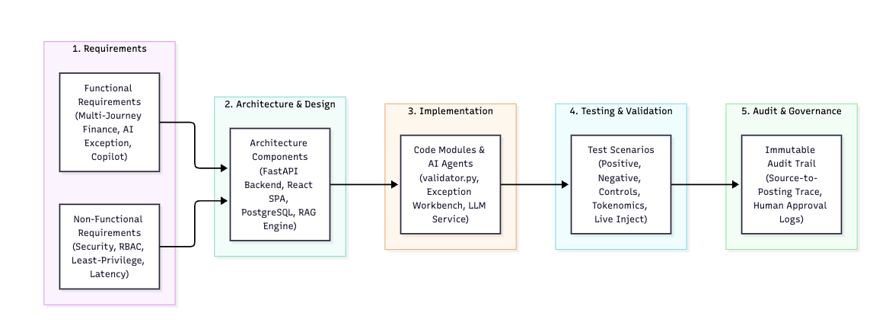
The matrix is the single source of truth linking User Stories → Requirements → Design → Code → Tests → Evidence. Any change to a requirement must trigger a traceability impact analysis (governed by the Change Management process).

Governance & Maintenance Process
Activity | Owner | Frequency | Artefact
Requirement Review | Business Analyst & Finance SME | Sprint‑start | Updated RTM (status = Reviewed)
Design Sign‑off | Solution Architect | End of Sprint 2 | Architecture Diagrams, Updated RTM
Code Review & Merge | Development Lead (peer‑review) | Per Pull‑Request | CI status badge, RTM status = Implemented
Test Execution | QA Lead | Continuous Integration | Test reports linked to TC IDs
Security & Compliance Scan | Security Architect | Nightly (Automated) | Scan reports, RTM status = Validated
Audit Trail Review | Internal Auditor | Monthly | Audit log export, RTM status = Closed
Model Governance Review | AI Governance Board | Quarterly | Model registry snapshot, Prompt Register, RTM status = Validated
Tokenomics Review | Finance Ops & Cloud Cost Owner | Monthly | Tokenomics Report, RTM status = Validated
All artefacts (RTM, design docs, code, test suites, prompt register) are stored in the Spendid_project Azure DevOps repository with branch protection, mandatory pull‑request approvals, and immutable tags for released versions.

Next Steps
- Finalize User Stories (US‑001 – US‑010) with finance SMEs.
- Populate Test Cases (TC‑* IDs) in Azure Test Plans and link them to the RTM.
- Run a baseline compliance scan (SOC 2 Type I) and update NFR‑004 status to Reviewed.
- Iterate the RTM after each sprint – any requirement that moves to Implemented must have at least one PASS test result attached.
The RTM will evolve throughout the SDLC, providing a transparent, auditable, and governance‑driven view of delivery health.

