Assignment – 2 | Git And Jenkins

Clone repository


Create two branches “branch1” and “branch2”

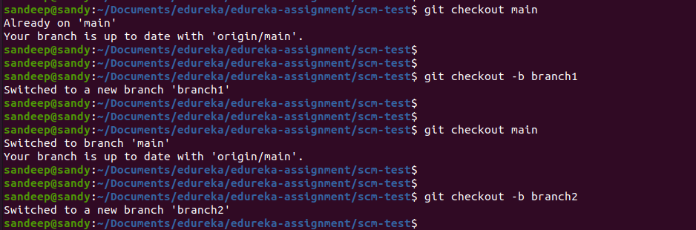
Make commit in “branch2”

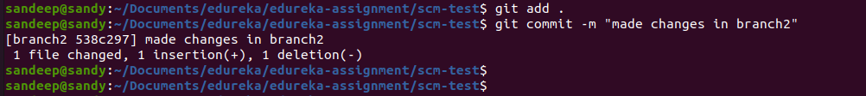
Make commit in “branch1”

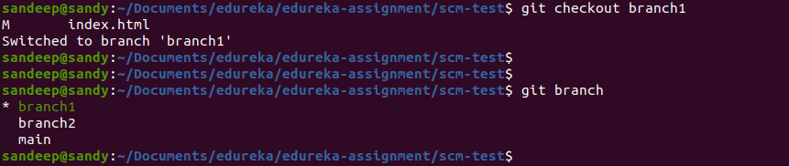
Merging from “branch1” to main



Merging from “branch2” to main

We got conflict while merging from branch2 as we made changes in the same file

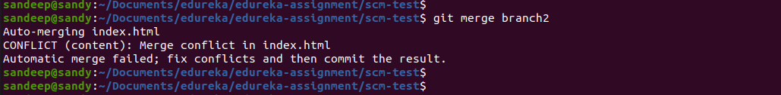
Installing merge tool and solving conflict issue


How to resolve conflict ??

- Need to remove conflict markers like <<<<<<<, =======, and >>>>>>>. These markers indicate the conflicting sections.Need to manually edit the file to choose which changes to keep. Remove the conflict markers and ensure that the file represents the desired state after the merge.


- Need to continue with merge


- commit the changes after final resolve conflict
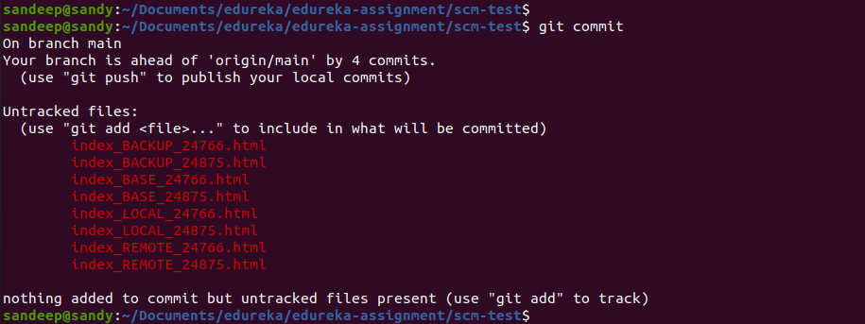
- Finally push the changes into main

