Assignment – 3 | Git And Jenkins

URL to login Jenkins dashboard

http://jenkins.local:8080/

Install necessary plugins for Git, Maven and Tomcat

- Git
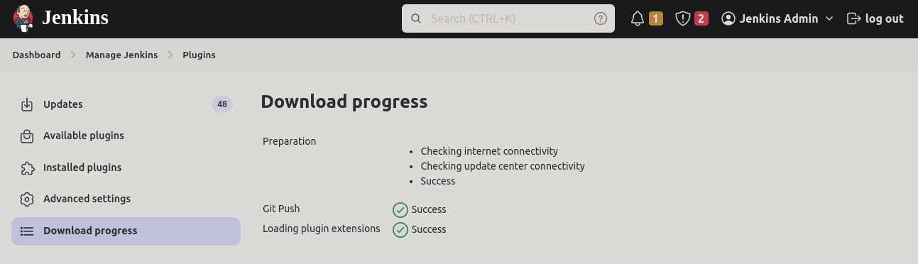
- Maven

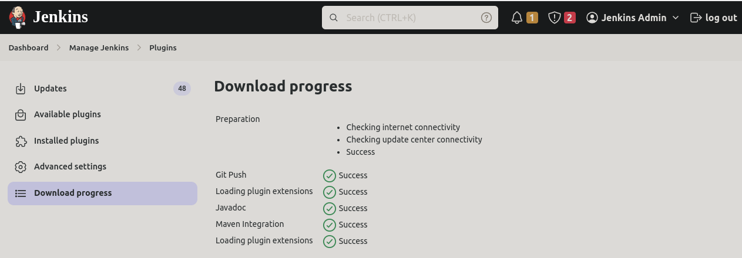
- Tomcat

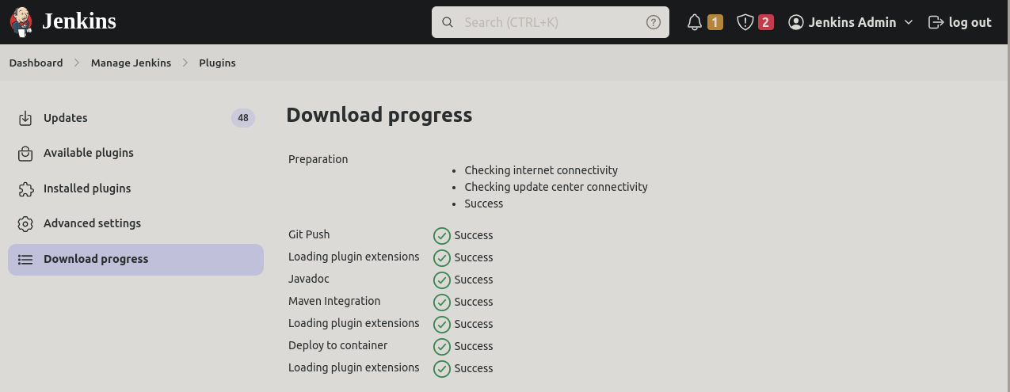
To create Jenkins Job

Setup Automatic trigger

- Configure source code management

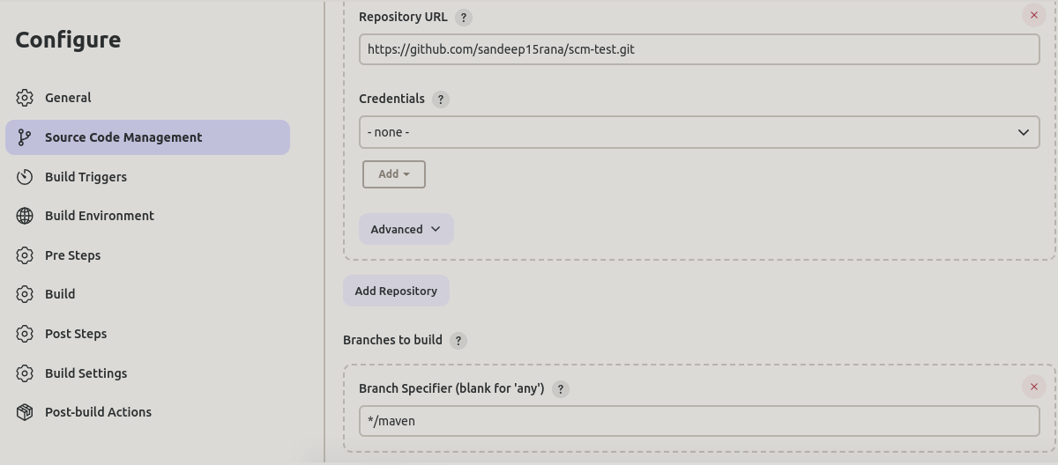
- Build trigger

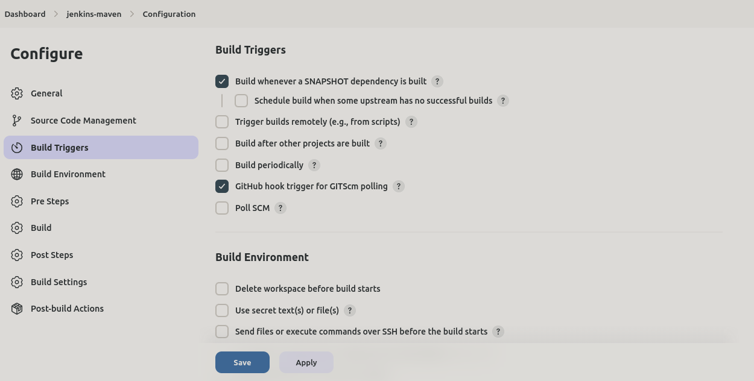
- Add webhooks
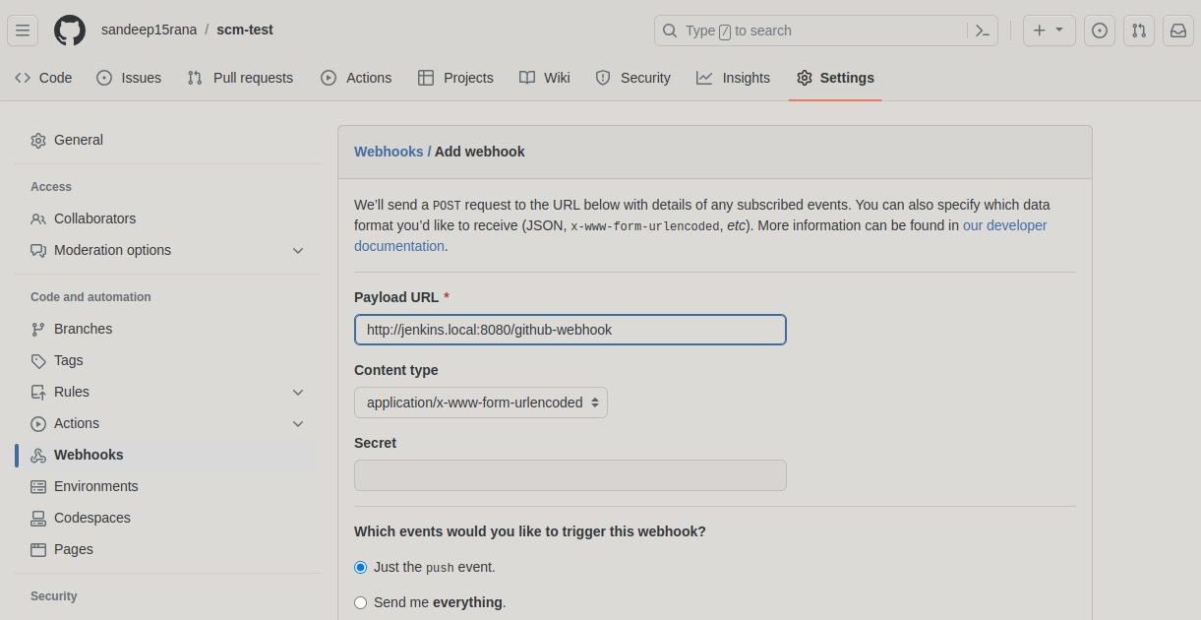
To Add build steps for each of the following stages: Compile, Code Review, Unit Test
, Package, and Deploy
installation of Maven

https://phoenixnap.com/kb/install-maven-on-ubuntu

https://maven.apache.org/guides/getting-started/maven-in-five-minutes.html

- Selecting project style as maven
- Worker node setup done & Agent Initialisation
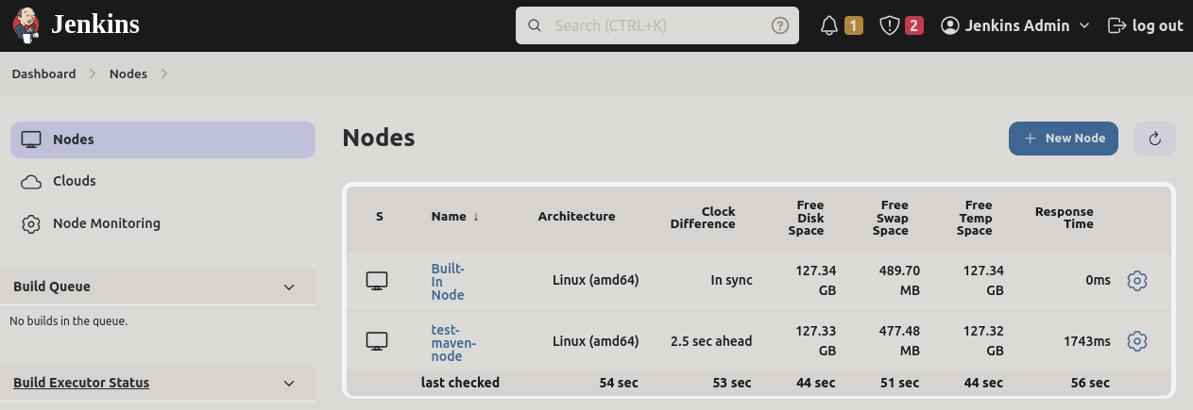

- maven target to jenkins job
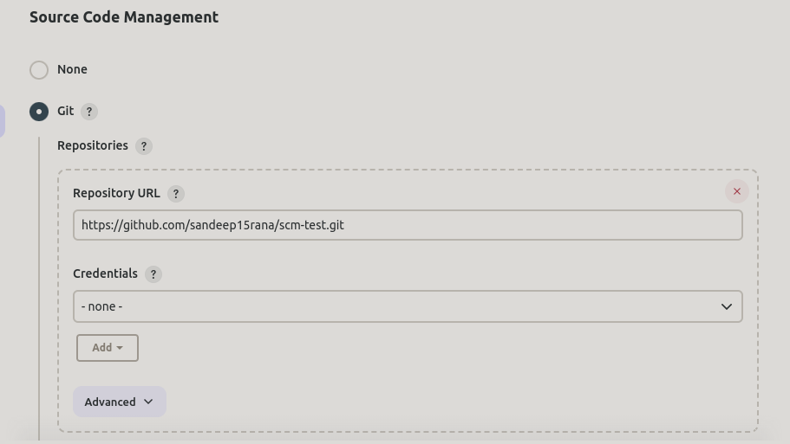
- correct pom.xml path in the jenkins build shell

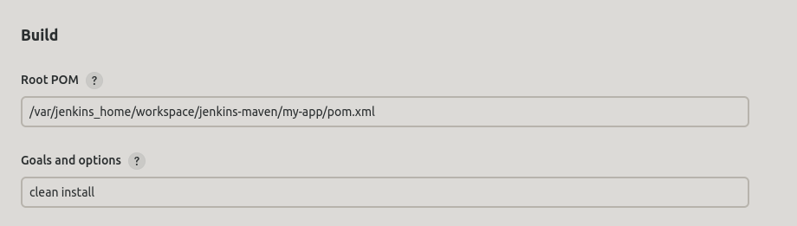
- Post build

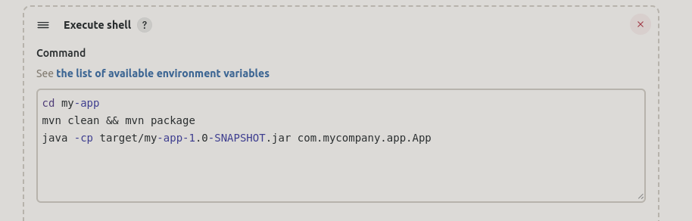
- Command executed in the terminal

It commit at the maven branch and once we initiate build in the jenkins.. Trigger will start.

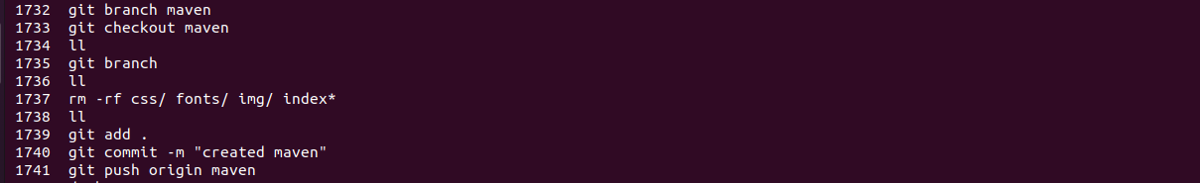
- Final output
