Assignment – 1 | SCM With Git

Initialise git repository

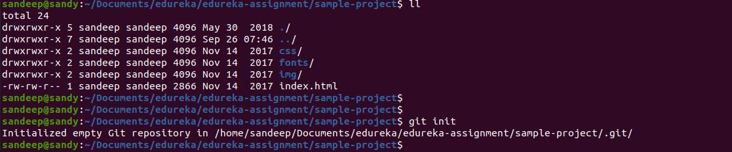
Add all the files to the repository and commit it

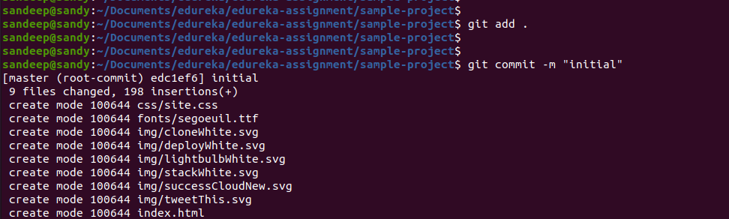
Switch to new branch

Made changes in the file and commit it

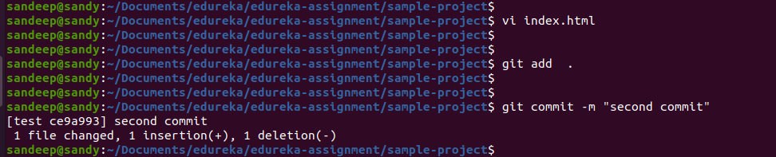
Switch to master and merge with “test” branch
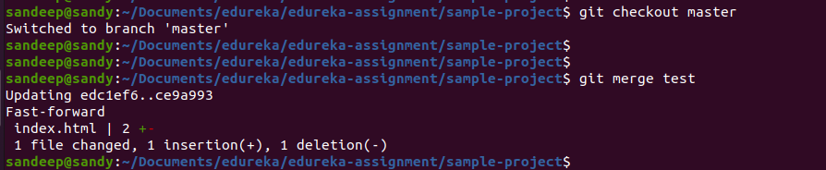
Add company repository

Push code to remote repository

