Assignment – 4 | Continuous Integration With Jenkins

1. freestyle project with the name QA_UNIT_TEST

Freestryle project created

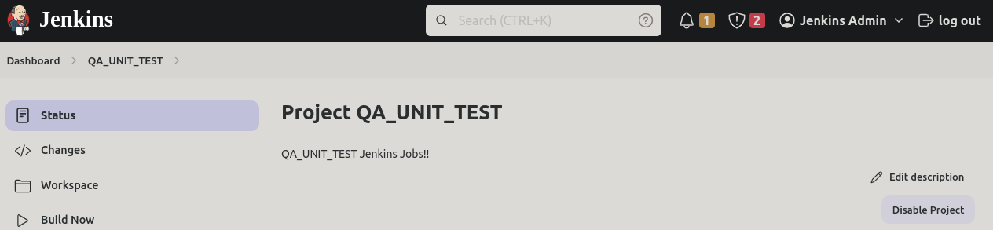
Added webhooks in GitHub and SCM in the build trigger

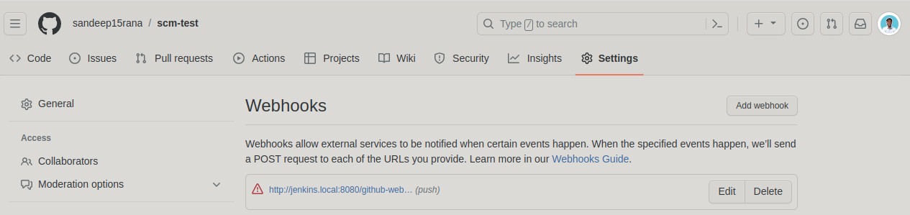
Activity at terminal

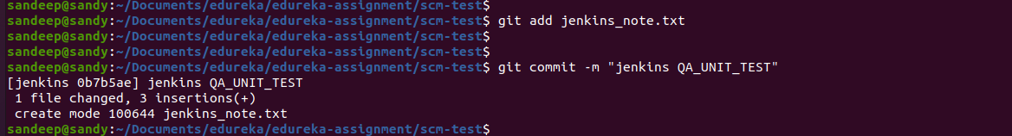
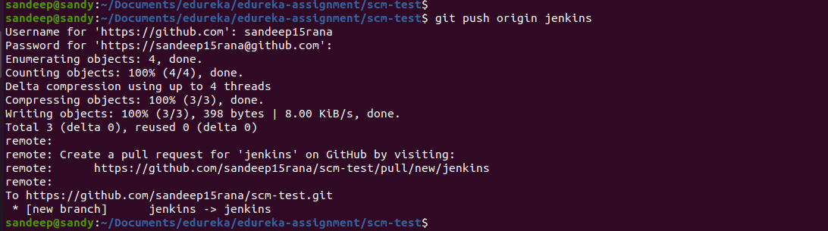
Console output
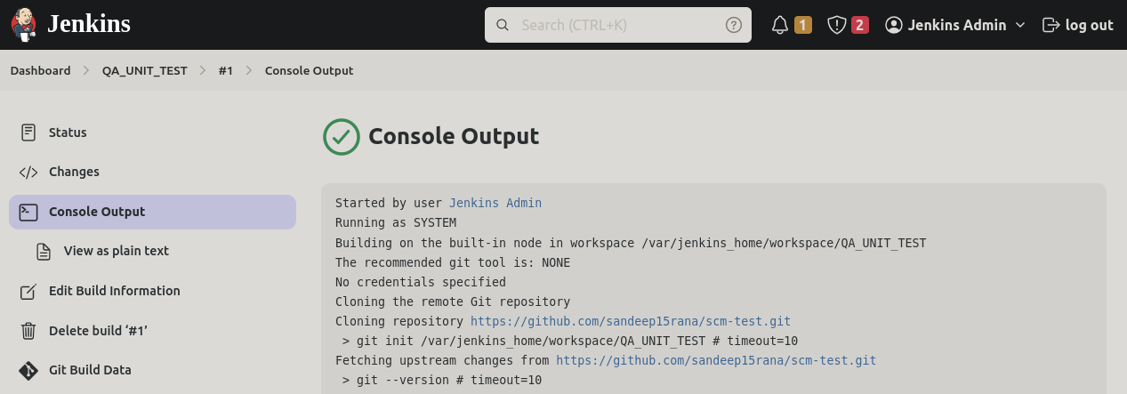
Started by user Jenkins Admin
Running as SYSTEM
Building on the built-in node in workspace /var/jenkins_home/workspace/QA_UNIT_TEST
The recommended git tool is: NONE
No credentials specified
Cloning the remote Git repository
Cloning repository https://github.com/sandeep15rana/scm-test.git
> git init /var/jenkins_home/workspace/QA_UNIT_TEST # timeout=10
Fetching upstream changes from https://github.com/sandeep15rana/scm-test.git
> git --version # timeout=10
> git --version # 'git version 2.30.2'
> git fetch --tags --force --progress -- https://github.com/sandeep15rana/scm-test.git +refs/heads/*:refs/remotes/origin/* # timeout=10
> git config remote.origin.url https://github.com/sandeep15rana/scm-test.git # timeout=10
> git config --add remote.origin.fetch +refs/heads/*:refs/remotes/origin/* # timeout=10
Avoid second fetch
> git rev-parse refs/remotes/origin/jenkins^{commit} # timeout=10
Checking out Revision 0b7b5aee91e70a36bdfdea2b900bc877db7e07b3 (refs/remotes/origin/jenkins)
> git config core.sparsecheckout # timeout=10
> git checkout -f 0b7b5aee91e70a36bdfdea2b900bc877db7e07b3 # timeout=10
Commit message: "jenkins QA_UNIT_TEST"
First time build. Skipping changelog.
[QA_UNIT_TEST] $ /bin/sh -xe /tmp/jenkins4043364062847269081.sh
+ echo Hello Jenkins !!
Hello Jenkins !!
+ echo QA_UNIT_TEST completed !!
QA_UNIT_TEST completed !!
Finished: SUCCESS

2. freestyle project with the name QA_ METRICS _CHECK

Cobertura plugin installation

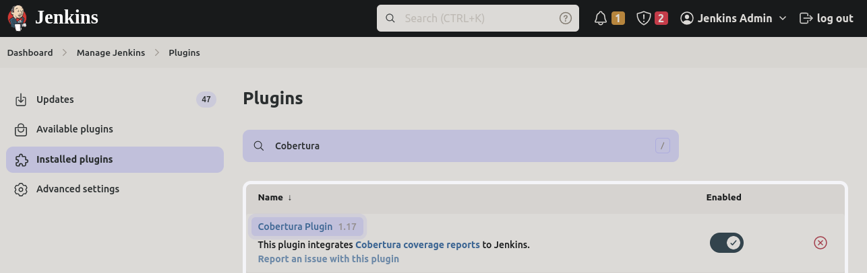
Jobs creation

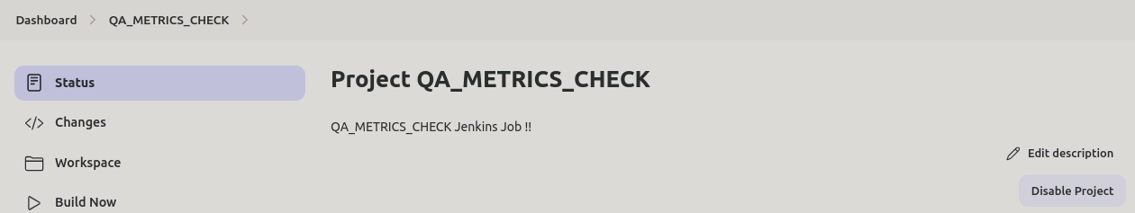
SCM

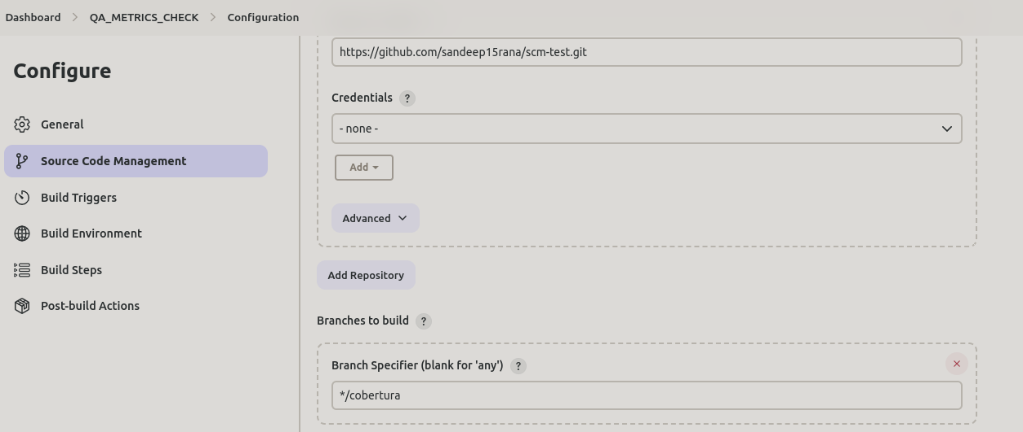
Build step

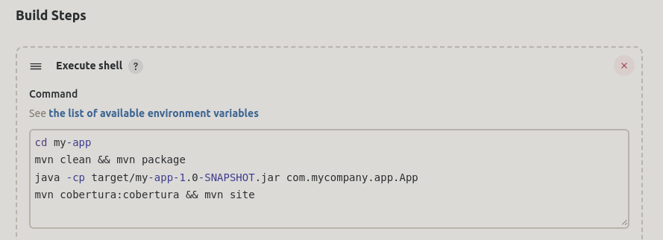

Post build step

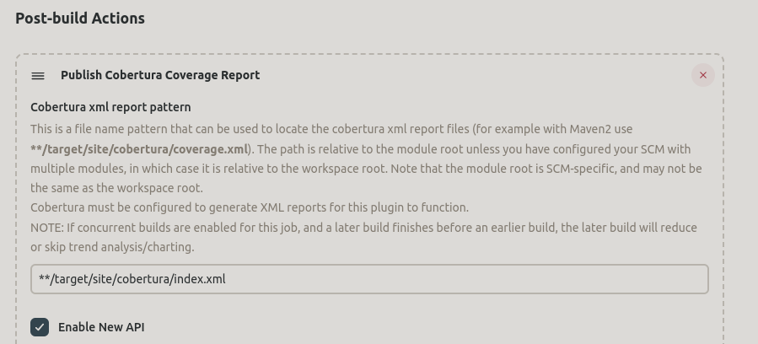
Cobertura Output :
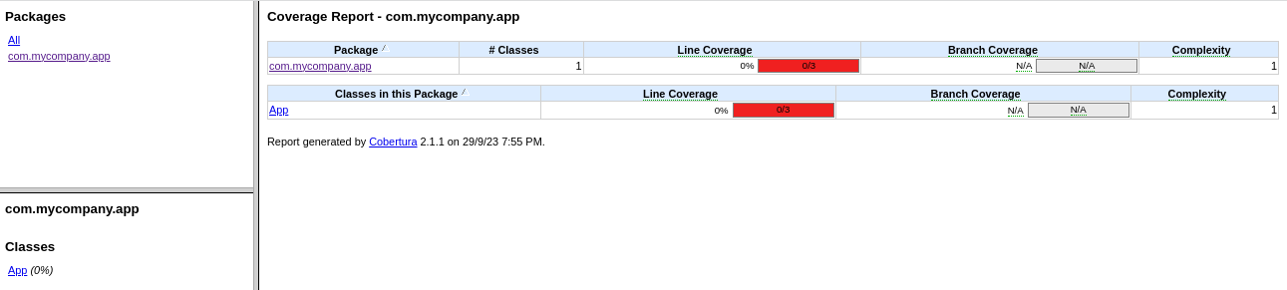
Ref:

https://plugins.jenkins.io/cobertura/

Cobertura Report https://mkyong.com/qa/maven-cobertura-code-coverage-example/#:~:text=Maven%20will%20generate%20the%20Cobertura,html%20.&text=Please%20refer%20to%20this%20Cobertura,page%2C%20look%20like%20a%20JavaDoc.

3. freestyle project with the name QA_ PACKAGE

Jenkins Job creation

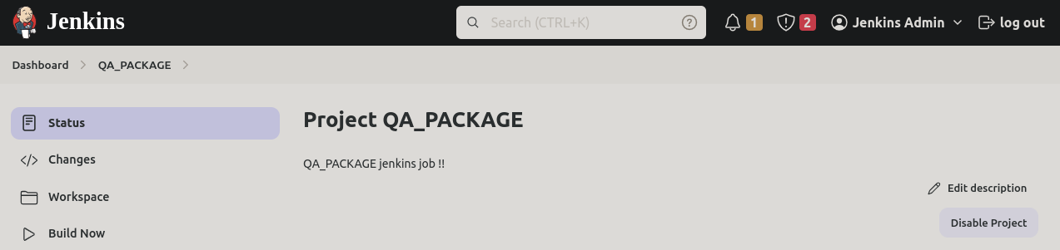
SCM Configuration

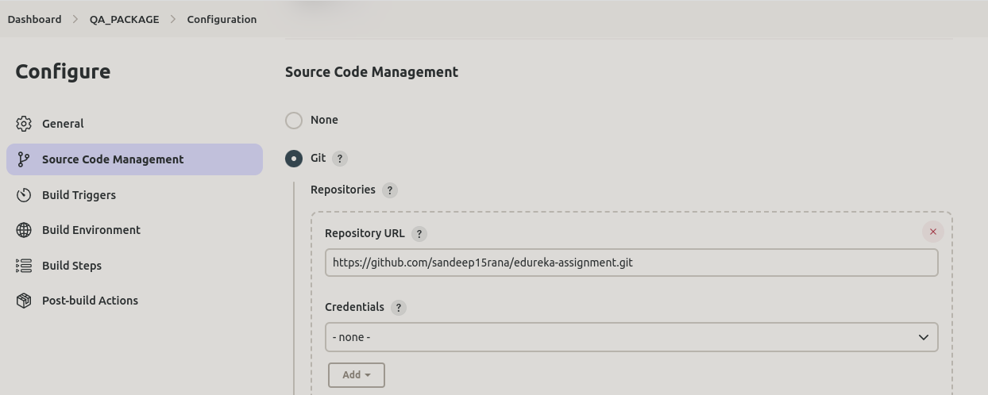
Build shell:

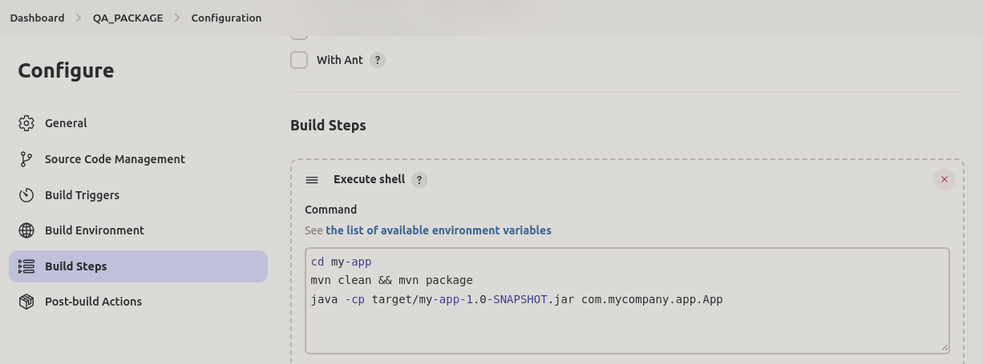
Ouptut:

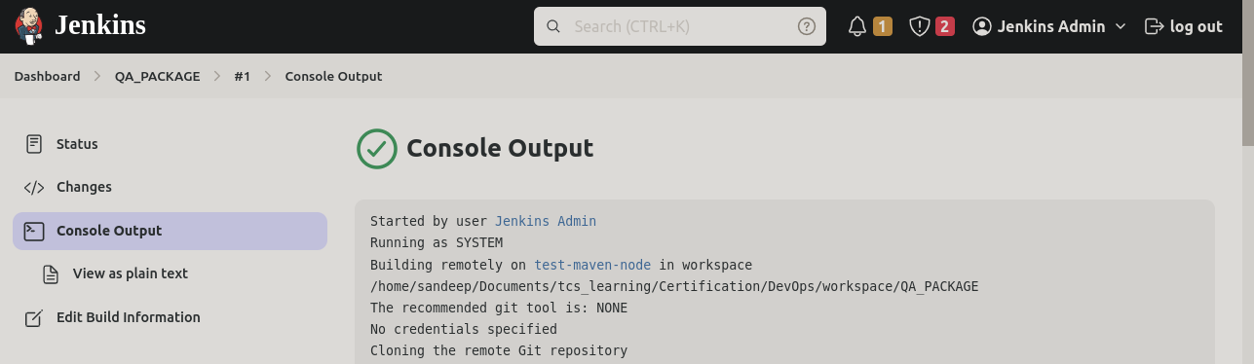
4. pipeline named SAMPLE_COMPILE_VIEW

Build pipeline plugin

https://plugins.jenkins.io/workflow-aggregator/releases/

https://www.jenkins.io/doc/book/managing/plugins/#advanced-installation

https://www.guru99.com/jenkins-pipeline-tutorial.html#:~:text=Step%204)%20Go%20to%20your,the%20initial%20job%20to%20run.

Output:
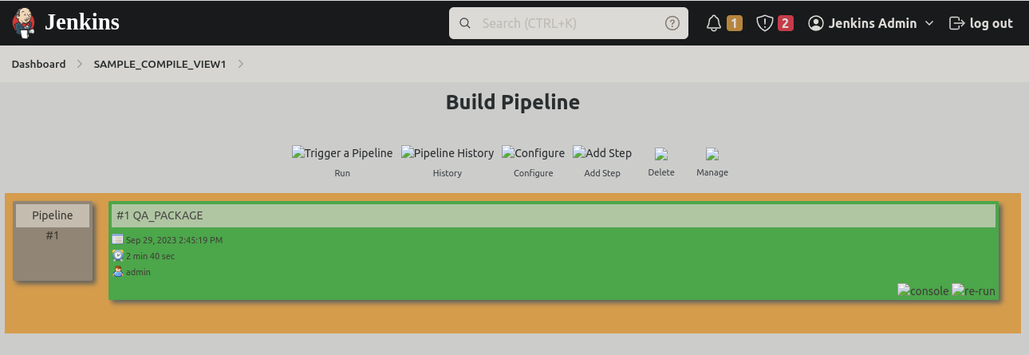
5. The pipelines can also be extended to running web tests and load tests. Explain how you would do the same using Jenkins?
Extending Jenkins pipelines to include web tests and load tests is a common practice to automate testing processes as part of the continuous integration and continuous delivery (CI/CD) pipeline. Below, I'll explain how you can integrate web tests and load tests into your Jenkins pipeline:
- Web Tests:
a. Select Testing Framework: Choose a testing framework suitable for web testing. Popular options include Selenium, Puppeteer, or Cypress.
b. Create Test Scripts: Write test scripts using the selected testing framework to automate interactions with your web application. These scripts should cover various scenarios and test cases.
c. Integrate with Jenkins: Store your test scripts in a version control system (e.g., Git) along with your application code. Ensure that your Jenkins pipeline can access these scripts.
d. Configure a Testing Stage: Add a new stage in your Jenkinsfile dedicated to running web tests. This stage should include commands to execute the test scripts using the chosen testing framework. For example:
groovyCopy code
stage('Run Web Tests') {
steps {
sh 'npm install' // Install dependencies (if using Node.js)
sh 'npm test' // Run web tests
}
}
- Load Tests:
a. Select Load Testing Tool: Choose a load testing tool such as Apache JMeter, Gatling, or Locust.
b. Create Load Test Scenarios: Develop load test scenarios that simulate real-world user traffic and interactions with your web application. Define target performance metrics.
c. Integrate with Jenkins: Similar to web tests, store your load test scenarios and scripts in version control along with your application code. Ensure Jenkins can access these resources.
d. Configure a Load Testing Stage: Add a stage to your Jenkins pipeline dedicated to load testing. This stage should include commands to execute the load tests using your chosen tool. For example:
groovyCopy code
stage('Run Load Tests') {
steps {
sh 'jmeter -n -t my-load-test.jmx -l load-test-results.jtl' // Example for JMeter
}
}
- Reporting and Analysis:
a. Collect Test Results: Configure your web and load test scripts to generate test result reports in a format that Jenkins can understand. Common formats include JUnit XML or JSON.
b. Publish Test Results: Add post-build actions in your Jenkins pipeline to publish the test results. For example:
groovyCopy code
post {
always {
junit '**/test-results/*.xml' // Example for JUnit XML
}
}
c. Performance Analysis: Use Jenkins plugins or integrations with third-party tools to visualize and analyze the test results. You can use plugins like "Performance" or "Performance Publisher" for load test analysis.
- Triggering Web and Load Tests:
a. Manual Trigger: You can manually trigger web and load tests by running the Jenkins pipeline when needed.
b. Scheduled Tests: For regular testing, set up a schedule using Jenkins cron syntax to automatically run tests at specific intervals (e.g., nightly or weekly).
- Notifications and Alerts:
a. Configure email notifications or chat notifications (e.g., Slack) to alert the development and operations teams if tests fail or if performance thresholds are breached.

