Problem Statement – II | Certification Project

Repo: https://github.com/bhavukm/cicd-pipeline-train-schedule-autodeploy

1. Fork the repository

Fork Repo: https://github.com/sandeep15rana/edureka-project.git

2. Jenkins setup and Installation of plugins --> Completed
- Docker

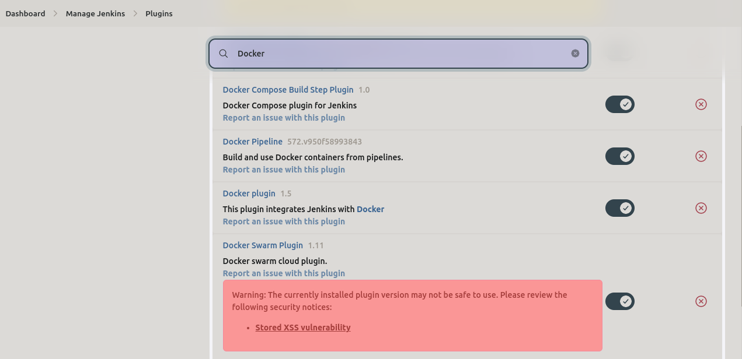
- Pipeline

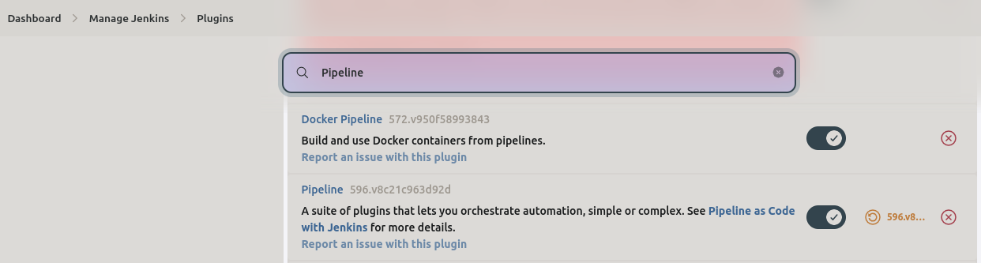
- GitHub

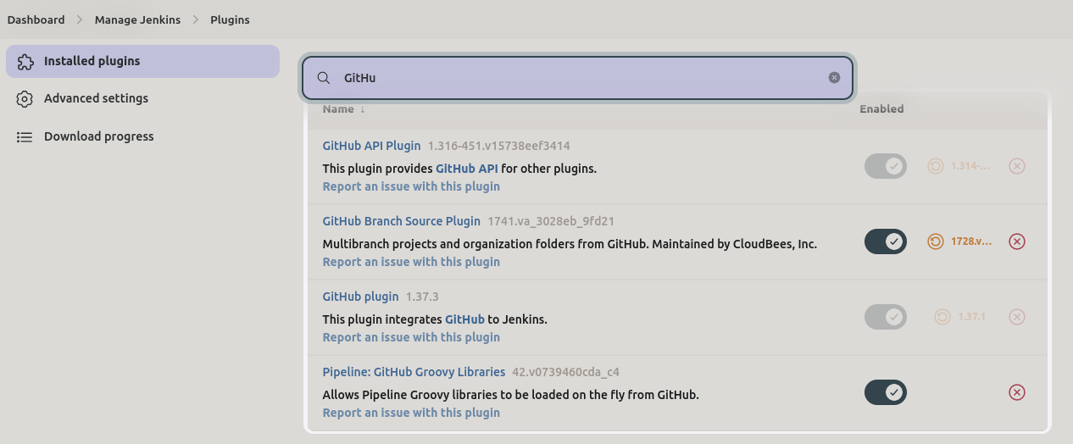
- Kubernetes
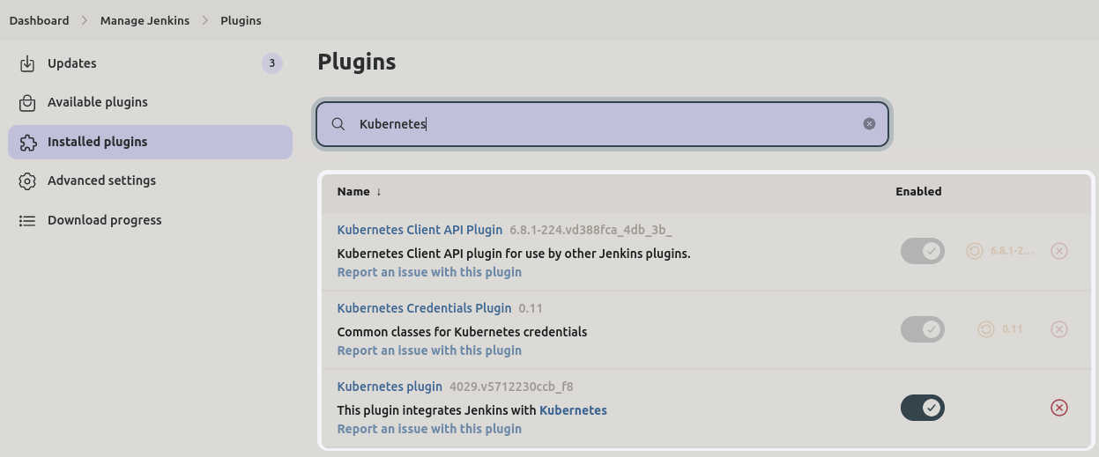
3. Configure GitHub WebHook --> Completed

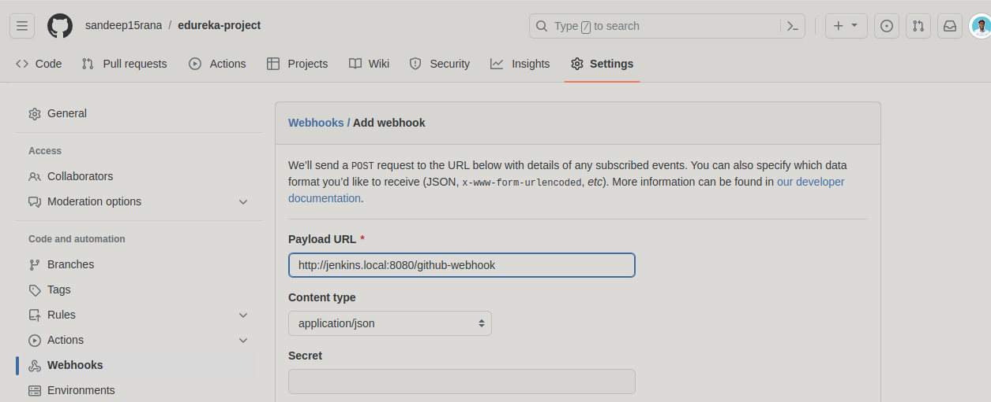
4. Create Jenkinsfile --> Completed
5. Configure Jenkins pipeline

Updated Jenkinsfile:

pipeline {
agent any
environment {
// Be sure to replace "bhavukm" with your own Docker Hub username
DOCKER_IMAGE_NAME = "sandeep10rana/train-schedule"
}
stages {
stage('Checkout') {
steps {
script {
// Use your Git credentials ID configured in Jenkins
checkout([$class: 'GitSCM', branches: [[name: '*/pipeline']], doGenerateSubmoduleConfigurations: false, extensions: [], userRemoteConfigs: [[credentialsId: 'github_login', url: 'https://github.com/sandeep15rana/edureka-project.git']]])
}
}
}
stage('Build') {
steps {
echo 'Running build automation'
sh './gradlew build --no-daemon'
archiveArtifacts artifacts: 'dist/trainSchedule.zip'
}
}
stage('Build Docker Image') {
steps {
script {
def app = docker.build(DOCKER_IMAGE_NAME)
//echo "Docker build command: ${app.getCommand()}"
app.inside {
sh 'echo Hello, World!'
}
}
}
}
stage('Push Docker Image') {
steps {
script {
docker.withRegistry('https://registry.hub.docker.com', 'docker_hub_login') {
app.push("${env.BUILD_NUMBER}")
app.push("latest")
}
}
}
}
stage('CanaryDeploy') {
environment {
CANARY_REPLICAS = 1
}
steps {
kubernetesDeploy(
kubeconfigId: 'kubeconfig',
configs: 'train-schedule-kube-canary.yml',
enableConfigSubstitution: true
)
}
}
stage('DeployToProduction') {
environment {
CANARY_REPLICAS = 0
}
steps {
input 'Deploy to Production?'
milestone(1)
kubernetesDeploy(
kubeconfigId: 'kubeconfig',
configs: 'train-schedule-kube-canary.yml',
enableConfigSubstitution: true
)
kubernetesDeploy(
kubeconfigId: 'kubeconfig',
configs: 'train-schedule-kube.yml',
enableConfigSubstitution: true
)
}
}
}
}

Ref: To set up pipeline

https://www.youtube.com/watch?v=fhIKugIdtMc

CI/CD : https://www.youtube.com/watch?v=R48W6BmGfbA&list=PL6XT0grm_Tfi21F8O0TvHmb78P2uEmhDq&index=34

Jenkinsfile: https://www.youtube.com/watch?v=RsD2nzPY0is
Graddle Compatibility: https://docs.gradle.org/current/userguide/compatibility.html#java

Issue 1:

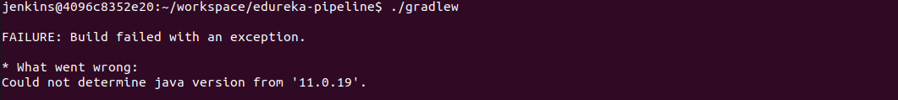
Sol:
- Updated jdk Global tool configuration through Jenkins Dashboard
- Checked the compatibility of JDK 11.0.19 with Gradle wrapper and updated in gradle-wrapper.properties to 5.0

Issue 2:

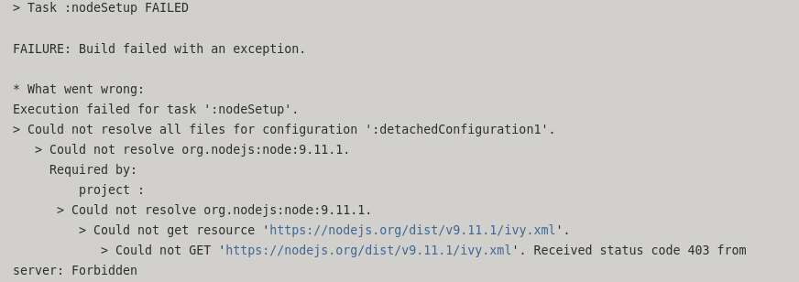
Sol: Changed the node, npm and id("com.github.node-gradle.node") version "2.2.0" ) in build.gradle file. This worked for me.

https://github.com/srs/gradle-node-plugin/issues/292

Issue 3:

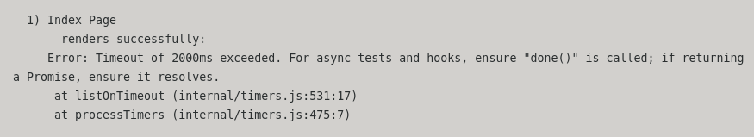
Sol:

Find command cheatsheet:

https://www.geeksforgeeks.org/find-command-in-linux-with-examples/

Issue 4:

Also: org.jenkinsci.plugins.workflow.actions.ErrorAction$ErrorId: 878c5e42-0d19-45d1-bcf1-3877295dca49
groovy.lang.MissingPropertyException: No such property: docker for class: groovy.lang.Binding

Sol: https://stackoverflow.com/questions/41215997/jenkins-error-no-such-property-docker-for-class-groovy-lang-binding

Issue 5: To solve docker not found issue
Sol:

Created new Dockerfile included Jenkins and Docker plugin installed
Issue 6:

ERROR: Could not find credentials entry with ID 'docker_hub_login' Finished: FAILURE

Sol:
Credentials Id in Jenkins

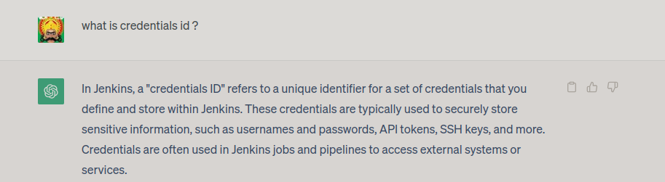
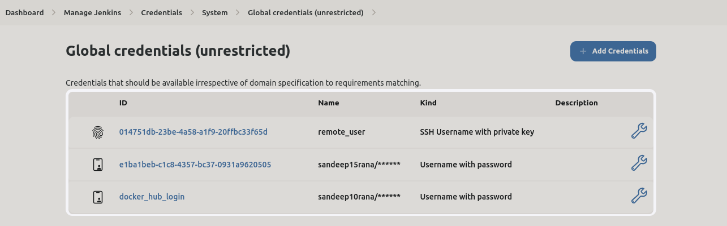
6. Docker and Kubernetes Installation --> Completed
7. Docker Hub and Kubernetes Cluster
8. Test the pipeline

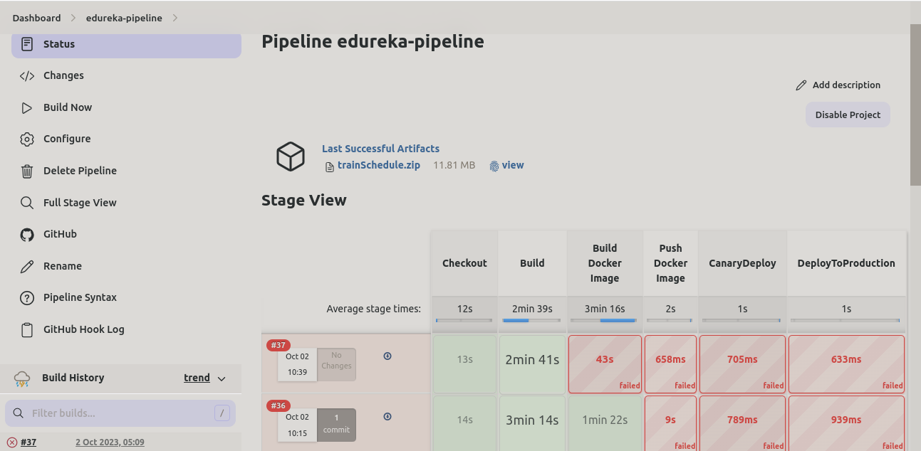
Output logs:

http://jenkins.local:8080/job/edureka-pipeline/36/consoleText

